The Commission for the Conservation and Management of
Highly Migratory Fish Stocks in the Western and Central Pacific Ocean

Scientific Committee

North Pacific Swordfish (Xiphias gladius)

Stock Status and Management Advice

Contents
SC19 2023 (STOCK ASSESSMENT CONDUCTED) 2
SC15 2019 (FISHERY INDICATORS UPDATED) 10
SC14 2018 (STOCK ASSESSMENT CONDUCTED) 10
SC13 2017 (FISHERY INDICATORS UPDATED) 15
Useful References 16
Previous Assessments 16

SC19 2023 (STOCK ASSESSMENT CONDUCTED)

Provision of scientific information

Stock Identification and Distribution

- The North Pacific swordfish (Xiphias gladius, NP SWO) stock area was defined to be the waters of the North Pacific Ocean contained in the Western and Central Pacific Fisheries Commission (WCPFC) Convention Area bounded by the equator and the waters of the Inter-American Tropical Tuna Commission (IATTC) Convention Area north of 10°N (Figure NPSWO-1). All available fishery data from the stock area were used for the stock assessment. For the purpose of modelling observations of catch-per-unit effort (CPUE) and size composition data, it was assumed that there was an instantaneous mixing of fish throughout the stock area on a quarterly basis. The stock was modelled using a fleets-as-areas approach with separate catch and index fleets for the Western and Central North Pacific Ocean (WCNPO) and Eastern Pacific Ocean (EPO) region delineated in (Figure NPSWO-1).

Catches

- The NP SWO catches were high from the 1970’s to the 1980’s averaging about 14,000 mt per year during 1975-1990, peaked with unusually high catches in 1998-2000, and then generally declined to the current levels around 11,000mt. Catches by most fleets have generally declined, while minor catches by other WCPFC CCMs have generally increased, except in in the last three years (Figure NPSWO-2). Overall, longline fishing gear has accounted for the vast majority of NP SWO catch.

Data and Assessment

- Catch and size composition data were collected from International Scientific Committee for tuna and tuna-like species in the North Pacific Ocean (ISC) countries (Chinese Taipei, Japan, and USA) and the WCPFC and IATTC. Standardized CPUE data used to measure trends in relative abundance were provided by Chinese Taipei, Japan, and USA. The NP SWO stock was assessed using an age- and length-structured assessment Stock Synthesis (SS3) model fit to time series of standardized CPUE and size composition data. Life history parameters for growth and maturity were updated for this benchmark stock assessment. The value for stock-recruitment steepness used for the base case model was h = 0.9. The assessment model was fit to relative abundance indices and size composition data in a likelihood-based statistical framework. Maximum likelihood estimates of model parameters, derived outputs, and their variances were used to characterize stock status and to develop stock projections. Several sensitivity analyses were conducted to evaluate the effects of changes in model parameters, including natural mortality rate at age, stock-recruitment steepness, growth curve parameters, and female length at 50% maturity, as well as uncertainty in the input data and model structure.

Biological Reference Points

- MSY-based biological reference points were computed for the base case model with SS3 (Table NPSWO-2). The point estimate of annual catch at F_{MSY} was calculated to be 14924 mt. The point estimate of the spawning biomass to produce MSY (adult female biomass) was 16,388 mt. The point estimate of F_{MSY}, the fishing mortality rate to produce SSB_{MSY} (average fishing mortality on ages 1 – 10) was 0.18 and the corresponding equilibrium value of spawning potential ratio at SSB_{MSY} was 19%.

Projections

- Stock projections for NP SWO were conducted using SS3. No recruitment deviations nor log-bias adjustment were applied to the future projections. Projections are reported as the mean and standard deviation around 100 bootstrapped model runs for each scenario. Projections started in 2022 and continued through 2031 under 5 levels of fishing mortality. The five fishing mortality stock projection scenarios were: (1) F at 20%SSB_{(F=0)} which was calculated from the mean dynamic SSB in the five years, (2) F₍₂₀₀₈₋₂₀₁₀₎ which is the reference years for the proposed CMM for NP SWO, (3) F_{Low} at F_{30%SPR}, (4) F_{MSY}, and (5) F status quo (average F during 2019-2021). Results show the projected female spawning stock biomass and the catch biomass under each of the scenarios (Table NPSWO-3 and Figure NPSWO-5-6).

Stock status and trends

- SC19 noted that the ISC provided the following conclusions on the stock status of North Pacific Swordfish:
- Estimates of population biomass fluctuated around an average of 80,800 mt during 1975-2021 and was estimated to be 88,800 mt in 2021 (Figure NPSWO-3a and Table NPSWO-1). Initial estimates of female spawning stock biomass (SSB) averaged around 27,600 mt in the late 1970s. SSB was at its highest level of 35,778 metric tons in 2021, and was at its minimum of 22,415 mt in 1981. Overall, spawning stock biomass has been relatively stable for the entirety of the assessment period (Figure NPSWO-3b). Estimated F (arithmetic average of F for ages 1 – 10) decreased from 0.17 year-1 in 1978 to a minimum of 0.09 year⁻¹ in 2021 (Figure NPSWO-3c). It averaged roughly F=0.09 during 2019-2021 or about 51% of FMSY with a relative fishing mortality of F/F_{MSY} = 0.49 in 2021. Fishing mortality has been below FMSY since the beginning of the assessment time period and has had a declining trend with the exception of a high peak in 1998 coinciding with high catch by the US LL fleet. Recruitment (age-0 fish) estimates averaged approximately 838,000 individuals during 1975-2021. While the overall pattern of recruitment varied, there was no apparent trend in recruitment strength over time (Figure NPSWO-3d). Overall, total annual catch is declining, CPUE is increasing, and recruitment is relatively stable. When the status of NP SWO is evaluated relative to MSY-based reference points, the 2021 SSB of 35,778 mt is 220% above SSBMSY (16,000 mt) and the 2019-2021 F is about 49% below F_{MSY}. Therefore, relative to MSY-based reference points, overfishing is very likely not occurring (>99% probability) and the NP SWO stock is very likely not overfished (>99% probability, Figure NPSWO-4).
- WCPFC16 established a limit reference point for the exploitation rate of NP SWO of F_{MSY}. SSB_{F=0}, set to equal the average of the last 5 years dynamic B₀ assuming no fishing during those years. NP SWO reference points will be provided with reference to MSY and with reference to 20%SSB_{F=0}.

- SC19 noted the following stock status from ISC:
- Female spawning stock biomass was estimated to be 35,778mt in 2021, with a relative SSB ratio of SSB/SSB_{MSY} = 2.18 in 2021;
- Estimated F (arithmetic average of F for ages 1 – 10) averaged roughly F=0.09 yr⁻¹ during 2019-2021 with a relative fishing mortality of F/F_{MSY} = 0.49 in 2021; and
- Relative to MSY-based reference points, overfishing is very likely not occurring (>99% probability) and the NP SWO stock is very likely not overfished (>99% probability, Figure NPSWO-4).

Management advice and implications

- SC19 noted the following conservation information from the ISC:
- Projections started in 2022 and continued through 2031 under five levels of fishing mortality. The five fishing mortality stock projection scenarios were: (1) F at 20%SSB_{(F=0)} which was calculated from the mean dynamic SSB in the most recent five years, (2) F₍₂₀₀₈₋₂₀₁₀₎ which are the reference years for the proposed CMM for NPO SWO, (3) F_{Low} at F_{30%SPR}, (4) F_{MSY}, and (5) F status quo (average F during 2019-2021). Results show the projected female spawning stock biomass and the catch biomass under each of the scenarios (Table NPSWO-3; Figure NPSWO-5, Figure NPSWO-6).

- Based on these findings, the following conservation information was provided:
- The NP SWO stock has produced annual yields of around 11,500 mt per year since 2016, or about 2/3 of the MSY catch amount.
- NP SWO stock status is positive with no evidence of excess F above F_{MSY} or substantial depletion of spawning potential.
- It was also noted that retrospective analyses show that the assessment model appears to underestimate spawning potential in recent years.

Special Comments
- The lack of sex-specific size data and the simplified treatment of the spatial structure of swordfish population dynamics remained as two important sources of uncertainty for improving future assessments.

Table NPSWO-1. Reported catch (mt) used in the stock assessment along with annual estimates of population biomass (age-1 and older, mt), female spawning biomass (mt), relative female spawning biomass (SSB/SSB_{MSY}), recruitment (thousands of age-0 fish), fishing mortality (average F, ages 1–10), relative fishing mortality (F/F_{MSY}), and spawning potential ratio of North Pacific swordfish (Xiphias gladius).
Year | 2016 | 2017 | 2018 | 2019 | 2020 | 2021 | Mean¹ | Min¹ | Max¹
Reported Catch | 12,648 | 11,831 | 12,730 | 11,093 | 10,731 | 10,136 | 12,876 | 9,539 | 19,230
Population Biomass | 83,200 | 86,835 | 89,418 | 89,617 | 89,992 | 88,755 | 80,762 | 65,722 | 89,992
Spawning Biomass | 28,205 | 29,785 | 31,661 | 33,761 | 35,159 | 35,778 | 28,777 | 22,415 | 35,778
Relative Spawning Biomass | 1.72 | 1.82 | 1.93 | 2.06 | 2.15 | 2.18 | 1.76 | 1.37 | 2.18
Recruitment (age 0) | 964,401 | 746,962 | 783,354 | 739,400 | 624,962 | 633,046 | 838,473 | 595,771 | 1,430,430
Fishing Mortality | 0.1 | 0.09 | 0.1 | 0.09 | 0.09 | 0.09 | 0.12 | 0.09 | 0.19
Relative Fishing Mortality | 0.55 | 0.52 | 0.57 | 0.49 | 0.5 | 0.49 | 0.68 | 0.49 | 1.09
Spawning Potential Ratio | 0.34 | 0.37 | 0.37 | 0.42 | 0.43 | 0.44 | 0.33 | 0.24 | 0.44
¹ During 1975-2021
Table NPSWO-2. Estimated biological reference points derived from the Stock Synthesis base case model for North Pacific swordfish where F is the instantaneous annual fishing mortality rate, SPR is the annual spawning potential ratio, SSB is spawning stock biomass, and SSB_{(F=0)} indicates the average 5-year SSB₀ estimate, 20%SSB_{(F=0)} is the associated reference point, and MSY is the maximum sustainable yield reference point.
Reference Point | Estimate
F_{20%SSB(F=0)} (age 1-10) | 0.16
F_{MSY} (age 1-10) | 0.18
F₂₀₂₁ | 0.09
F₂₀₁₉₋₂₀₂₁ | 0.09
SSB_{F=0} | 95,732
20%SSB_{F=0} | 19,146
SSB_{MSY} | 16,388
SSB₂₀₂₁ | 35,778
SSB₂₀₁₉₋₂₀₂₁ | 34,899
C_{20%SSB(F=0)} | 14,815
C_{MSY} | 14,924
C₂₀₁₉₋₂₀₂₁ | 10,653
SPR_{20%SSB(F=0)} | 22%
SPR_{MSY} | 19%
SPR₂₀₂₁ | 44%
SPR₂₀₁₉₋₂₀₂₁ | 43%

Table NPSWO-3. Projected median values of Western and Central North Pacific swordfish spawning stock biomass (SSB, mt) and catch (mt) under five constant fishing mortality rate (F) and two recruitment scenarios during 2021-2040.
Year | 2022 | 2023 | 2024 | 2025 | 2026 | 2027 | 2028 | 2029 | 2030 | 2031
Scenario 1: F_{20%SSB(F=0)}
SSB | 40,457 | 38,288 | 36,295 | 35,452 | 35,425 | 35,611 | 36,064 | 36,387 | 36,264 | 36,478
Catch | 16,906 | 14,986 | 13,531 | 13,120 | 13,298 | 13,612 | 13,875 | 14,053 | 14,161 | 14,220
Scenario 2: F₁₉₉₈₋₂₀₀₀
SSB | 41,567 | 40,422 | 38,952 | 38,309 | 38,371 | 38,565 | 39,133 | 39,534 | 39,336 | 39,625
Catch | 14,302 | 13,389 | 12,608 | 12,428 | 12,656 | 12,967 | 13,224 | 13,399 | 13,509 | 13,572
Scenario 3: Low F (F_{SPR30%})
SSB | 42,268 | 42,368 | 41,811 | 41,756 | 42,235 | 42,712 | 43,610 | 44,300 | 44,162 | 44,705
Catch | 11,370 | 11,249 | 11,096 | 11,255 | 11,623 | 11,990 | 12,263 | 12,445 | 12,557 | 12,631
Scenario 4: F_{MSY}
SSB | 38,291 | 34,051 | 31,164 | 29,979 | 29,800 | 29,894 | 30,225 | 30,452 | 30,322 | 30,473
Catch | 23,395 | 17,817 | 14,992 | 14,169 | 14,264 | 14,565 | 14,812 | 14,966 | 15,052 | 15,095
Scenario 5: F_{Status Quo} (Average F₂₀₁₉₋₂₀₂₁)
SSB | 38,828 | 35,056 | 32,339 | 31,201 | 31,036 | 31,138 | 31,489 | 31,733 | 31,602 | 31,765
Catch | 21,803 | 17,218 | 14,723 | 13,981 | 14,082 | 14,379 | 14,627 | 14,785 | 14,875 | 14,921

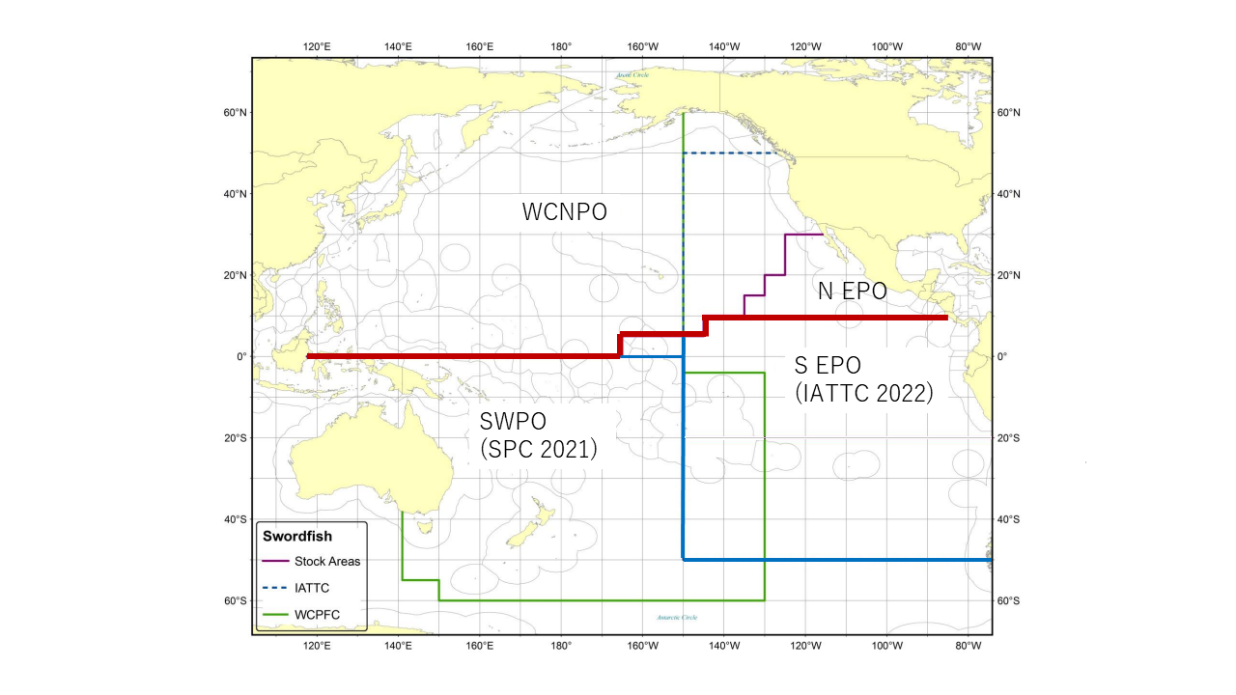
Figure NPSWO-1. Western and Central North Pacific Ocean and North Eastern Pacific Ocean swordfish stock boundaries for the 2023 North Pacific swordfish assessment. Spatial structure is treated implicitly using fleets as areas (Figure S1 from SC19-SA-WP-09).
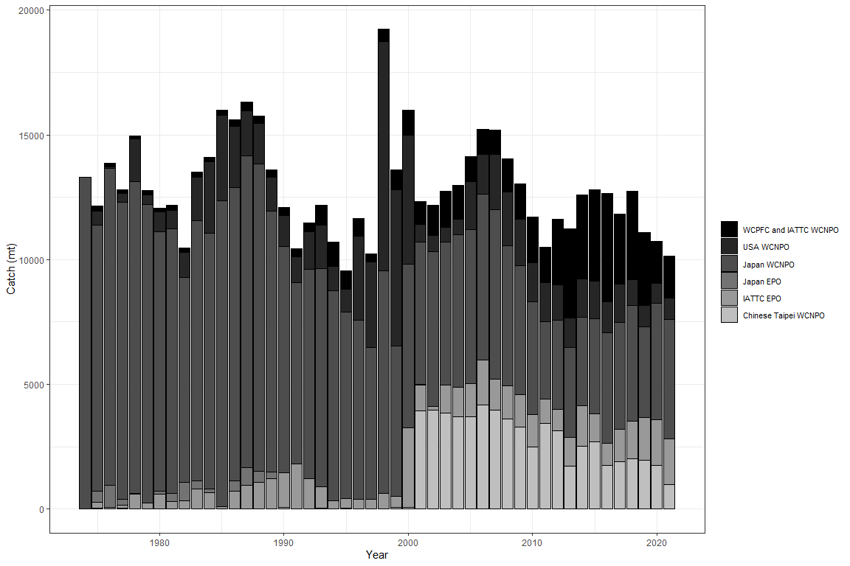
Figure NPSWO-2. Annual catch of NP swordfish by country or commission and area (Figure S2 from SC19-SA-WP-09).

(a) | (b)

(c) | (d)

Figure NPSWO-3. Time series of estimates of (a) population biomass (age 1+), (b) spawning biomass, (c) instantaneous fishing mortality (average for age 1-10, year⁻¹), and (d) recruitment (age-0 fish) for North Pacific swordfish (Xiphias gladius) derived from the 2023 stock assessment. The circles represents the maximum likelihood estimates by year for each quantity and the error bars represent the uncertainty of the estimates (95% confidence intervals), green dashed lines indicate the dynamic SSB_{MSY} and F_{MSY} reference points (Figure S3 from SC19-SA-WP-09).

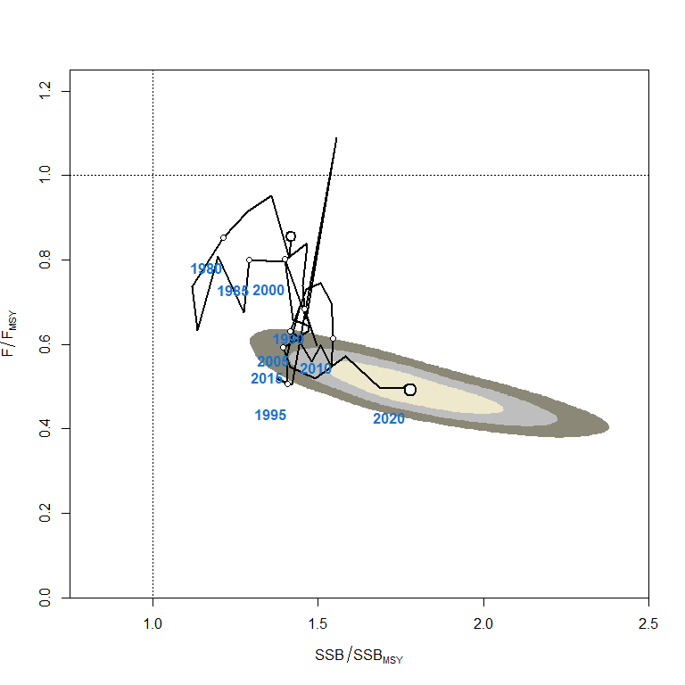
Figure NPSWO-4. Kobe plot of the time series of estimates of relative fishing mortality (average of age 1-10) and relative spawning stock biomass of North Pacific swordfish (Xiphias gladius) during 1977-2020. The first white dot indicates 1975, subsequent dots are in 5-year increments. Shading indicates 50%, 80%, and 95% confidence intervals, respectively (Figure S4 from SC19-SA-WP-09).

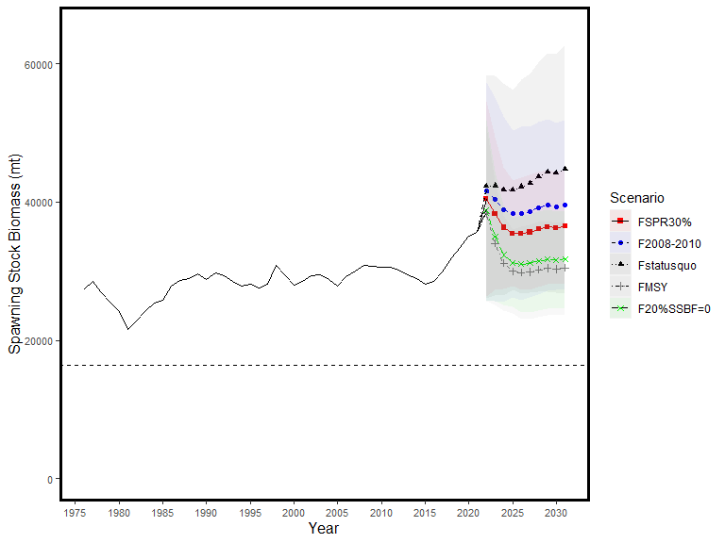
Figure NPSWO-5. Historical and projected trajectories of spawning biomass from the North Pacific swordfish base case model based upon F scenarios. Dashed line indicates the spawning stock biomass at SSB_{MSY}. The list of projection scenarios can be found in SC19-SA-WP-09 Table S3 (Figure S5 from SC19-SA-WP-09).

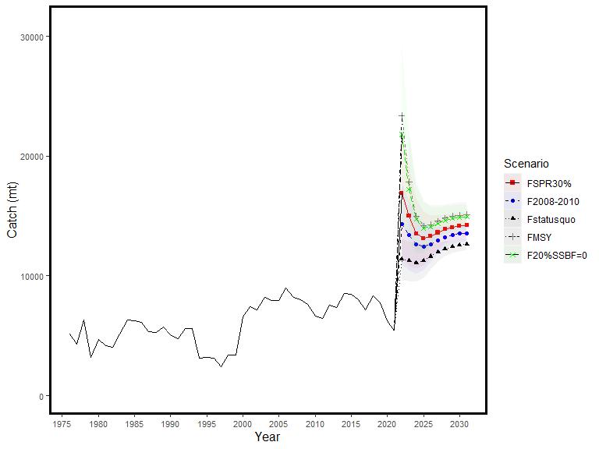
Figure NPSWO-6. Historical and projected trajectories of catch from the North Pacific swordfish base case model based upon F scenarios. The list of projection scenarios can be found in SC19-SA-WP-09 Table S3 (Figure S6 from SC19-SA-WP-09).

SC15 2019 (FISHERY INDICATORS UPDATED)

- Stock status and trends

- SC15 noted that no stock assessments were conducted for North Pacific swordfish in 2019. Therefore, the stock status descriptions from SC14 are still current for North Pacific swordfish. For further information on the stock status and trends from SC14, please see https://www.wcpfc.int/node/32155. Updated information on catches was not compiled for and reviewed by SC15.

- Management Advice and implications

- SC15 noted that no management advice has been provided since SC14 for North Pacific swordfish. Therefore, the advice from SC14 should be maintained, pending a new assessment or other new information. For further information on the management advice and implications from SC14, please see https://www.wcpfc.int/node/32155

SC14 2018 (STOCK ASSESSMENT CONDUCTED)

a. Status and trends

- SC14 noted that ISC provided the following conclusions on the stock status of Western and Central North Pacific Swordfish in the Pacific Ocean in 2017 presented in SC14-SA-WP-07 (Stock Assessment for Swordfish (Xiphias gladius) in the Western and Central North Pacific Ocean through 2016).

Estimates of total stock biomass show a relatively stable population, with a slight decline until the mid-1990s followed by a slight increase since 2000. Population biomass (age-1 and older) averaged roughly 97,919 t in 1974-1978, the first 5 years of the assessment time frame, and has declined by only 20% to 71,979 t in 2016 (Figure NPS-3). Female spawning stock biomass was estimated to be 29,403 t in 2016, or about 90% above SSB_{MSY} (Table NPS-1 and Table NPS-2). Fishing mortality on the stock (average F, ages 1 – 10) averaged roughly F = 0.08 yr⁻¹ during 2013-2015, or about 45% below F_{MSY}. The estimated SPR (the predicted spawning output at the current F as a fraction of unfished spawning output) is currently SPR₂₀₁₆ = 45%. Annual recruitment averaged about 717,000 recruits during 2012-2016, and no long-term trend in recruitment was apparent. Overall, the time series of spawning stock biomass and recruitment estimates indicate a stable spawning stock biomass and suggest a fluctuating pattern without trend for recruitment (Figure NPS-3). The Kobe plot depicts the stock status relative to MSY-based reference points for the base case model (Figure NPS-4) and shows that spawning stock biomass declined to almost the MSY level in the mid-1990s, but SSB has remained above SSB_{MSY} throughout the time series (Figure NPS-3B).

For this 2018 benchmark assessment, note that biomass status is based on female spawning stock biomass, whereas for the 2014 update assessment, biomass status was based on exploitable biomass (effectively age-2+ biomass). It is also important to note that there are no currently agreed upon reference points for the WCNPO swordfish stock and that retrospective analyses show that the assessment model appears to underestimate spawning stock biomass in recent years.

Based on these findings, the following information on the status of the WCNPO SWO stock is provided:
  - The WCNPO swordfish stock has produced annual yields of around 10,200 t per year since 2012, or about 2/3 of the MSY catch amount.
  - There is no evidence of excess fishing mortality above F_{MSY} (F₂₀₁₃₋₂₀₁₅ is 45% of F_{MSY}) or substantial depletion of spawning potential (SSB₂₀₁₆ is 87% above SSB_{MSY}).
  - Overall, the WCNPO swordfish stock is not likely overfished and is not likely experiencing overfishing relative to MSY-based or 20% of unfished spawning biomass-based reference points.

b. Management advice and implications

- SC14 noted the following conservation advice from ISC:
Stock projections were conducted using a two-gender projection model. The five stock projection scenarios were: (1) F status quo, (2) F_{MSY}, (3) F at 0.2*SSB_{F=0}, (4) F_{20%}, and (5) F_{50%} (Figure NPS-5). These projection scenarios were applied to the base case model results to evaluate the impact of alternative levels of fishing intensity on future spawning biomass and yield for swordfish in the Western and Central North Pacific Ocean. The projected recruitment pattern was generated by stochastically sampling the estimated stock-recruitment model from the base case model. The projection calculations employed model estimates for the multi-fleet, multi- season, size- and age-selectivity, and structural complexity in the assessment model to produce consistent results.

Based on these findings, the following conservation information is provided:
- The results show that projected female spawning biomass is expected to remain above SSB_{MSY} under all of the harvest scenarios (Table NPS-3 and Figure NPS-5), with increases in spawning biomass expected under lower fishing mortality rates.
- Similarly, projected catch is expected to increase under each of the five harvest scenarios, with greater increases expected under higher fishing mortality rates (Table NPS-3 and Figure NPS-5).

Research needs

The lack of sex-specific size composition data and the simplified treatment of the spatial structure of swordfish population dynamics remained as two important sources of uncertainty for this benchmark assessment

Table NPS-1. Reported catch (mt) used in the stock assessment along with annual estimates of population biomass (age-1 and older, mt), female spawning biomass (mt), relative female spawning biomass (SSB/SSB_{MSY}), recruitment (thousands of age-0 fish), fishing mortality (average F, ages 1 to 10), relative fishing mortality (F/F_{MSY}), and spawning potential ratio of Western and Central North Pacific Ocean swordfish.
Year | 2010 | 2011 | 2012 | 2013 | 2014 | 2015 | 2016 | Mean¹ | Min¹ | Max¹
Reported Catch | 12,716 | 9,971 | 10,608 | 9,241 | 9,211 | 11,672 | 10,068 | 12,863 | 9,211 | 17,793
Population Biomass | 66,417 | 66,087 | 68,117 | 67,885 | 69,560 | 71,951 | 71,979 | 67,487 | 51,856 | 97,919
Spawning Biomass | 26,136 | 26,448 | 26,569 | 27,546 | 28,580 | 28,865 | 29,404 | 24,442 | 17,191 | 44,100
Relative SB | 1.66 | 1.68 | 1.69 | 1.75 | 1.82 | 1.84 | 1.87 | 1.56 | 1.09 | 2.81
Recruitment (age 0) | 789 | 565 | 671 | 710 | 683 | 742 | 781 | 761 | 401 | 1241
Fishing mortality | 0.10 | 0.08 | 0.09 | 0.07 | 0.07 | 0.09 | 0.07 | 0.12 | 0.07 | 0.18
Relative F | 0.57 | 0.46 | 0.51 | 0.44 | 0.40 | 0.51 | 0.44 | 0.72 | 0.40 | 1.05
Spawning Potential Ratio | 38% | 41% | 39% | 45% | 47% | 39% | 45% | 29% | 17% | 47%
¹ During 1975-2016

Table NPS-2. Estimates of biological reference points along with estimates of fishing mortality (F), spawning stock biomass (SSB), recent average yield (C), and SPR of WCNPO swordfish, derived from the base case model assessment model, where “MSY” indicates reference points based on maximum sustainable yield.
Reference Point | Estimate
FMSY | 0.17 yr-1
F0.2*SSB(F=0) | 0.16 yr-1
F2013-2015 | 0.08 yr-1
SSBMSY | 15,702 mt
SSB2016 | 29,403 mt
SSBF=0 | 97,286 mt
MSY | 14,941 mt
C2012-2016 | 10,160 mt
SPRMSY | 18%
SPR2016 | 45%

Table NPS-3. Projected values of WCNPO swordfish spawning stock biomass (SSB, mt) and catch (mt) under five constant fishing mortality rate (F, yr⁻¹) scenarios during 2017-2026.
Year | 2017 | 2018 | 2019 | 2020 | 2021 | 2022 | 2023 | 2024 | 2025 | 2026
Scenario 1: F = F2013-2015
SSB | 32,118 | 33,207 | 34,599 | 35,476 | 36,270 | 37,082 | 37,951 | 38,967 | 40,083 | 41,087
Catch | 8,851 | 9,135 | 9,407 | 9,599 | 9,794 | 10,022 | 10,275 | 10,595 | 11,053 | 11,142
Scenario 2: F = FMSY
SSB | 28,267 | 23,963 | 21,443 | 19,458 | 18,303 | 17,618 | 17,293 | 17,197 | 17,253 | 17,263
Catch | 20,885 | 18,323 | 16,509 | 15,294 | 14,666 | 14,353 | 14,308 | 14,520 | 14,650 | 14,348
Scenario 3: F = F20%SSB(F=0)
SSB | 28,425 | 24,384 | 21,800 | 19,735 | 18,530 | 17,874 | 17,496 | 17,586 | 17,818 | 17,779
Catch | 20,691 | 18,122 | 16,454 | 15,261 | 14,653 | 14,361 | 14,319 | 14,554 | 14,665 | 14,384
Scenario 4: F = F20%
SSB | 29,007 | 25,431 | 23,527 | 21,763 | 20,736 | 20,131 | 19,893 | 19,883 | 19,981 | 20,066
Catch | 18,680 | 16,933 | 15,657 | 14,726 | 14,242 | 14,033 | 14,050 | 14,292 | 14,496 | 14,253
Scenario 5: F = F50%
SSB | 32,559 | 34,334 | 36,290 | 37,666 | 38,836 | 39,984 | 41,148 | 42,490 | 44,049 | 45,625
Catch | 7,556 | 7,973 | 8,343 | 8,605 | 8,847 | 9,101 | 9,366 | 9,692 | 10,087 | 10,223

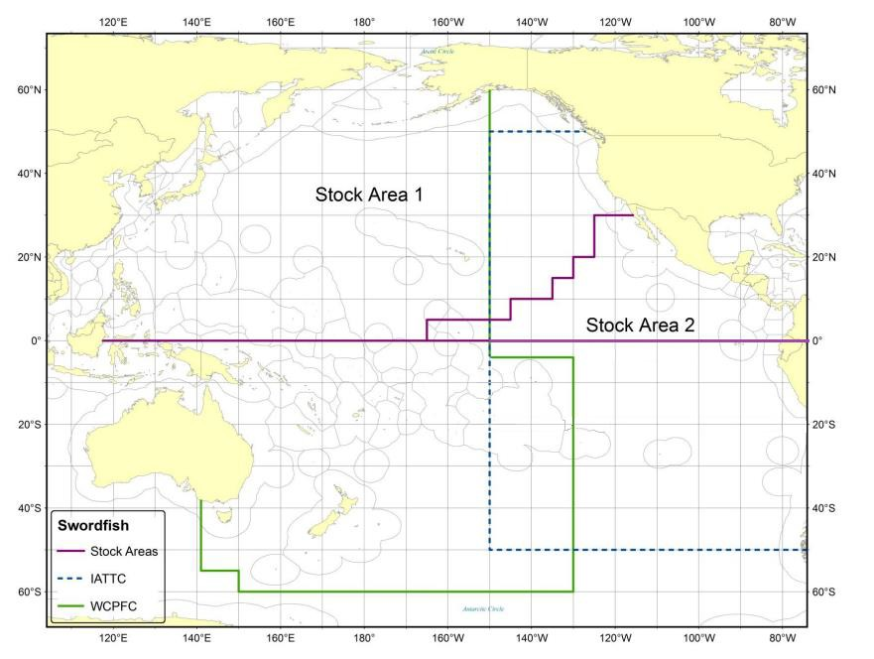 | 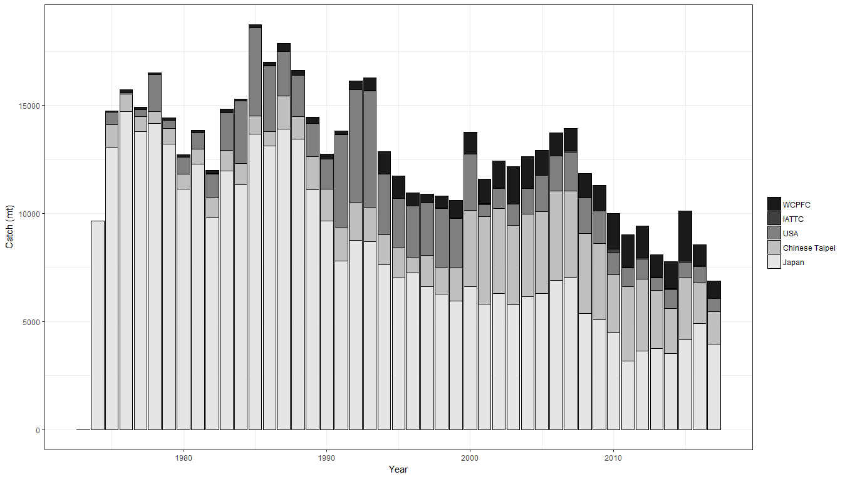
Figure NPS-1. Stock boundaries used for this assessment of North Pacific Ocean swordfish: purple lines indicate stock area divisions; stock area 1 was assessed as the WCNPO stock, stock area 2 contains the Eastern Pacific Ocean stock, the green line indicates Western Central Pacific Fisheries Commission convention area, blue dashed line indicates IATTC convention area. | Figure NPS-2. Annual catch biomass (t) of WCNPO swordfish (Xiphias gladius) by country for Japan, Chinese Taipei, the U.S.A., and all other countries during 1975-2016.

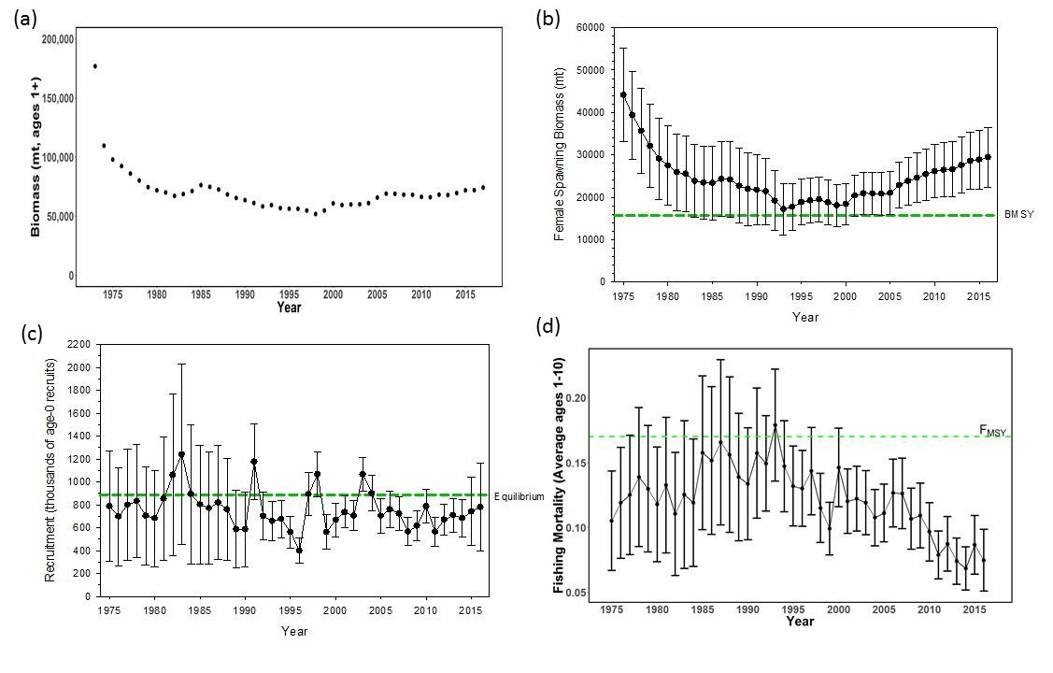 | 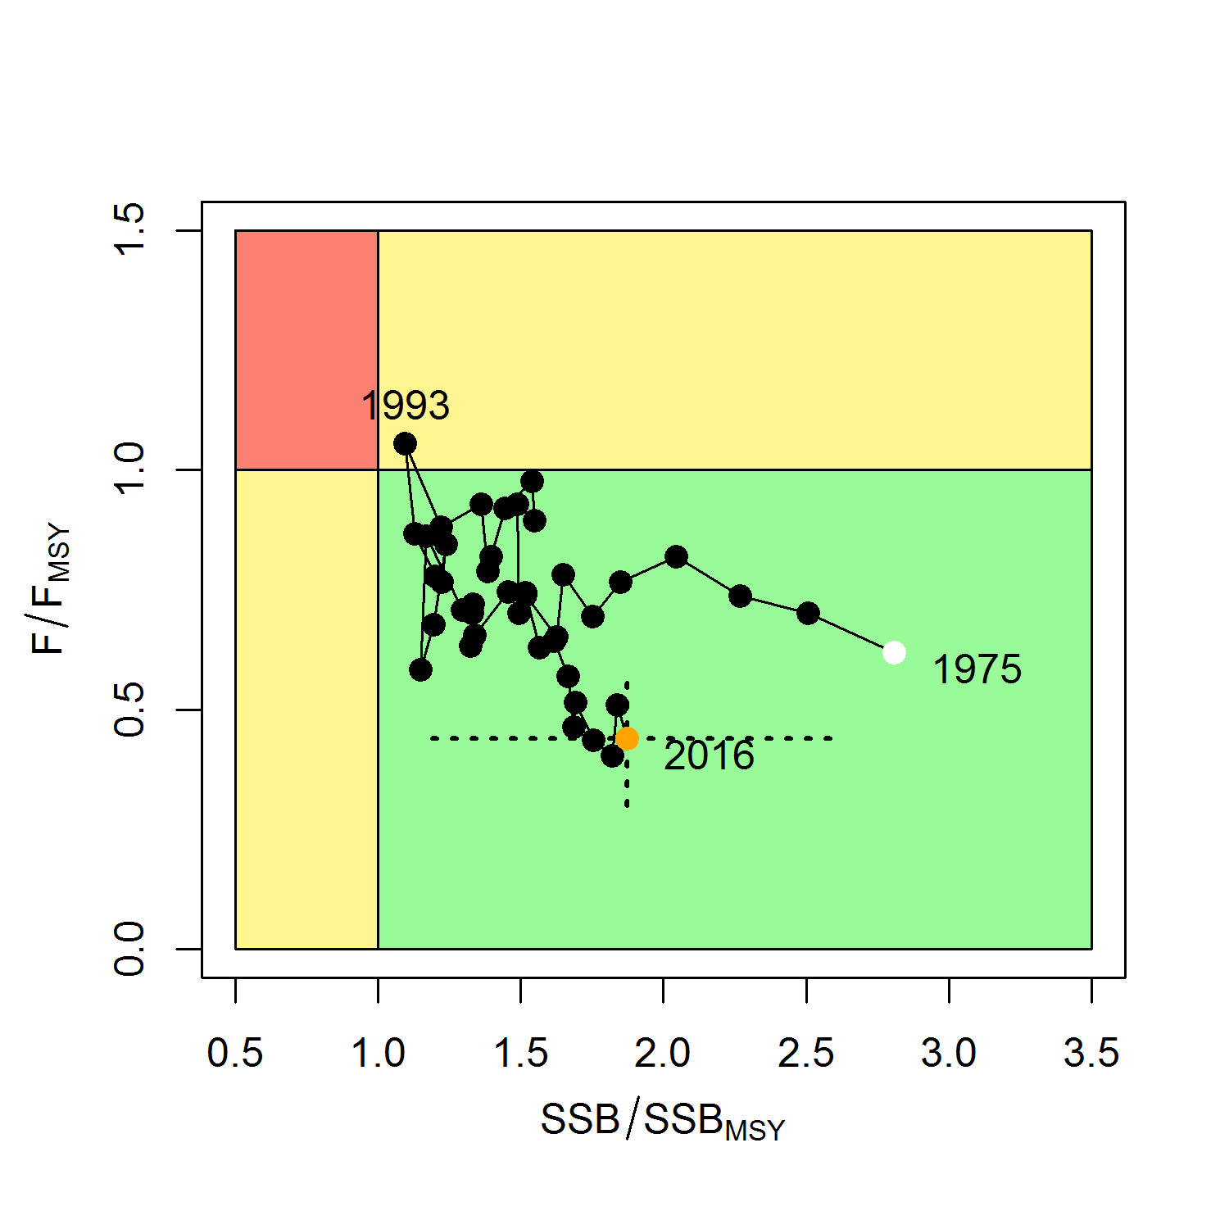
Figure NPS-3. Time series of estimates of (a) population biomass (age 1+) (first point in time series represents unfished biomass), (b) spawning biomass, (c) recruitment (age-0 fish), and (d) instantaneous fishing mortality (average for ages 1 to 10, yr⁻¹) for WCNPO swordfish (Xiphias gladius) derived from the 2018 stock assessment. The solid circles are the maximum likelihood estimates by year for each quantity and the error bars represent the uncertainty of the estimates (80% confidence intervals), green dashed lines indicate BMSY, equilibrium recruitment, and F_{MSY} except for the population biomass time series. | Figure NPS-4. Kobe plot of the time series of estimates of relative fishing mortality (average of ages 1-10) and relative spawning stock biomass of WCNPO swordfish (Xiphias gladius) during 1975-2016. The white circle denotes the first year (1975) and the yellow circle denotes the last year (2016) of the assessment time horizon. The dashed lines represent the 95% confidence intervals around the 2016 estimate.

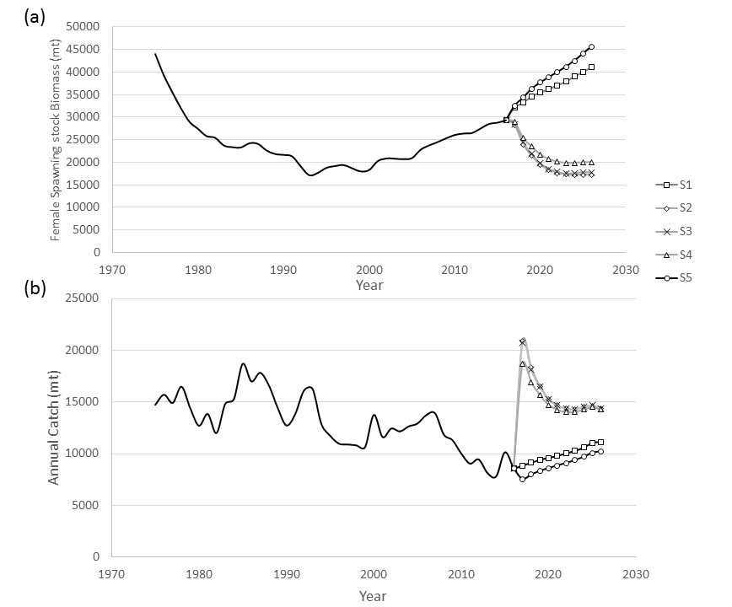 | Figure NPS-5. Historical and projected trajectories of (a) spawning stock biomass and (b) total catch from the WCNPO swordfish base case model. Stock projection results are shown for S1 = the status quo or average fishing intensity during 2013-2015 (𝐹₂₀₁₃₋₂₀₁₅= 𝐹_{43%}); S2 = F_{MSY} (𝐹_{18%}); S3 = F to produce 20% of unfished spawning stock biomass or F_{0.2}*SSB_{F=0} (𝐹_{22%}); S4 = the highest 3-year average F during 1975-2016 or High F (F_{20%}); S5 = Low F (F_{50%}).

SC13 2017 (FISHERY INDICATORS UPDATED)

Stock status and trends

- SC13 noted that no stock assessments were conducted for these species in 2017. Therefore, the stock status descriptions from SC10 are still current. Updated information on North Pacific swordfish catches is available in the ISC Plenary Report but was not compiled for and reviewed by SC13. For further information on the stock status and trends from SC10, please see http://www.wcpfc.int/node/19472

Management advice and implications

- SC13 noted that no management advice has been provided since SC10. Therefore, the advice from SC10 should be maintained, pending a new assessment or other new information. For further information on the management advice and implications from SC10, please see http://www.wcpfc.int/node/19472

Useful References

SC14-SA-WP-07 Stock Assessment for Swordfish (Xiphias gladius) in the Western and Central North Pacific Ocean through 2016 Rev 1. https://www.wcpfc.int/node/31010

For current information related to Northern Stocks Working Group Reports and the ISC Plenary Report:
http://isc.fra.go.jp/reports/isc/isc18_reports.html

Previous Assessments

SC10-SA-WP13 North Pacific Swordfish (Xipiaus gladius) Stock Assessment in 2014. ISC Billfish Working Group (International Scientific Committee for Tuna and Tuna-like Species in the North Pacific Ocean).
https://www.wcpfc.int/node/19203

