The Commission for the Conservation and Management of
Highly Migratory Fish Stocks in the Western and Central Pacific Ocean

Scientific Committee

Oceanic Whitetip Shark (Carcharhinus longimanus)

Stock Status AND Management Advice

Contents
SC15 2019 (STOCK ASSESSMENT CONDUCTED) 2
SC9, 2013 – SC14, 2018 (NO STOCK ASSESSMENTS) 7
Useful References 8
PREVIOUS ASSESSMENTS 8

SC15 2019 (STOCK ASSESSMENT CONDUCTED)

- Stock status and trends

- The median values of relative recent (2013-2015) spawning biomass (SB_{recent}/SB_{F=0}, SB_{recent}/SB_{MSY}) and relative recent fishing mortality (F_{recent}/F_{MSY}) over the structural uncertainty grid were used to measure the central tendency of stock status. The span of the recent time period was determined to only include years following the adoption of CMM-2011-04. The values of the upper 90th and lower 10th percentiles of the empirical distributions of relative spawning biomass and relative fishing mortality from the uncertainty grid were used to characterize the probable range of stock status.

- Descriptions of the updated structural sensitivity grid used to characterize uncertainty in the assessment are provided in Table OCS-01. Historical catch data used for the diagnostic case is presented in Figure OCS-01. Estimated annual average total biomass, recruitment and spawning biomass are shown in Figure OCS-02, and fishing mortality in Figure OCS-03. The time series of depletion in spawning biomass over all runs in the structural uncertainty grid is shown in Figure OCS-04. Kobe and Majuro plots summarizing the results for each of the models in the structural uncertainty grid retained for management advice are represented in Figures OCS-05 and OCS-06. Table OCS-02 provides a summary of reference points used to determine stock status over the 648 models in the structural uncertainty grid using the grid weights agreed upon by SC and outlined in Table OCS-01.

- SC15 noted that the median level of spawning biomass depletion from the uncertainty grid was SB_{recent}/SB₀ ₌ 0.04 with a probable range of 0.03 to 0.05 (80% probability interval). While no limit reference point has been adopted, the depletion in spawning biomass is very high. The median level of recent spawning biomass relative to that leading to MSY was SB_{recent}/SB_{MSY} = 0.09 (range: 0.05–0.17).

- SC15 noted that the recent relative fishing mortality was very high and the grid median F_{recent}/F_{MSY} was 3.94, with a range of 2.67 to 5.89 (80% probability interval), and that there were no model runs in the grid where F_{recent}/F_{MSY} was below 1.

- The key conclusions are that overfishing is occurring and the stock is in an overfished state relative to MSY and depletion-based reference points (noting that depletion-based reference points have only been adopted for tunas) (Tables OCS-1 and OCS-2). This conclusion is robust to uncertainties in key model assumptions (Figure OCS-5).

- SC noted that the inclusion of discard mortality (DM) scenarios in the historical catches was an improvement to the assessment and was necessary to account for the potential impacts of the no-retention measure (CMM-2011-04) for oceanic whitetip sharks.

- SC noted that stock status improved relative to F-based reference points in the period since CMM 2011-04 became active, which covers the last 4 years of the assessment’s time-span (2013–2016). Notably, F/F_{MSY} is predicted to have declined by more than half from 6.12 to 2.67 (n=432, unweighted grid median) (Figure OCS-2), for the last year of the assessment when the impact of CMM 2011-04 on survival is accounted for under 25% and 43.75% discard mortality scenarios (Figure OCS-6 and OCS-7). Relative fishing mortalities under two alternative reference points that have not been adopted by the WCPFC, specifically F /F_{lim,AS} (the fishing mortality resulting in 0.5 of SB_{MSY}) and F/F_{crash,AS} (the fishing mortality resulting in population extinction when sustained over the long-term, follow similar trends. Under the survival scenarios above, median SB/SB_{MSY} is predicted to have increased slightly from 2013 to 2016 (8.6% to 9.2%).

- SC15 noted that there was some inconsistency between observed and estimated CPUEs for 2013-2016 in the diagnostic case, which is probably caused by the assumptions about the stock recruitment relationship in this stock assessment. Whether or not this inconsistency is present in all models across the included uncertainty grid remains unknown.

- Management advice and implications

- Despite the data limitations going into the assessment and the wide range of uncertainties considered, all of the feasible grid model runs indicate that the WCPO oceanic whitetip shark stock continues to be overfished and overfishing is occurring relative to commonly used depletion and MSY-based reference points.

- SC15 noted that while the assessment estimates that overfishing is still occurring (F_{recent}/F_{MSY} was 3.94) the stock assessment also estimates a slight recovery in stock biomass in recent years (2013-2016). It remains unclear whether the stock status will continue to improve or perhaps decline in the future. To help clarify this issue SC15 recommends that stock projections based on the assessment are undertaken and presented to SC16.

- SC15 noted that there now appear to be few if any major fisheries targeting oceanic whitetip. The greatest impact on the stock is attributed to bycatch from the longline fisheries, with lesser impact from purse seining.

- Noting that there are existing CMMs directed at oceanic whitetip, SC15 recommended that further efforts to mitigate catch and improve handling and release practices are required to further reduce fishing mortality and improve stock status.

- SC15 noted that the assessment would be improved with better data collection for longline fisheries, such as improved observer coverage, as these fisheries are the major component of fishing mortality and would provide additional information on interaction rates, mitigation options and the fate and condition at release.

- SC15 recommends that, as a minimum, CCM’s meet the observer coverage specified in CMM 2018-05.

- SC15 noted the need for improved estimates of age, growth and fecundity, as well as new length-length conversion factors that would allow for an improved assessment and the inclusion of a greater number of observed lengths.

- SC15 noted that following the implementation of CMM 2011-04 and CMM 2014-05, the amount of scientific information available per year on oceanic whitetip sharks and other sharks species covered by a retention ban and the ban on shark lines or wire traces (e.g., bycatch estimates, length measurement, species and sex identification, and biological samples) has declined. SC15 also noted that the decline in information available for the oceanic whitetip shark assessment resulted in higher uncertainty in stock status, especially in more recent years since the introduction of these CMMs. This will also affect the capacity of SC to undertake future assessments if this decline in available information persists. SC15 recommends that WCPFC16 gives more consideration to the data needs for estimating reliable CPUE and other inputs into assessments when management measures are put in place, as these measures may have unintended consequences on continued availability and reliability of data. SC15 also recommended that WCPFC16 also take these considerations into account when reviewing the relevant sharks CMMs.

- Noting that no limit reference points have been adopted for oceanic whitetip sharks, as well as other WCPO shark species, SC15 recommends that WCPFC16 consider identifying appropriate limit reference points for WCPO sharks.

Table OCS-01. Description of the axes for the structural uncertainty grid, and assigned weight by level in the final resampling of stock status metrics. Settings used under the diagnostic case are highlighted with a star.
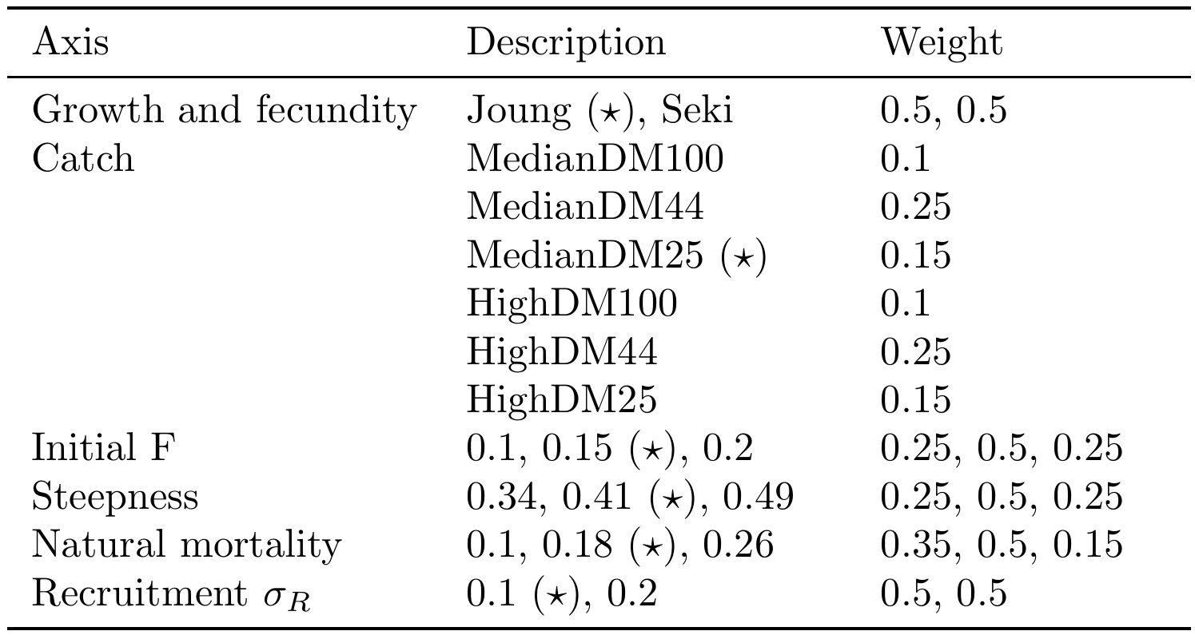

Table OCS-02. Summary of reference points using SC15 adopted weights by axes over the 648 models in the structural uncertainty grid.
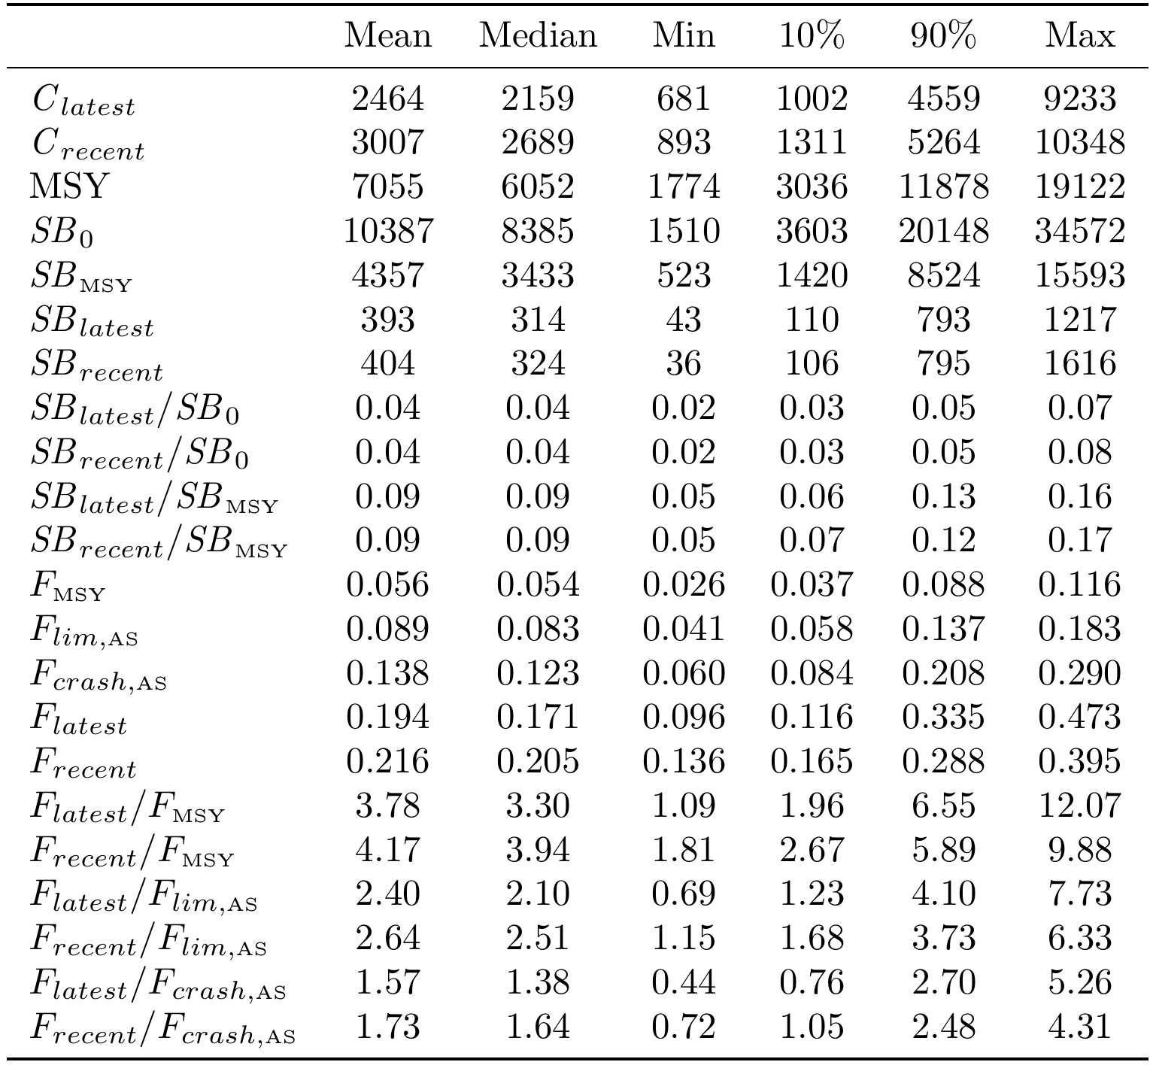

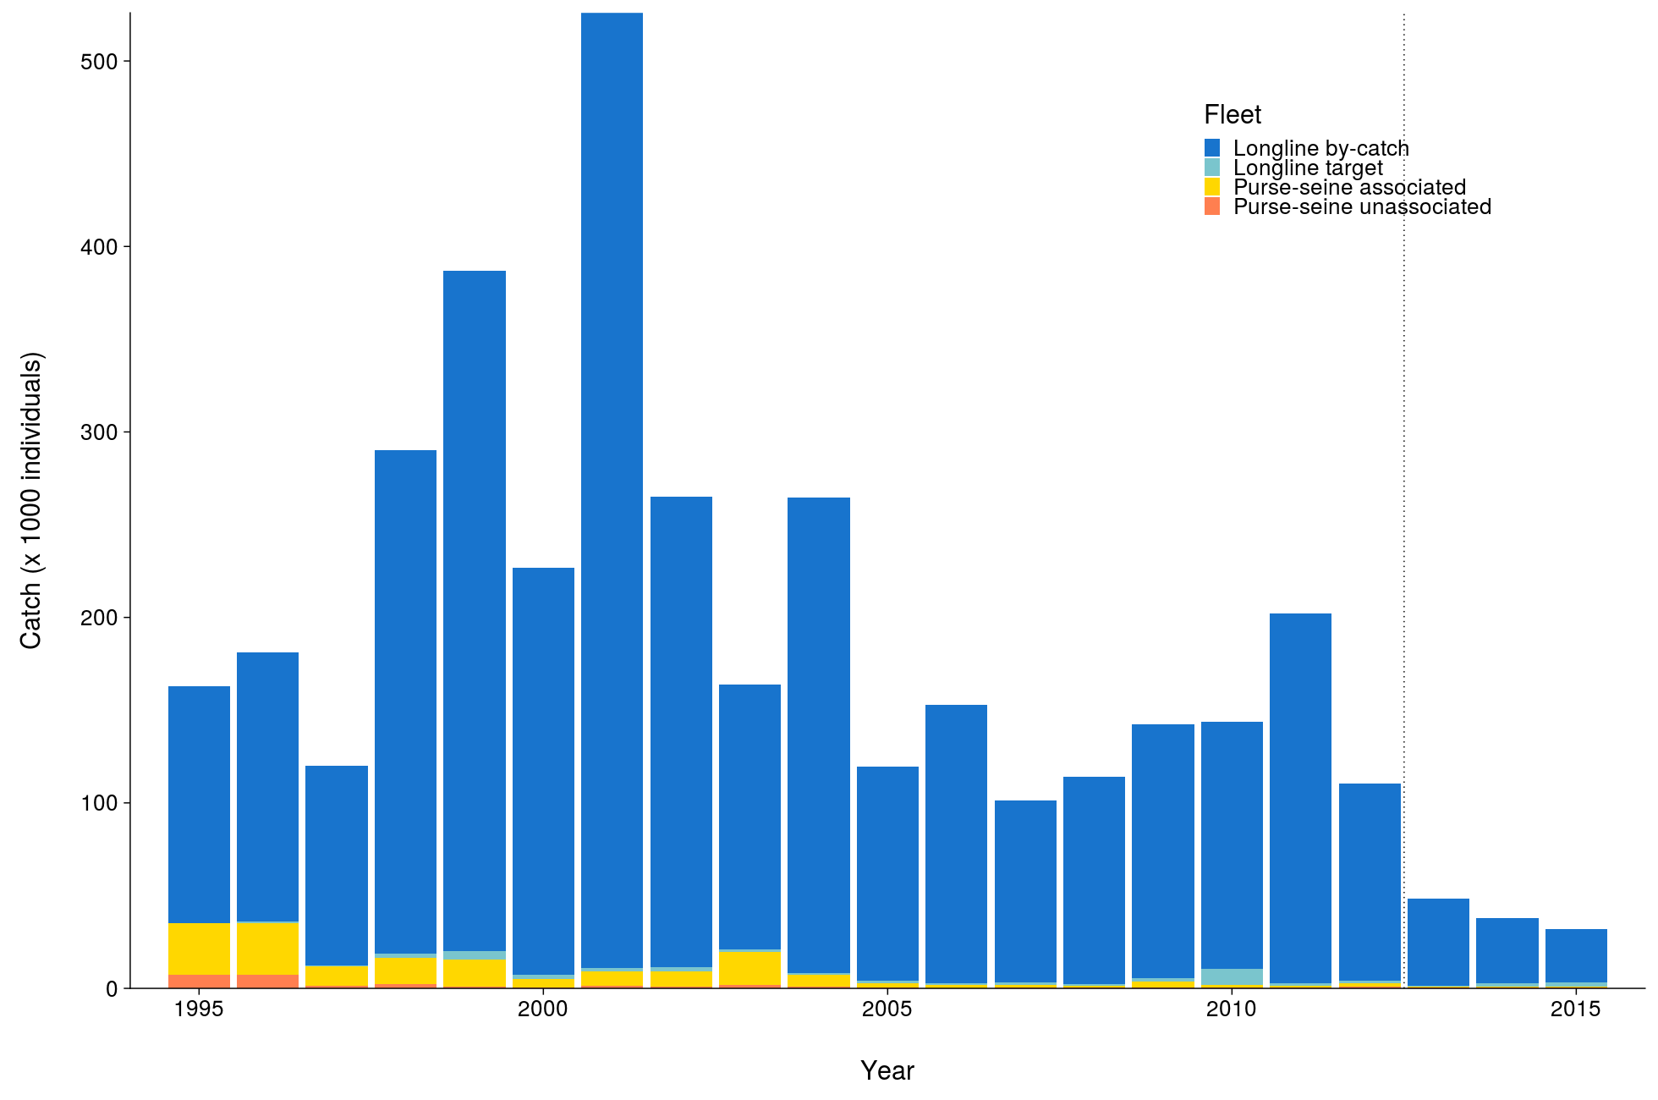 | 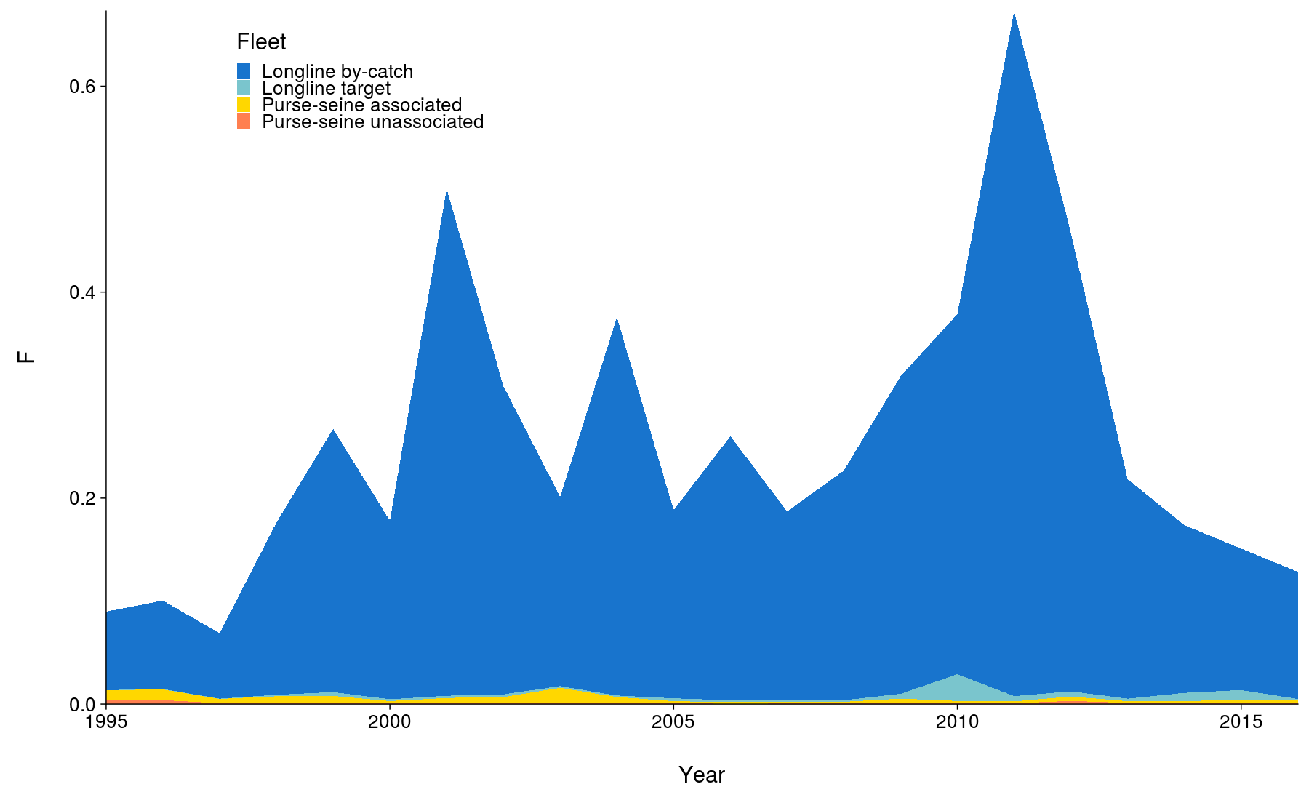
Figure OCS-01. Total reconstructed catches by fleet over time used for the diagnostic case. | Figure OCS-02. Cumulative fishing mortality by fleet estimated for the diagnostic case over the time-span of the assessment (1995-2016).
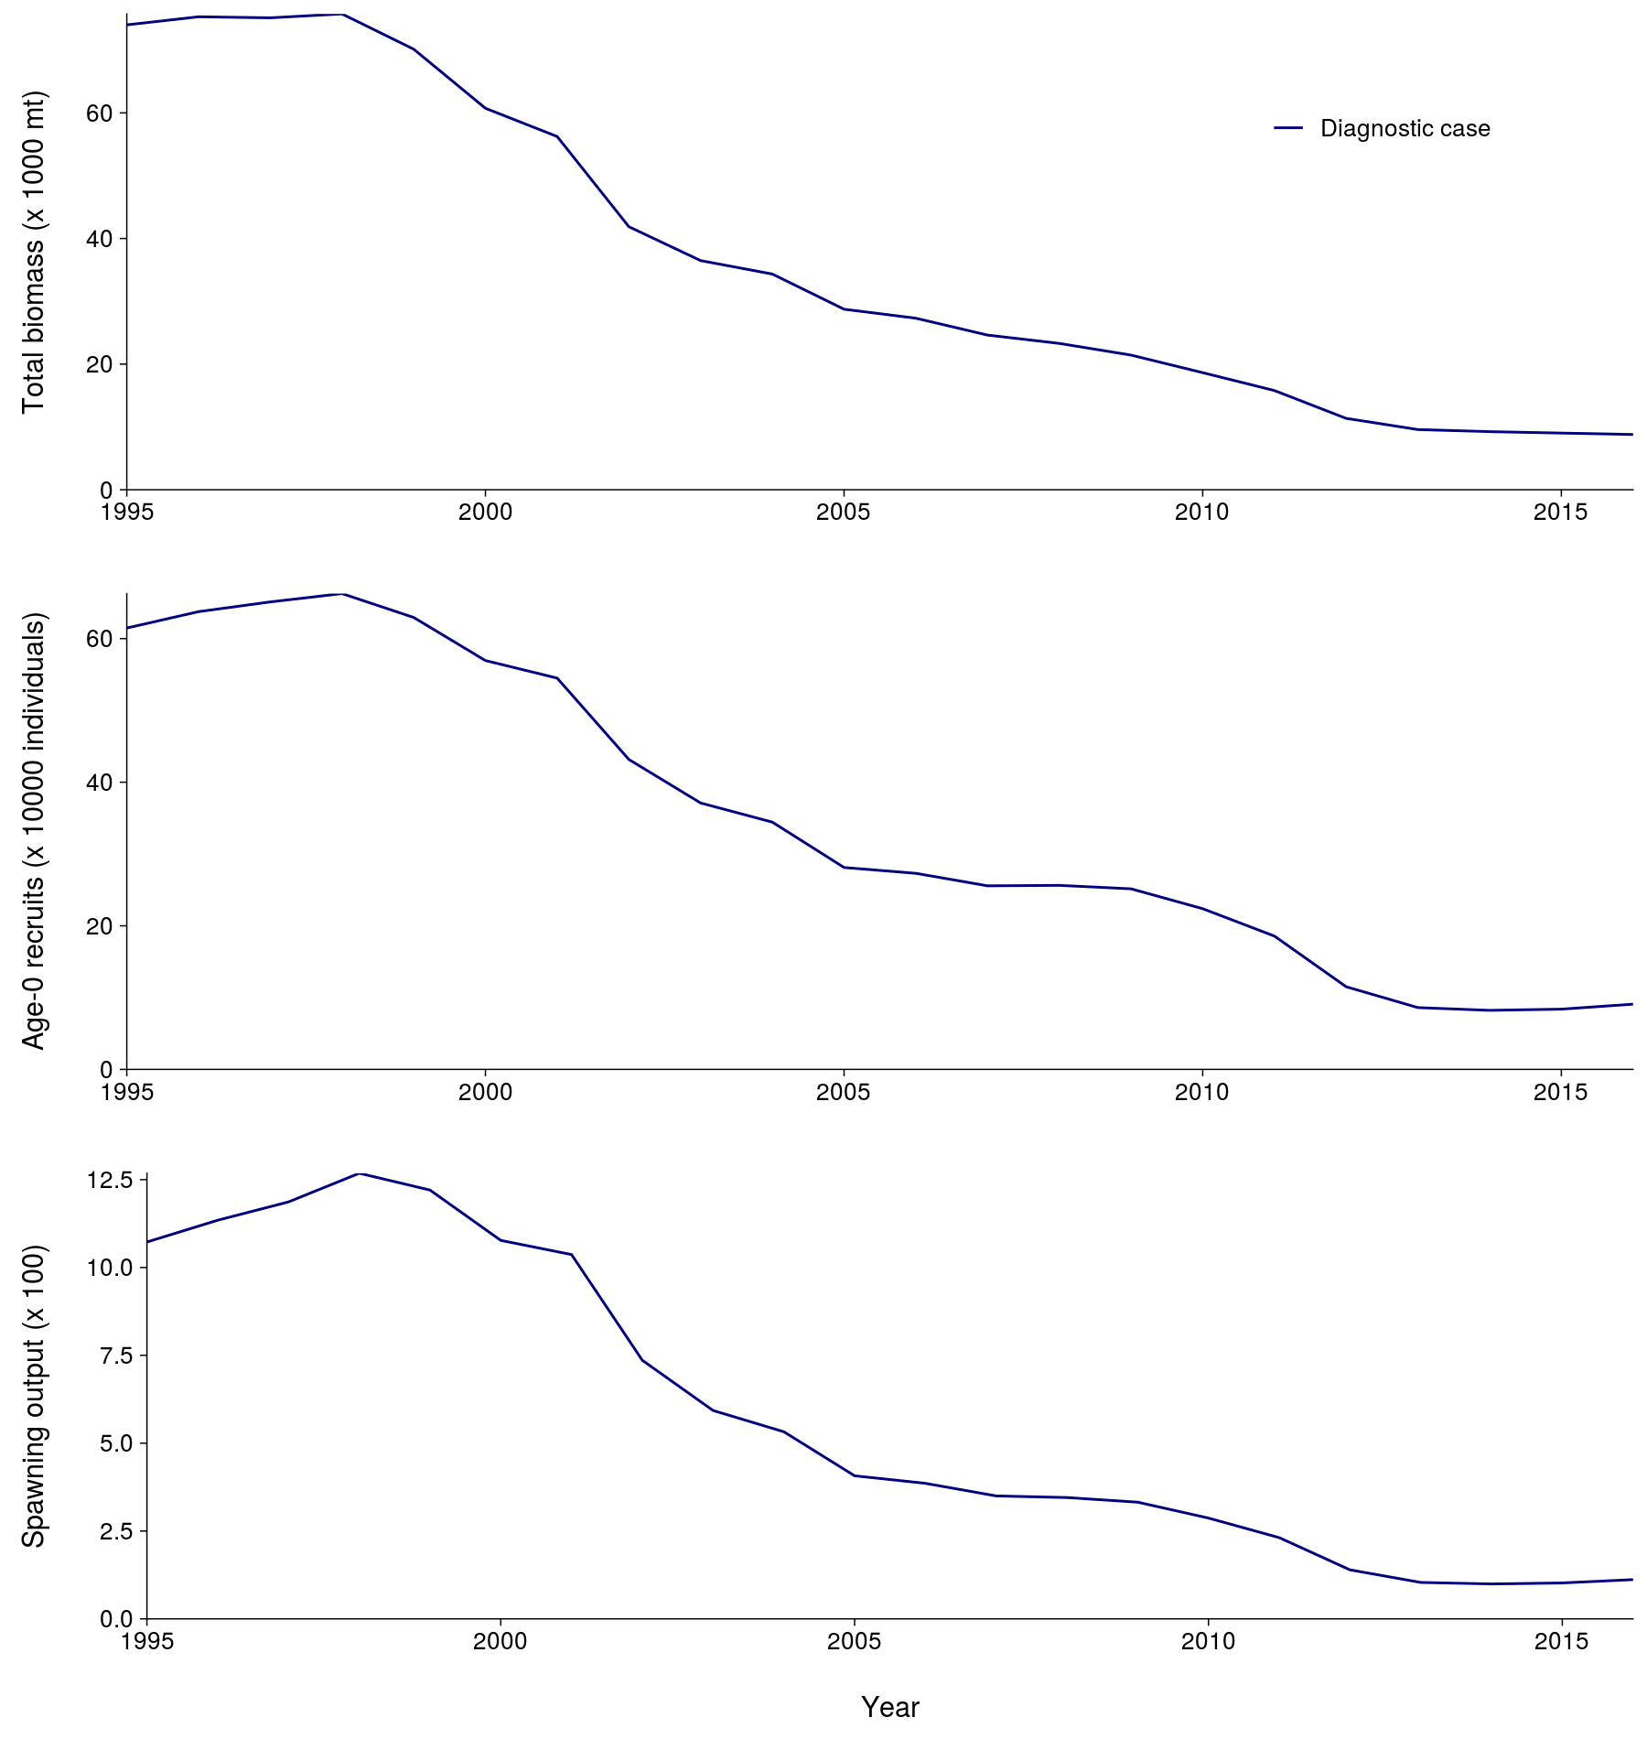 | 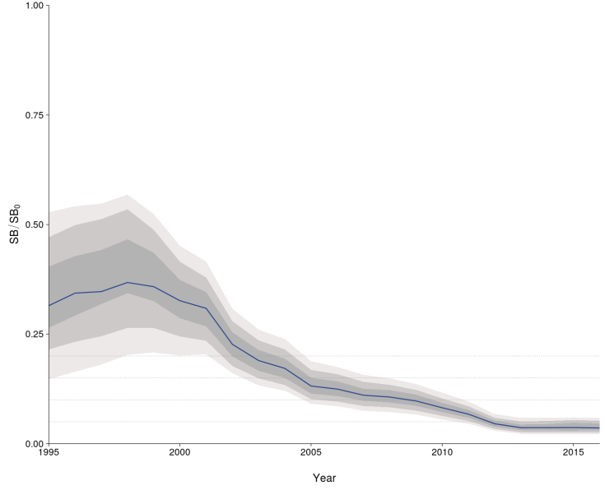
Figure OCS-03. Total biomass, recruitment and spawning biomass for the diagnostic case over the time-span of the assessment (1995-2016). | Figure OCS-04: Median estimates of depletion in spawning biomass over all (weighted) grid runs, with 2.5th -97.5th, 10th-90th and 25th -75th quantile intervals. Horizontal grey lines are placed at intervals of 5% in the lower part of the graph to aid visualization.

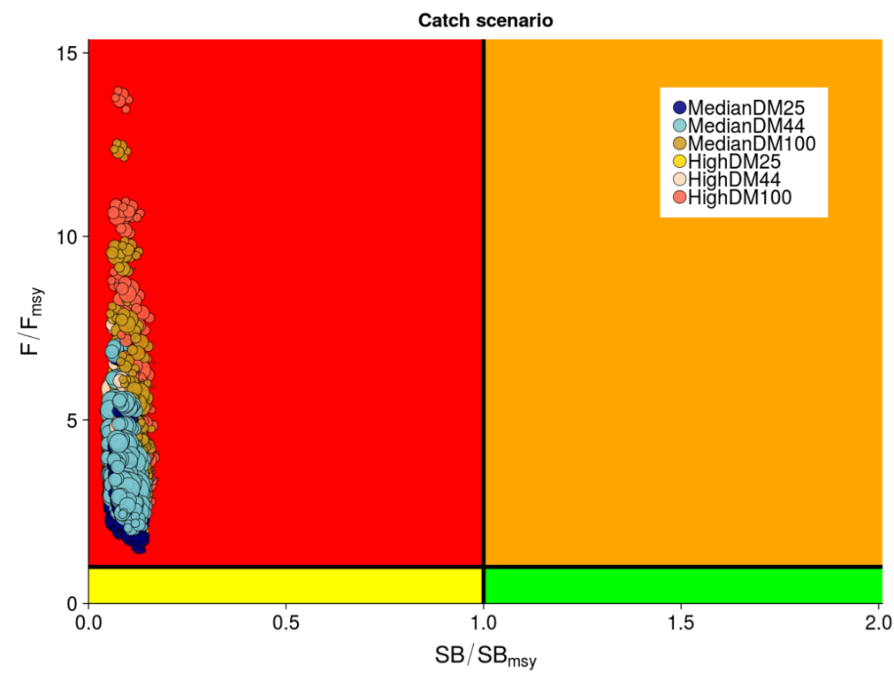
Figure OCS-05: Kobe plot summarizing recent status (2013-2015) for each of the (weighted) models in the structural uncertainty grid, based on SB/SB_{MSY} and F/F_{MSY}. The stock is considered to be overfished when SB/SB_{MSY} > 1 and undergoing overfishing when F/F_{MSY} > 1. The points are coloured according to the catch scenario that was used as input to the individual grid run. The size of the circle relates to the weight of that particular model run.

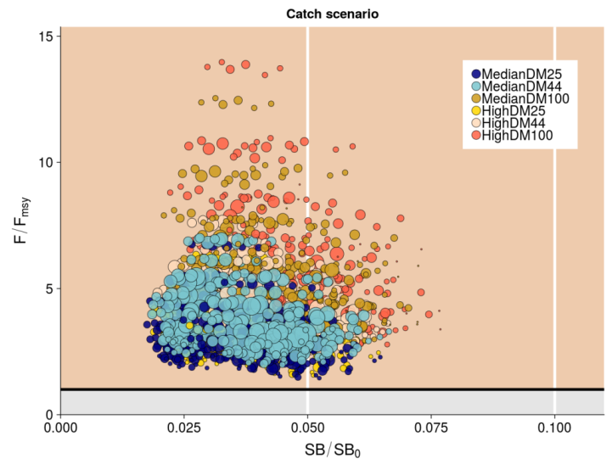 | 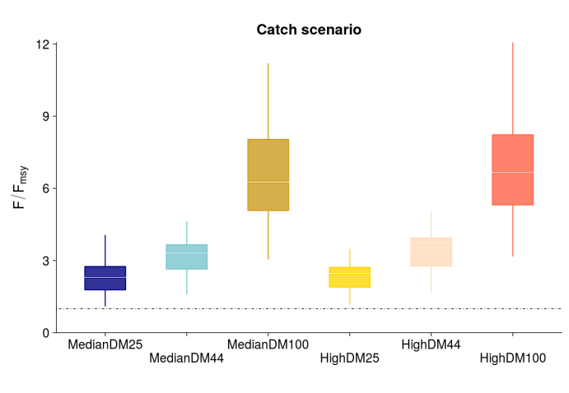
Figure OCS-06: Panel plot summarizing recent stock status (2013-2015) for each of the weighted models in the structural uncertainty grid for SB/SB₀ and F/F_{MSY}, noting no limit or target reference points have been adopted for oceanic whitetip shark. The stock is considered to be undergoing overfishing when F/F_{MSY} > 1 (beige zone). The SB/SB₀ axis was scaled to span the range of depletion values. Guidelines were added in white at 0.5SB/SB₀ and 0.1SB/SB₀. The points are coloured according to the catch scenario that was used as input to the individual grid run. The size of the circle relates to the weight of that particular model run. | Figure OCS-07: Median (white bar) and inter-quartile bounds (box) for F/F_{MSY} in the final year of the assessment (2016) under the 6 catch scenarios used in the structural uncertainty axis. The catch scenarios included baseline and high levels of catches with 3 scenarios of discard mortality (25%, 43.75% and 100%). The whiskers extend to 1.5 times the interquartile range.

SC9, 2013 – SC14, 2018 (NO STOCK ASSESSMENTS)

- Stock status and trends

- SC14 noted that no stock assessments were conducted for oceanic whitetip shark in 2018. Therefore, the stock status descriptions from SC8 are still current for oceanic whitetip shark. Updated information on catches was not compiled for and reviewed by SC14.

- Management advice and implications

- SC14 noted that no management advice has been provided since SC8 for oceanic whitetip shark. Therefore, previous advice should be maintained, pending a new assessment or other new information. For further information on the management advice and implications from SC8, please see below.

Useful References

SC15-SA-WP-06 Stock Assessment of Oceanic Whitetip Shark in the Western and Central Pacific Ocean. https://www.wcpfc.int/node/42932

SC15-SA-WP-13 Alternative Assessment Methods for Oceanic Whitetip Shark. https://www.wcpfc.int/node/43050

SC15-SA-IP-17 Historical catch reconstruction and CPUE standardization for the stock assessment of oceanic whitetip shark in the Western and Central Paciﬁc Ocean. https://www.wcpfc.int/node/43122

PREVIOUS ASSESSMENTS

WCPFC-SC8-SA-WP-06 Stock Assessment of Oceanic Whitetip Sharks in the Western and Central Pacific Ocean Rev 1 (3 August 2012). https://www.wcpfc.int/node/3235

