The Commission for the Conservation and Management of
Highly Migratory Fish Stocks in the Western and Central Pacific Ocean

Scientific Committee

South Pacific Albacore Tuna (Thunnus alalunga)

Stock Status And Management Advice

Contents
SC17-2021 (STOCK ASSESSMENT CONDUCTED) 2
SC16-2020 (NO STOCK ASSESSMENT) 11
SC15-2019 (FISHERY INDICATORS UPDATED) 11
SC14-2018 (STOCK ASSESSMENT CONDUCTED) 12
SC13-2017 (FISHERY INDICATORS UPDATED) 18
Useful References 20
Previous Assessments 20

SC17-2021 (STOCK ASSESSMENT CONDUCTED)

- SC17 accepted SC17-SA-WP-02 (Stock assessment of South Pacific albacore) providing the best available scientific information for the purpose of stock assessment determination.

- Stock status and trends

- The median values of relative recent (2016-2019) spawning biomass depletion (SB_{recent}/ SB_{F=0}) and relative recent (2015-2018) fishing mortality (F_{recent}/F_{MSY}) over the uncertainty grid of 72 models (Table SPA-01) were used to define South Pacific albacore stock status. The values of the upper 90th and lower 10th percentiles of the empirical distributions of relative spawning biomass and relative fishing mortality from the uncertainty grid were used to characterize the probable range of stock status.

- A description of the updated structural sensitivity grid used to characterize uncertainty in the assessment is illustrated in Table SPA-01. Tables SPA-02, SPA-03, and SPA-04 show reference points for South Pacific-wide, WCPFC-CA (Convention Area) and IATTC-CA, respectively, including the median values of relative ‘recent’ (2016-2019) and ‘latest’ (2019) spawning biomass depletion (SB_{recent}/SB_{F=0}) and relative recent (2015-2018) fishing mortality (F_{recent}/F_{MSY}) over the uncertainty grid of 72 models used to define stock status. These values are based on the uncertainty grid with the downweighted SEAPODYM (M2) movement hypothesis. The values of the upper 90th and lower 10th percentiles of the empirical distributions of relative spawning biomass and relative fishing mortality from the uncertainty grid were used to characterize the probable range of stock status.

- The spatial structure used in the 2021 stock assessment is shown in Figure SPA-01. Time series of total annual catch by fishing gear over the full assessment period and by region are shown in Figure SPA-02. Estimated annual average recruitment, spawning potential, and total biomass by model region for the diagnostic case model are shown in Figure SPA-03. Estimated trends in spawning potential by region for the diagnostic case are shown in Figure SPA-04, and juvenile and adult fishing mortality rates from the diagnostic model are shown in Figure SPA-05. Time series of estimated spawning potential for the 72 models are shown in Figure SPA-06. Time-dynamic percentiles of depletion (SB_{t}/SB_{t},_{F=0}) for the 72 models are shown in Figure SPA-07. Majuro and Kobe plots summarizing the results for each of the 72 models in the weighted structural uncertainty grid are shown in Figures SPA-08 and SPA-09 for the ‘recent’ and ‘latest’ periods, respectively.

- The most influential axis of uncertainty with respect to estimated stock status was movement, where assuming SEAPODYM derived movement resulted in more pessimistic outcomes.

- SC17 noted that the median value of relative recent (2016-2019) spawning biomass depletion for South Pacific albacore (SB₂₀₁₆₋₂₀₁₉/SB_{F=0}) was 0.52 with a 10th to 90th percentile interval of 0.41 to 0.57.

- SC17 further noted that there was 0% probability (0 out of 72 models) that the recent (2016-2019) spawning biomass had breached the adopted limit reference point (LRP).

- SC17 noted that there has been a long-term increase in fishing mortality for adult South Pacific albacore, with a notable steep increase in fishing mortality since 2000.

- SC17 noted that the median of relative recent fishing mortality for South Pacific albacore (F₂₀₁₅₋₂₀₁₈/F_{MSY}) was 0.24 with a 10th to 90th percentile interval of 0.15 to 0.37.

- SC17 further noted that there was 0% probability (0 out of 72 models) that the recent (2015-2018) fishing mortality was above F_{MSY}.

- SC17 noted the results of stochastic projections (based on the weighted grid, SC17-SA-WP-02a, Figures 1 and 2) from the 2021 assessment, which indicated the potential stock consequences of fishing at “status quo” conditions (2017–2019 or 2020 average catch or, separately, fishing effort) using the uncertainty framework approach endorsed by SC17. These results are provided for both South Pacific-wide and for the WCPFC Convention area only. All projections show a steep and rapid decline in biomass towards the LRP in the year 2021 followed by an increase in biomass thereafter.

Table SPA-01. Description of the structural uncertainty grid used to characterize uncertainty in the management quantities derived from this assessment. Note that the M2-SEAPODYM hypothesis was downweighted by 50% by the SC17.
Axis | 1 | 2 | 3
Steepness (S) | 0.65 | 0.80 | 0.95
Movement (M) | M1-Estimated,  age-dependent | M2-SEAPODYM
Size data weight (D) | Low (50) | Medium (25) | High (10)
Recruitment distribution (R) | R1-SEAPODYM | R2-Regions 3 and 4
Growth/M (G/M) | Fixed otolith,  Nat-M1 | Estimated from length frequency, Nat-M2

Table SPA-02. South Pacific-wide (all regions) reference point estimates from the assessment based on the weighted grid.
 | Mean | Median | Min | 10% | 90% | Max
C_{latest} | 87,184 | 86,827 | 83,519 | 85,092 | 87,633 | 130,936
F_{MSY} | 0.06 | 0.06 | 0.05 | 0.05 | 0.07 | 0.08
f_{mult} | 4.37 | 4.25 | 2.11 | 2.69 | 6.62 | 7.84
F_{recent} / F_{MSY} | 0.25 | 0.24 | 0.13 | 0.15 | 0.37 | 0.47
MSY | 115,661 | 120,020 | 68,200 | 75,584 | 158,600 | 166,240
SB₀ | 623,542 | 660,200 | 361,800 | 392,590 | 845,100 | 929,300
SB_{F=0} | 675,861 | 678,345 | 524,886 | 537,740 | 824,855 | 873,278
SB_{latest} / SB₀ | 0.41 | 0.41 | 0.34 | 0.37 | 0.46 | 0.48
SB_{latest} / SB_{F=0} | 0.37 | 0.40 | 0.25 | 0.27 | 0.45 | 0.46
SB_{latest} / SB_{MSY} | 2.50 | 2.33 | 1.45 | 1.69 | 3.921 | 4.28
SB_{MSY} | 109,710 | 104,100 | 48,040 | 61,497 | 157,500 | 190,000
SB_{MSY} / SB₀ | 0.18 | 0.18 | 0.11 | 0.11 | 0.22 | 0.23
SB_{MSY} / SB_{F=0} | 0.16 | 0.16 | 0.09 | 0.11 | 0.22 | 0.23
SB_{recent} / SB_{F=0} | 0.50 | 0.52 | 0.37 | 0.41 | 0.57 | 0.59
SB_{recent} / SB_{MSY} | 3.34 | 3.22 | 2.07 | 2.24 | 5.18 | 5.33
Y F_{recent} | 81,998 | 85,020 | 58,440 | 63,656 | 94,720 | 101,400

Table SPA-03. WCPFC-CA reference point estimates from the assessment based on the weighted grid.
 | Mean | Median | Min | 10% | 90% | Max
C_{latest} | 78,788 | 78,455 | 75,673 | 76,959 | 79,126 | 118,706
SB_{F=0} | 459,648 | 463,424 | 415,746 | 431,617 | 491,092 | 501,602
SB_{latest} / SB_{F=0} | 0.37 | 0.39 | 0.26 | 0.28 | 0.43 | 0.45
SB_{recent} / SB_{F=0} | 0.51 | 0.52 | 0.39 | 0.42 | 0.58 | 0.61

Table SPA-04. IATTC-CA reference point estimates from the assessment based on the weighted grid.
 | Mean | Median | Min | 10% | 90% | Max
C_{latest} | 8,396 | 8,242 | 7,845 | 8,074 | 8,760 | 12,229
SB_{F=0} | 216,213 | 233,755 | 92,190 | 98,063 | 356,491 | 379,718
SB_{latest} / SB_{F=0} | 0.38 | 0.42 | 0.22 | 0.25 | 0.46 | 0.48
SB_{recent} / SB_{F=0} | 0.47 | 0.52 | 0.28 | 0.32 | 0.56 | 0.57

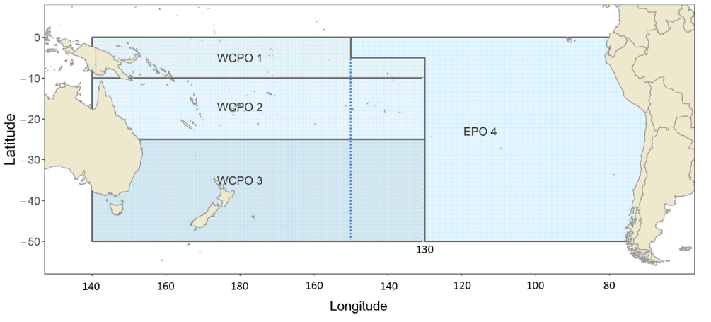
Figure SPA-01. The geographical area covered by the stock assessment and the boundaries of the four model regions used for South Pacific-wide 2021 albacore assessment. The overlap region between the WCPFC and IATTC convention areas is the area between 130º - 150º west demarcated by the dashed line. The catch from the ‘overlap’ area is included within the WCPFC-CA for this assessment.

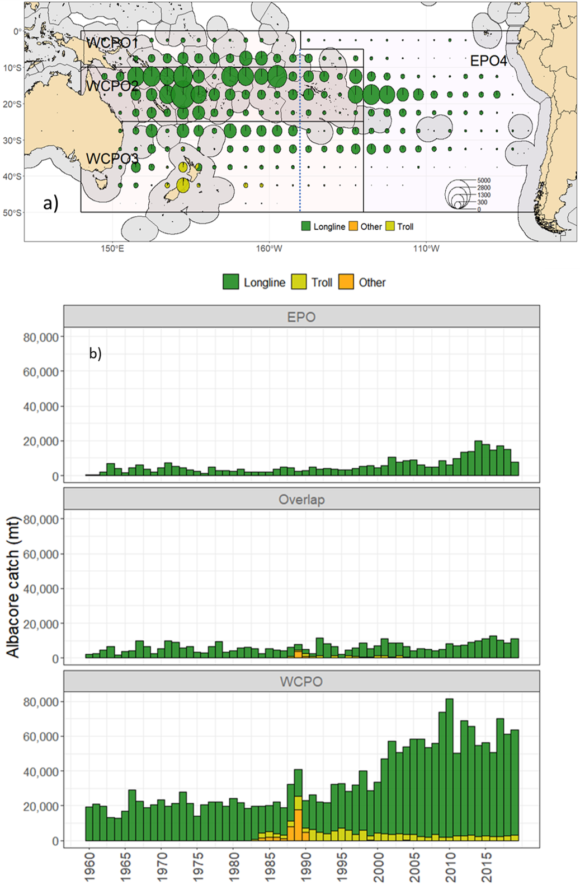
Figure SPA-02. a) Spatial pattern of albacore catch by gear type over the last decade, and b) historical catches of albacore across the model region from 1952-2019 by gear type.

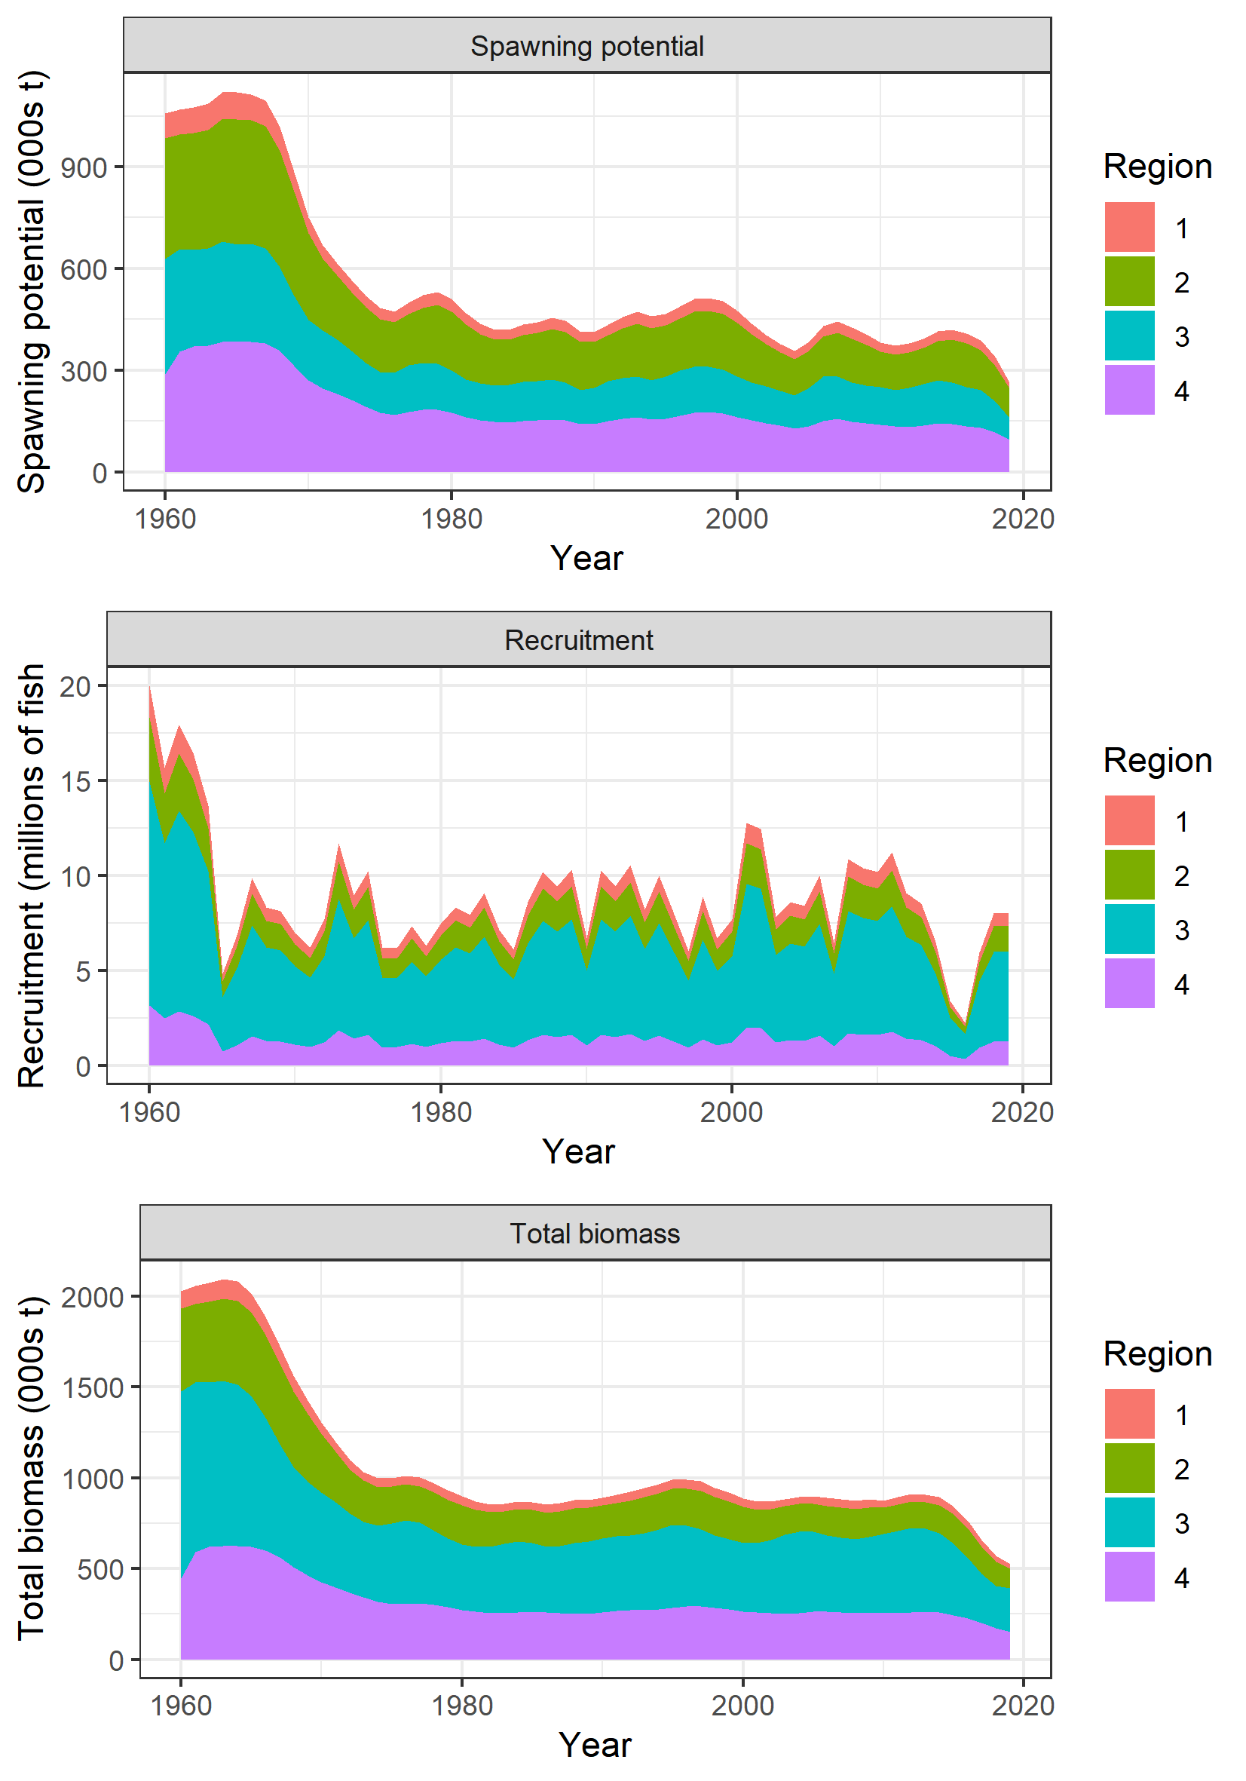 | 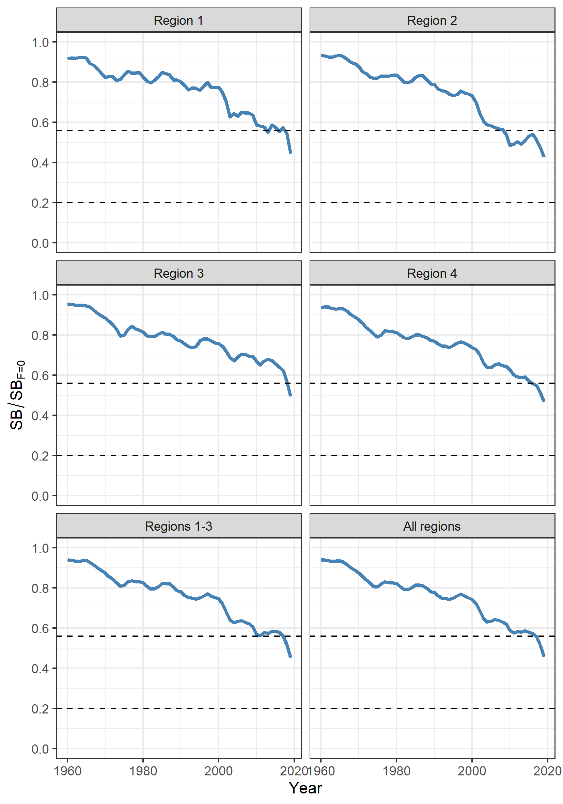
Figure SPA-03. Estimated annual average a) spawning potential, b) recruitment, and c) total biomass by model region for the diagnostic case model, showing the relative levels among regions. | Figure SPA-04. Estimated temporal spawning potential by model region, grouped by region (WCPFC-CA, EPO) and South Pacific as a whole for the diagnostic case model. The dotted lines are included to indicate the SB/SB_{F=0} interim target reference point (iTRP)=0.56 and the LRP=0.2 for the WCPFC-CA albacore fishery. Regions 1-3 represent the WCPFC-CA (including the “overlap”), Region 4 is the IATTC-CA.

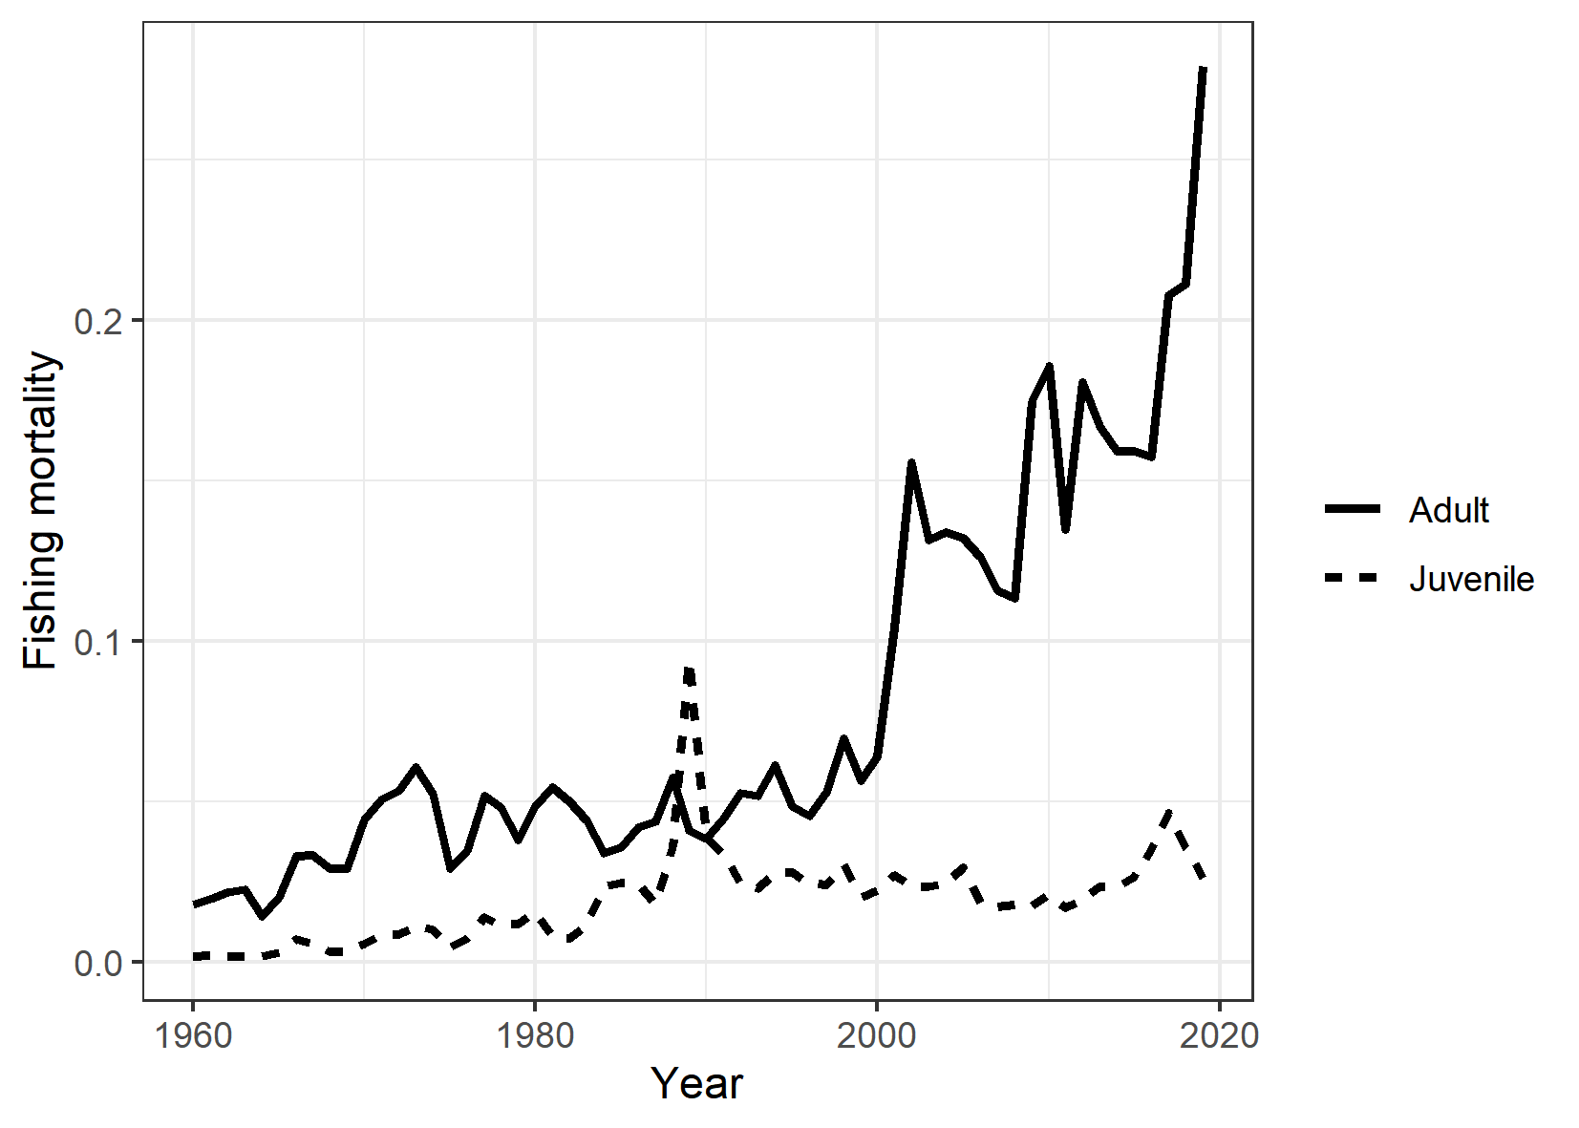
Figure SPA-05. Estimated annual average juvenile and adult fishing mortality for the diagnostic case model.

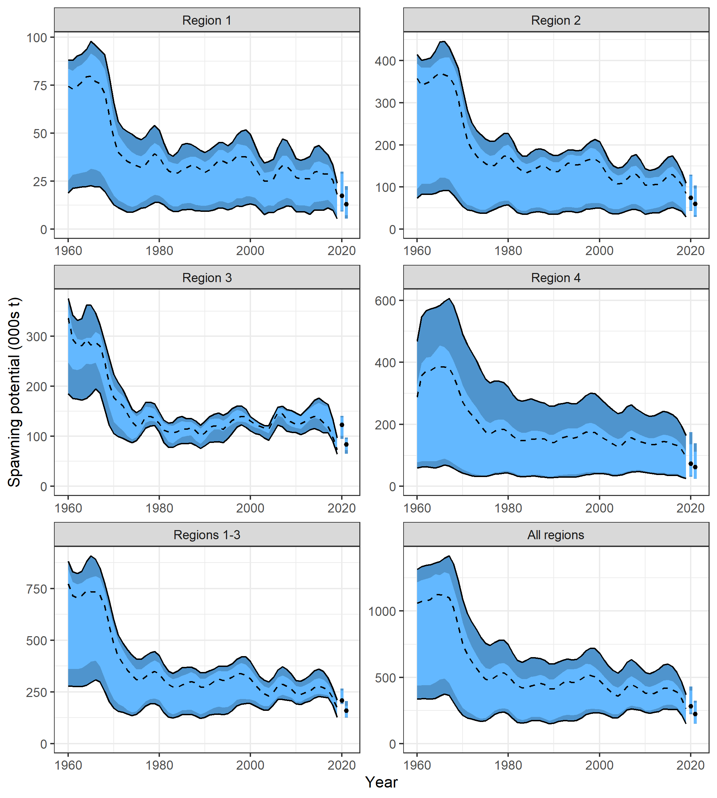 | 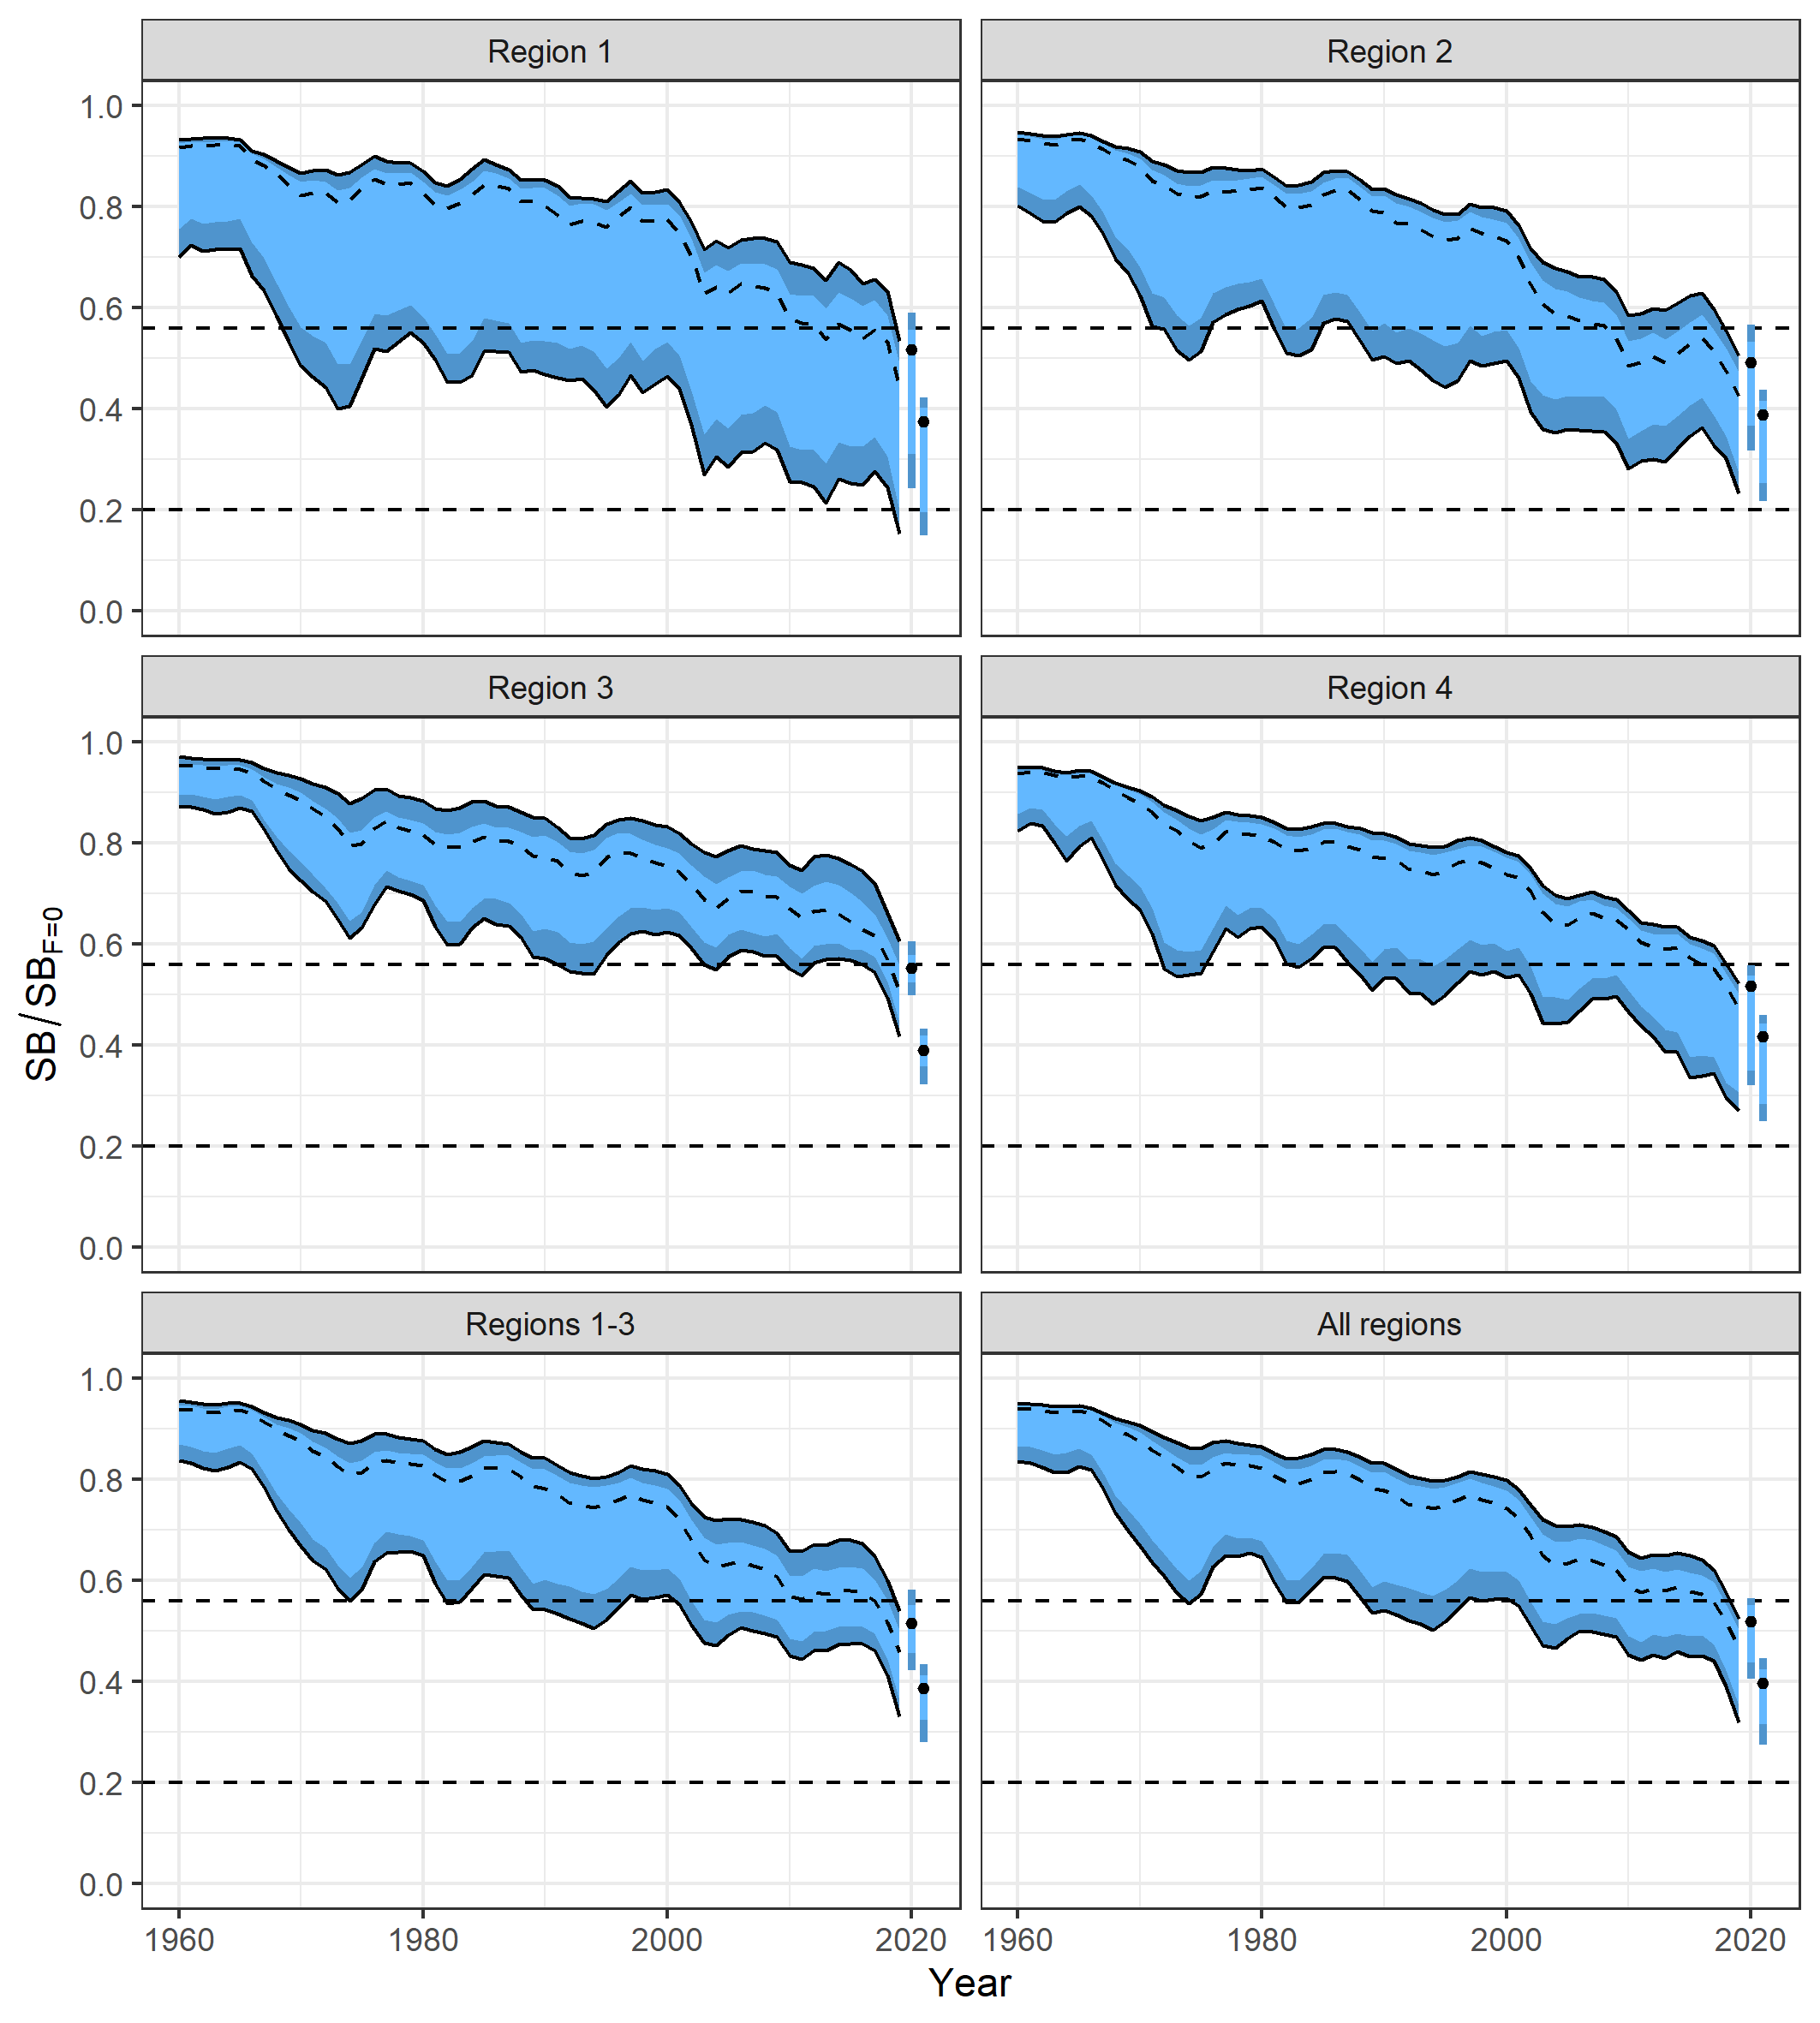
Figure SPA-06. Estimated spawning potential across all models in the structural uncertainty grid over the period 1960-2019. The dashed line represents the median. The darker band shows the 10th-90th percentile, and the lighter band shows the 25th-75th percentile of the model estimates. Regions 1-3 represent the WCPFC-CA (including the “overlap”), Region 4 is the IATTC-CA. The bars at right in each plot are the median values (points) and percentiles for recent (left) and latest (right) spawning potential. | Figure SPA-07. Estimated spawning depletion across all models in the structural uncertainty grid over the period 1960-2019. The dashed line represents the median. The darker band shows the 10th-90th percentile, and the lighter band shows the 25th-75th percentile of the model estimates. Regions 1-3 represent the WCPFC-CA (including the “overlap”), Region 4 is the IATTC-CA. The dashed horizontal lines indicate the depletion LRP (0.2) and the WCPFC-CA TRP for SB/SB_{F=0} (0.56). The bars at right in each plot are the median values (points) and percentiles for SB_{recent}/SB_{F=0} (left) and SB_{latest}/SB_{F=0} (right)

.

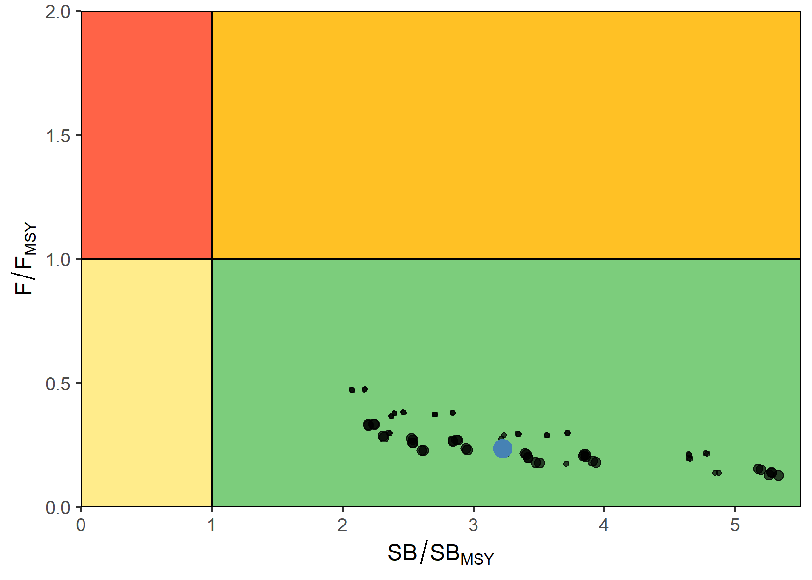 | 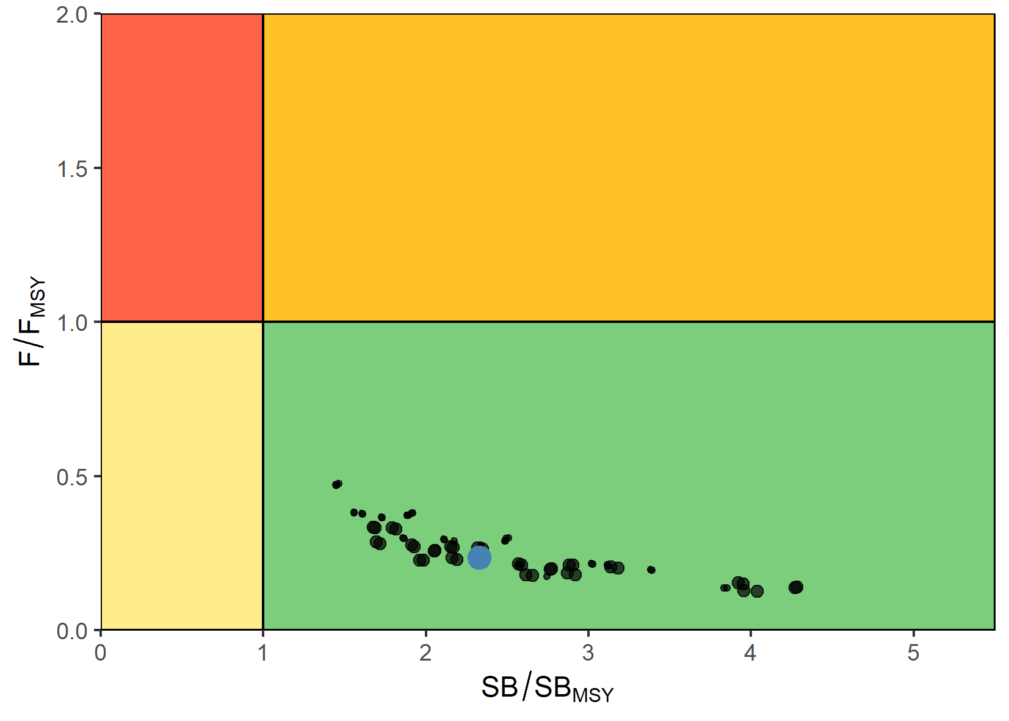
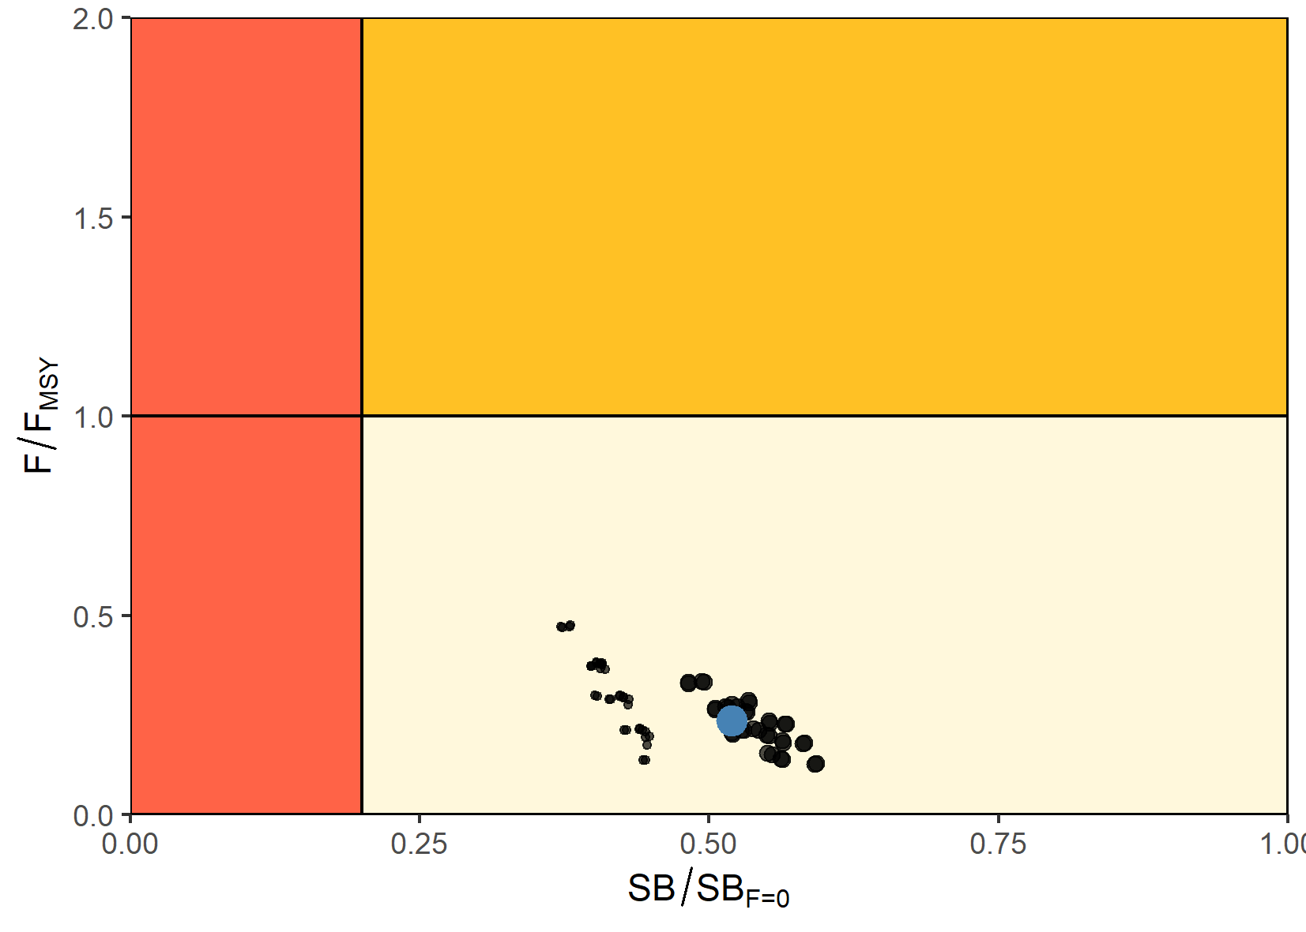 | 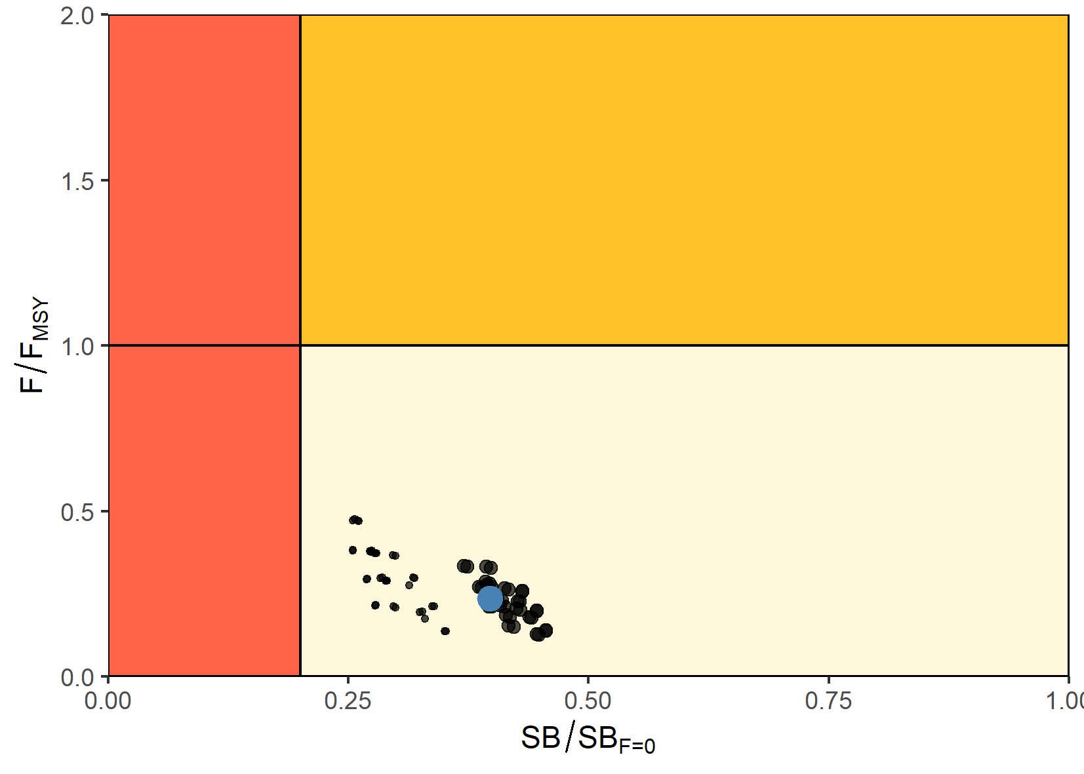
Figure SPA-08. Majuro (bottom) and Kobe (top) plots summarizing the Pacific-wide results for each of the models in the structural uncertainty grid for the ‘recent’ (2016-2019) period. The blue point is the median value based on the weighted grid models, with the more heavily weight models indicated by the larger black dots. | Figure SPA-09. Majuro (bottom) and Kobe (top) plots summarizing the Pacific-wide results for each of the models in the structural uncertainty grid for the ‘latest’ (2019) period. The blue point is the median value based on the weighted grid models, with the more heavily weighted models indicated by the larger black dots.
      - Management advice and implications

- Annual catch estimates for albacore in the South Pacific peaked at 93,835 mt (all gears) in 2017 (SC17-SA-IP-04). Catch by longliners represented 93% of the catch weight in 2020 at 64,963 mt and represented a 21% decrease from 2019 despite a shift of effort from the tropical to the southern longline fishery in 2020. By comparison, the 2020 total albacore catch within the southern part of the WCPFC-CA was 61,778 mt and the longline catch was 57,006 mt.

- The 2021 South Pacific albacore stock assessment provided results consistent with the 2018 assessment. The addition of the EPO region into the current entire South Pacific assessment did not notably alter the main assessment outcomes, and similar trajectories and terminal depletion were estimated in both RFMO regions.

- The spawning stock biomass has become more depleted across the model period (1960-2019), with a notable increase in depletion in the most recent years. Based on the set of models in the SC endorsed structural uncertainty grid, the South Pacific albacore assessment indicates the stock is not overfished, and there was zero estimated risk of the stock being below the Limit Reference Point of 20%SB_{F=0}. However, the decline in the latest estimated SB_{latest}/SB_{F=0} (year 2019; median 0.40; 10th and 90th percentiles 0.27 - 0.45) is notably more pessimistic than those of SB_{recent}/SB_{F=0} (years 2016-2019; median 0.52; 10th and 90th percentiles 0.41 - 0.57) indicating that there has been a substantial decline in stock status estimated over the last three years. The general trends are consistent for estimates across all regions of the South Pacific stock, and for the WCPFC-CA only.

- For the WCPFC-CA region, the ‘recent’ and ‘latest’ SB estimates are on average both below the interim TRP of 0.56. Further, 86% of models (62 out of 72 models) in the structural uncertainty grid endorsed by SC17 estimated that SB_{recent}/SB_{F=0} was below the interim TRP. In relation to management objectives for the WCPFC-CA longline fishery, this assessment estimated that the median `latest' (2019) and `recent' (2016-2019) longline vulnerable biomass for the WCPFC-CA are 56% and 76% of the 2013+8% target level that defined the interim TRP.

- SC17 noted CPUE declines in many domestic longline fisheries in the southern portion of the WCPFC-CA.

- SC17 noted that depletion is greatest in regions north of 25⁰S, specifically in assessment Regions 1 and 2 where most domestic Pacific Island Countries and Territories (PICTs) fleets operate, including Small Island Developing States (SIDS) and Participating Territories that may have no high seas access. These are areas mostly unaffected by current management measure for South Pacific albacore (CMM 2015-02), which prescribe effort controls and reporting provisions south of 20⁰S.

- SC17 expressed great concern with the projected status of South Pacific albacore if recent catch or effort levels are maintained (SC17-SA-WP-02a REV2). Projections indicated that South Pacific albacore stock has a greater than 20% risk of falling below the LRP in 2021 under both catch and effort scenarios. These projections indicate an extended period where biomass is below the current interim TRP and in most cases the TRP is not achieved within the 30-year projection period.

- Recalling its previous advice from SC11, SC12, and SC13, SC17 recommended that longline catch be reduced to avoid further and extended declines in the vulnerable biomass so that economically viable catch rates can be maintained, especially for longline catch of adult albacore.

- SC17 recommended a recalibration of the interim TRP for review at WCPFC18 in accordance with the process agreed at WCPFC15 (WCPFC15 Summary Report, para 207). Further, SC17 recommended projections be undertaken to estimate the constant catch levels that would achieve that TRP on average over the long-term. SC17 recommended that these analyses be provided to WCPFC18 to guide its consideration of reductions in longline fishing mortality that will be required to return the vulnerable biomass to the 2013 +8% level as agreed.

      - Future research recommendations

- SC17 noted with concern that the standardized CPUE indices do not show linear contrast with catches over the past 20 years when the catch has increased by 2 to 3-fold and also that the fit to the indices show a residual pattern over time. SC17 supported the assessment scientist’s suggestion to consider split indices in future assessments, which might allow for the incorporation of more informative catchability and density covariates during the contemporary period, which is more important for estimates of recent status.

- SC17 noted a possible nonlinear relationship between catch and effort or a time-varying relationship with changing fishing power and catchability. The next assessment could investigate such nonlinear relationships and explore alternative effort metrics.

- SC17 noted with concern that the standardized CPUE model with hooks between floats (HBF) did not converge. The time-series is almost 70 years with substantial shifts to deploy more HBF though time. These gear changes have probably altered South Pacific albacore catchability and require additional research. HBF is one characteristic of longline gear that could affect catchability; operational longline data are largely absent of detailed vessel and gear characteristics that could be valuable in a standardization model. Reliably collecting additional gear characteristics will better inform these models on variability in catchability among vessels and fleets and over time and these data enhancements could be achieved by revisiting the minimum logsheet data standards, increasing observer coverage, or expanding electronic monitoring applications. Without this additional information the large uncertainties associated with the use of standardised-CPUE in assessments will remain unresolved and continue to impact on future assessments.

- SC17 noted the need to both recalibrate the interim TRP according to the procedure agreed at WCPFC15 (WCPFC15 Summary Report, para 207) and estimate the constant catch levels that would achieve that TRP on average over the long-term. Specifically, based upon the SC-agreed 2021 South Pacific albacore stock assessment:
- re-calibrate the WCPFC interim TRP (the median depletion in the WCPFC-CA, SB/SB_{F=0}) that would on average achieve the agreed objective of an 8 % increase in vulnerable biomass (CPUE proxy) for the southern longline fishery as compared to 2013 levels.
- undertake projections to estimate the constant catch levels that would achieve the recalibrated TRP, on average, over the long-term.
- within that projection-based analysis, WCPFC-CA longline and troll fisheries should be modelled based upon catch, and fishing levels within the EPO should be adjusted in the same way as the WCPO for one scenario and fixed at recent catch levels for another scenario. Future recruitment should be sampled from the long-term recruitment pattern.

- A number of key research needs were identified in undertaking the assessment that should be investigated either internally or through directed research.

- As with the previous South Pacific albacore assessment, the fishery dependent CPUE-based indices of abundance lacked contrast to inform population responses to increased fishing pressure. This continues to be a significant concern for the reliability of estimates of population size. The CPUE analysis has been a major focus of preparatory work for this and previous assessments, and despite the attempts of various scientists, application of new approaches including attempts at splitting time series and testing various covariates, the CPUE continues to lack contrast. It is recommended that alternative fishery independent estimates of population size be explored, especially the genetic method of Close-Kin Mark-Recapture (CKMR).

- The implications of uncertainty in movement were clearly evident in this year’s assessment, with this being the most influential uncertainty for management advice. In the absence of strong empirical data to inform decisions on alternative movement hypotheses and based on the quality of fits to the data, the SC decided to down-weight one of the two movement hypothesis for provision of management advice. This is an unsatisfactory situation and there is a clear need to improve understanding of connectivity among albacore populations across the South Pacific, and, in particular, the fishery regions in the WCPFC and IATTC convention areas. This is particularly critical if South Pacific-wide assessments are to continue. The CKMR method as a by-product can also address this uncertainty.

- Despite applying the new growth data to this assessment, the modal structure in the New Zealand troll fishery size composition was still not fit adequately. Further work on growth modelling is required. It should also be noted that otolith-based growth data being used is mostly derived for otolith samples collected in 2009 -2010. Further, to update the growth information for albacore, samples from the IATTC-CA are needed. Again, samples required to address this issue could be collected as part of a CKMR project that would also include a component to develop (tissue-based) epigenetic ageing methods and sex determination. This would be a major advance in including more contemporary growth information in tuna assessments.

- Follow-up studies to assess the reliability of size composition data for providing information on recruitment and population trends, and if necessary, develop better stratification methods to improve the representativeness of size composition data should be considered.

- Finally, the current model is highly parameterized, and reducing model parameters and complexity should be considered to improve model fits and diagnostics. One key advancement would be the application of the “catch conditioned” approach that will be available in MULTIFAN-CL for the next assessment.

SC16-2020 (NO STOCK ASSESSMENT)

There was no stock assessment for south Pacific albacore in 2020. This was not discussed at SC17 due to its streamlined agenda and discussion were conducted virtually due to the impacts of COVID-19 pandemic. Therefore, the stock status descriptions and management advice from SC15 are still current for south Pacific albacore.

SC15-2019 (FISHERY INDICATORS UPDATED)

- Stock status and trends

- SC15 noted that no stock assessments were conducted for South Pacific albacore in 2019. Therefore, the stock status descriptions from SC14 are still current for South Pacific albacore. For further information on the stock status and trends from SC14, please see https://www.wcpfc.int/node/32155. Updated information on fishery trends and indicators were compiled for and reviewed by SC15.

- SC15 noted that the total provisional Pacific Ocean catch south of the equator in 2018, updated since the paper was submitted, was 80,820 mt, a 13% decrease from 2017 and a 2% decrease from the average 2013-2017. Longline catch in 2018 (77,776 mt) was a 14% decrease from 2017 and an 8% decrease from the 2013-2017 average.

- The average stock status in 2016 (the last year of the assessment) across the 72 model runs was SB_{latest}/SB_{F=0} = 0.52, below the interim target reference point (SB_{latest}/SB_{F=0} = 0.56) established by the WCPFC in 2018. The probability of being below the TRP in 2016 is 63%. The stock is not overfished nor is overfishing occurring.

- SC15 noted projections from the 2018 assessment which apply to the WCPFC Convention Area. The historical status and projections have a greater uncertainty in spawning stock depletion than observed for bigeye and yellowfin tuna because South Pacific albacore has a different grid which incorporates natural mortality and growth, and this gives a wider spread of uncertainty. SC15 noted that under recent fishery conditions of assuming that the 2018 catch remains constant, the albacore stock is initially projected to increase as recent estimated relatively high recruitments support adult stock biomass, then decline as future recruitment is sampled from the long-term historical estimates The projections indicate that median F₂₀₂₀/F_{MSY} = 0.24; median SB₂₀₂₀/SB_{F=0} = 0.43; and median SB₂₀₂₀/SB_{MSY} = 3.2. The risk that SB₂₀₂₀/SB_{F=0} < LRP = 0%, SB₂₀₂₀ < SB_{MSY} = 0% and F₂₀₂₀ > F_{MSY} = 0%.

- The stock biomass is expected to decline from the 2016 level of 0.52 to 0.39 by 2035. The risk of the stock biomass breaching the LRP in 2035 is expected to be 23%. The longline-vulnerable biomass (the longline CPUE proxy) is expected to decrease by 36% relative to 2013 levels.

- Management advice and implications

- Given the stock assessment in 2018 and SC15 projections, SC15 advises that WCPFC develop comprehensive binding South Pacific albacore management measures which will result in the stock reaching the TRP within the 20-year time horizon. SC15 advises WCPFC16 may consider establishing a CMM to further reduce total catch or effort in order to reverse the projected decline in the vulnerable biomass.

- SC15 notes that the 2018 South Pacific albacore stock assessment pertained to the WCPFC Convention Area. The South Pacific albacore catch in the eastern Pacific Ocean has recently increased and the scheduled 2021 South Pacific albacore assessment may pertain to the entire south Pacific stock in order to incorporate all population dynamics. WCPFC and IATTC compatible measures would be more easily implemented should an entire south Pacific assessment be conducted.

- Research recommendation

- SC15 noted that the assumed future recruitment can have a large impact on the projection result. It was recommended that research be undertaken to quantify autocorrelation behavior of recruitment to be included in the future projection.

SC14-2018 (STOCK ASSESSMENT CONDUCTED)

- SC14 accepted as SC14-SA-WP-05 as providing the best available scientific information for the purpose of stock assessment determination.

- Stock status and trends

- The median, 10 percentile and 90 percentile values of recent (2013-2016) spawning biomass ratio (SBrecent/ SBF=0) and recent fishing mortality in relation to FMSY (Frecent/FMSY) over the structural uncertainty grid were used to characterize uncertainty and describe the stock status.

- A description of the structural sensitivity grid used to characterize uncertainty in the assessment is set out in Table SPA-1. The regional structure used within the assessment is presented in Figure SPA-1, and the time series of total annual catch by fishing gear for the diagnostic case model over the full assessment period is shown in Figure SPA-2 for the total assessment region, and Figure SPA-3 by model region. Estimated annual average recruitment, spawning potential, juvenile and adult fishing mortality and fishing depletion for the diagnostic case model are shown in Figures SPA-4 – SPA-7. Figure SPA-8 displays Majuro plots summarising the results for each of the models in the structural uncertainty grid, while Figure SPA-9 shows equivalent Kobe plots for SBrecent and SBlatest across the structural uncertainty grid. Figure SPA-10 provides estimates of reduction in spawning potential due to fishing by region, and over all regions attributed to various fishery groups (gear-types) for the diagnostic case model. Table SPA-2 provides a summary of reference points over the 72 models in the structural uncertainty grid. Figure SPA-11 presents the history of the annual estimates of MSY for the diagnostic case model, compared with annual catch by the main gear types. Finally, Figure SPA-12 presents the estimated time-series (or ‘dynamic’) Kobe plots for four example models from the assessment (one from each of the combinations of growth types, and natural mortality M set to 0.3 or 0.4)

- SC14 noted that the median level of spawning biomass depletion from the uncertainty grid was SBrecent/SBF=0 = 0.52 with a probable range of 0.37 to 0.63 (80% probability interval). There were no individual models where (SBrecent/SBF=0) < 0.2 which indicated that the probability that recent spawning biomass was below the LRP was zero. SC14 noted that the grid median Frecent/FMSY was 0.20, with a range of 0.08 to 0.41 (80% probability interval) and that no values of Frecent/FMSY in the grid exceeded 1.

- SC14 also noted that there was a 0% probability (0 out of 72 models) that the recent fishing mortality had exceeded FMSY.

- SC14 noted that the structural uncertainty grid for the south Pacific albacore had changed since the 2015 assessment, with the 2018 assessment examining additional axes of uncertainty including assumptions on growth and CPUE standardization approach. As a consequence, the uncertainty identified is higher than in previous assessments.

- SC14 also noted that the assessment results show that while the stock depletion (SB/SBF=0) has exhibited a long-term decline (Figure SPA-7) the stock is not in an overfished state and overfishing is not taking place.

b. Management Advice and implications

- SC14 noted that the preliminary estimate of total catch of south Pacific albacore (within the WCPFC Convention Area south of the equator) for 2017 was 75,707mt, which was a 33% increase from 2016 and a 13% increase over 2012-2016. (see SC14-SA-WP-02).

- Preliminary catch for longliners in 2017 (72,785mt) was 34% higher compared with 2016 and a 14% increase over 2012-2016. Preliminary other gear (primarily troll) catch in 2017 (2,896t) was 17% higher compared with 2016 but a 1% decrease over 2012-2016. (see SC14-SA-WP-02).

- Based on the uncertainty grid adopted by SC14, the South Pacific albacore tuna spawning biomass is very likely to be above the biomass LRP and recent F is very likely below FMSY, and therefore the stock is not experiencing overfishing (100% probability F < FMSY) and is not in an overfished condition (100% probability SBrecent > LRP).

- SC14 recalled its previous advice from SC11, SC12, and SC13 that longline fishing mortality and longline catch be reduced to avoid decline in the vulnerable biomass so that economically viable catch rates can be maintained, especially for longline catch of adult albacore. SC14 recommends that this advice be taken into consideration when the TRP for South Pacific albacore is discussed at WCPFC15.

Table SPA-1. Description of the structural sensitivity grid used to characterize uncertainty in the 2018 south Pacific albacore assessment. Levels used within the diagnostic case are starred.
Axis | Levels | Option
Steepness | 3 | 0.65, 0.80*, 0.95
Natural mortality | 2 | 0.3*, 0.4
Growth | 2 | Estimated* (K, L∞) or fixed (Chen-Wells)
Size frequency weighting | 3 | Sample sizes divided by 20, 50* or 80
CPUE | 2 | Geostatistical*, Traditional

Table SPA-2. Summary of reference points over all the 72 individual models in the structural uncertainty grid.
 | Mean | Median | Min | 10% | 90% | Max
Clatest | 61719 | 61635 | 60669 | 60833 | 62704 | 63180
MSY | 100074 | 98080 | 65040 | 70856 | 130220 | 162000
YFrecentt | 71579 | 71780 | 56680 | 62480 | 80432 | 89000
fmult | 6.2 | 4.96 | 1.89 | 2.44 | 12.05 | 17.18
FMSY | 0.07 | 0.07 | 0.05 | 0.05 | 0.09 | 0.1
Frecent/FMSY | 0.23 | 0.2 | 0.06 | 0.08 | 0.41 | 0.53
SBMSY | 71407 | 68650 | 26760 | 39872 | 100773 | 134000
SB0 | 443794 | 439800 | 308800 | 353870 | 510530 | 696200
SBMSY/SB0 | 0.16 | 0.17 | 0.07 | 0.1 | 0.21 | 0.23
SBF=0 | 469004 | 462633 | 380092 | 407792 | 534040 | 620000
SBMSY/SBF=0 | 0.15 | 0.15 | 0.06 | 0.09 | 0.2 | 0.22
SBlatest/SB0 | 0.55 | 0.56 | 0.33 | 0.42 | 0.69 | 0.74
SBlatest/SBF=0 | 0.53 | 0.52 | 0.3 | 0.37 | 0.69 | 0.77
SBlatest/SBMSY | 4 | 3.42 | 1.45 | 1.96 | 7.07 | 10.74
SBrecent/SBF=0 | 0.51 | 0.52 | 0.32 | 0.37 | 0.63 | 0.72
SBrecent/SBMSY | 3.88 | 3.3 | 1.58 | 1.96 | 6.56 | 9.67

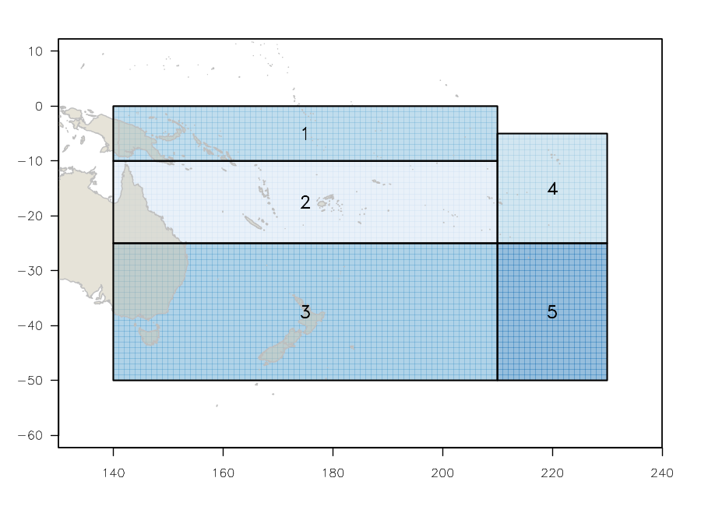 | 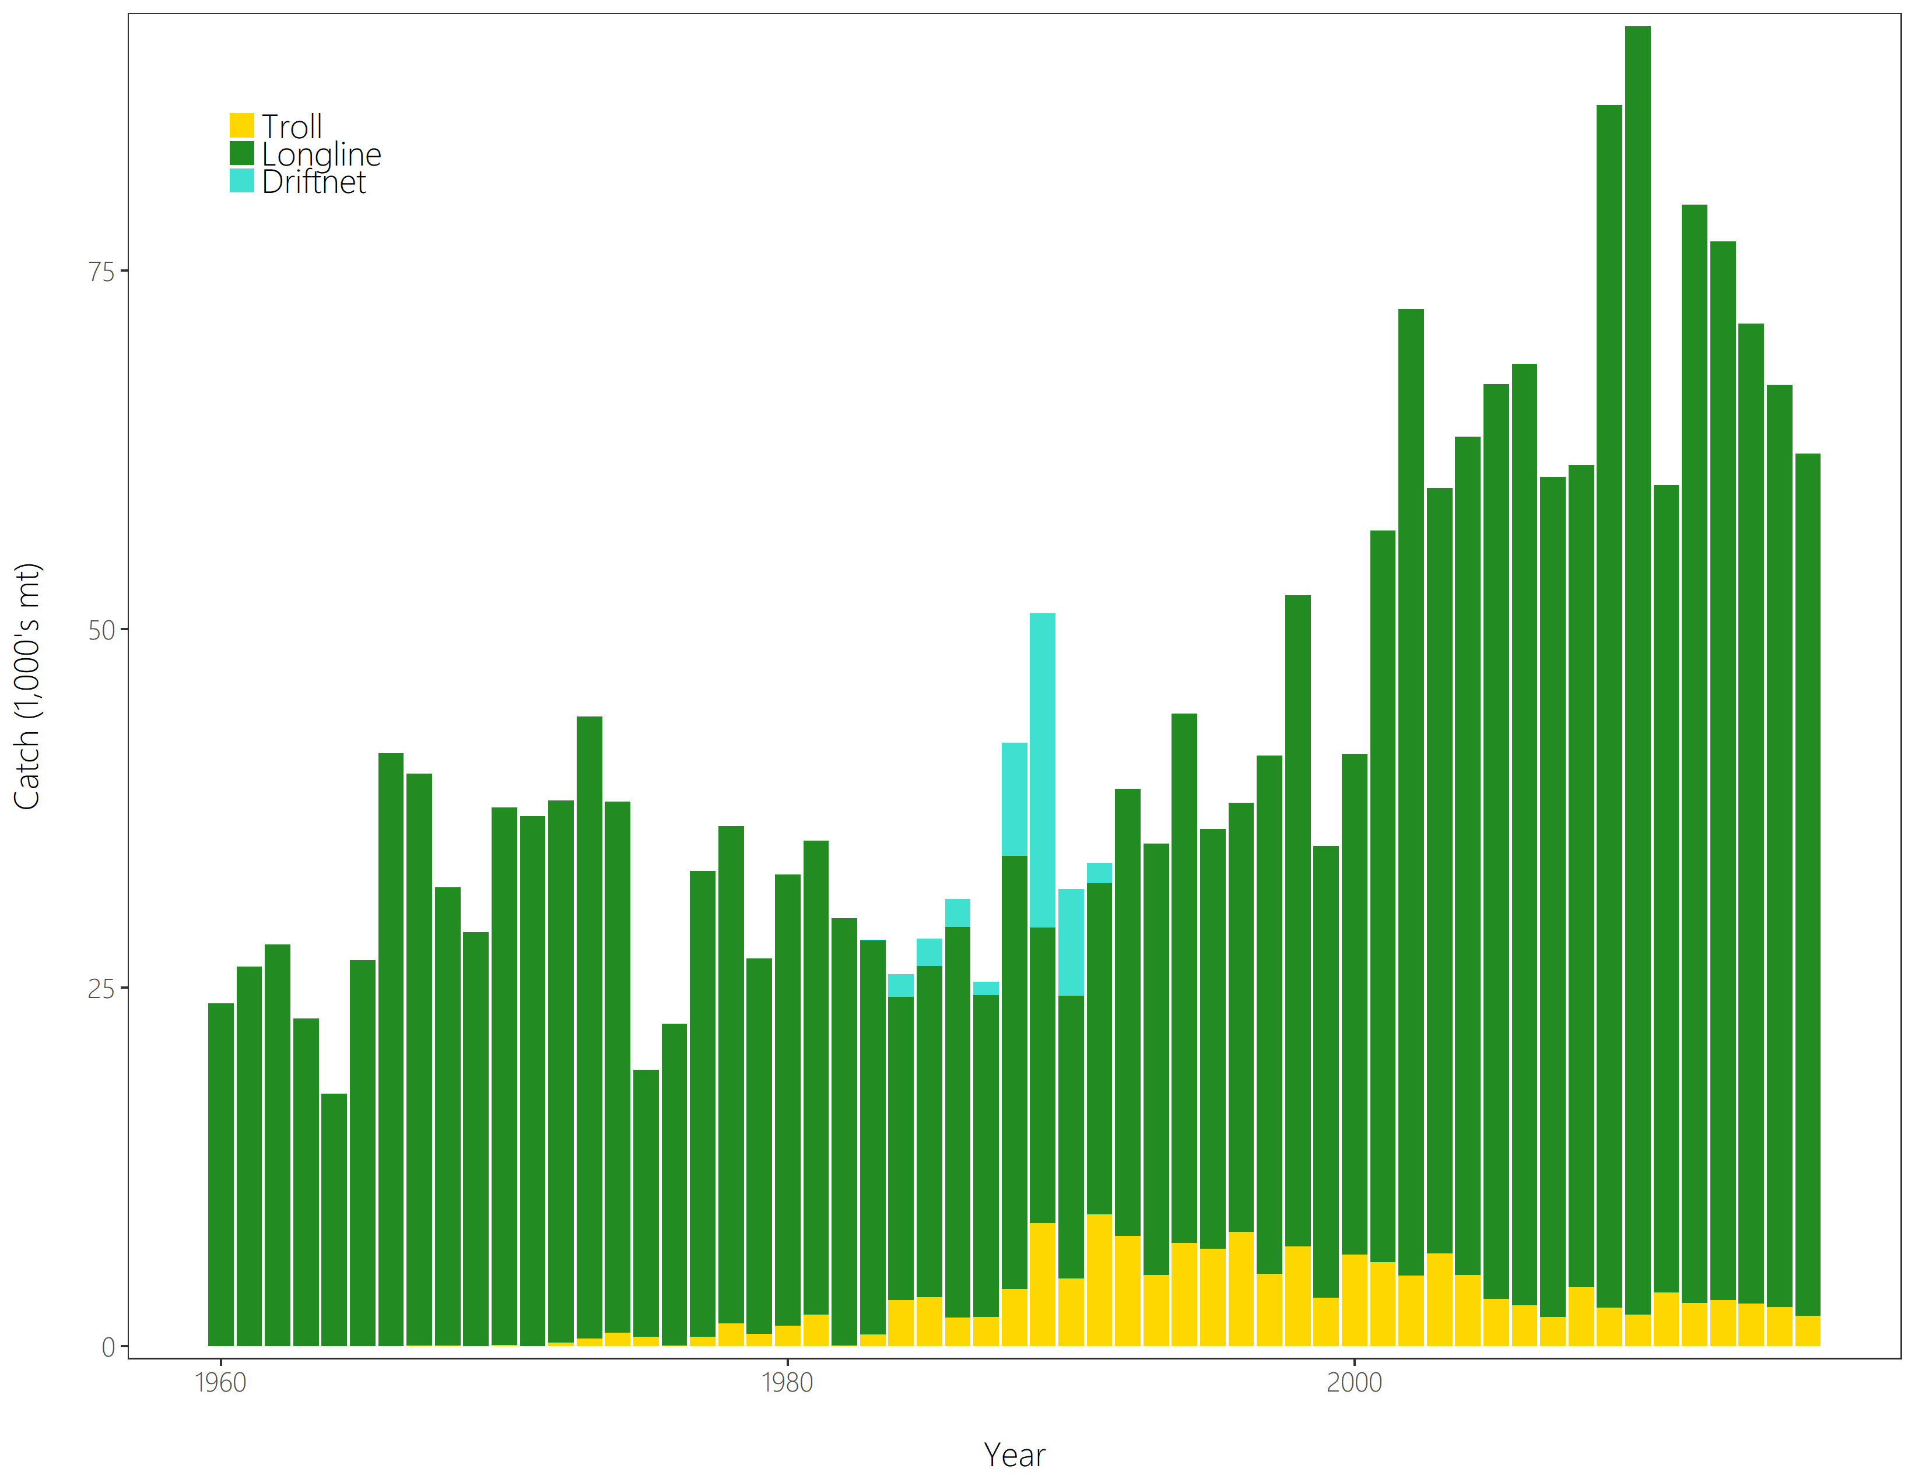
Figure SPA- 1. The geographical area covered by the stock assessment and the boundaries for the 5 regions under the “updated 2018 regional structure". | Figure SPA- 2. Time series of total annual catch (1000’s mt) by fishing gear for the diagnostic case model over the full assessment period. The different colours refer to longline (green), troll (yellow) and driftnet (turquoise). Note that the catch by longline gear has been converted into catch-in-weight from catch-in-numbers.

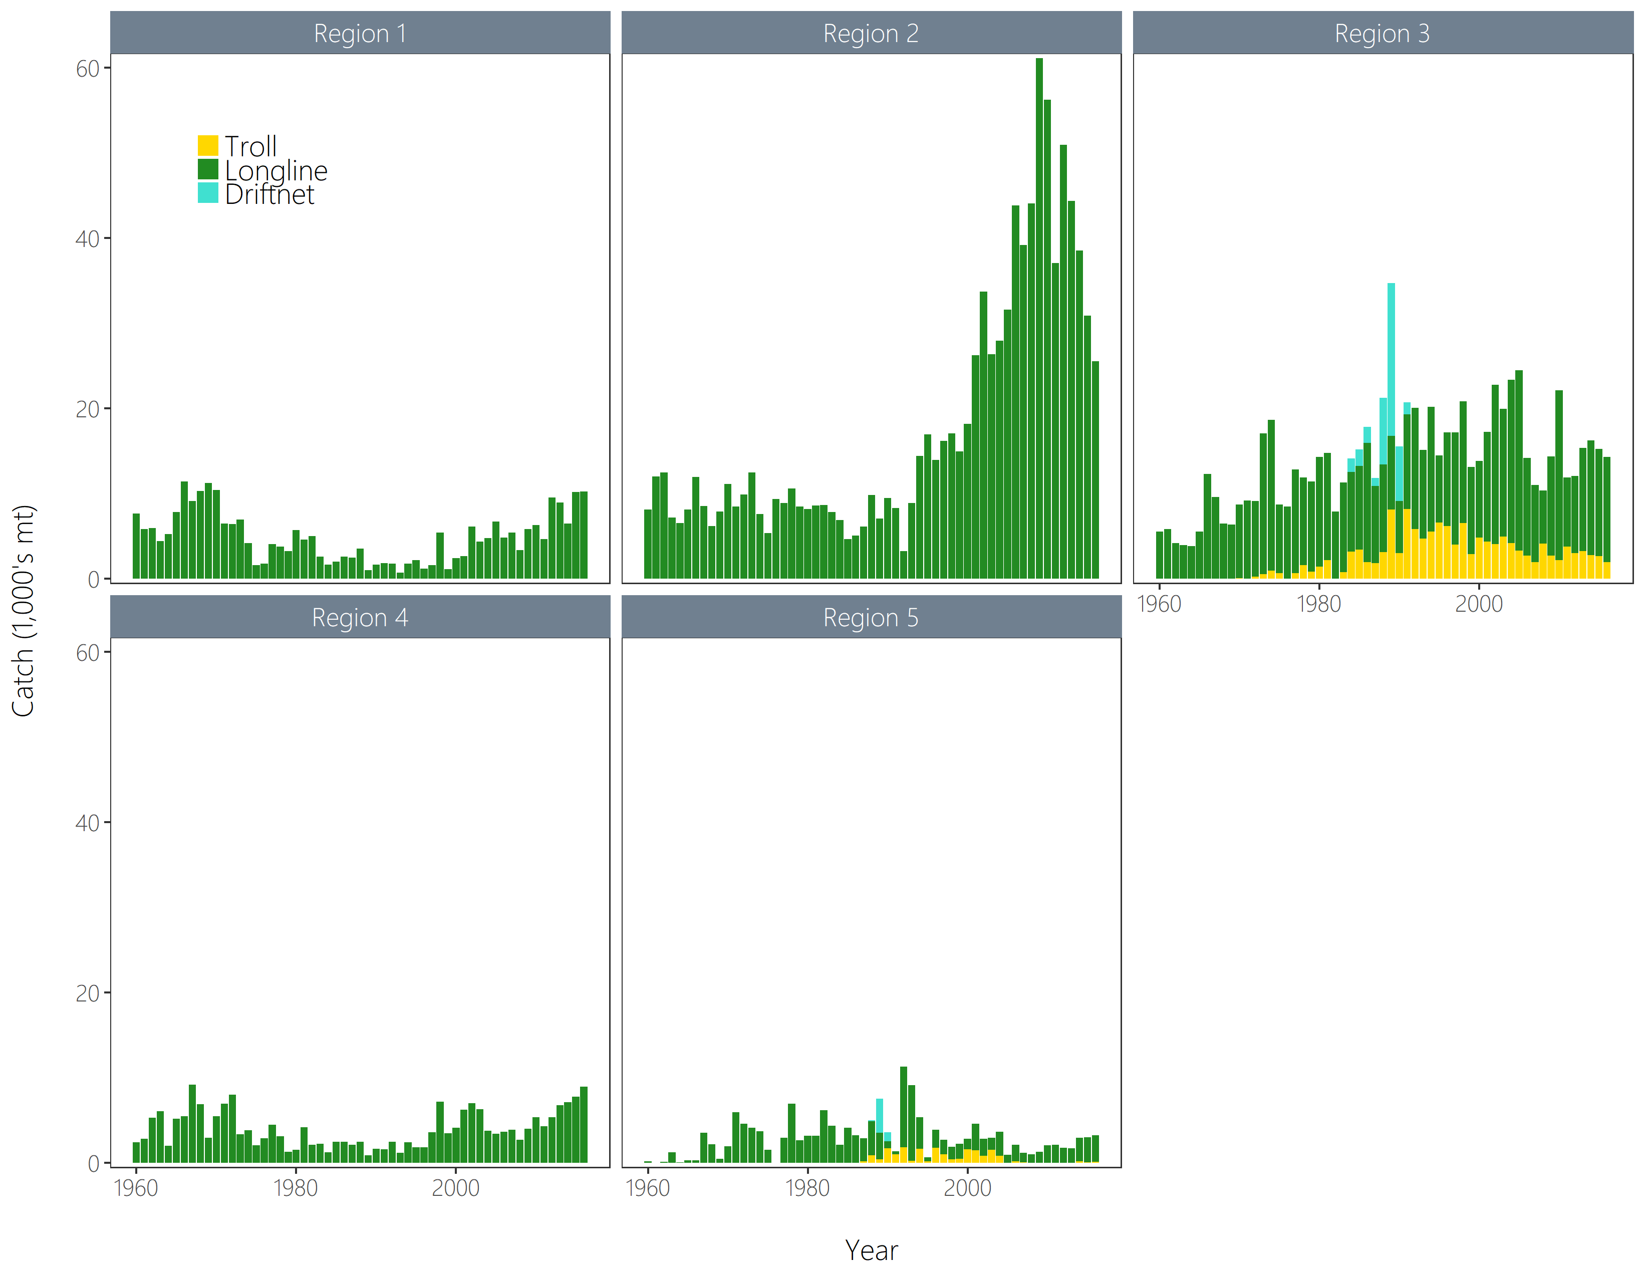 | 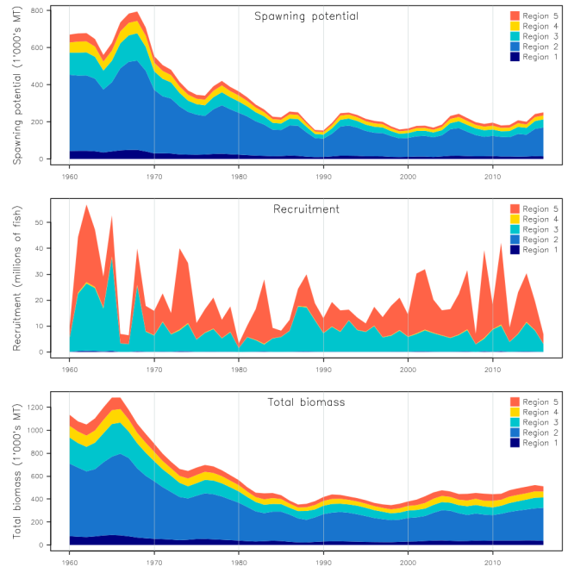
Figure SPA-3. Time series of total annual catch (1000’s mt) by fishing gear and assessment region from the diagnostic case model over the full assessment period. The different colours denote longline (green), driftnet (turquoise) and troll (yellow). | Figure SPA-4. Estimated annual average recruitment, spawning potential and total biomass by model region for the diagnostic case model, showing the relative sizes among regions.

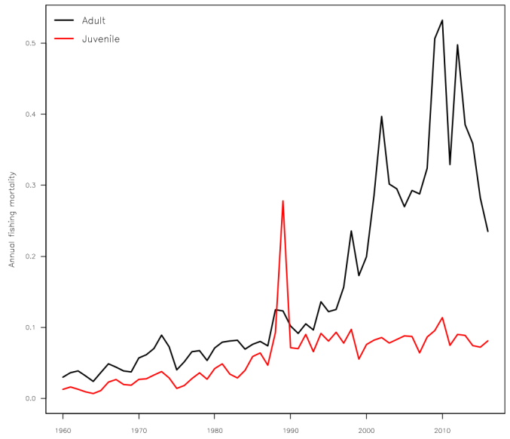 | 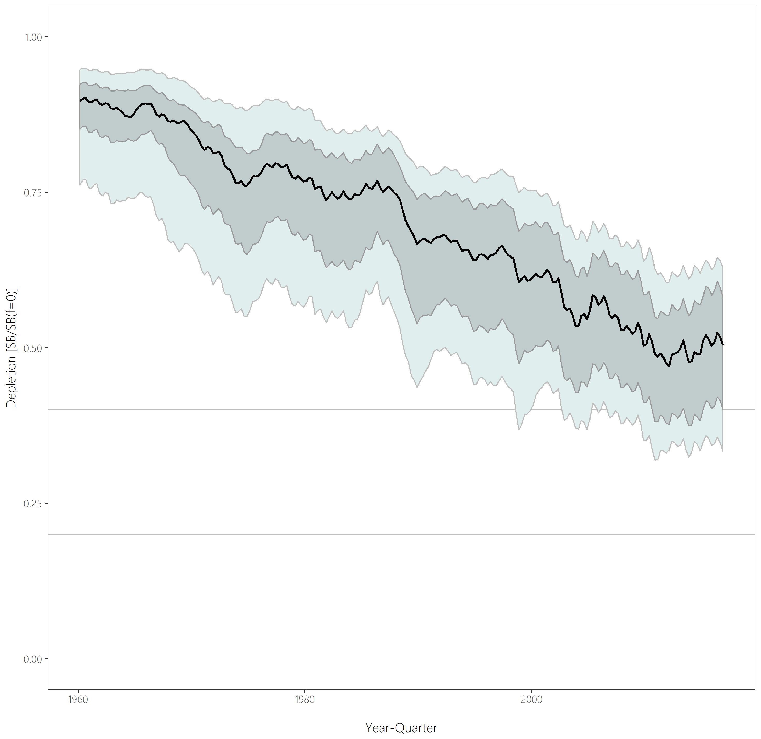
Figure SPA-5. Estimated annual average juvenile and adult fishing mortality for the diagnostic case model. | Figure SPA-6. Distribution of time series depletion estimates across the structural uncertainty grid. Black line represents the grid median trajectory, dark grey region represents the 50%ile range, light grey the 90%ile range.

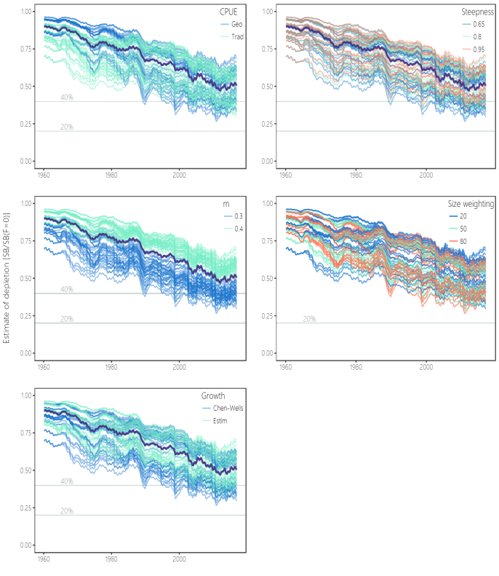 | 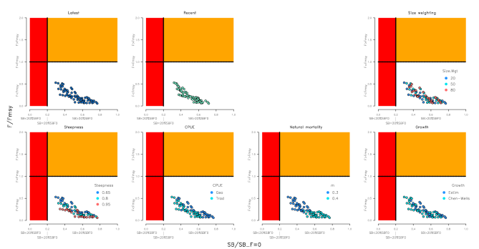
Figure SPA-7. Plots showing the trajectories of fishing depletion (of spawning potential) for the model runs included in the structural uncertainty grid. The five panels show the models separated on the basis of the five axes used in the grid, with the colour denoting the level within the axes for each model. | Figure SPA-8. Majuro plots summarising the results for each of the models in the structural uncertainty grid under the SBlatest/SBF=0 and the SBrecent/SBF=0 reference points (top left) and each axis of uncertainty.

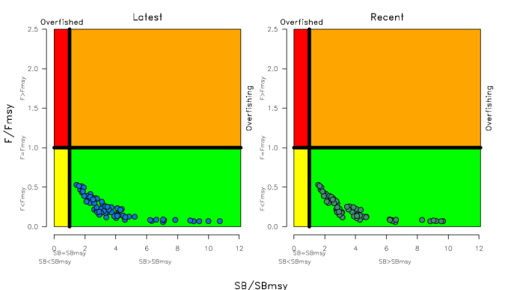 | 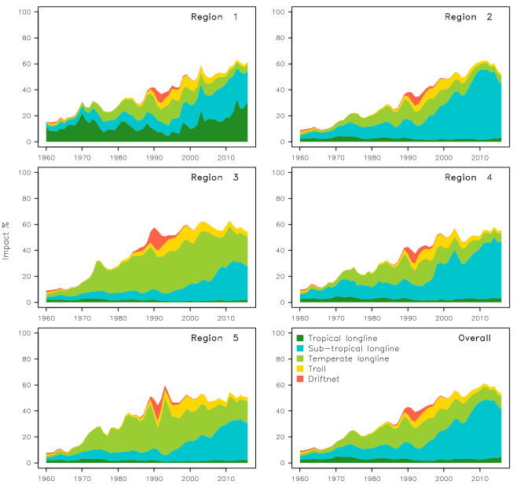
Figure SPA-9. Kobe plots summarising the results for each of the models in the structural uncertainty grid under the SBlatest/SBF=0 and the SBrecent/SBF=0 reference points. | Figure SPA-10. Estimates of reduction in spawning potential due to fishing (fishery impact = 1-SB latest/SB F=0) by region, and over all regions (lower right panel), attributed to various fishery groups for the diagnostic case model.

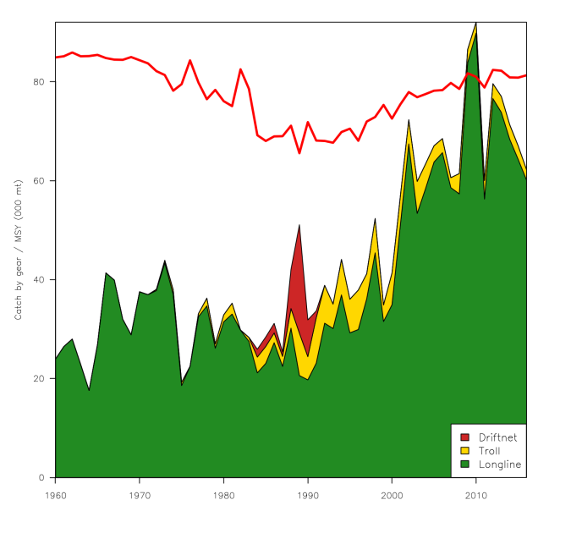 | 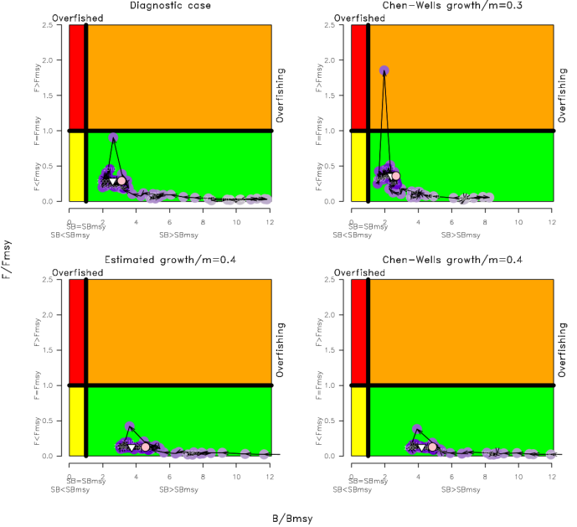
Figure SPA-11. History of the annual estimates of MSY (red line) for the diagnostic case model compared with annual catch by the main gear types. | Figure SPA-12. Estimated time-series (or ‘dynamic’) Kobe plots for four example models from the assessment (one from each of the combinations of growth types, and natural mortality M set to 0.3 or 0.4).

SC13-2017 (FISHERY INDICATORS UPDATED)

- Stock status and trends

- SC13 noted that no stock assessment was conducted for South Pacific albacore tuna in 2017. Therefore, the stock status description from SC11 is still current. For further information on the stock status and trends from SC11, please see http://www.wcpfc.int/node/26922

- SC13 considered an update of trends in South Pacific albacore fisheries (SC13-SA-WP-08) and noted that there had been reductions in longline effort in the WCPF Convention Area south of 10^{ᴼ}S through 2014-2016 (declining from about 300 million hooks in 2013 to around 254 million in 2015, and 200 million hooks in 2016 – with the 2016 value being provisional) and that effort distributions vary a little and show an area of highly concentrated fishing effort. SC13 noted an issue of transhipment that needs to be clarified at TCC13. Status quo projections were calculated, assuming current southern longline and troll fishery effort would continue into the future at levels equal to those seen in 2015 (Figure SPA-1). If 2015 fishing effort levels continue into the future, the stock is predicted to continue to decline on average, falling to SB_{current}/SB_{F=0} = 0.35 in 2033 with a 7% predicted probability of being below the LRP. Overall vulnerable biomass (a CPUE proxy) in longline fisheries is estimated to decrease by 7% from 2013-2033.
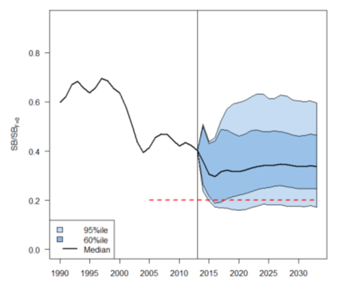
Figure SPA-1. Stochastic projections of adult stock status under 2014 longline and troll effort levels. The limit reference point (20% SB_{F=0}) is indicated by the horizontal dashed red line. Note: from 1960 up to 2013 inclusive the line represents the median across the 9 assessment model runs (structural uncertainty only); uncertainty after 2013 represents both structural uncertainty and stochastic recruitment (1800 simulation runs).

- Management advice and implications

- SC13 noted that no stock assessment was conducted for South Pacific albacore tuna in 2017. Therefore, the advice from SC11 should be maintained. For further information on the stock status and trends from SC11, please see https://www.wcpfc.int/node/26922

- SC13 noted that the preliminary estimate of total catch of south Pacific albacore (within the WCPF Convention Area south of the equator) for 2016 was 58,033 mt which was an 8% decrease from 2015 and a 13% decrease over 2011-2015. (see SC13-SA-WP-02).

- Preliminary longline catch in 2016 (55,635 mt) was 8% lower compared with 2015 and a 13% decrease over 2011-2015. Preliminary troll catch in 2016 (2,372 mt) was 17% lower compared with 2015 and a 24% decrease over 2011-2015. (see SC13- SA-WP-02).

- SC13 considered an update of trends in South Pacific albacore fisheries (SC13-SA-WP-08) and noted that there had been reductions in longline effort in the WCPF Convention Area south of 10ᴼS through 2014-2016 (by approximately 15%) and that effort distributions vary a little and show an area of highly concentrated fishing effort. SC13 noted an issue of transhipment that needs to be clarified at TCC13. Status quo projections were calculated, assuming current southern longline and troll fishery effort would continue into the future at levels equal to those seen in 2015 (Figure SPA-1). If 2015 fishing effort levels continue into the future, the stock is predicted to continue to decline on average, falling to SB_{current}/SB_{F=0} = 0.35 in 2033 with a 7% predicted probability of being below the LRP. Overall vulnerable biomass (a CPUE proxy) in longline fisheries is estimated to decrease by 7% from 2013-2033.

- Pending a new assessment in 2018, SC13 recalls its previous advice from SC11 and SC12 that longline fishing mortality and longline catch be reduced to avoid further decline in the vulnerable biomass so that economically viable catch rates can be maintained, especially for longline catches of adult albacore. SC13 recommends that this advice be taken into consideration when the TRP for South Pacific albacore is discussed at WCPFC14.

Useful References

SC17-SA-WP-02 Stock assessment of South Pacific albacore
https://meetings.wcpfc.int/node/12551
SC17-SA-WP-02a Stock assessment of SP albacore – results of weighted stochastic projections
https://meetings.wcpfc.int/node/13206

SC17-SA-IP-03 Background analyses and data inputs for the 2021 South Pacific albacore tuna stock assessment
https://meetings.wcpfc.int/node/12561

SC17-SA-IP-10 Updating age and growth parameters for South Pacific albacore (project 106)
https://meetings.wcpfc.int/node/12568

SC17-SA-IP-19 Characterisation and CPUE analyses of the New Zealand albacore fishery
https://meetings.wcpfc.int/node/12794

SC15- SA-WP-01 A compendium of fisheries indicators for tuna stocks. https://www.wcpfc.int/node/42927

SC15-SA-WP-08 Trends in the South Pacific Albacore Longline and Troll Fisheries. https://www.wcpfc.int/node/42934

SC14-SA-WP-05 Stock assessment of South Pacific albacore tuna Rev 2.
https://www.wcpfc.int/node/31182

SC14-SA-WP-02 A compendium of fisheries indicators for tuna stocks. https://www.wcpfc.int/node/30987

SC14-SA-IP-07 Background Analysis for the 2018 stock assessment of South Pacific albacore tuna. https://www.wcpfc.int/node/31260

SC14-SA-IP-08 Trends in the South Pacific Albacore Longline and Troll Fisheries Rev 2. https://www.wcpfc.int/node/30986
And associated excel files
https://www.wcpfc.int/node/30988
https://www.wcpfc.int/node/30989

SC13-WCPFC13-03 Biological and Economic Consequences of Alternative Trajectories to Achieve a Candidate South Pacific Albacore Target Reference Point; Pilling G [1]., M. Skirtun [2], C. Reid [2] and J. Hampton [1] – ([1] SPC-OFP & [2] FFA).
https://www.wcpfc.int/node/29429

SC13-WCPFC13-04 Performance Indicators and Monitoring Strategies for Skipjack and South Pacific Albacore Commensurate with Candidate Management Objectives for the Tropical Purse Seine and Southern Longline Fisheries; Scott R., G. Pilling and J. Hampton (SPC-OFP).
https://www.wcpfc.int/node/29430

SC13-MI-WP-01 Implications of a range of Target Reference Points for the south Pacific albacore stock; FFA.
https://www.wcpfc.int/node/29544

SC13-MI-WP-02 Performance indicators and monitoring strategies for South Pacific Albacore compatible with candidate management objectives for the Southern Longline Fishery; Scott R., G. Pilling and J. Hampton. (SPC-OFP).
https://www.wcpfc.int/node/29545

SC7-SA-WP-05 Regional study of South Pacific albacore population biology: Year 3 – Biological sampling and analysis. https://wcpfc.int/node/2788

Previous Assessments

SC11-SA-WP-06 Stock assessment for south Pacific albacore tuna. Rev 1 (4 August 2015). Harley, S. J[1], N. Davies[2], L Tremblay-Boyer[1], John Hampton[1], and S McKechnie [1] ([1] SPC-OFP & [2] Te Takina Ltd).
https://www.wcpfc.int/node/21776

SC8-SA-WP-04 Stock Assessment of Albacore in the south Pacific Ocean Rev 1 (29 July 2012) https://wcpfc.int/node/3233

SC7-SA-WP-06 Stock assessment of albacore tuna in the South Pacific Ocean. https://wcpfc.int/node/2813

SC5-SA-WP-06 Stock assessment of albacore tuna in the south Pacific Ocean. https://wcpfc.int/node/2177

SC4-SA-WP-08 Stock assessment of Albacore tuna in the south Pacific Ocean. https://wcpfc.int/node/1225

SC2-SA-WP-04 An update of the stock assessment for South Pacific albacore tuna, including an investigation of the sensitivity to key biological parameters included in the model. https://wcpfc.int/node/1749

SC1-SA-WP-03 Stock assessment of albacore tuna in the South Pacific Ocean. https://wcpfc.int/node/1885

