The Commission for the Conservation and Management of
Highly Migratory Fish Stocks in the Western and Central Pacific Ocean

Scientific Committee

North Pacific Striped Marlin (Kajikia audax)

Stock Status AND Management Advice

Contents
SC19 2023 (STOCK ASSESSMENT CONDUCTED) 2
SC18 2022 (STOCK ASSESSMENT CONDUCTED) 15
SC16 2020 - SC17 2021 (NO STOCK ASSESSMENT) 15
SC15 2019 (STOCK ASSESSMENT CONDUCTED) 15
SC14 2018 (NO STOCK ASSESSMENT) 24
SC13 2017 (NO STOCK ASSESSMENT) 27
Useful References 28
Previous Assessments 28

SC19 2023 (STOCK ASSESSMENT CONDUCTED)

Provision of scientific information

Stock Identification and Distribution

- The WCNPO MLS (Kajikia audax) stock area was defined to be the waters of the North Pacific Ocean contained in the Western and Central Pacific Fisheries Commission Convention Area bounded by the equator and 150°W. All available fishery data from the stock area were used for the stock assessment. For the purpose of modeling observations of CPUE and size composition data, it was assumed that there was an instantaneous mixing of fish throughout the stock area on a quarterly basis.

Catches

- The WCNPO MLS catches were high from the 1970’s to the 1990’s averaging about 7,200 mt per year during 1977-1999 and have decreased to an annual average of 2,500 mt during 2018-2020. Catches by Japanese fleets have decreased and catches from the US and Chinese Taipei have varied without trend, while minor catches by other WCPFC countries have generally increased (Figure WCNPOMLS-1). Overall, longline fishing gear has accounted for the vast majority of WCNPO MLS catches since the 1990’s while catches by the Japanese driftnet fleet were predominant during 1977 to 1993. It should be noted that the Japanese driftnet catch during this period is highly uncertain due to possible inaccurate reporting as well as possible inclusion of catch from southern hemisphere, both of which cannot be verified at this moment.

Data and Assessment

- Catch and size composition data were collected from ISC countries (Chinese Taipei, Japan, and USA) and the WCPFC. Standardized catch-per-unit effort (CPUE) data used to measure trends in relative abundance were provided by Chinese Taipei, Japan, and USA. The WCNPO MLS stock was assessed using an age- and length-structured assessment Stock Synthesis (SS3) model fit to time series of standardized CPUE and size composition data. Life history parameters for growth and maturity were updated for this benchmark stock assessment. The value for stock-recruitment steepness used for the base case model was h = 0.87. The assessment model was fit to relative abundance indices and size composition data in a likelihood-based statistical framework. Maximum likelihood estimates of model parameters, derived outputs, and their variances were used to characterize stock status and to develop stock projections. Several sensitivity analyses were conducted to evaluate the effects of changes in model parameters, including natural mortality rate at age, stock-recruitment steepness, growth curve parameters, and female length at 50% maturity, as well as uncertainty in the input catch data and model structure.

Biological Reference Points

- Biological reference points were computed for the base case model with SS3 (Table WCNPOMLS-2). The reference points were based upon 20% of the dynamic B₀ (SSB_{(F=0)}) averaged over the last 20 years (2001-2020), which corresponds to about 4 mean generation times for WCNPO-MLS. The point estimate of equilibrium annual catch at the dynamic 20%SSB_{(F=0)} was calculated to be 4,468 mt. The point estimate of the spawning biomass to produce 20%SSB_{(F=0)} (adult female biomass) was 3,660 mt. The point estimate of F_{20%SSB(F=0)}, the fishing mortality rate to produce 20% of SSB_{(F=0)} (average fishing mortality on ages 3 – 12) was 0.53 and the corresponding equilibrium value of spawning potential ratio at 20%SSB_{(F=0)} was 22%.

Projections

- Stock projections for WCNPO-MLS were conducted using SS3. No recruitment deviations nor log-bias adjustment were applied to the future projections. The absolute future recruitments were based on two deterministic scenarios: the expected stock-recruitment relationship and the average recruitment in the last 20 years (2001-2020). Projections started in 2021 and continued through 2040. The five levels of fishing mortality with the two recruitment scenarios and the ten catch levels with only the 20-year average recruitment scenario were applied for projections. The five fishing mortality scenarios were: F status quo (average F during 2018-2020), F_{MSY}, F at 20%SSB_{(F=0)}, F_{High} at the highest 3-year average during 1977-2017 (1998-2000), and F_{Low} at F_{30%}. The ten catch level scenarios were: No catch (F=0), 500 mt catch, 1,000 mt catch, 1,500 mt catch, 2,000 mt catch, 2,300 mt catch, 2,400 mt catch, 2,500 mt catch, 3,000 mt catch, and 3,500 mt catch. Twenty results show the projected female spawning stock and catch biomasses under each scenario (Tables WCNPOMLS-3, WCNPOMLS-4, Figures WCNPOMLS-4 and WCNPOMLS-5).

Stock status and trends

- SC19 noted the following conclusions on the stock status of the North Pacific striped marlin:
- Estimates of population biomass from the base-case fluctuated around an average of 11,300 mt during 1977-2020 and was estimated to be 7,300 mt in 2020 (Figure WCNPOMLS-2a). Initial estimates of female spawning stock biomass (SSB) averaged around 4,700 mt in 1977-1979. SSB was at its highest level of 5,096 metric tons in 1977, and declined to its lowest level 1,080 mt in 2011. The time-series of SSB during 2011-2020 averaged about 1,200 metric tons, or about 33% of the dynamic 20-year 20%SSB_{(F=0)} and about 42% of SSB_{MSY}. Overall, SSB exhibited a strong decline during 1992-1998 and has stabilized to an average of about 1,400 mt since then (Figure WCNPOMLS-2b). Estimated fishing mortality (arithmetic average of F for ages 3 – 12) increased from 0.53 year⁻¹ in 1977 to a peak of 1.42 year⁻¹ in 1998, and subsequently declined to 0.58 year⁻¹ in 2020 (Figure WCNPOMLS-2c). It averaged roughly F=0.68 during 2018-2020 or about 28% above F_{20%SSB(F=0)} and 8% above F_{MSY}, with a relative fishing mortality of F/F_{20%SSB(F=0)} = 1.09 in 2020. Fishing mortality has been above F_{20%SSB(F=0)} and F_{MSY} since the beginning of the assessment time period, but has had a declining trend since 1998.
- Recruitment (numbers of age-0 fish) estimates averaged approximately 366,000 during 1977-2020. While the overall pattern of recruitment from 1977-2020 varied, there was an apparent declining trend in recruitment strength over time with higher recruitments observed during 1977-1992 and lower recruitments from 2000 to the present (Figure WCNPOMLS-2d). Recruitment from 2001-2020 averaged about 225,000 age-0 fish, which was 60% of the 1977-2020 average. The WCPFC has requested the BILLWG to provide estimates of stock status for WCNPO MLS relative to biological reference points based on 20% of a dynamic SSB₀ estimate (SSB_{(F=0)}), where SSB₀ is the moving average of the last 20 years SSB₀ estimates. Despite the relative large L₅₀/L_{inf} ratio for WCNPO MLS, the stock is expected to be highly productive due to its rapid growth and high resilience to reductions in spawning potential. Recent recruitments have been lower than expected and have been below the long-term average since 2000 (Figure WCNPOMLS-2b). Although fishing mortality has decreased since 2000, the two decades of low recruitment combined with consistent landings of immature fish have inhibited increases in spawning biomass since 2001.

- SC19 noted the following stock status from the ISC:
Based upon these findings, the following information on the status of the WCNPO MLS stock is provided:
- When the status of WCNPO MLS is evaluated relative to dynamic 20%SSB_{F=0}-based reference points, the 2020 spawning stock biomass of 1,696 mt is 54% below 20%SSB_{F=0} (3,660 mt) and the 2018-2020 fishing mortality is about 28% above F_{20%SSB(F=0)}.
- Therefore, relative to 20%SSB_{F=0}-based reference points, the WCNPO MLS stock is very likely to be overfished (>99% probability) and is likely to be subject to overfishing (>66% probability, Figure WCNPOMLS-3).

Management advice and implications

- SC19 noted the following conservation information from the ISC however, some CCMs recommended that the catch limit be set at 2,300 mt or lower due to concern about the reliability of the model and associated increased risk:
- Stock projections for WCNPO MLS were conducted using two deterministic scenarios for future recruitment: the expected stock recruitment relationship and the average recruitment in the last 20 years (2001-2020). Projections started in 2021 and continued through 2040. Five levels of fishing mortality with the two recruitment scenarios (Table WCNPOMLS-3) and the ten catch levels with only the 20-year average recruitment scenario (Table WCNPOMLS-4) were applied for projections. The five fishing mortality scenarios were: F status quo (average F during 20182-020), F_{MSY}, F at 20%SSB_{F= 0}, F_{High} at the highest 3-year average during 1977-2017 (1998-2000), and F_{Low} at F30%. The ten catch level scenarios were: No catch (F=0), 500 t catch, 1,000 t catch, 1,500 t catch, 2,000 t catch, 2,300 t catch, 2,400 t catch, 2,500 t catch, 3,000 t catch, and 3,500 t catch.
- Twenty results show the projected female spawning stock and catch biomasses under each scenario (Table WCNPOMLS-3 and Table WCNPOMLS-4; Figure WCNPOMLS-4 and Figure WCNPOMLS-5). When recruitment is assumed to be consistent with the stock recruitment relationship, then only two fixed F scenarios result in the WCNPO MLS stock rebuilding beyond SSB_{MSY} and 20%SSB_{F=0}: F_{Low} and F_{20%SSB(F=0)} (Figure WCNPOMLS-4a). In contrast, when recruitment is assumed to be the average over the last 20 years (2001-2020), none of the fixed F scenarios result in the stock rebuilding to or beyond F_{20%SSB(F=0)} and only one scenario, F_{Low}, resulted in the stock rebuilding above the SSB_{MSY} level (Figure WCNPOMLS-4b). Constant catch scenario results are different that the constant F projection results. At catch levels less than 2,400 t, the projections show that the WCNPO MLS stock rebuilds beyond the SSB_{MSY} and 20%SSB_{F=0} levels by 2040 (Figure WCNPOMLS-4c).
- The assumed recruitment levels for projections vary substantially for the two scenarios, with the average recruitment from the stock recruitment curve around 350,000 individuals per year and the recruitment from the low recruitment scenario around 225,000 individuals per year. In the past, the WG has recommended that management measures consider the low recruitment scenarios as the projections using the stock recruitment curve do not consider the long-term declining trend in recruitment (ISC21). If spawning biomass rebuilds to the target, which is about equal to the average spawning biomass observed during the 1977-1989 period, then recruitment may be expected to return to the high levels observed during the 1977-1989 period or about twofold higher than current recruitment (Figure WCNPOMLS-2d). The WG intends to provide additional stochastic ensemble projection results considering model uncertainty, as requested by WCPFC16. One of the important axes of uncertainty will be the assumptions on future recruitment.
- Based on these findings, the following information on the conservation of the WCNPO MLS stock is provided by ISC:
- It is recommended that catch should be kept at or below the recent level (2018-2020 average catch = 2,428 t); and
- The results of deterministic projection show that when catches are 2,400 t, or less, the stock is expected to recover above SSB_{MSY} and near the 20% SSB_{F=0} reference level (3,660 t) by 2040, or sooner at the lower catch levels under a low recruitment regime.

Special Comments
- While the WG agreed upon a base case model for WCNPO MLS, there is concern about the reliability of the base case results for providing conservation advice due to uncertainty in growth, Japanese driftnet catches and initial conditions of the model. The ISC22 Plenary requested that the WG continue working on the 2022 WCNPO MLS base case model, with a focus on the growth parameters, particularly incorporating the Richard’s four parameter growth curve directly into the SS3 model, for presentation to ISC23. The WG concluded that a revised von Bertalanffy growth curve rather than the Richard’s curve was the best information available at this time for use in the 2023 base case model, while highlighting the suite of sensitivity runs to show the sensitivity of the model to changes in the growth curve (Figure WCNPOMLS-6; see the list and description of the sensitivity runs in table 12 in SC19-SA-WP-11). The sensitivity runs show that the growth curve assumption may affect the interpretation of stock status. The WG also noted a concern that the estimation of initial F and thus the virgin biomass scale is largely affected by the selection of the growth curve, as the initial catch remains uncertain.

- The WG recognized that substantial uncertainties have been discussed and documented in this stock assessment report. The high seas drift net catch data are highly uncertain owing to limited record availability, the estimation of life history parameters, such as growth, from limited data, and the mixing of the stock with other management areas, as revealed by genetic analyses. The WG evaluated the fit of several growth assumptions to the data and other diagnostics. The WG found that the stock assessment results showed large differences in estimated biomass among various growth curves. Future improvements of the growth curve are expected due to incoming data from the ongoing International Billfish Biological Sampling program, which will be followed by continued biological research and model development to address other sources of uncertainty.

Table WCNPOMLS-1. Reported catch (mt) used in the stock assessment along with annual estimates of population biomass (age-1 and older, mt), female spawning biomass (mt), relative female spawning biomass (SSB/20%SSB_{F=0}), recruitment (thousands of age-0 fish), fishing mortality (average F, ages-3 – 12), relative fishing mortality (F/F_{20%SSB(F=0)}), and spawning potential ratio of Western and Central North Pacific striped marlin.
Year | 2014 | 2015 | 2016 | 2017 | 2018 | 2019 | 2020 | Mean¹ | Min¹ | Max¹
Reported Catch | 2,745 | 3,272 | 2,456 | 2,256 | 2,177 | 2,695 | 2,412 | 5,383 | 2,177 | 10,912
Population Biomass | 7,142 | 6,476 | 5,944 | 5,506 | 5,316 | 6,831 | 7,339 | 11,283 | 5,316 | 19,463
Spawning Biomass | 1,142 | 1,293 | 1,305 | 1,238 | 1,223 | 1,158 | 1,696 | 2,266 | 1,081 | 5,118
Relative Spawning Biomass | 0.31 | 0.35 | 0.35 | 0.33 | 0.33 | 0.31 | 0.46 | 0.61 | 0.29 | 1.38
Recruitment (age 0) | 102,169 | 196,286 | 138,584 | 150,045 | 299,538 | 215,884 | 263,519 | 366,217 | 89,526 | 711,480
Fishing Mortality | 0.77 | 0.91 | 0.70 | 0.74 | 0.69 | 0.77 | 0.58 | 0.89 | 0.53 | 1.42
Relative Fishing Mortality | 1.46 | 1.70 | 1.31 | 1.39 | 1.30 | 1.45 | 1.09 | 1.67 | 1.00 | 2.67
Spawning Potential Ratio | 0.14 | 0.11 | 0.16 | 0.16 | 0.16 | 0.14 | 0.20 | 0.13 | 0.06 | 0.23
¹ During 1977-2020

Table WCNPOMLS-2. Estimates of biological reference points along with estimates of fishing mortality (F), spawning stock biomass (SSB), recent average yield (C), and spawning potential ratio (SPR) of Western and Central North Pacific striped marlin, derived from the base case model assessment model, where SSB_{F=0} indicates the average 20-year dynamic B0 estimate, 20%SSB_{F=0} is the associated reference point, and MSY indicates the maximum sustainable yield reference point.
Reference Point | Estimate
F_{20%SSB(F=0)} (age 3-12) | 0.53
F_{MSY} (age 3-12) | 0.63
F₂₀₂₀ (age 3-12) | 0.58
F₂₀₁₈₋₂₀₂₀ | 0.68
SSB_{F=0} | 18,300 mt
20%SSB_{F=0} | 3,660 mt
SSB_{MSY} | 2,920 mt
SSB₂₀₂₀ | 1,696 mt
SSB₂₀₁₈₋₂₀₂₀ | 1,359 mt
C_{20%SSB(F=0)} | 4,468 mt
MSY | 4,512 mt
C₂₀₁₈₋₂₀₂₀ | 2,428 mt
SPR_{20%SSB(F=0)} | 22%
SPR_{MSY} | 18%
SPR₂₀₂₀ | 20%
SPR₂₀₁₈₋₂₀₂₀ | 17%

Table WCNPOMLS-3. Projected median values of Western and Central North Pacific striped marlin spawning stock biomass (SSB, mt) and catch (mt) under five constant fishing mortality rate (F) and two recruitment scenarios during 2021-2040. For scenarios which have a 50% probability of reaching the target of 20%SSB_{F=0}, the year in which this occurs is provided; NA indicates projections that did not meet this criterion. Note that 20%SSB_{F=0} is 3,660 mt.
Year | 2021 | 2022 | 2023 | 2024 | 2025 | 2030 | 2040 | Year when target achieved
Scenario 1: F_{20%SSB(F=0),} F_{Btgt}; Stock – Recruitment Curve
SSB | 2084 | 2412 | 2775 | 3071 | 3275 | 3620 | 3658 | NA
Catch | 2624 | 3041 | 3461 | 3803 | 4039 | 4426 | 4468
Scenario 2: Highest F (Average F₁₉₉₈₋₂₀₀₀); Stock – Recruitment Curve
SSB | 2032 | 2217 | 2464 | 2663 | 2796 | 3017 | 3043 | NA
Catch | 3080 | 3386 | 3729 | 3997 | 4174 | 4461 | 4494
Scenario 3: Low F (F_{30%}); Stock – Recruitment Curve
SSB | 2390 | 3059 | 3758 | 4367 | 4825 | 5675 | 5783 | 2024
Catch | 1807 | 2293 | 2770 | 3177 | 3477 | 4009 | 4072
Scenario 4: F_{MSY}; Stock – Recruitment Curve
SSB | 2062 | 2369 | 2712 | 2991 | 3182 | 3504 | 3540 | NA
Catch | 2685 | 3090 | 3502 | 3836 | 4064 | 4439 | 4481
Scenario 5: F_{Status Quo} (Average F₂₀₁₈₋₂₀₂₀); Stock – Recruitment Curve
SSB | 2026 | 2291 | 2593 | 2837 | 3005 | 3289 | 3322 | NA
Catch | 2795 | 3170 | 3550 | 3854 | 4062 | 4406 | 4445
Scenario 6: F_{20%SSB(F=0),} F_{btgt}; 20-year Average Recruitment
SSB | 2084 | 2343 | 2411 | 2392 | 2371 | 2351 | 2351 | NA
Catch | 2623 | 2886 | 2952 | 2924 | 2896 | 2871 | 2871
Scenario 7: Highest F (Average F₁₉₉₈₋₂₀₀₀); 20-year Average Recruitment
SSB | 2032 | 2149 | 2130 | 2077 | 2046 | 2023 | 2022 | NA
Catch | 3080 | 3182 | 3131 | 3056 | 3014 | 2986 | 2986
Scenario 8: Low F (F_{30%}); 20-year Average Recruitment
SSB | 2390 | 2979 | 3296 | 3414 | 3456 | 3483 | 3484 | NA
Catch | 1806 | 2177 | 2368 | 2430 | 2447 | 2453 | 2454
Scenario 9: F_{MSY}; 20-year Average Recruitment
SSB | 2062 | 2301 | 2355 | 2331 | 2308 | 2287 | 2287 | NA
Catch | 2684 | 2932 | 2987 | 2952 | 2921 | 2895 | 2895
Scenario 10: F_{Status Quo} (Average F₂₀₁₈₋₂₀₂₀); 20-year Average Recruitment
SSB | 2026 | 2225 | 2254 | 2220 | 2194 | 2171 | 2171 | NA
Catch | 2794 | 2996 | 3016 | 2968 | 2932 | 2905 | 2905

Table WCNPOMLS-4. Projected median values of Western and Central North Pacific striped marlin spawning stock biomass (SSB, mt) under ten constant catches with low recruitment scenarios during 2021-2040. For scenarios that have a 50% probability of reaching the target of 20%SSB_{F=0}, the year in which this occurs is provided; NA indicates projections that did not meet this criterion. Note that 20%SSB_{F=0} is 3,660 mt.
Year | 2021 | 2022 | 2023 | 2024 | 2025 | 2030 | 2040 | Year when  target achieved
Scenario 11: No catch; 20-year Average Recruitment
SSB | 3097 | 4809 | 6370 | 7587 | 8486 | 10304 | 10644 | 2022
Scenario 12: 500 mt catch; 20-year Average Recruitment
SSB | 2907 | 4350 | 5639 | 6629 | 7358 | 8858 | 9159 | 2022
Scenario 13: 1,000 mt catch; 20-year Average Recruitment
SSB | 2719 | 3892 | 4915 | 5679 | 6236 | 7405 | 7660 | 2022
Scenario 14: 1,500 mt catch; 20-year Average Recruitment
SSB | 2537 | 3454 | 4213 | 4771 | 5160 | 5986 | 6182 | 2023
Scenario 15: 2,000 mt catch; 20-year Average Recruitment
SSB | 2361 | 3030 | 3540 | 3874 | 4106 | 4607 | 4738 | 2024
Scenario 16: 2,300 mt catch; 20-year Average Recruitment
SSB | 2258 | 2783 | 3152 | 3368 | 3509 | 3809 | 3895 | 2026
Scenario 17: 2,400 mt catch; 20-year Average Recruitment
SSB | 2224 | 2703 | 3026 | 3204 | 3316 | 3551 | 3619 | NA
Scenario 18: 2,500 mt catch; 20-year Average Recruitment
SSB | 2190 | 2623 | 2901 | 3042 | 3126 | 3297 | 3347 | NA
Scenario 19: 3,000 mt catch; 20-year Average Recruitment
SSB | 2026 | 2238 | 2303 | 2274 | 2230 | 2104 | 2058 | NA
Scenario 20: 3,500 mt catch; 20-year Average Recruitment
SSB | 1868 | 1881 | 1779 | 1631 | 1505 | 1202 | 1083 | NA

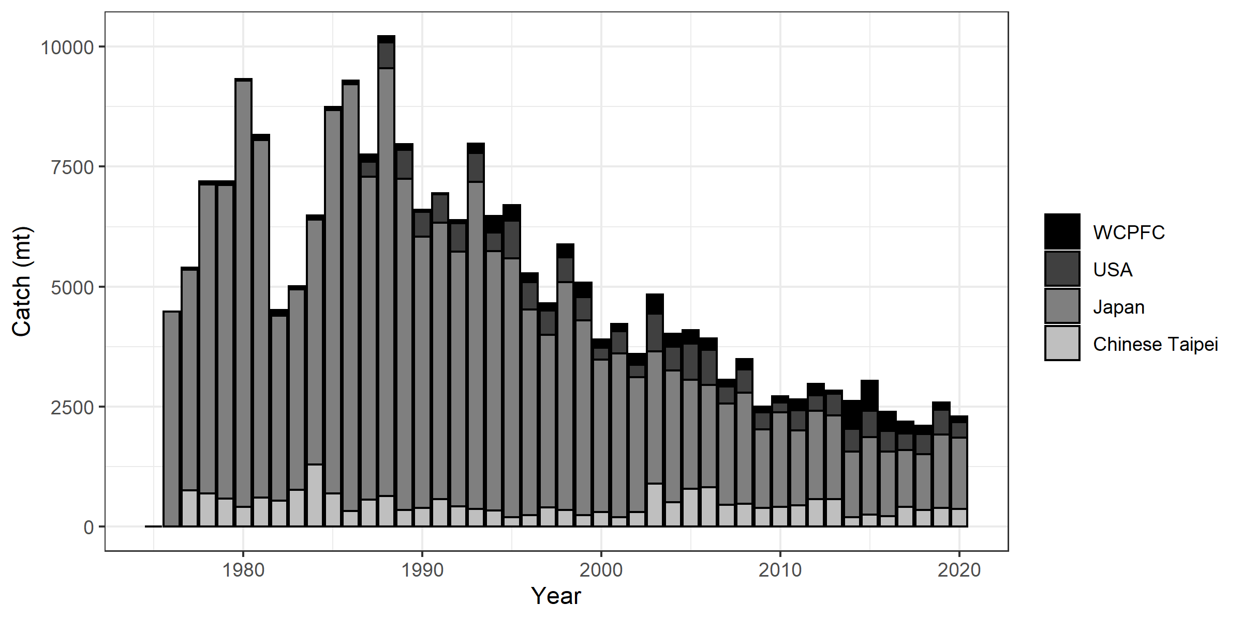
Figure WCNPOMLS-1. Annual catch biomass (mt) of Western and Central North Pacific striped marlin (Kajikia audax) by country for Japan, Chinese Taipei, the U.S.A., and all other countries during 1977-2020 (Figure S1 from SC19-SA-WP-11).

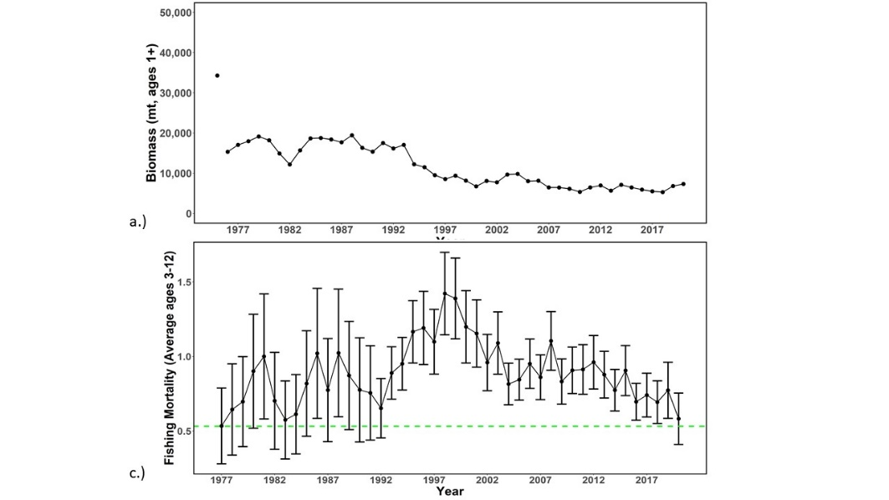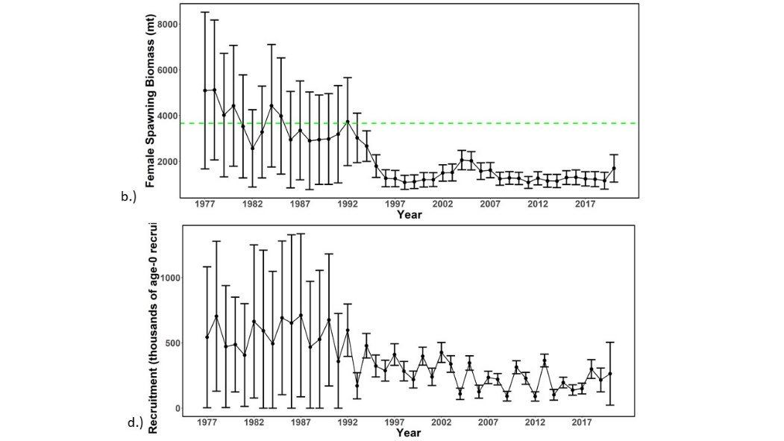

Figure WCNPOMLS-2. Time series of estimates of (a) population biomass (age 1+), (b) spawning biomass, (c) instantaneous fishing mortality (average for age 3-12, year⁻¹), and (d) recruitment (age-0 fish) for Western and Central North Pacific striped marlin (Kajikia audax) derived from the 2023 stock assessment. The circles represent the maximum likelihood estimates by year for each quantity and the error bars represent the uncertainty of the estimates (95% confidence intervals), green dashed lines indicate the dynamic 20%SSB_{F=0} and F_{20%SSBF=0} reference point (Figure S2 from SC19-SA-WP-11).

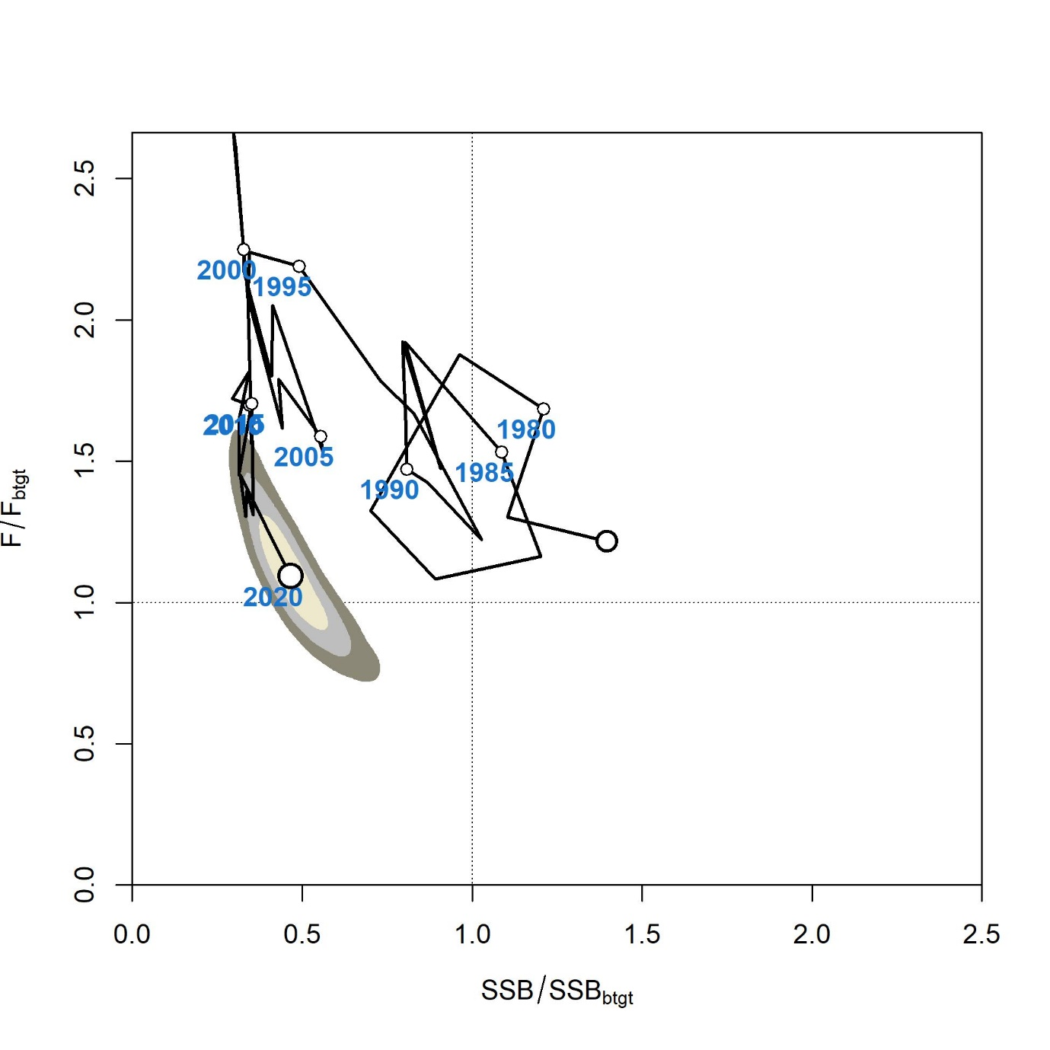

Figure WCNPOMLS-3. Majuro plot of the time series of estimates of relative fishing mortality (average of age 3-12) and relative spawning stock biomass of Western and Central North Pacific striped marlin (Kajikia audax) during 1977-2020. F_{btgt} and SSB_{btgt} refer to F_{20%SSBF=0} and 20%SSB_{F=0}, respectively. The large, un-labeled open circle indicates 1977, subsequent open circles are in 5-year increments. Shading indicates 50%, 80%, and 95% confidence intervals, respectively (Figure S3 from SC19-SA-WP-11).

a.)
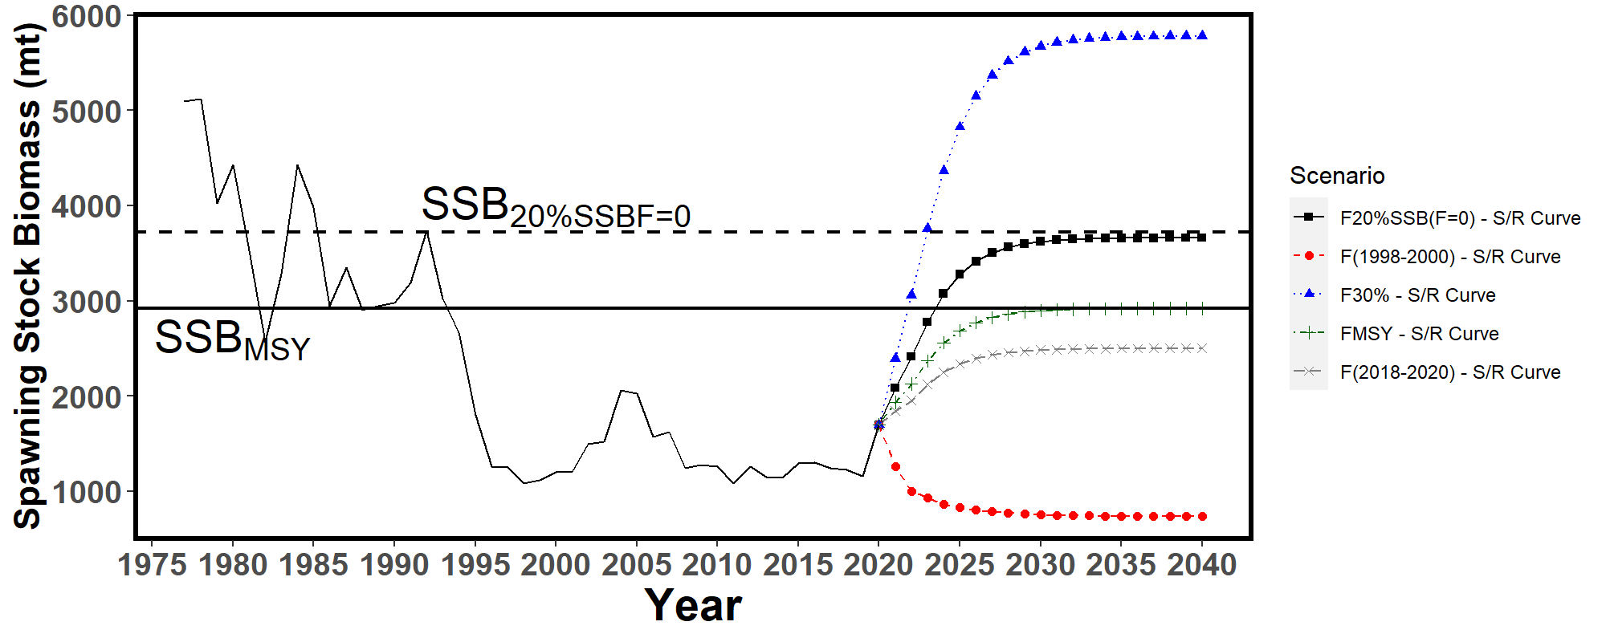
b.)
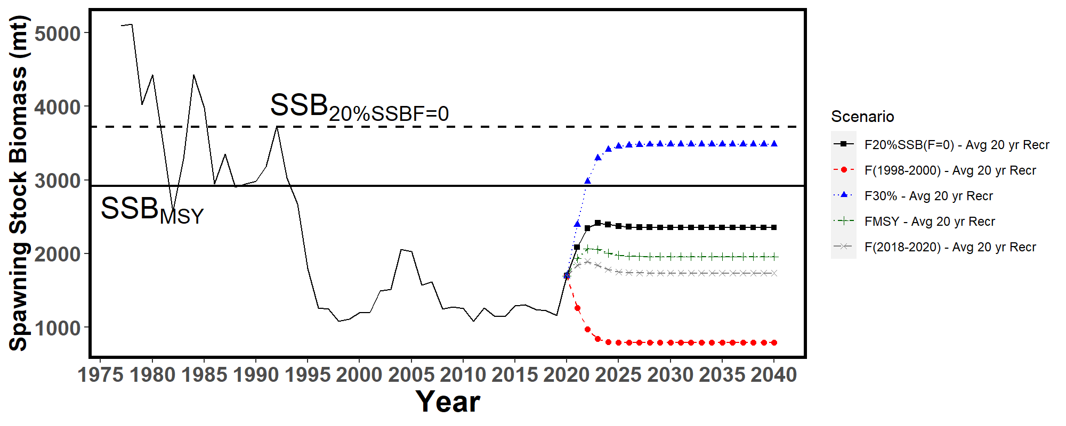
c.)
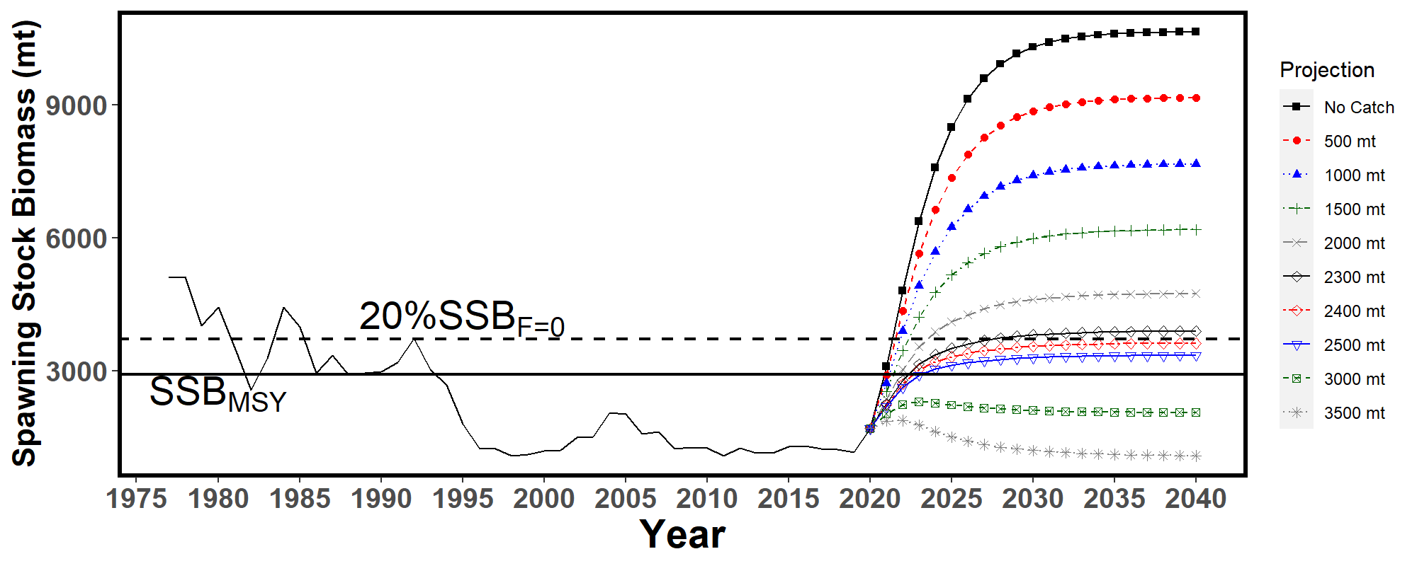
Figure WCNPOMLS-4. Historical and projected trajectories of spawning biomass from the Western and Central North Pacific striped marlin base case model based upon F scenarios: (a) F scenarios projected spawning biomass using recruitment estimated from the stock-recruitment curve; (b) F scenarios projected spawning biomass using average recruitment from 2001-2020. (c) Catch scenarios projected spawning biomass using average recruitment from 2001-2020. Dashed line indicates the spawning stock biomass at the dynamic 20%SSB_{F=0} reference point. Solid line indicates the spawning stock biomass at SSB_{MSY}. The list of projection scenarios can be found in SC19-SA-WP-11 Tables S3 and S4 (Figure S4 from SC19-SA-WP-11).

a.)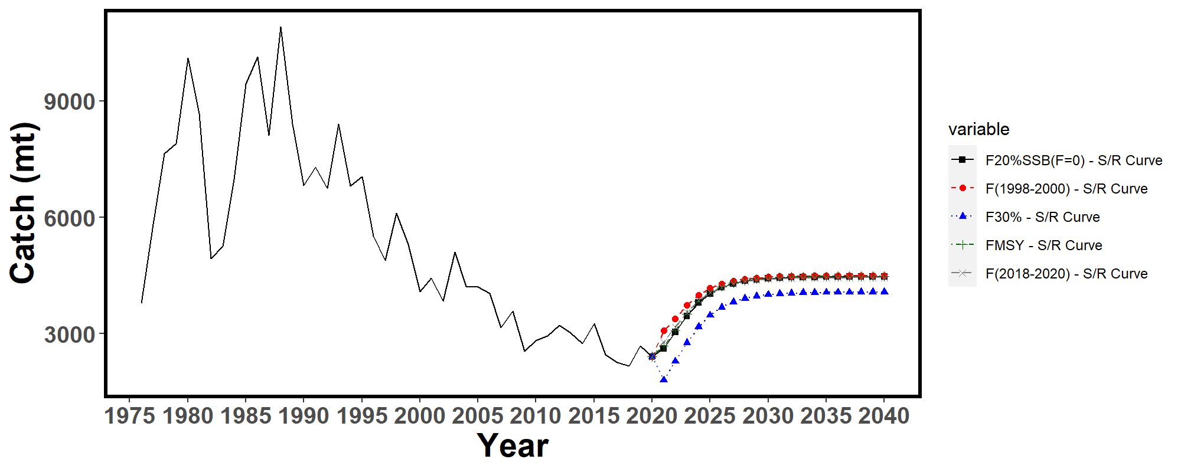
b.)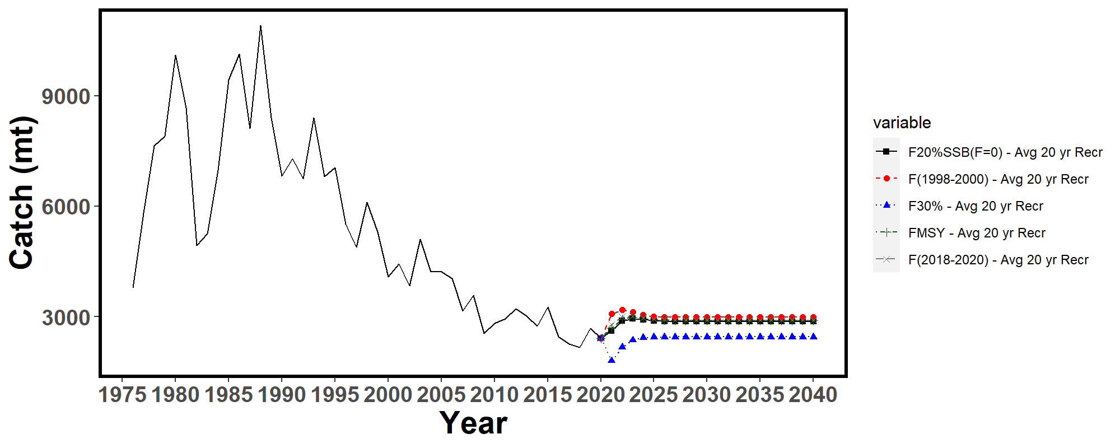
Figure WCNPOMLS-5. Historical and projected trajectories of catch from the Western and Central North Pacific striped marlin base case model based upon F scenarios: (a) F scenarios projected catch using recruitment estimated from the stock-recruitment curve; (b) F scenarios projected catch using recruitment estimated from 2001-2020 average. The list of projection scenarios can be found in SC19-SA-WP-11 Table S3 (Figure S5 from SC19-SA-WP-11).

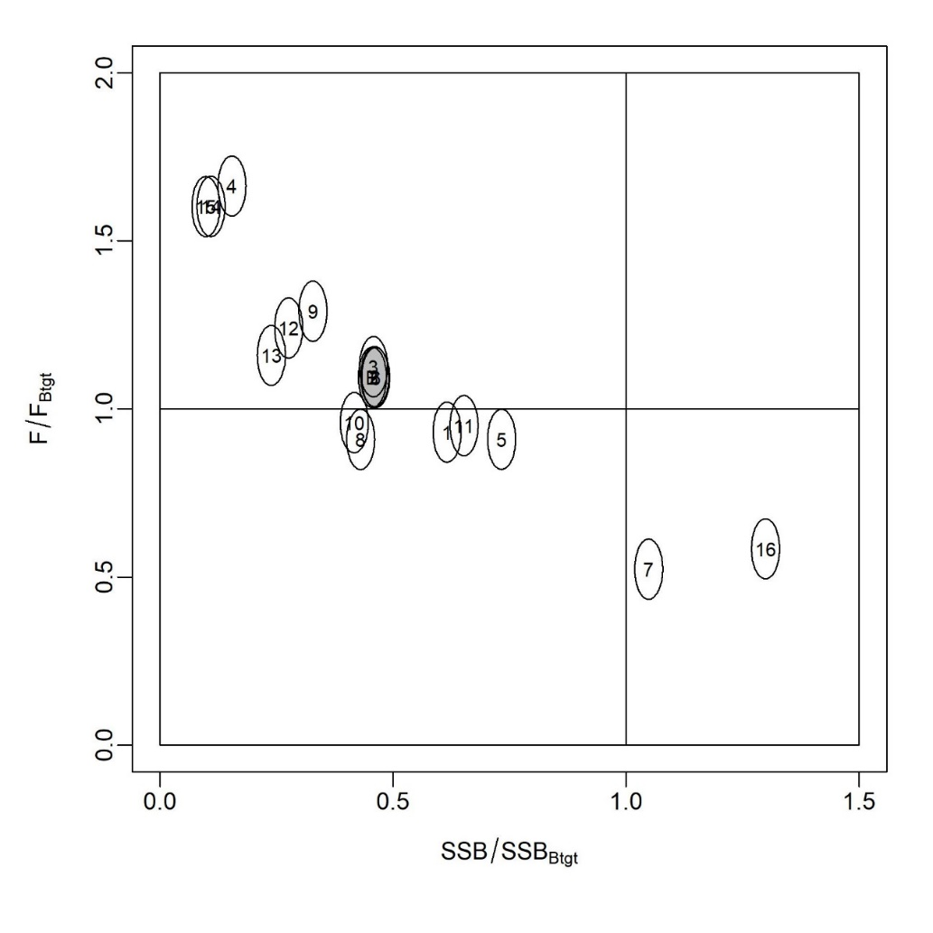
Figure WCNPOMLS-6. Majuro plot showing the terminal year stock status for the base-case model (gray circle, B) and the 16 sensitivity runs used to evaluate the sensitivity of the model to various model assumptions (circled numbers, circles are used as a visual aid). Models 12, 13, 15, and 16 are all sensitivity runs on assumptions on growth. See SC19-SA-WP-11 Table 12 in the stock assessment report for the full list and description of the sensitivity runs (Figure S6 from SC19-SA-WP-11).

SC18 2022 (STOCK ASSESSMENT CONDUCTED)

- SC18 reviewed SC18-SA-WP-07 (Modelling improvements for the Western and Central north Pacific Ocean striped marlin (Kajikia audax) to be implemented in the benchmark stock assessment in 2023).

  - Status and trends

- The SC18 concurred with the ISC22 Plenary, which reviewed new modelling and data improvements for the Western and Central North Pacific Ocean striped marlin (WCNPO MLS) stock and concluded that this report is a work in progress, but new stock status and conservation and management advice was not available. SC18 stated it looks forward to the ISC BILLWG workplan to explore the growth curve and complete a benchmark WCNPO MLS assessment for approval at ISC23.

  - Management advice and implications

- SC18 agreed that the Conservation and Management advice for North Pacific striped marlin will be carried forward from 2019.

SC16 2020 - SC17 2021 (NO STOCK ASSESSMENT)

There were no stock assessments conducted for North Pacific striped marlin in 2020 - 2021. SC16 and SC17 did not discuss this in its abbreviated agenda due to the virtual nature of the meeting under the COVID-19 pandemic situation. Therefore, the stock status descriptions from SC15 are still current for North Pacific striped marlin. For further information on the stock status and trends from SC15, please see SC15-SA-WP-09 or https://meetings.wcpfc.int/node/11225.

SC15 2019 (STOCK ASSESSMENT CONDUCTED)

- Stock Status and trends

- SC15 noted that ISC provided the following conclusions on the stock status of Western and Central North Pacific striped marlin:

Estimates of population biomass of the Western and Central North Pacific Ocean (WCNPO) striped marlin fluctuated without trend between 1975 and 1993. The population deceased substantially in 1994 and fluctuated without trend until the present year. Population biomass (age-1 and older) averaged roughly 17,969 mt, or 54% below unfished biomass during the 1975-1993 period and declined to 4,508 mt, or 89% below unfished biomass by 2008. The minimum spawning stock biomass was estimated to be 618 t in 2011 (76% below SSB_{MSY}, the spawning stock biomass to produce MSY, Figure NMLS-1a). In 2017, SSB = 981 t and SSB/SSB_{MSY} = 0.38. Fishing mortality on the stock (average F on ages 3-12) has been around F_{MSY} since 2014 (Figure NMLS-1b). It averaged roughly 0.64 yr-1 during 2015-2017, or 7% above F_{MSY} and in 2017, F=0.80 yr-1 with a relative fishing mortality of F/F_{MSY} = 1.33 (Table NMLS-02). Fishing mortality has been above FMSY in every year except 1984, 1992, and 2016. The predicted value of the spawning potential ratio (SPR, the predicted spawning output at current F as a fraction of unfished spawning output) is estimated to be SPR₂₀₁₅₋₂₀₁₇ = 17% and is approximately equal to the SPR required to produce MSY. Recruitment averaged about 263,000 age-0 recruits between 1994 and 2017, which was 34% below the 1975-2017 average. No target or limit reference points have been established for the WCNPO striped marlin stock under the auspices of the WCPFC. Despite the relatively large L50/Linf ratio for WCNPO striped marlin, the stock is expected to be highly productive due to its rapid growth and high resilience to reductions in spawning potential. Recent recruitments have been lower than expected and have been below the long-term trend since 2005. Although fishing mortality has decreased since 2000, due to the prolonged low recruitment and landings of immature fish, the biomass of the stock has remained below MSY. When the status of WCNPO striped marlin is evaluated relative to MSY-based reference points, the 2017 spawning stock biomass of 981 mt is 62% below SSB_{MSY}(2,604 t) and the 2015-2017 fishing mortality exceeds F_{MSY} by 7%. Therefore, relative to MSY-based reference points, overfishing is occurring and the WCNPO striped marlin stock is overfished (Figure NMLS-02).

Biological reference points were computed for the base case model with Stock Synthesis (Table NMLS-01 and Table NMLS-02). The point estimate of maximum sustainable yield (MSY) was 4,946 t. The point estimate of the spawning biomass to produce MSY (adult female biomass, SSB_{MSY}) was 2,604 t. The point estimate of F_{MSY}, the fishing mortality rate to produce MSY (average fishing mortality on ages 3 – 12) was 0.60 and the corresponding equilibrium value of spawning potential ratio at MSY was SPR_{MSY} = 18%.

Stock projections for WCNPO striped marlin were conducted using the age-structured projection model software AGEPRO. Stochastic projections were conducted using results from the base case model to evaluate the probable impacts of alternative fishing intensities or constant catch quotas on future spawning stock biomass and yield for striped marlin in the WCNPO. For fishing mortality projections, a standard set of F-based projections were conducted. For catch quota projections, the set of rebuilding projection analyses requested by NC14 were conducted. Two future recruitment scenarios were evaluated (Figure 3 and Figure 4): (1) a short-term recruitment scenario based on resampling the empirical cumulative distribution function of recruitment observed during 2012-2016 and (2) a long-term recruitment scenario based on resampling the empirical cumulative distribution function of recruitment observed during 1975- 2016. The short-term recruitment scenario had an average recruitment of 134,020 age-0 fish and the long-term recruitment mean was 306,989 age-0 fish. The stochastic projections employed model estimates of the multi-fleet, multi-season, size- and age-selectivity, and structural complexity in the assessment model to produce consistent results. Fishing mortality-based projections started in 2018 and continued through 2037 under five levels of fishing mortality and the two recruitment scenarios. The five fishing mortality stock projection scenarios were: 1) F status quo (average F during 2015-2017), 2) F_{MSY}, 3) F at 0.2·SSB₀, 4) F_{High} at the highest 3-year average during 1975-2017, and 5) F_{Low} at F_{30%.} For the F-based scenarios, fishing mortality in 2018-2019 was set to be F status quo (0.64) and fishing mortality during 2020-2037 was set to the projected level of F. Catch-based projections also ran from 2018 to 2037 and included seven levels of constant catch for the long-term recruitment scenario and 10 levels of catch for the short-term recruitment scenario. For the catch-based scenarios, catch biomass in 2018-2019 was set to be the status quo catch during 2015-2017 (2,151 t) and annual catches during 2020-2037 were set to the projected catch quota. The ten constant catch stock projection scenarios were: 1) Quota based upon WCPFC CMM10-01, 2) 90% of the quota, 3) 80% of the quota, 4) 70% of the quota, 5) 60% of the quota, 6) 50% of the quota, 7) 40% of the quota, 8) 30% of the quota, 9) 20% of the quota, and 10) 10% of the quota. Results show the projected female spawning stock biomasses and the catch biomasses under each of the scenarios (Table NMLS-03, Figure NMLS-03 and Figure NMLS-04).

- SC15 noted the following stock status from ISC:

Biomass (age 1 and older) for the WCNPO striped marlin stock decreased from 17,000 t in 1975 to 6,000 t in 2017. Estimated fishing mortality averaged F=0.97 yr-1 during the 1975-1994 period with a range of 0.60 to 1.59 yr-1, peaked at F=1.71 year-1 in 2001, and declined sharply to F=0.64 yr-1 in the most recent years (2015-2017). Fishing mortality has fluctuated around F_{MSY} since 2013. Compared to MSY-based reference points, the current spawning biomass (average for 2015- 2017) was 76% below SSB_{MSY} and the current fishing mortality (average for ages 3 – 12 in 2015-2017) was 7% above F_{MSY}.

Based on these findings, the following information on the status of the WCNPO striped marlin stock is provided:
- There are no established reference points for WCNPO striped marlin;
- Results from the base case assessment model show that under current conditions the WCNPO striped marlin stock is overfished and is subject to overfishing relative to MSY- based reference points (Table NMLS-01, Table NMLS-02, and Figure NMLS-01).

- SC15 noted that the assessment results are sensitive to the growth assumption and the ISC billfish working group (hereafter, WG) chair noted that the WG will attempt to revise the growth curve at the next stock assessment.

- SC15 also highlighted the sharp decline in the stock biomass in the mid-1990s and recommends that ISC further investigate the reasons for this decline.

- Management advice and implications

- SC15 noted that some CCMs expressed concerns that based on the new assessment the WCNPO striped marlin stock was overfished and overfishing was occurring relative to MSY-based reference points.

- SC15 noted that while fishing mortality has declined since 2000 fishing mortality has generally remained above F_{MSY} since the introduction of CMM 2010-01 and the stock biomass continues to remain well below SB_{MSY} and the NC target, while noting that the assessment model overestimate biomass in the terminal years. This is despite the phased reduction of the total catch to 80% of the levels caught in 2000-2003 as prescribed in the CMM. SC15 recommends that WCPFC16 note that further reduction in catch will be required to rebuild the stock to MSY levels and the NC target.

- SC15 also noted that this stock does not have agreed upon limit reference points and measures on catch limits and reductions in fishing mortality to allow rebuilding of this stock.

- SC15 recommends that WCPFC16 consider identifying appropriate limit reference points for WCNPO striped marlin.

- SC15 recommends the WCPFC consider appropriate actions to ensure rebuilding this stock to the NC14 rebuilding target. SC15 noted that if lower than average recruitment persists over the near future the probability of rebuilding the stock would be low, noting that there has been a long-term decline in recruitment since the 1990s. Under the F_{MSY} scenario with short-term recruitment assumptions, the probability of achieving 20%SB₀ in 2027 is <0.5%.

- SC15 noted the following conservation advice from ISC:

The status of the WCNPO striped marlin stock shows evidence of substantial depletion of spawning potential (SSB2017 is 62% below SSBMSY), however fishing mortality has fluctuated around F_{MSY} in the last four years. The WCNPO striped marlin stock has produced average annual yields of around 2,100 t per year since 2012, or about 40% of the MSY catch amount. However, the majority of the catch are likely immature fish. All of the projections show an increasing trend in spawning stock biomass during the 2018-2020 period, with the exception of the high F scenario under the short-term recruitment scenario. This increasing trend in SSB is due to the 2017 year class, which is estimated from the stock-recruitment curve and is more than twice as large as recent average recruitment.

Based on these findings, the following conservation information is provided:
- Projection results under the long-term recruitment scenario show that the stock has at least a 60% probability of rebuilding to 20%SSB₀, the rebuilding target specified by NC14, by 2022 for all harvest scenarios, with the exception of the highest F scenario (Average F 1975-1977);
- However, if the stock continues to experience recruitment consistent with the short- term recruitment scenario (2012-2016), catches must be reduced to 60% of the WCPFC catch quota from CMM 2010-01 (3,397 t) to 1,359 t in order to achieve a 60% probability of rebuilding to 20%SSB₀=3,610 t by 2022. This corresponds to a reduction of roughly 37% from the recent average yield of 2,151 t;
- For the constant catch projection scenarios that were tested, it was notable that all of the projections under the long-term recruitment scenario would be expected to achieve the spawning biomass target by 2020 with probabilities ranging from 61% to 73% and corresponding catch quotas ranging from 3,397 to 1,359 t (Table NMLS-03).

It was also noted that retrospective analyses show that the assessment model appears to overestimate spawning potential in recent years, which may mean the projection results are ecologically optimistic.

Special Comments

The WG achieved a base-case model using the best available data and biological information. However, the WG recognized uncertainty in some assessment inputs including drift gillnet catches and initial catch amounts, life history parameters such as maturation and growth, and stock structure.

Overall, the base case model diagnostics and sensitivity runs show that there are some conflicts in the data (ISC/19/ANNEX/11). When developing a conservation and management measure to rebuild the resource, it is recommended that these issues be recognized and carefully considered, because they affect the perceived stock status and the probabilities and time frame for rebuilding of the WCNPO striped marlin stock.

Research Needs

To improve the stock assessment, the WG recommends continuing model development work, to reduce data conflicts and modeling uncertainties, and reevaluating and improving input assessment data.

Existing genetic studies suggest regional spawning subgroups of striped marlin throughout the entire Pacific. More research is needed to improve upon knowledge of regional stock structure and regional mixing for incorporation into the stock assessment.

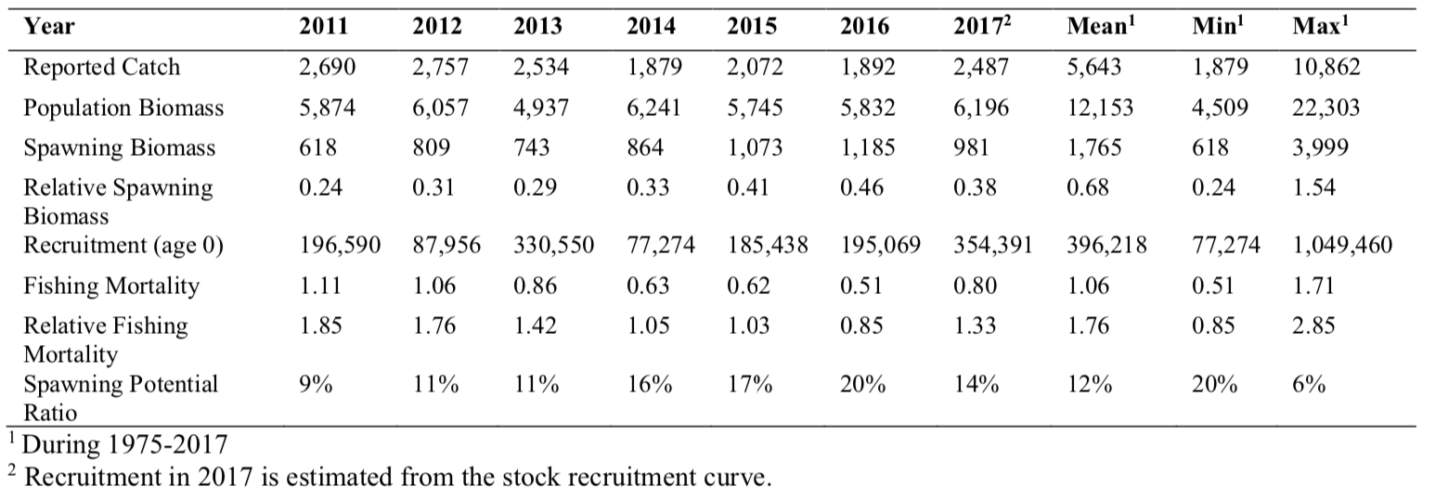
Table NMLS-01. Reported catch (t) used in the stock assessment along with annual estimates of population biomass (age-1 and older, t), female spawning biomass (t), relative female spawning biomass (SSB/SSB_{MSY}), recruitment (thousands of age-0 fish), fishing mortality (average F, ages-3 – 12), relative fishing mortality (F/F_{MSY}), and spawning potential ratio of WCNPO striped marlin.

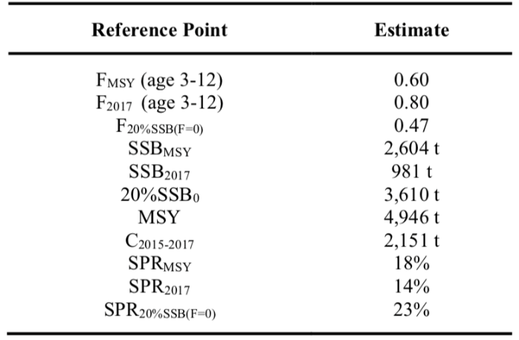
Table NMLS-02. Estimates of biological reference points along with estimates of fishing mortality (F), spawning stock biomass (SSB), recent average yield (C), and spawning potential ratio (SPR) of WCNPO MLS, derived from the base case model assessment model, where “MSY” indicates reference points based on maximum sustainable yield.

Table NMLS-03. Projected median values of WCNPO striped marlin spawning stock biomass (SSB, t), catch (t), and probability of reaching 20%SSB0 under five constant fishing mortality rate (F) and ten constant catch scenarios during 2018-2037. For scenarios which have a 60% probability of reaching the target of 20%SSB_{F=0}, the year in which this occurs is provided; NA indicates projections that did not meet this criterion. Note that 20%SSB_{F=0} is 3,610 t and SSB_{MSY} is 2,604 t.
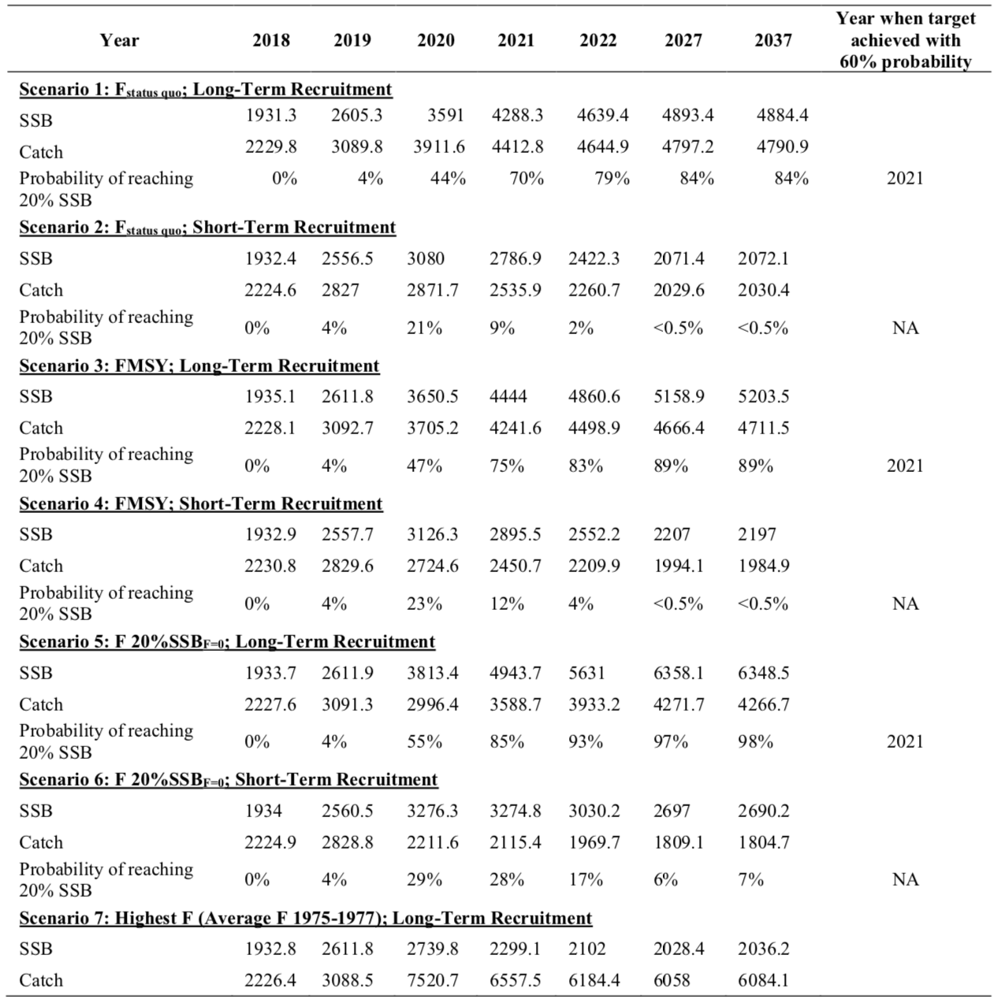
Table NMLS-03. (Continued)
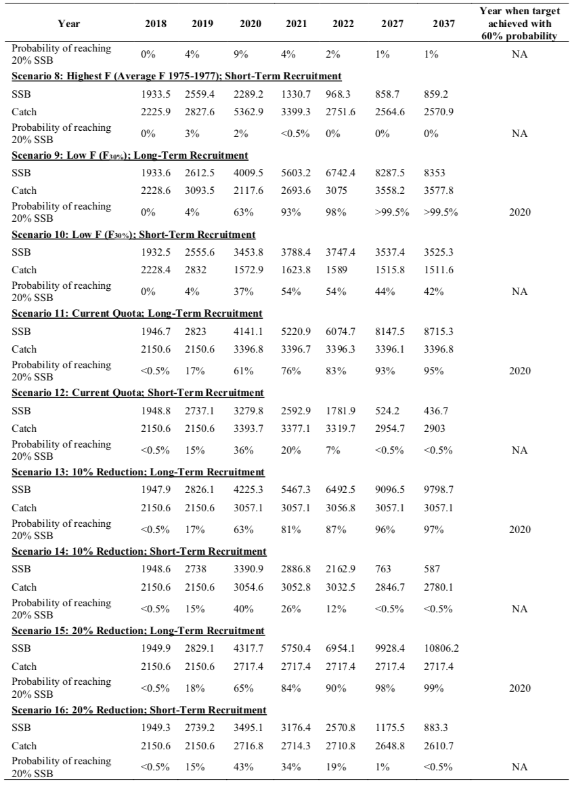

Table NMLS-03. (Continued)
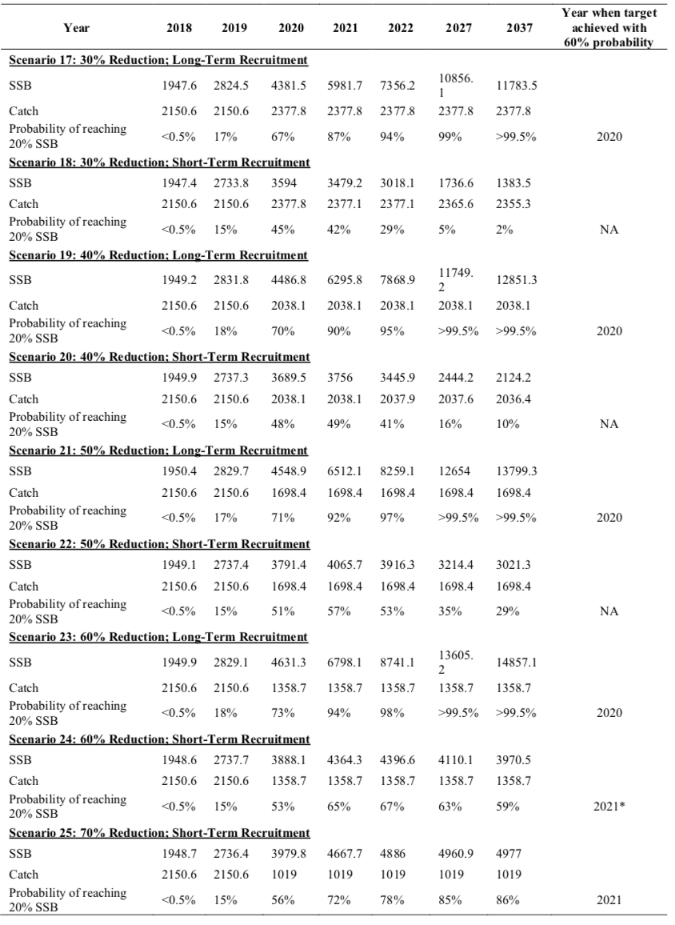

Table NMLS-03. (Continued)
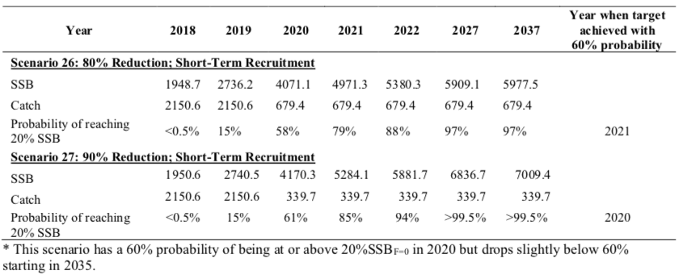

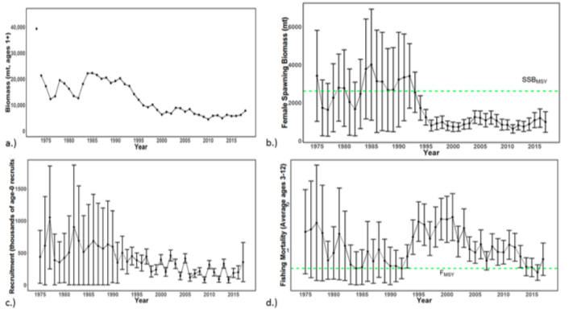 | 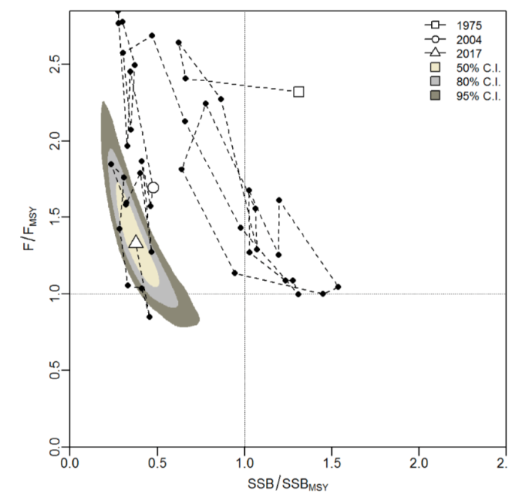
Figure NMLS-01. Time series of estimates of (a) population biomass (age 1+), (b) spawning biomass, (c) recruitment (age-0 fish), and (d) instantaneous fishing mortality (average for age 3-12, year-1) for WCNPO striped marlin (derived from the 2019 stock assessment. The circles represent the maximum likelihood estimates by year for each quantity and the error bars represent the uncertainty of the estimates (95% confidence intervals), green dashed lines indicate SSB_{MSY} and F_{MSY}. | Figure NMLS-02. Kobe plot of the time series of estimates of relative fishing mortality (average of age 3-12) and relative spawning stock biomass of WCNPO striped marlin during 1975-2017. The white square denotes the first year (1975) of the assessment, the white circle denotes 2004, and the white triangle denotes the last year (2017) of the assessment.
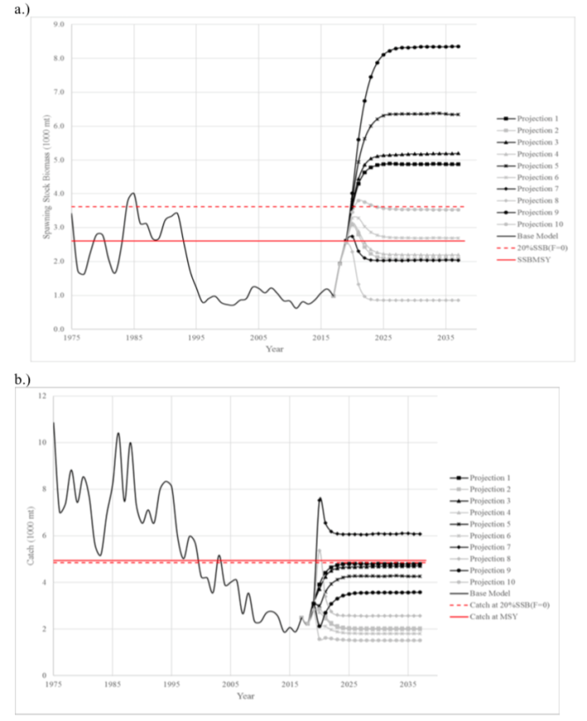 | 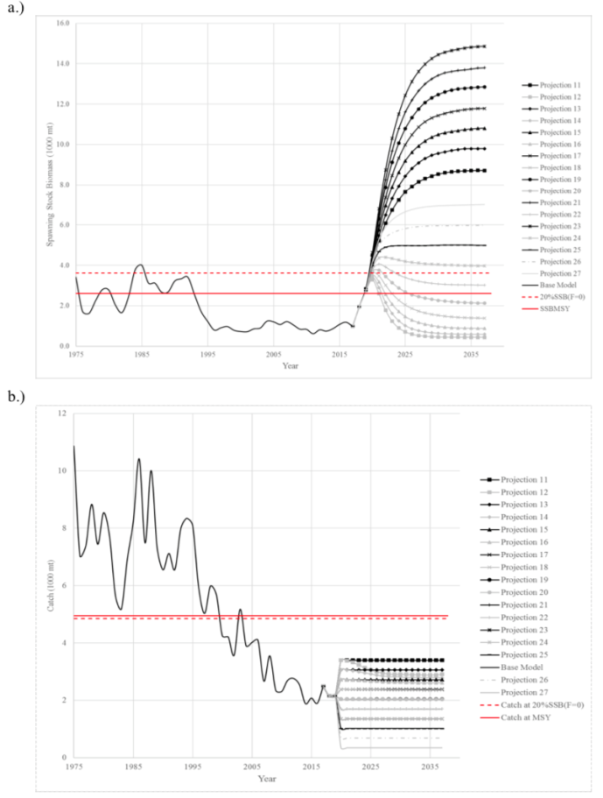
Figure NMLS-03. Historical and projected trajectories of spawning biomass and total catch from the WCNPO striped marlin base case model based upon F scenarios (projection 1-10): (a) projected spawning biomass and (b) projected catch. | Figure NMLS-04. Historical and projected trajectories of spawning biomass and total catch from the WCNPO striped marlin base case model based upon constant catch scenarios (projections 11-15): (a) projected spawning biomass; and (b) projected catch.

Note on Figure NMLS-3 and Figure NMLS-4: Black lines are the long-term recruitment scenario results; grey lines show the short-term recruitment scenario results. The red dashed line shows the catch or spawning stock biomass at 20%SSB_{F=0} and the solid red line is the catch or spawning stock biomass at SSB_{MSY}. The list of projection scenarios can be found in Table NMLS-03.

SC14 2018 (NO STOCK ASSESSMENT)

  - Stock status and trends

- SC14 noted that no stock assessments were conducted for North Pacific striped marlin in 2018. Therefore, the stock status descriptions from SC11 are still current for North Pacific striped marlin. Updated information on catches was not compiled for and reviewed by SC14.

- To emphasize the importance of developing a stock rebuilding plan for North Pacific striped marlin, SC14 reiterated the ISC15 stock status information, excerpted from SC11:

“Estimates of population biomass of the Western and Central North Pacific (WCNPO) striped marlin stock (Kajikia audax) exhibit a long-term decline (Table 1). Population biomass (age-1 and older) averaged roughly 20,513 mt, or 46% of unfished biomass during 1975-1979, the first 5 years of the assessment time frame, and declined to 6,819 mt, or 15% of unfished biomass in 2013. Spawning stock biomass is estimated to be 1,094 mt in 2013 (39% of SSBMSY, the spawning stock biomass to produce MSY). Fishing mortality on the stock (average F on ages 3 and older) is currently high and averaged roughly F =0.94 during 2010-2012, or 49% above FMSY. The predicted value of the spawning potential ratio (SPR, the predicted spawning output at current F as a fraction of unfished spawning output) is currently SPR2010-2012 = 12% which is 33% below the level of SPR required to produce MSY. Recruitment averaged about 308 thousand recruits during 1994-2011, which was 25% below the 1975-2013 average. No target or limit reference points have been established for the WCNPO striped marlin stock under the auspices of the WCPFC.

The WCNPO striped marlin stock is expected to be highly productive due to its rapid growth and high resilience to reductions in spawning potential. The status of the stock is highly dependent on the magnitude of recruitment, which has been below its long-term average since 2007, with the exception of 2010 (Table S1). Changes in recent size composition data in comparison to the previous assessment resulted in changes in fishery selectivity estimates and also affected recruitment estimates. This, in turn, affected the scaling of biomass and fishing mortality to reference levels.

Table S1: Reported annual values of catch (mt), poulation biomass (mt), spawning stock biomass (mt), relative spawning stock biomass SSB/SSBMSY), recruitment (000s), fishing mortality, relative fishing mortality (F/FMSY), exploitation rate, and spawning potential ration for the WCNPO striped marlin stock.
Year | 2007 | 2008 | 2009 | 2010 | 2011 | 2012 | 2013 | Mean1 | Min1 | Max1
Reported Catch | 3084 | 3503 | 2468 | 2852 | 3125 | 3521 | 2984 | 5822 | 2468 | 10594
Population Biomass | 6915 | 6773 | 6409 | 5156 | 7823 | 7349 | 6819 | 12758 | 5156 | 28440
Spawning Stock Biomass | 1192 | 1171 | 970 | 984 | 873 | 1013 | 1094 | 2025 | 815 | 6946
Relative Spawning Biomass | 0.42 | 0.42 | 0.34 | 0.35 | 0.31 | 0.36 | 0.39 | 0.75 | 0.29 | 2.46
Recruitment (age 0) | 240 | 242 | 63 | 496 | 155 | 224 | 352 | 410 | 63 | 1369
Fishing Mortality | 0.82 | 0.99 | 0.80 | 0.96 | 0.89 | 0.97 | 0.76 | 0.95 | 0.47 | 1.54
Relative Fishing Mortality | 1.29 | 1.57 | 1.27 | 1.51 | 1.41 | 1.53 | 1.20 | 1.50 | 0.74 | 2.44
Exploitation Rate | 45% | 52% | 39% | 55% | 40% | 48% | 44% | 48% | 32% | 65%
Spawning Potential Ratio | 15% | 12% | 16% | 13% | 12% | 12% | 14% | 13% | 7% | 24%
1 During 1975-2013

When the status of striped marlin is evaluated relative to MSY-based reference points, the 2013 spawning stock biomass is 61% below SSB_{MSY} (2819 t) and the 2010-2012 fishing mortality exceeds F_{MSY} by 49%. Therefore, overfishing is occurring relative to MSY-based reference points and the WCNPO striped marlin stock is overfished.”

  - Management advice and implications

- SC14 noted that no management advice has been provided since SC11 for North Pacific striped marlin. Therefore, previous advice should be maintained, pending a new assessment or other new information. For further information on the management advice and implications from SC11, please see below.

- To emphasize the importance of developing a stock rebuilding plan for North Pacific striped marlin, SC14 reiterated the following management advice and information, excerpted from SC11.

“SC11 noted the following conservation advice from ISC:
The stock has been in an overfished condition since 1977, with the exception of 1982 and 1983, and fishing appears to be impeding rebuilding especially if recent low recruitment levels persist.

Projection results show that fishing at FMSY could lead to median spawning biomass increases of 25%, 55%, and 95% from 2015 to 2020 under the recent recruitment, medium- term recruitment, and stock recruitment-curve scenarios.

Fishing at a constant catch of 2,850 t could lead to potential increases in spawning biomass of 19% to over 191% by 2020, depending upon the recruitment scenario.

In comparison, fishing at the 2010-2012 fishing mortality rate, which is 49% above FMSY, could lead to changes in spawning stock biomass of -18% to +18% by 2020, while fishing at the average 2001-2003 fishing mortality rate (F2001-2003=1.15), which is 82% above FMSY, could lead to spawning stock biomass decreases of -32% to -9% by 2020, depending upon the recruitment scenario.

SC11 expressed concerns about the updated stock status of WCNPO striped marlin, noting that the stock was overfished (SSB2013 at 61% below SSBMSY) and that overfishing was occurring (F2010-2012 exceeds FMSY by 49%). Although a LRP for billfish species has not been adopted by the WCPFC, SC11 noted that SSBcurrent/SSBcurrent,F=0=0.12 and is below the LRP adopted for tunas. SC11 also noted that projections indicate that Prob(SSB2020>SSB2015)<50% for all constant catch scenarios over 2,850 mt (under the three recruitment hypotheses modelled), which means that in order to allow the spawning biomass to rebuild then catches need to be reduced to less than 2,850mt. SC11 recommends that the Commission develop a rebuilding plan for North Pacific striped marlin with subsequent revision of CMM 2010-01 in order to improve stock status.”

  - Recommendations on the designation of North Pacific striped marlin as a Northern Stock

- Regarding the issue of the designation of North Pacific striped marlin as a Northern Stock (WCPFC14 Report, Para 378), SC14 provides the following recommendations:
- SC14 recommends that the Commission clarify and quantify what is meant by “mostly north of 20 degrees N”.
- In relation to paragraph 1, SC14 recommends that a check-list of benchmark scientific information for North Pacific striped marlin be developed to support the Commission’s deliberations in determining the designation of a northern stock. As such, the following table is forwarded for the Commission’s consideration.
No | Criteria | Response | Comments
1 | What proportion of the total estimated stock biomass occurs on average north of 20N? | *Proportion of biomass above 20 ºN is 2-4 times larger than the proportion of biomass south of 20 ºN in the North Pacific | WCPFC-SC14-2018/ SA-IP-011 This value was estimated by stock assessment result in 2007.
2 | Does all of the breeding/spawning area(s) occur north of 20 ºN? | Unknown
3 | Does all of the nursery area(s) occur north of 20 ºN | Unknown
4 | Do any other important life history stages occur south of 20N? | Unknown
5 | What proportion of the total estimated catch occurs north of 20 ºN? | **Range of annual percentages of 66%-96% above 20 ºN. During the 2000s the average percentage was 73% above 20 ºN | WCPFC-SC14-2018/ SA-IP-011 These values were estimated from stock assessment results in 2007, but were not endorsed by SC3.
6 | Is fishery catch-per-unit-effort demonstrably higher north of 20 ºN for comparable fisheries? | Unknown
7 | Is there sufficient information about fish movement between north and south of 20 ºN? | No
*Proportion of biomass was calculated in 1964 and 1969 that is near the initial condition.
**The average proportion of the total catch in numbers were calculated by decade (1950's-2000's).

SC13 2017 (NO STOCK ASSESSMENT)

- Stock status and trends

- SC13 noted that no stock assessments were conducted for these species in 2017. Therefore, the stock status descriptions from SC11 for North Pacific striped marlin are still current. Updated information on North Pacific striped marlin catches may be available in the ISC Plenary Report, but was not compiled for and reviewed by SC13.

- Management advice and implications

- SC13 noted that no conservation advice has been provided since SC11 for North Pacific striped marlin. Therefore, previous advice should be maintained, pending a new assessment or other new information.

Useful References

SC15-SA-WP-09 Stock Assessment Report for Striped Marlin (Kajikia audax) in the Western and Central North Pacific Ocean through 2017. https://www.wcpfc.int/node/42926

SC11-SA-WP-10 Stock assessment update for striped marlin (Kajikia audax) in the western and central North Pacific Ocean through 2013. ISC Billfish Working Group (International Scientific Committee for Tuna and Tuna-like Species in the North Pacific Ocean)
https://www.wcpfc.int/node/21780

For current information related to Northern Stocks Working Group Reports and the ISC Plenary Report:
http://isc.fra.go.jp/reports/isc/isc17_reports.html

Previous Assessments

SC8-SA-WP-10 Stock Assessment of North Pacific Striped Marlin https://wcpfc.int/node/3281

The rebuilding target, 20% SSB0, is estimated from the stock recruitment curve.

