The Commission for the Conservation and Management of
Highly Migratory Fish Stocks in the Western and Central Pacific Ocean

Scientific Committee

Southwest Pacific Striped Marlin (Kajikia audax)

Stock Status and Management Advice

Contents
SC15 2019 (STOCK ASSESSMENT CONDUCTED) 2
SC9, 2013 – SC14, 2018 (NO STOCK ASSESSMENTS) 6
Useful References 8
Previous Assessments 8

SC15 2019 (STOCK ASSESSMENT CONDUCTED)

- Stock status and trends

- The description of the updated structural sensitivity grid used to characterize uncertainty in the assessment is provided in Table SMLS-01. The spatial structure used in the assessment model is shown in Figure SMLS-01, with sub-regions used to define fisheries shown. Catch trend data is presented in Figure SMLS-02. Estimated annual average recruitment, spawning biomass, and total biomass from the diagnostic case are shown in Figure SMLS-03. Fishing mortality and depletion estimated from the diagnostic case are shown in Figures SMLS-04 and SMLS-05, respectively. The median and 80 percent quantile trajectories of the fishing depletion for models in the structural uncertainty across the grid axes in Table SMLS-01 are shown in Figure SMLS-6.

- The Majuro plot summarizing the results for each of the models in the structural uncertainty grid retained for management advice are represented in Figure SMLS-07. Figure SMLS-08 presents the Kobe plot summarizing the results for each of the models in the structural uncertainty grid retained for management advice.

- SC15 noted that the median of recent spawning biomass depletion relative to the unfished condition was (SB_{recent}/SB_{F=0}) = 0.198, with a probable range of 0.093 to 0.464 (80% probable range), and there was a roughly 50.33% probability (151 out of 300 models) that the recent spawning biomass depletion relative to the unfished condition was below the LRP adopted for tunas (SB_{recent}/SB_{F=0} = 0.2). The median estimate (0.198) is below that estimated from the previous (2012) assessment (SB₂₀₀₆₋₂₀₀₉/SB_{F=0} = 0.34) (see SC8-SA-WP-05), noting the differences in the use of the grid in the two assessments and different model assumptions. In the current assessment the feasible grid consisted of 300 models (186 model runs removed from 486 grid models).

- SC15 noted that the median of recent spawning biomass relative to the spawning biomass at MSY was (SB_{recent}/SB_{MSY}) = 0.737 with a probable range of 0.334 to 1.635 (80% probable range), and there was a roughly 68.66% probability (206 out of 300 models) that the recent spawning biomass depletion was below the spawning biomass at MSY. The median estimate (0.737) is below that estimated from the previous (2012) assessment (SB_{current}/SB_{MSY} = 0.87) (see SC8-SA-WP-05), noting the differences between the two assessments.

- SC15 noted that the median of relative recent fishing mortality was (F_{recent}/F_{MSY} = 0.911) with an 80% probability interval of 0.313 to 1.891, and there was a roughly 44.3% probability (133 out of 300 models) that the recent fishing mortality was above F_{MSY}. The median estimate (0.911) is above that estimated from the previous assessment (F_{current}/F_{MSY} = 0.81) (see SC8-SA-WP-05), noting the differences in the use of the grid in the two assessments.

Table SMLS-01. Description of the structural sensitivity grid used to characterize uncertainty in the assessment. The star denotes the level assumed in the diagnostic case.
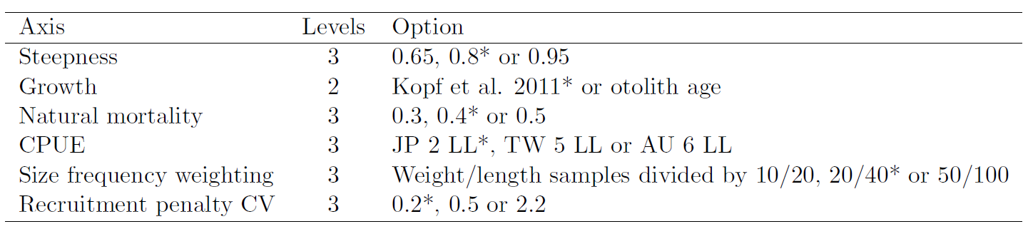

Table SMLS-02. Summary reference points over the models in the structural uncertainty grid.
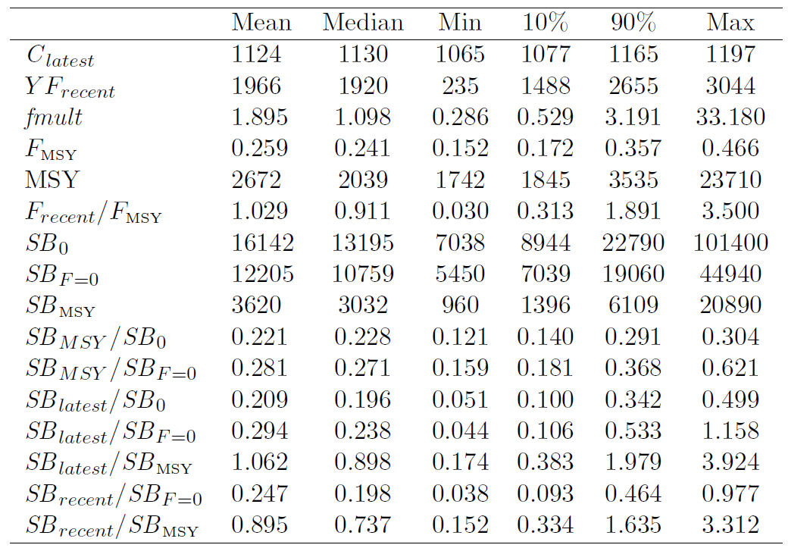

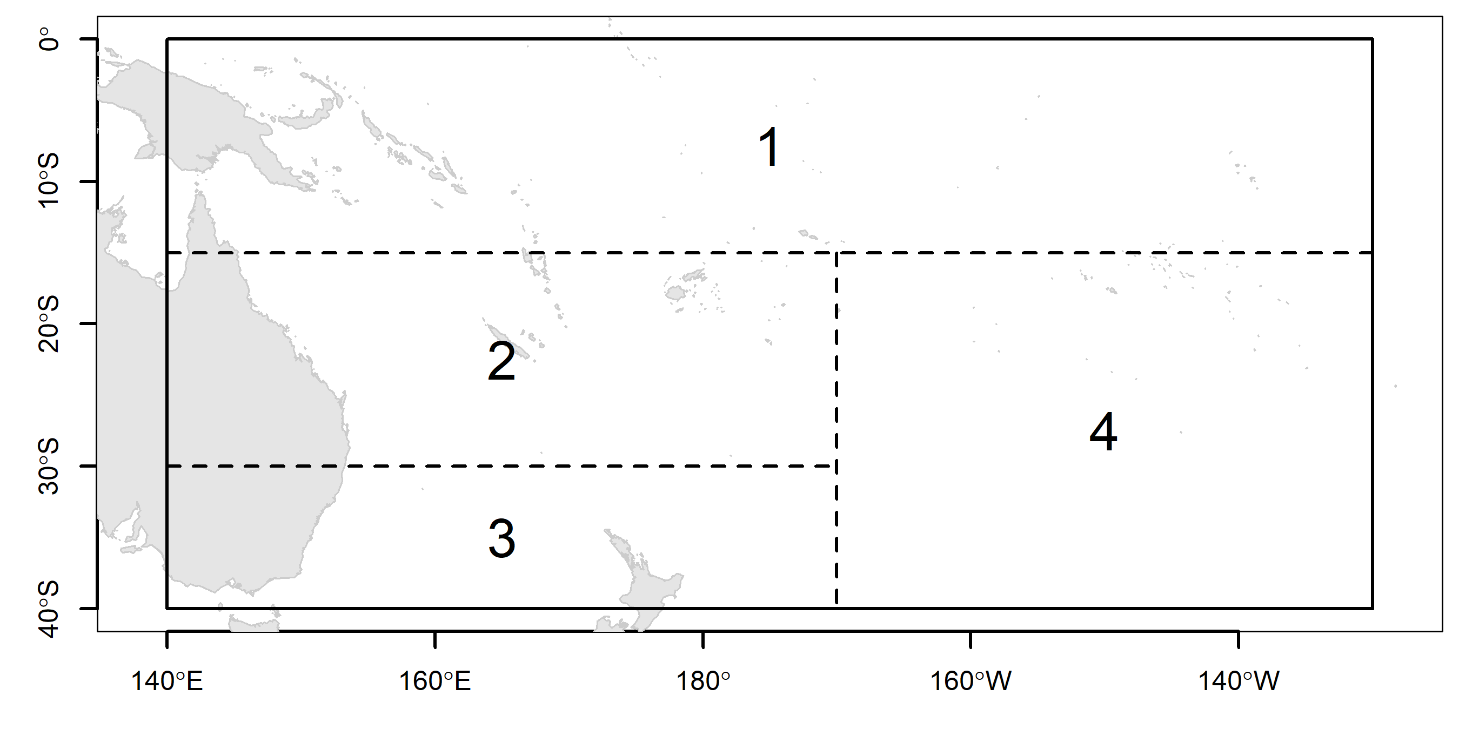 | 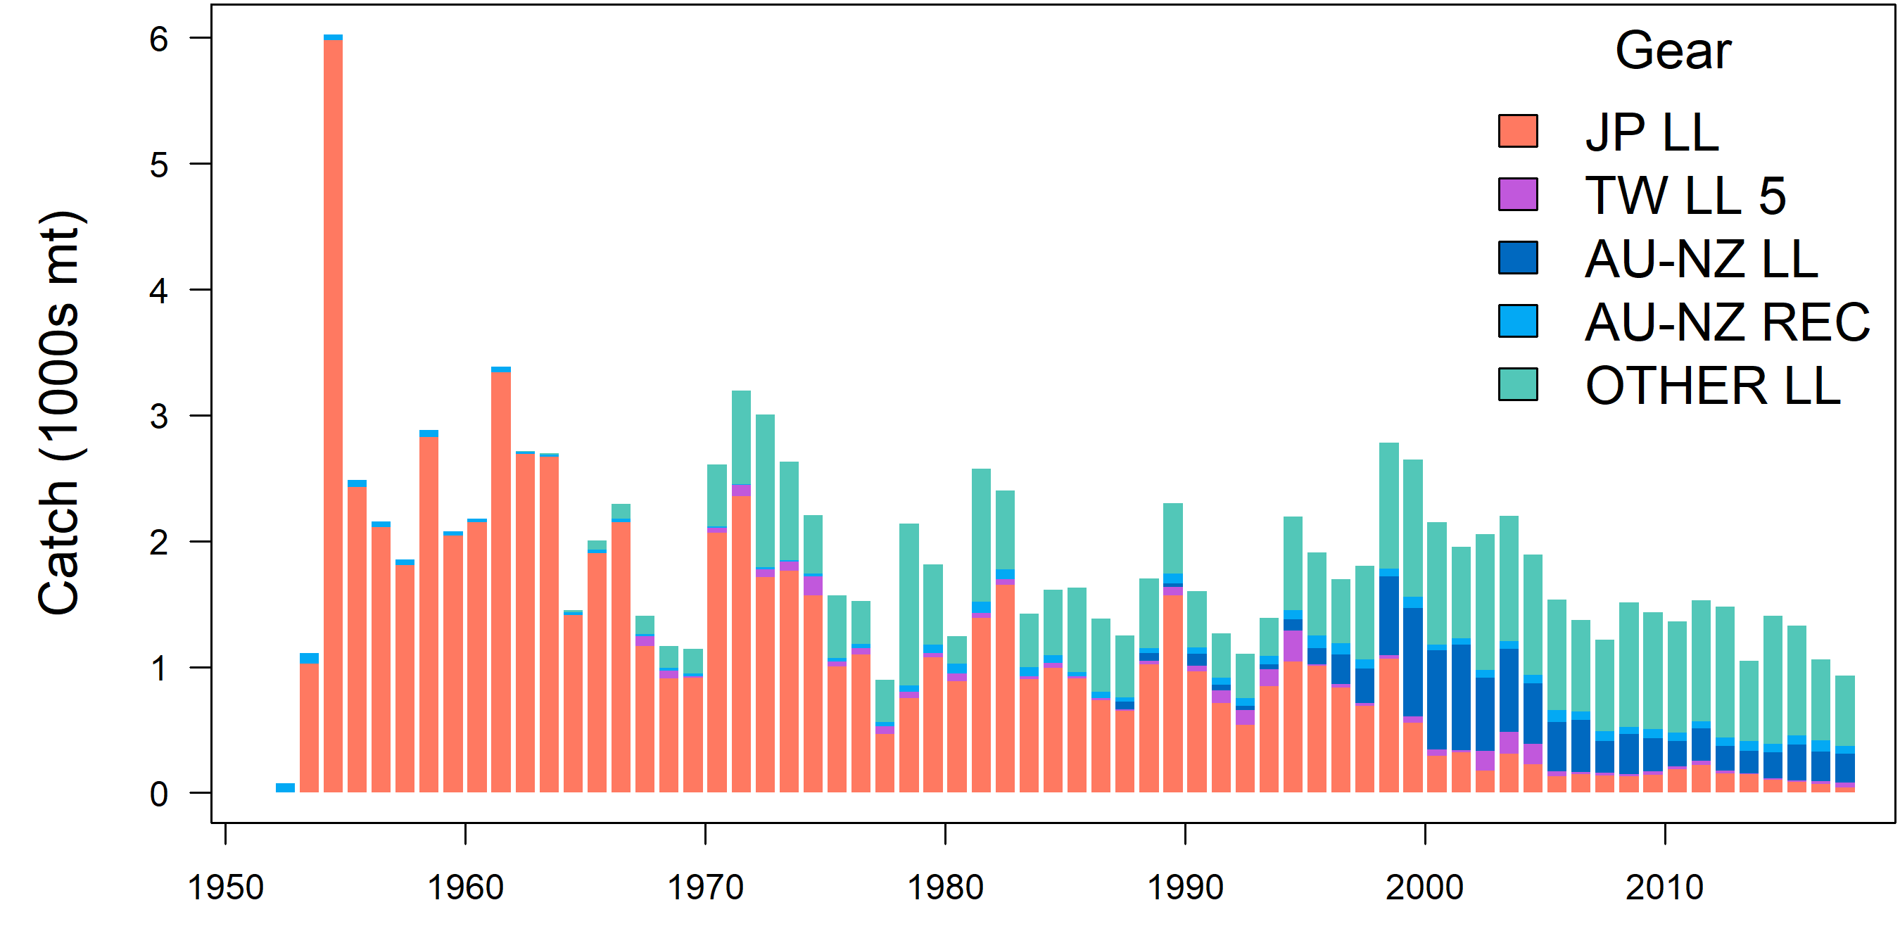
Figure SMLS-01. Single region spatial structure used in the 2019 stock assessment. | Figure SMLS-02. Time series of total annual catch (1000s mt) by fishery group over the full assessment period.
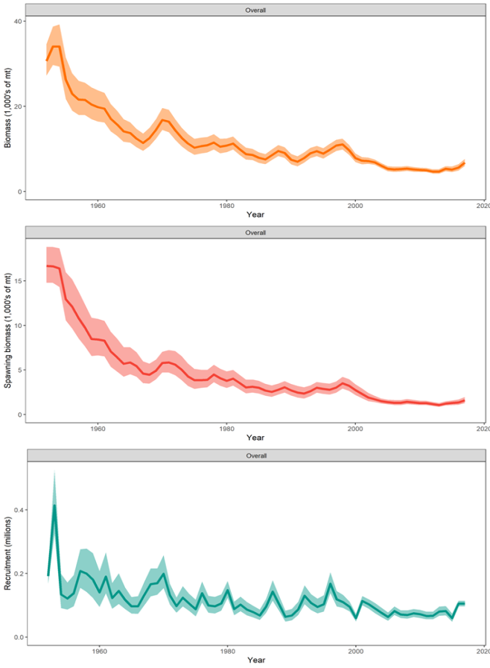 | Figure SMLS-03. Estimated annual average total biomass, spawning biomass, and recruitment for the diagnostic model. Shaded region gives ± 2 standard deviations (i.e., 95% CI).

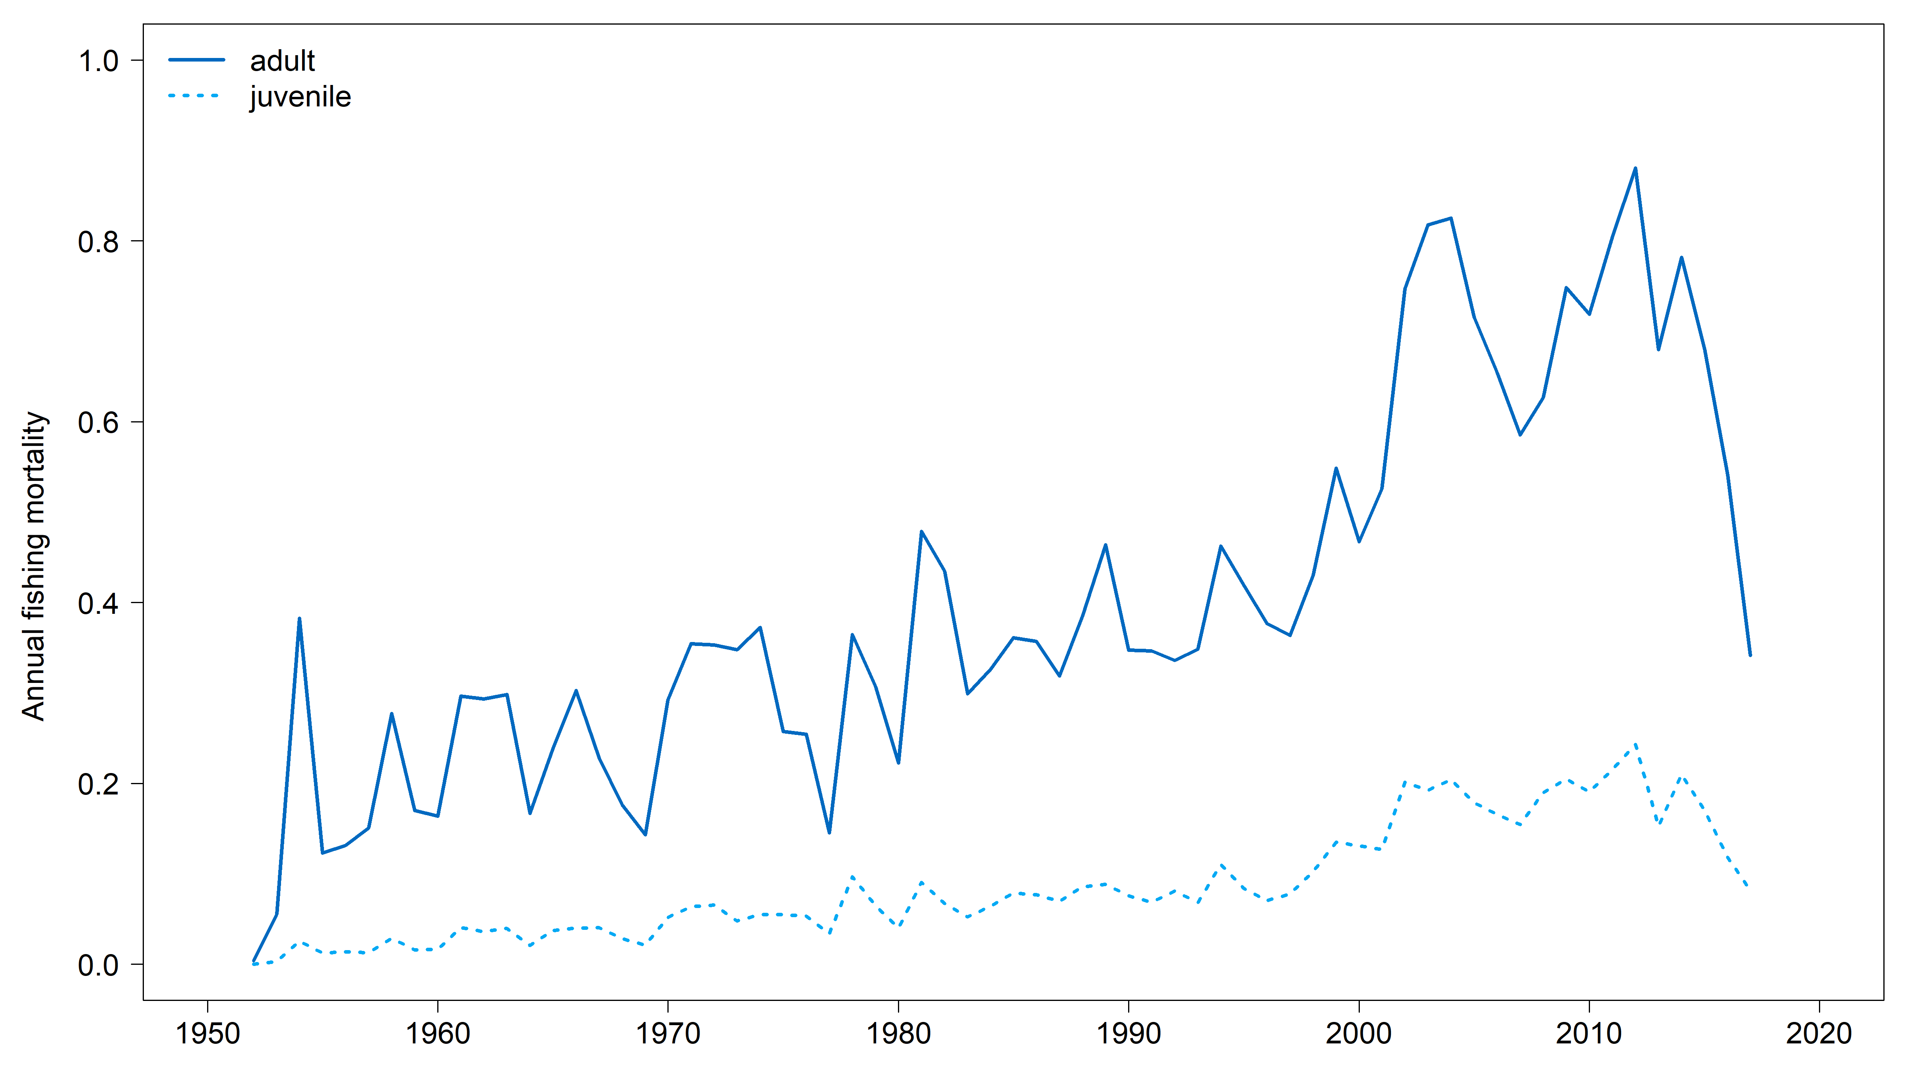 | 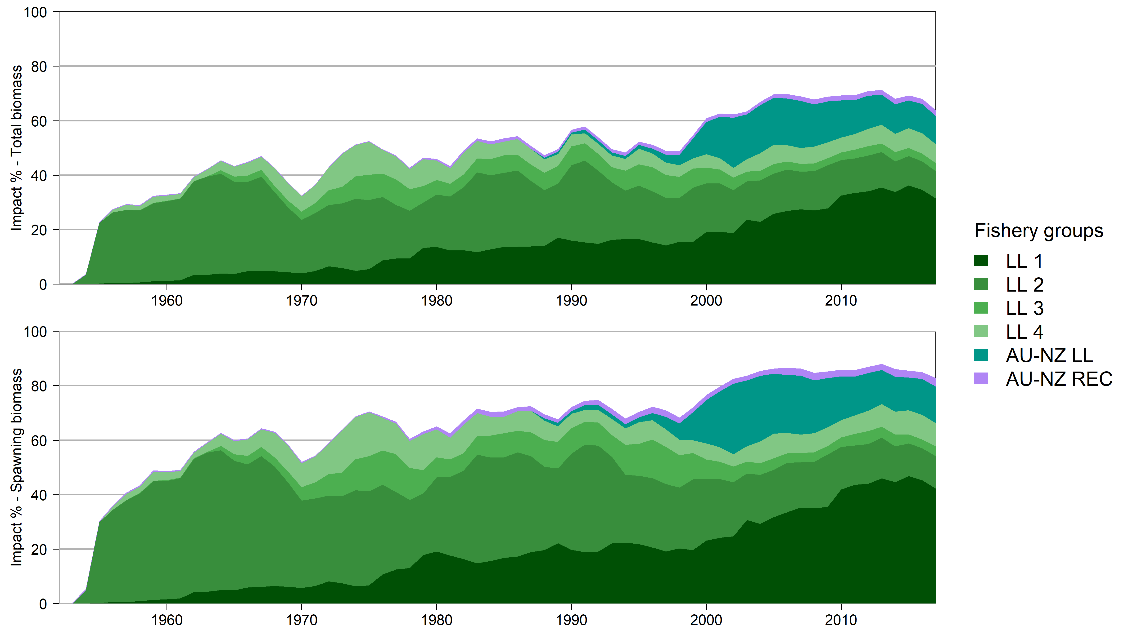
Figure SMLS-04. Estimated annual average juvenile and adult fishing mortality for the diagnostic model. | Figure SMLS-05. Estimates in reduction in spawning biomass and total biomass due to fishery impact for the diagnostic case model.

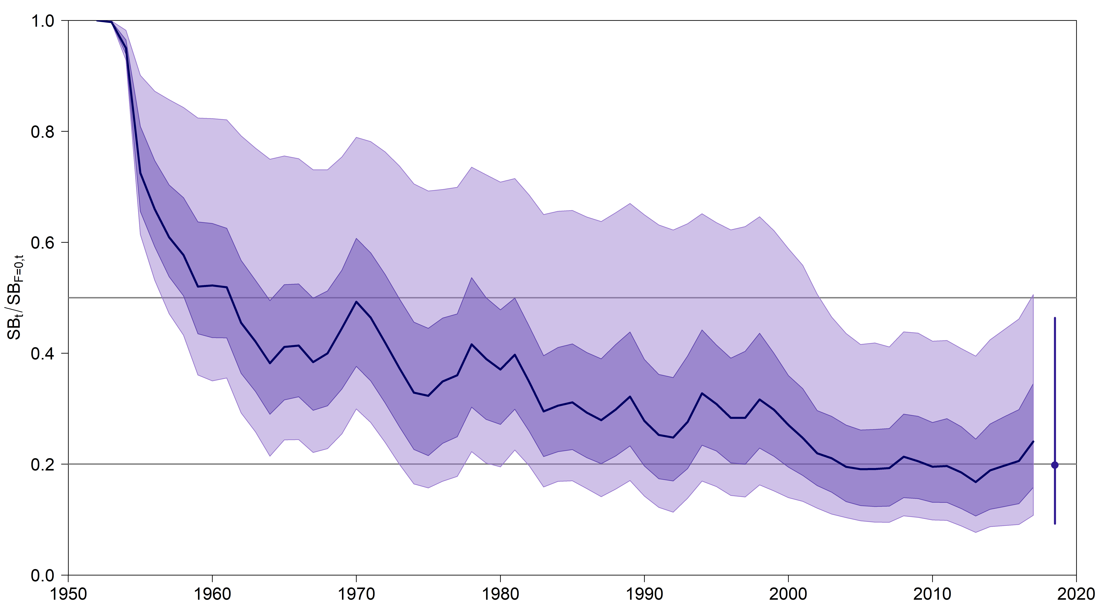 | 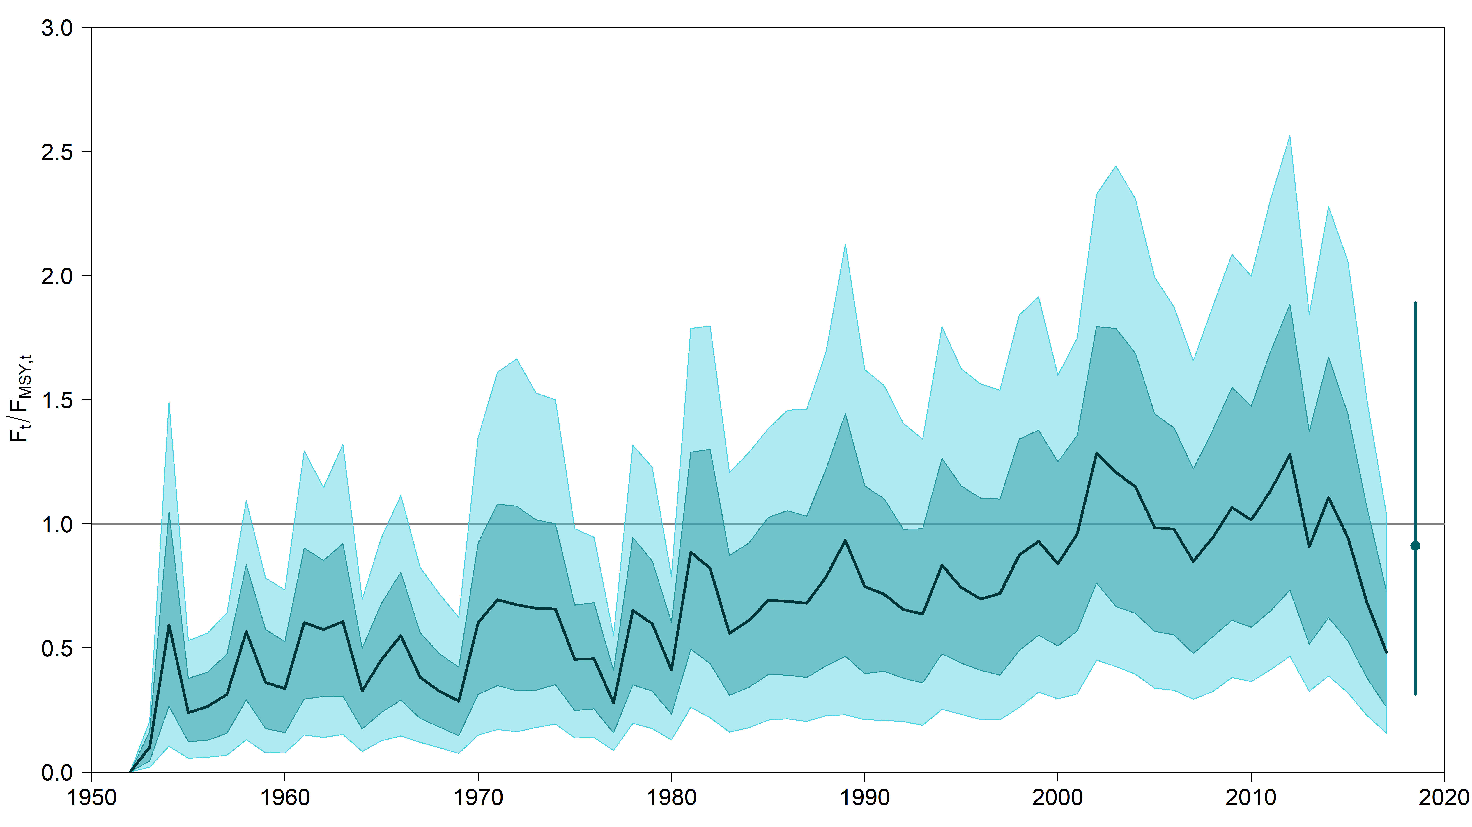
Figure SMLS-06. Plot showing the trajectories of spawning biomass depletion for the model runs included in the structural uncertainty grid described in Table SMLS-01. Gray horizontal lines indicate 50% and 20% levels of depletion. On the right of the depletion is the median point estimate of the recent level reference point with the bar indicating the 80th percentile. | Figure SMLS-06bis. Plot showing the trajectories of fishing mortality for the model runs included in the structural uncertainty grid described in Table SMLS-01. Gray horizontal lines indicate F_{MSY}. On the right of the depletion is the median point estimate of the recent level reference point with the bar indicating the 80th percentile.
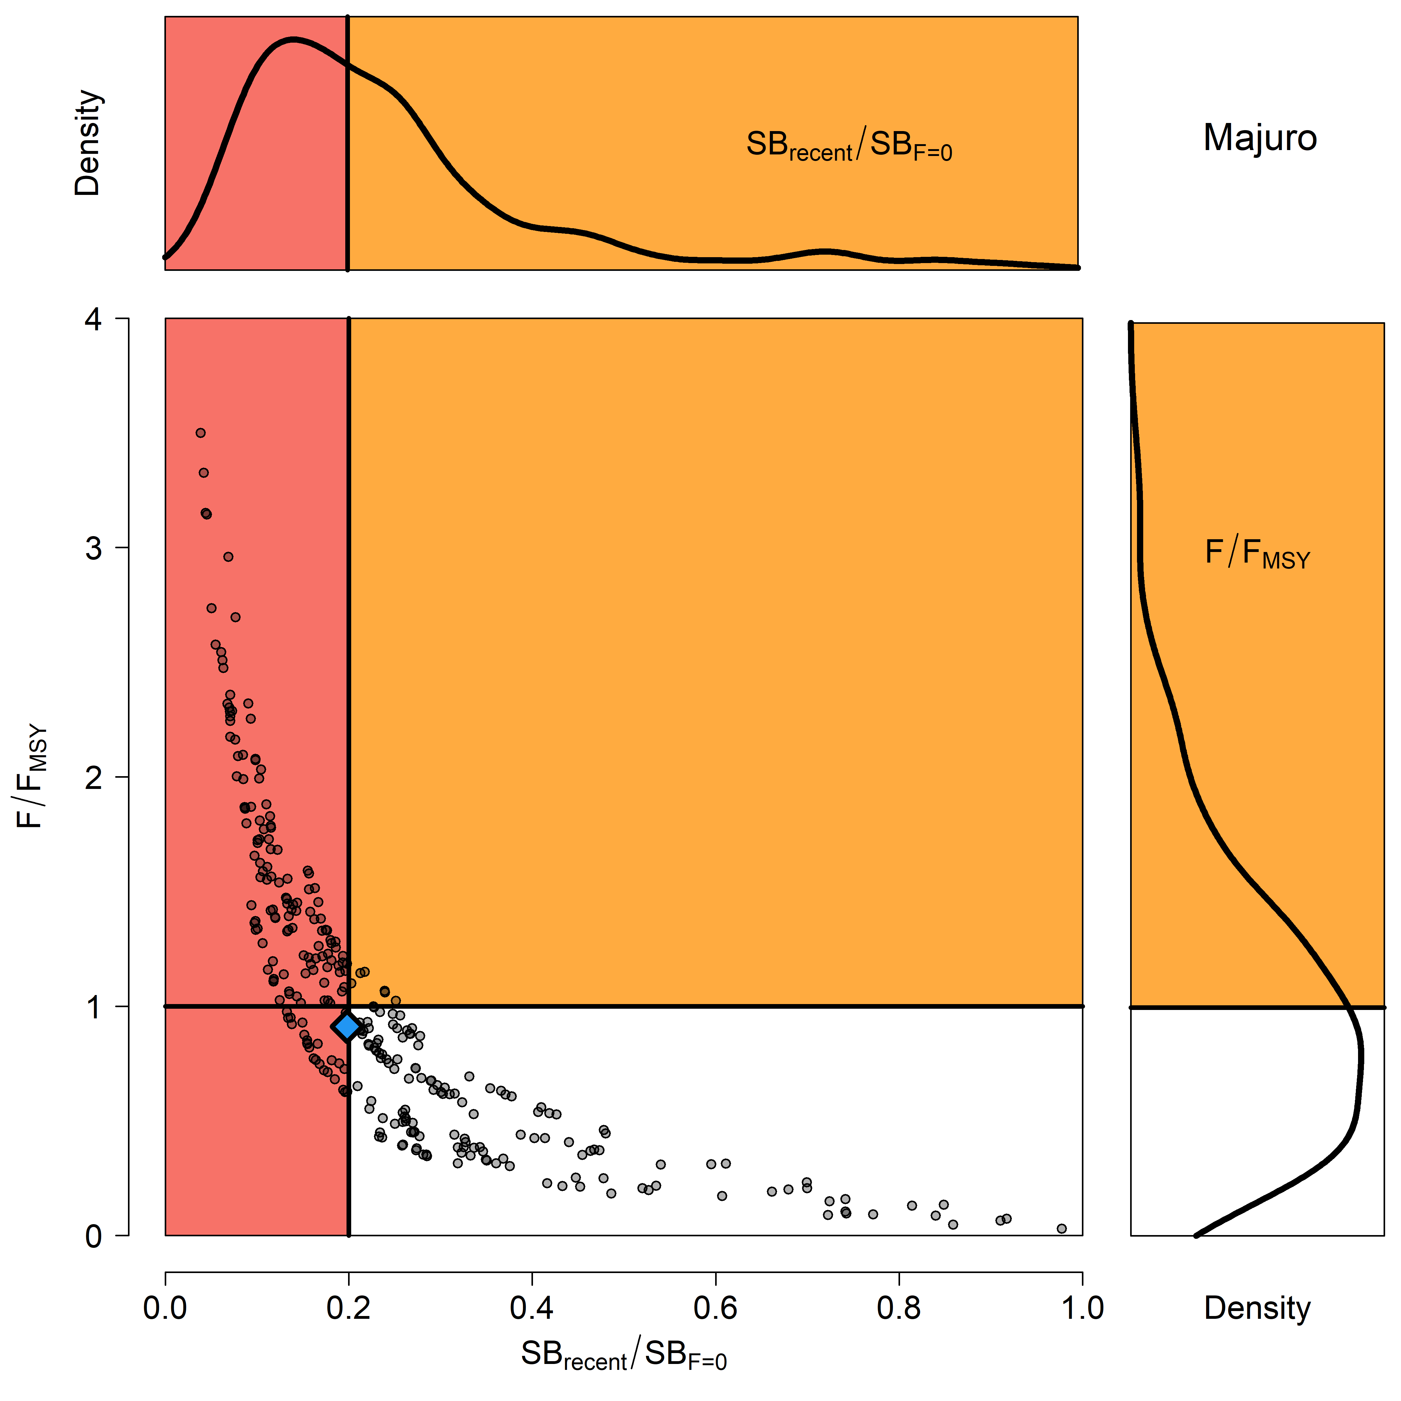 | 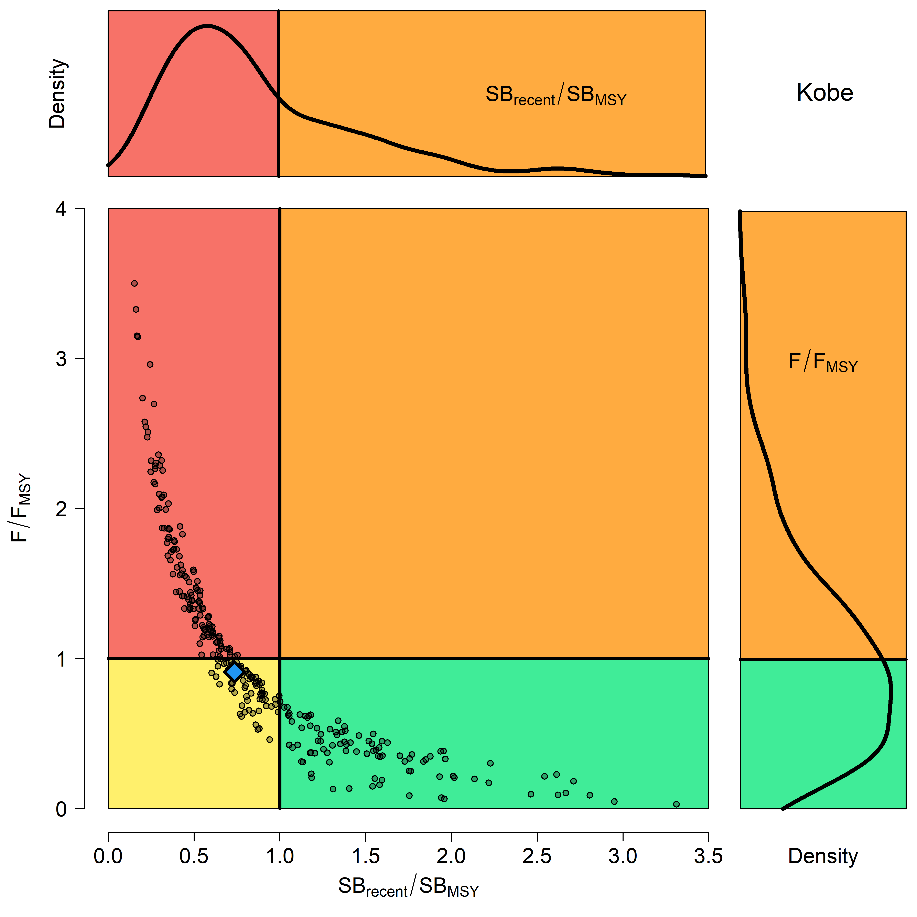
Figure SMLS-07. Majuro plot for the recent spawning biomass (2014 – 2017) summarizing the results for each of the models in the structural uncertainty grid. The plots represent estimates of stock status in terms of spawning biomass depletion and fishing mortality, and marginal distributions of each are presented. The blue square is the median of the grid. | Figure SMLS-08. Kobe plot for the recent spawning biomass (2014 – 2017) summarizing the results for each of the models in the structural uncertainty grid. The plots represent estimates of stock status in terms of spawning biomass relative to the spawning biomass that produces MSY and fishing mortality, and marginal distributions of each are presented. The blue square is the median of the grid.

- Management Advice and implications

- SC15 noted that there are no agreed limit reference points for the WCPO billfish. However, SC15 also noted that based on the adopted uncertainty grid, the southwest Pacific striped marlin assessment results indicate that the stock is likely overfished, and close to undergoing overfishing according to MSY-based reference points. SC15 recommends that WCPFC16 identify an appropriate limit reference point for this stock. Key management quantities can be found in Table SMLS-02. The recent spawning biomass depletion relative to the unfished condition was close to the LRP adopted for tunas (SB_{recent}/SB_{F=0} = 0.2).

- SC15 noted that recent catches are approximately half the MSY, and that recent fishing mortality is slightly less than the fishing mortality that would result in MSY.

- SC15 recommended SC16 use stochastic stock projections, including the expansion of the geographic scope of CMM2006-04 by assuming average fishing effort during 2000-2004 by CCMs and zero fishing mortality in assessment region 1, to evaluate the potential long-term performance of the CMM.

- SC15 recommended that WCPFC16 consider measures to reduce the overall catch of this stock, including through the expansion of the geographical scope of CMM2006-04, in order to cover the distribution range of the stock.

- Research recommendations

- The following research activities were recommended by SC15 in order to progress the assessment of Southwestern Pacific striped marlin.
- Improved estimates of life history parameters including growth, maturity, and natural mortality. Verify the aging method used to derive the growth relationship in order to inform meta analyses for M and steepness specific to SWPO striped marlin. Additionally, efforts should be made to increase sampling of smaller individuals.
- Better estimates of striped marlin movement (>180 days) are needed to characterize mixing rates across model region in order to develop spatially explicit model structure and improve upon “areas as fleets” approach.
- Improved estimates of conversion factors (such as weight-to-length and length-to-length) are needed, together with improved length-at-age estimates to better inform the data inputs used in the stock assessment.
- Conduct sensitivities analyses with respect to the uncertainties in conversion factors used in the stock assessment and assess whether this should be included as an axis in the structural uncertainty grid.
- Develop better estimates of historical catch (1950-1960) to resolve the potential issue of misidentification caused by merging the billfishes datasets.

SC9, 2013 – SC14, 2018 (NO STOCK ASSESSMENTS)

- Stock Status

      - SC14 noted that no stock assessments were conducted for southwest Pacific striped marlin in 2018. Therefore, the stock status descriptions from SC8 are still current for southwest Pacific striped marlin. Updated information on catches was compiled but not reviewed by SC14.

- Management Advice

      - SC14 noted that no management advice has been provided since SC8 for southwest Pacific striped marlin. Therefore, previous advice should be maintained, pending a new assessment or other new information. For further information on the management advice and implications from SC8, please see below.

Useful References

SC15-SA-WP-07 Stock assessment of SW Pacific striped marlin in the WCPO. https://www.wcpfc.int/node/42933

SC15-SA-IP-07 Background analyses for the 2019 stock assessment of SW Pacific striped marlin. https://www.wcpfc.int/node/42944

SC15-SA-IP-16 Characterisation of New Zealand striped marlin fisheries. https://www.wcpfc.int/node/2851

SC15-SA-IP-18 Preliminary ageing of striped marlin in the southwest Pacific using otoliths. https://www.wcpfc.int/node/43330

SC9-SA-WP-07 Distribution of longline catches for southwest Pacific striped marlin.
https://www.wcpfc.int/node/3704

SC8-SA-WP-05 Stock Assessment of Striped Marlin (Kajikia audax) in the Southwest Pacific Ocean. https://www.wcpfc.int/node/3234

Previous Assessments

SC2-SA-WP-06 Stock assessment of striped marlin (Tetrapturus audax) in the southwest Pacific Ocean. https://wcpfc.int/meetings/2nd-regular-session

