The Commission for the Conservation and Management of
Highly Migratory Fish Stocks in the Western and Central Pacific Ocean

Scientific Committee

Pacific Bigeye Thresher Shark (Alopias superciliosus)

Stock Status AND Management Advice

Contents
SC15 2019 (NO STOCK ASSESSMENT) 2
SC14 2018 (NO STOCK ASSESSMENT) 2
SC13 2017 (Risk Assessment CONDUCTED) 2
USEFUL REFERENCES 5

SC15 2019 (NO STOCK ASSESSMENT)

- Stock status and trends

- SC15 noted that no stock assessments were conducted for Pacific bigeye thresher shark in 2019. Therefore, the stock status descriptions from SC13 are still current for Pacific bigeye thresher shark. For further information on the stock status and trends from SC13, please see https://www.wcpfc.int/node/29904. Updated information on catches was not compiled for and reviewed by SC15.

- Management advice and implications

- SC15 noted that no management advice has been provided since SC13 for Pacific bigeye thresher shark. Therefore, previous advice should be maintained, pending a new assessment or other new information. For further information on the management advice and implications from SC13, please see https://www.wcpfc.int/node/29904.

SC14 2018 (NO STOCK ASSESSMENT)

- A Pacific-wide sustainability risk assessment of bigeye thresher shark was conducted in 2017. SC14 received no new information.

- Status and trends

- SC14 noted that no stock assessments were conducted for Pacific bigeye thresher shark in 2018. Therefore, the stock status descriptions from SC13 are still current for Pacific bigeye thresher shark respectively. Updated information on catches was not compiled for and reviewed by SC14.

- Management advice and implications

- SC14 noted that no management advice has been provided since SC13 for Pacific bigeye thresher shark. Therefore, previous advice should be maintained, pending a new assessment or other new information. For further information on the management advice and implications from SC13, please see https://www.wcpfc.int/node/29904

SC13 2017 (Risk Assessment CONDUCTED)

- Stock status and trends

- SC13 noted that the results of the assessment indicate that assuming a range of longline post-capture survival rates of 30-70%, which likely reflects current fishing operations, median sustainability risk for the 2000-2014 period ranged between:
- 20% below to 60% above the MIST based on 0.5r,
- 50% below to 10% above the MIST based on 0.75r, and
- 60% to 20% below the MIST based on r.

- SC13 also noted that CPUE increased in the calibration area (the Hawaii-based fleet) in the last year of the assessment. This may suggest an increase in biomass, but the reason for the CPUE increase is not understood.

- Management advice and implications

- SC13 noted that although the stock status of this species is currently unknown, the bigeye thresher assessment showed that, estimating for current fishing operations (with 30-70% post-capture mortality) across a range of scenarios, some of the median F estimates exceeded two of the three indicative reference points (0.5r and 0.75r) (Table BTH-1). Across all 30-70% post-capture scenarios, there is a >50% probability in most years that F > MIST based on 0.5r and a >20% probability in most years that F > MIST based on 0.75r. (Table BTH-2).

TABLE BTH-1. Sustainability risk (ratio of impact to MIST, at three levels of the MIST, with values >1 considered to be unsustainable) (median values and 95% quantile range) for bigeye thresher in the Pacific. Estimates are for the Core Area and the Assessment Area assuming the occurrence of post-capture survival (random occurrence between 30% and 70%) in impact estimation and three initial population status assumptions (low (0.3), medium (0.5), and high (0.7)). Results are contrasted for the fifteen-year period (2000-2014) and the recent period (2011-2014). Fcrash = r, Flim = 0.75r, and Fmsm = r/2.
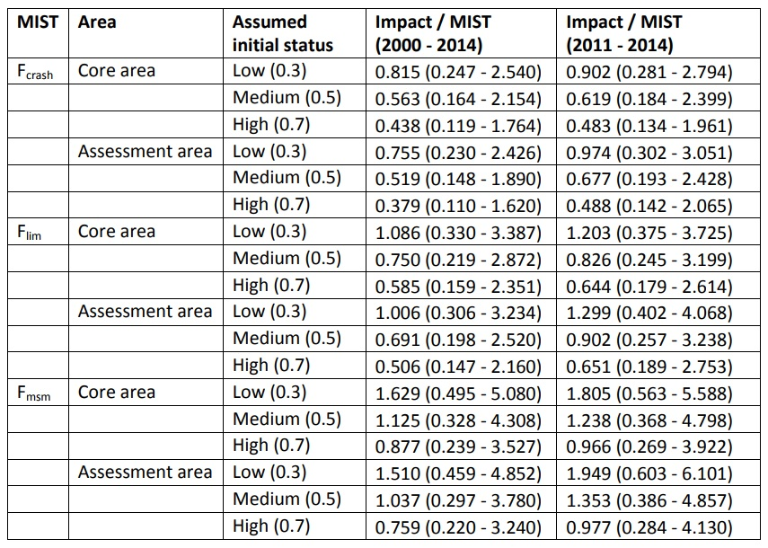

TABLE BTH-2. Sustainability risk probabilities (Pr(Impact > MIST), for 3 levels of MIST: Fcrash, Flim, and Fmsm) for bigeye thresher in the Pacific, 2000-2014, assuming 100% capture mortality (left) and the occurrence of post-capture survival (right) over the Core Area and the Assessment Area (combined values across three initial population status assumptions). Fcrash = r, Flim = 0.75r, and Fmsm = r/2.
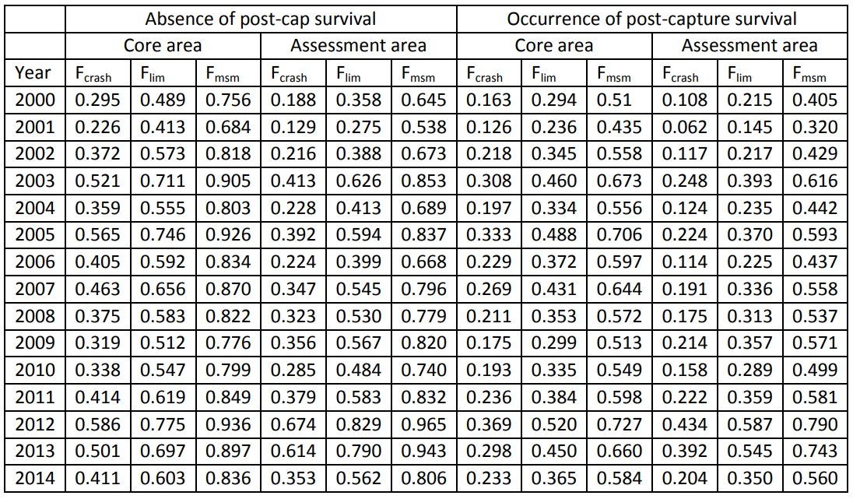

- SC13 noted that the modelled scenario of 30-70% post-capture survival reduced F estimates by approximately one third and reduced the risk that the MIST based on r will be exceeded by 50% compared to the scenario assuming no post-catch survival. A “no-retention” measure was not modelled but would be expected to reduce F even further.

- SC13 noted that the area of highest estimated fishing mortality overlapped with the region of higher relative abundance for the species, corresponding to a narrow band between approximately 10-15°N and 150°E-140°W. Fishing operations targeting bigeye tuna and operating during the April-June period had the highest mortality over the recent period (2011-2014).

- SC13 noted that the Commission needs to further consider appropriate limit reference points and risk tolerances for exceeding LRPs for sharks.

- SC13 recommends that WCPFC14 take the results of this assessment into consideration when framing a management measure for bigeye thresher sharks in the WCPO.

USEFUL REFERENCES

WCPFC-SC13-SA-WP-11 Pacific-wide sustainability risk assessment of bigeye thresher shark (Alopias superciliosus) Rev 2 (12 August 2017). https://www.wcpfc.int/node/29524

