SCIENTIFIC COMMITTEE
NINTH REGULAR SESSION

Pohnpei, Federated States of Micronesia
6-14 August 2013

2013 ANNUAL REPORT TO THE COMMISSION
PART 1: INFORMATION ON FISHERIES, RESEARCH AND STATISITICS
Republic of Korea

Zang Geun KIM, Sung Il LEE, Kim, Sang Chul YOON, Mi Kyung LEE, Jeong Eun Ku and Dong Woo LEE

2013 ANNUAL REPORT TO THE COMMISSON
Part 1. INFORMATION ON FISHERIES, RESEARCH AND STATISTICS

Republic of Korea
Zang Geun KIM, Sung Il LEE, Sang Chul YOON and Dong Woo LEE
National Fisheries Research and Development Institute (NFRDI)
216 Gijang-Haeanro, Gijang-eup, Gijang-gun, Busan 619-705, Republic of Korea

Scientific data was provided to the Commission in accordance with the decision relating to the provision of scientific data to the Commission by 30 April 2013 | YES

- SUMMARY

Korea has two types of fishing gears, distant water purse seine and longlines, that engage in fishing tuna and tuna-like species in the WCPFC Convention Area. These fisheries are managed by the Distant Water fisheries Development Act of Korea. Total catch in the WCPFC by the Korean fisheries in 2012 was 295,649 mt, which accounted for 23% greater than that of 2011. The catch of purse seine fisheries was 262,192 mt reported from 28 vessels active in 2012, which was 7% lower than that of 2009 showing the highest during 5 recent years (2008-2012). The catch of longline fisheries was 33,457 mt reported from 126 vessels active in 2012, and it showed the highest during 5 recent years. In purse seine fisheries, skipjack and yellowfin catches in 2012 were 25% and 28% greater than those of 2011, respectively, but bigeye catch was 61% lower than that of 2011. In longline fisheries, bigeye and albacore catches in 2012 was 23 % and 89% greater than that of 2011, but striped marlin catch was 55% lower than that of 2011. Purse seine fishing efforts increased from 6,624 sets in 2011 to 7,337 sets in 2012, which was the highest level during 5 recent years. Longline fishing efforts decreased from 78,949 thousand hooks in 2011 to 74,973 thousand hooks in 2012, which accounted for 5% lower than that of 2011. Purse seine fishing efforts in 2012 were concentrated relatively higher on the central areas and extended farther to the east comparing to those of 2010 and 2011. Longline fishing efforts in 2012 were similar to that of 2011, but they deployed relatively lower in the central areas. The coverage rates of logsheet were 100% for purse seine and 83% for longline in 2012.

- Tabular Annual Fisheries Information

Table 1(a). Annual catch and effort estimates for the Korean purse seine fisheries by primary species in the WCPFC Convention Area, 2008-2012
Year | No. of sets | Total | SKJ | BET | YFT | OTH
2008 | 7,064 | 248,802 | 187,277 | 45 | 61,480 | -
2009 | 7,122 | 283,278 | 257,481 | 135 | 25,652 | 10
2010 | 7,307 | 277,312 | 216,026 | 2,972 | 58,314 | -
2011 | 6,624 | 207,702 | 168,690 | 2,295 | 36,717 | -
2012 | 7,337 | 262,192 | 210,613 | 900 | 50,677 | 2
* The catch for 2011 and 2012 are provisional.

Table 1(b). Annual catch and effort estimates for the Korean longline fisheries by primary species in the WCPFC Convention Area, 2008-2012
Year | No. of  hooks (×10³) | Total | ALB | YFT | BET | BFT | SKJ | BLM | BUM | STM | SWO | OTH
2008 | 80,582 | 31,035 | 1,481 | 7,846 | 17,001 | 0 | 2 | 422 | 1,966 | 59 | 1,206 | 1,052
2009 | 68,843 | 32,370 | 1,608 | 10,032 | 15,231 | 0 | 0 | 571 | 2,453 | 54 | 1,134 | 1,289
2010 | 65,971 | 28,513 | 1,337 | 7,644 | 13,914 | 51 | 0 | 579 | 1,595 | 27 | 786 | 2,581
2011 | 78,949 | 30,736 | 670 | 7,881 | 15,282 | 0 | 23 | 331 | 1,415 | 73 | 1,340 | 3,723
2012 | 74,973 | 33,457 | 1,264 | 7,832 | 18,823 | 0 | 14 | 148 | 1,486 | 43 | 1,267 | 2,579
* The catch for 2011 and 2012 are provisional.

Fig. 1(a). Historical annual catch for the Korean purse seine fisheries by primary species in the WCPFC Convention Area during 1980-2012.

Fig. 1(b). Historical annual catch for the Korean longline fisheries by primary species in the WCPFC Convention Area during 1987-2012.

Fig. 2. Historical annual vessel numbers for the Korean tuna fisheries by gear in the WCPFC Convention Area during 1980-2012.

Table 2. Number of Korean vessels by gear and size, active in the WCPFC Convention Area, 2008-2012
Year | GRT class by gear
 | Longline |  |  |  |  | Purse seine
 | Total | 0-50 | 51-200 | 201-500 | 500+ | Total | 0-500 | 501-1,000 | 1,001-1,500 | 1,500+
2008 | 108 | - | - | 108 | - | 28 | - | 15 | 12 | 1
2009 | 111 | - | - | 111 | - | 27 | - | 13 | 11 | 3
2010 | 122 | - | - | 122 | - | 28 | - | 13 | 12 | 3
2011 | 124 | - | - | 124 | - | 28 | - | 12 | 11 | 5
2012 | 126 | - | - | 126 | - | 28 | - | 12 | 11 | 5
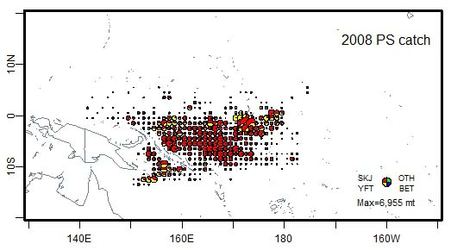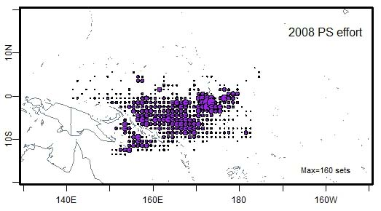
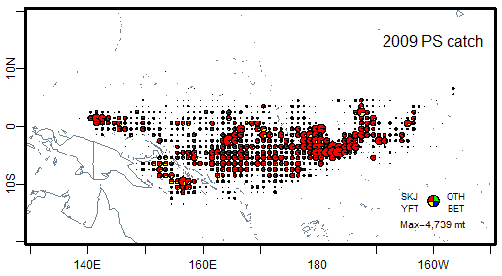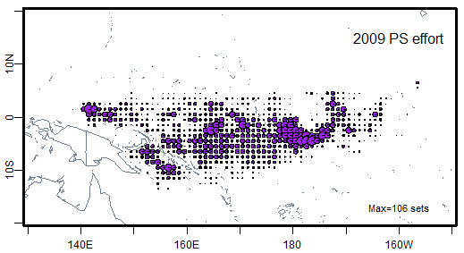
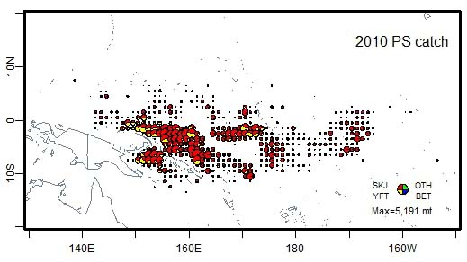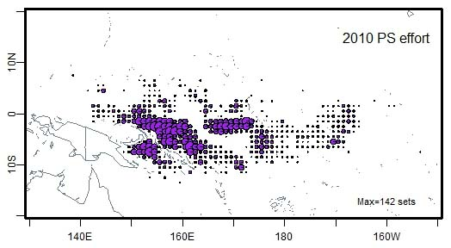
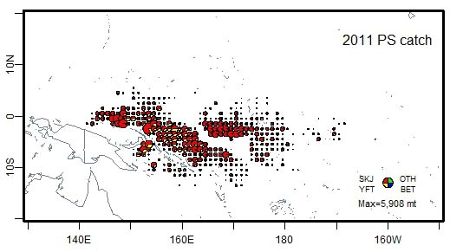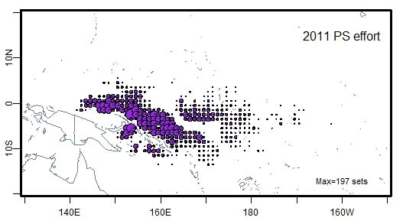
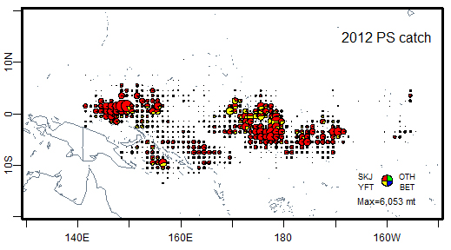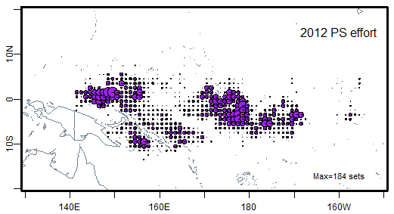
Fig. 3(a). Annual catch and effort distributions of target species by the Korean purse seine fisheries active in the WCPFC Convention Area, 2008-2012.

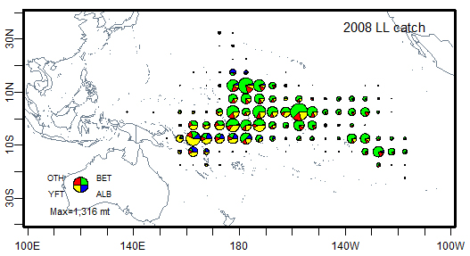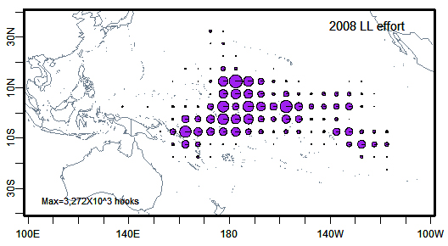
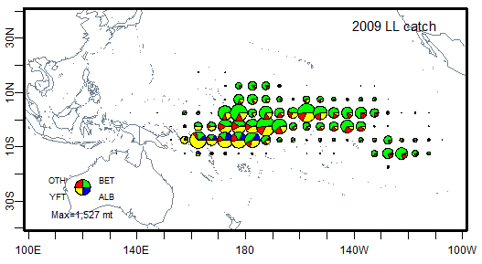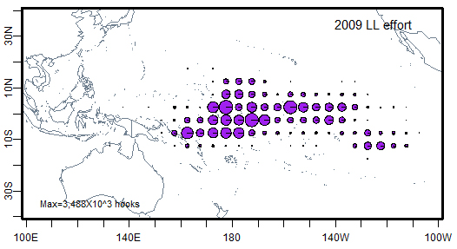
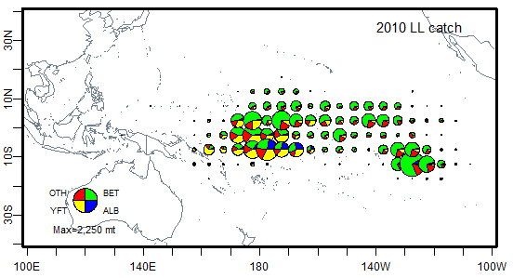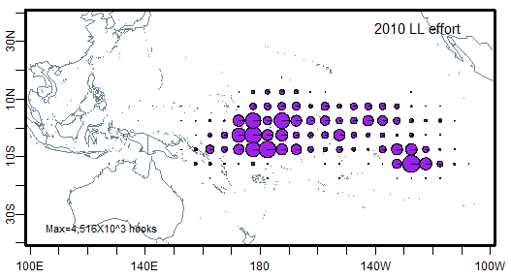
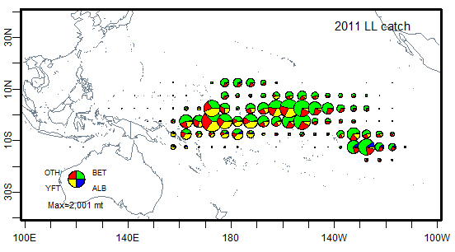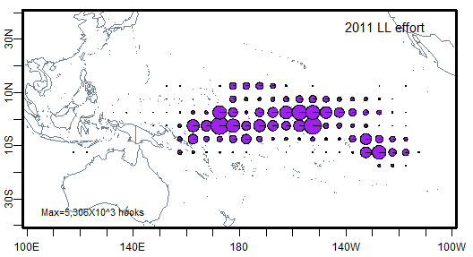
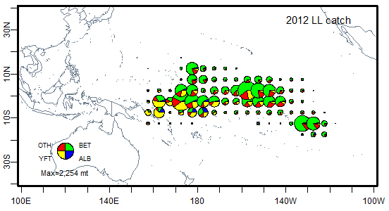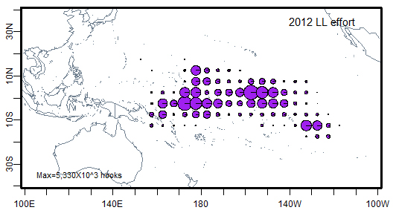
Fig. 3(b). Annual catch and effort distributions of target species by the Korean longline fisheries active in the Pacific Ocean, 2008-2012.

Table 4. Annual estimated catch of key sharks by the Korean longline fisheries in the WPCFC convention area, 2011-2012
Year | Catch by key shark species
 | Blue  shark | Thresher  sharks | Hammerhead  sharks | Mako  sharks | Silky  shark | Oceanic  whitetip shark | Others
2011 | 9 | 1 | <0.1 | - | - | - | 1,047
2012 | 68 | 33 | 4 | 6 | 4 | 1 | 640
* Others include catch of unidentified species as well as non-key sharks, and these data are provisional.

Table 5. Estimated annual coverage of operational catch/effort and observer data for the Korean fisheries by gear, active in the WCPFC Convention Area, 2011-2012
Year | Gear | Logsheet coverage (%) | Observer coverage (%)
2011 | Purse seine | 100 | 100
 | Longline | 85 | 5
2012 | Purse seine | 100 | 100
 | Longline | 83 | 5

- Background

About 60 year-old Korean distant water tuna longline fishery that stepped up the first fishing in the Indian Ocean in 1957, has explored the Pacific Ocean since 1958 and the Atlantic Ocean since 1967. The high-seas and within the coastal states in the South Pacific have been the main fishing grounds for Korean longline fishery and purse seine fishery as well. There was a sort of change in the longline fishing operation types. Longline vessels used foreign ports for fishing base near the fishing grounds from the beginning but they has gradually equipped with deep freezing facilities and used use home ports for fishing base since 1972. All longline vessels have based domestic ports since 1999. This change gave advantages in exporting the products to Japanese markets and others. In domestic markets, tuna sashimi demands have been increasing year by year.

The Korean purse seine fishery was initiated by accessing into the Eastern Pacific fishing ground with 3 vessels in 1971. Helicopter-aided mass operations were introduced in 1979 for the first time, and the number of active vessels had the highest level of 39 in 1990 and was 28 in recent years. Most of the catches are supplied to the packers for our domestic consumption, and the remainders are being exported to foreign canneries.
These fisheries are managed by the Distant Water fisheries Development Act put into effect on the 4 February, 2008. Currently, over 90% of Korean catch of tuna and tuna-like species has occurred in the western and central Pacific ocean (WCPO) area.

- Flag State Reporting

  - Annual catch and effort
Annual catch and effort for the Korean tuna fisheries by gear and primary species are shown in table 1 and Fig. 1. The average of total catch in the WCPO by Koran tuna fisheries was 290,816 mt during 5 recent years (2008-2012). Total catch in 2012 was 295,649 mt, which accounted for 23% greater than that of 2011.
The average catch of purse seine fisheries was 255,857 mt during 5 recent years. The purse seine catch in 2012 was 262,192 mt from 28 vessels active, which was 7% lower than that of 2009 showing the highest during 5 recent years. In purse seine fisheries, skipjack, bigeye and yellowfin catches in 2012 were 210,613 mt, 900 mt and 50,677 mt, respectively. The catches of skipjack and yellowfin were 25% and 28% greater than those of 2011, but bigeye was 61% lower than that of 2011. Purse seine fishing efforts ranged from 6,600 to 7,300 sets during recent 5 recent years and increased from 6,624 sets in 2011 to 7,337 sets in 2012, which was the highest level during 5 recent years.
The average catch of longline fisheries was 31,222 mt during recent 5 years. The longline catch in 2012 was 33,457 mt from 126 vessels active, and it showed the highest during 5 recent years. In longline fisheries, bigeye and albacore catches in 2012 was 23 % and 89% greater than that of 2011, but striped marlin catch was 55% lower than that of 2011. Longline fishing efforts ranged from 66,000 to 80,000 thousand hooks and decreased from 78,949 thousand hooks in 2011 to 74,973 thousand hooks in 2012, which accounted for 5% lower than that of 2011.

  - Fleet structure
The number of vessels active by gear and size is presented in Fig. 2 and Table 2. The number of purse seine vessels, once peaked at 39 in 1990, and had been reduced to 28 in 1996. Since then it has been maintained at the level of 27-28 until recent year, and was 28 in 2012. In terms of GRT class, of 28 vessels in 2012, 12 vessels were of 501-1,000 class, 11 vessels of 1,001-1,500 class and 5 vessels of over 1,500 class. The number of longline vessels was reduced from 220 in 1991 to 108 in 2008, but had slightly increasing to about 120 in recent years and 126 in 2012. All longline vessels belong to class of 201-500 GRT with deep freezing facilities.

  - Fishing patterns
The distributions of catch and effort of target species by gear are shown in Fig. 3. Korean tuna purse seine fisheries have generally been operating throughout the year in the tropical area of the WCPO between 140ºE-180ºE and extended farther to the east when oceanographic conditions were favorable. Purse seine fishing efforts in 2010 and 2011 were concentrated on the western areas, while in 2012 they were concentrated relatively higher on the central areas and extended farther to the east. These fishing patterns were quite comparable to those of the previous years. In 2009, purse seine fishing efforts were high in the central area with an extension farther to the east, and in 2010, they shifted a bit westward but less than in 2011. In 2012, their main distributions shifted again to the central area with an extension to the east, but it concentrated to particular area comparing to those of 2009. Longline fisheries were deployed relatively higher in both the central and the eastern areas. Longline fishing efforts in 2012 were deployed relatively higher in both the central and the eastern areas, which were similar to that of 2011, than those of 2009 and 2010. In case of longline fishing efforts in 2009 and 2010, they were higher in the central area than the eastern area. It was suggested that these differences in yearly distributions for each gear efforts was attributable to species distribution depth subject to the oceanographic conditions and to the ability of gears to attain the depth where fish were.

  - Estimated total catches of non-target, associated and dependent
Catch estimates of shark species caught incidentally by lingline fisheries are presented in table 4. These data were compiled from logsheet recorded by captain onboard. As key shark species, the catches in 2012 were estimated to be 68 mt for blue shark, thresher sharks 33 mt, mako sharks 6 mt, silky shark 4 mt and oceanic whitetip shark 1 mt, respectively. The catch of other sharks was 640 mt, which included unidentified species as well as non-key sharks.

  - Estimated annual coverage of catch and effort and observer data
Estimated annual coverage of catch and effort and observer data is shown in table 5. Logsheet data coverage in 2012 was 100% for purse seine and 83% for longline. The observer coverage in 2012 was 100% for purse seine and over 5% for longline.

- Coastal State Reporting

N/A

- Onshore developments

Korea consistently promotes investment plans on land facility in the coastal states which our distant waters fleets are operating.

- Future Prospects of the fishery

The fleet power of purse seine and longline is expected to keep the current level, and production seems to be affected by fisheries resources trend in the oceans, conservation and management measures of RFMOs and permission policy of the coastal states. Meanwhile recognizing that demand at international and domestic market is increasing on production caught from responsible and sustainable fishing activity, Korea strives to strengthen on MCS, scientific survey and education relating to by-catch for fishermen.

- Status of tuna fishery data collection systems

8.1. Logsheet data collection and verification
Tuna catch statistics of Korea are obtained from two sources of data reports. Korea Deep-Sea Fisheries Association (KODEFA) collects total catches by gear and species from the Korean tuna industries, which are used as Korea’s official total catch. National Fisheries Research and Development Institute (NFRDI) collects logsheet data from vessels completed by captain onboard. To address the past shortcomings and the ever-increasing data requirement by the RFMOs, necessary improvements have recently made in terms of the types of mandatory data, the area of coverage, submission timeframes and formats, and now the Association and NFRDI cooperate with each other to provide the data to the government and the RFMOs. To improve fisheries database systems and data cross-checking systems, the NFRDI has made a program being able to monitor the state of being submitted from fishing vessel in real time and to manage/cross-check the data. With the above improvement, the Distant-water Fisheries Act obliges fishers to report the catch statistics to NFRDI every month in the electronic format. This measure was taken by revision of the Act put into effect from December 2012.

8.2. Observer programme
The scientific observer program of distant-water fisheries of Korea was started in 2002. National Fisheries Research and Development Institute (NFRDI) is responsible for implementing and developing the program. The qualification for observers is college graduated where major field is nature science or fisheries high school graduated with at least 1-year experience on board and certificate of qualification to deck officer. Candidate for observer who have passed the paper review (including medical check) and oral interview have to take training programs for 3 weeks. Observer training programs include basic safety training for seafaring, operations of navigation devices, biological information training for target and non-target species and data collecting/reporting method for fishing activities. During the training program they have two kinds of test. First is the test for a technical term of fisheries and biology, and the other is the test for species identification. The person who scored 70% overall in the two tests and attended 100% of the course timetable can be qualified and deployed on board as a scientific observer. Korea has a total of 20 scientific observers at present.

8.3. Port sampling programme
In Korea, there are 4 domestic landing ports for tunas caught in WCPO, which are Busan, Masan, Tonyeong and Mokpo, all located along the southern coast of Korea, nearby the landing port, there are 5 canneries owned by 4 companies in which about 100,000 tons of tunas from WCPO are landing.
The National Fisheries Research and Development Institute (NFRDI) used to conduct biological sampling in the domestic cannery of Dongwon industry from 1997 to 2006. A preliminary study for species identification from the catch of purse seine was conducted in a cannery of Korea in April 2011.

8.4. Unloading/Transhipment
In accordance with Article 13 of the DSFA, all distant waster fishermen shall comply with procedures and regulations of transhipment at sea and in ports set out in each Regional Fisheries Management Organization. Transhipment on the high sea is allowed only where the receiving vessel carries WCPFC ROP observer whose identity (name and nationality) should be reported prior to the commencement of such transhipment to the Korean government to ensure that observer is onboard and monitor transhipments as required by CMM2009-06. Also, vessel operators are encouraged to assist the WCPFC ROP observers in having full access to both the unloading and the receiving vessels to verify that the transhipped quantities of fish are consistent with other information available to observers. After the completion of transhipment, the transhipment declaration is subject to verification against fishing vessel’s monthly catch report, logsheets and observer reports (if available).

- Research activities covering target and non-target species

To establish management plan of FADs for the Korean tuna purse seine fisheries, we have carried out study on the fishing characteristics of Korean tuna purse seine fisheries, and have a plan to conduct a sea trial on FADs in next year. And we will conduct a sea trial on circle hooks to mitigate bycatch of sea turtle in the Korean tuna longline fisheries.

National Fisheries Research and Development Institute, 216 Gijang-Haeanro, Gijang-eup, Gijang-gun, Busan 619-705, Korea

