The Commission for the Conservation and Management of
Highly Migratory Fish Stocks in the Western and Central Pacific Ocean

Scientific Committee

Pacific Blue Marlin (Makaira nigricans)

Stock Status and Management Advice

Contents
SC17-2021 (STOCK ASSESSMENT CONDUCTED) 2
SC13-2017 – SC16-2020 (NO STOCK ASSESSMENTS) 8
SC12-2016 (STOCK ASSESSMENT CONDUCTED) 8
Useful References 11
Previous Assessments 11

SC17-2021 (STOCK ASSESSMENT CONDUCTED)

- SC17 reviewed and accepted SC17-SA-WP-08 (Stock assessment report for Pacific blue marlin (Makaira Nigricans) through 2019). The ISC Billfish working group, IATTC, and SPC scientists conducted the current benchmark stock assessment.

- Stock status and trends

- SC17 noted that ISC provided the following conclusions on the stock status of Pacific blue marlin:

Stock status, biomass trends, and recruitment of Pacific blue marlin for both models in the ensemble had equal weights and similar trends, although the estimates of initial conditions are different. All reported results are the model-averaged estimates from the ensemble model unless otherwise noted.

Estimates of population biomass declined until the mid-2000s, increased again until 2019, and were relatively flat until the present. The minimum spawning stock biomass is estimated to be 17,592 mt (95% C.I. 14,512-20,703 mt) in 2006 which corresponds to 5% above SB_{MSY}, the spawning stock biomass to produce MSY, (i.e., SB/SB_{MSY} = 1.05; 95% C.I. 0.70-1.01, Figure PBUM-1). In 2019, SB = 24,272 mt and the relative SB/SB_{MSY} = 1.17 (95% C.I. 0.87-1.51).

Combined median fishing mortality on the stock (average F on ages 1-10) is currently below F_{MSY} (Figure PBUM-1). It averaged roughly F = 0.13 during 2017-2019, or 40% below F_{MSY}, and in 2019, F=0.11 with a relative fishing mortality of F/F_{MSY} = 0.50 (95% C.I. 0.37-0.69). Median fishing mortality has been below F_{MSY} in all years except the period 2003 to 2006.

The predicted value of the spawning potential ratio (SPR, the predicted spawning output at current F as a fraction of unfished spawning output) is currently SPR₂₀₁₇₋₂₀₁₉ = 31% for the average of the ensemble model, which is above the SPR required to produce MSY (17%). Recruitment was relatively consistent throughout the assessment time horizon, with occasional pulses in recruitment, but no notable periods of below-average recruitment.

No target or limit reference points have been established for Pacific blue marlin under the auspices of the WCPFC. Blue marlin is expected to be highly productive due to its rapid growth and high resilience to reductions in spawning potential. Although fishing mortality has approached F_{MSY} and exceeded MSY from 2003 to 2006, the biomass of the stock has remained above SB_{MSY} since this time. With continued decreases in fishing effort and associated catches of Pacific blue marlin, the stock is expected to remain within MSY limits. When the status of blue marlin is evaluated relative to MSY-based reference points, the 2019 spawning stock biomass of 24,272 mt is 17% above SB_{MSY} (20,677 mt, 95% C.I. -13% to +50%) and the 2017-2019 fishing mortality is 50% of F_{MSY} (95% C.I. 37% to 69%). Therefore, relative to MSY-based reference points, overfishing was very likely not occurring (>90% probability) and Pacific blue marlin is likely not overfished (81% probability, Figure PBUM-2).

Deterministic stock projections were conducted with Stock Synthesis to evaluate the impact of alternative future levels of harvest intensity on female spawning stock biomass, fishing mortality, and yield for Pacific blue marlin. Future recruitment was predicted based on the stock- recruitment curve. These projections used all the multi-fleet, multi-season, size- and age- selectivity, and complexity in the assessment model to produce consistent results. The stock projections started in 2020 and continued through 2029 (10 years) under 4 levels of constant fishing mortality: (1) constant fishing mortality equal to the 2003-2005 average (F₂₀₀₃₋₂₀₀₅); (2) constant fishing mortality equal to F_{MSY}; (3) constant fishing mortality equal to the 2016-2018 average defined as current; and (4) constant fishing mortality equal to F30% (F30% corresponds to the fishing mortality that produces 30% of the spawning potential ratio). Stock projections for each F scenario were run for both growth models in the ensemble and combined using the multivariate lognormal method. Using the deterministic projection result, the multivariate lognormal approximation was applied to generate 10,000 trajectories of SSB and F to calculate the model-averaged results of the new and old growth models. Results showing the projected female spawning stock biomasses, fishing mortality, and the catch biomasses under each of the combined scenarios are provided in Table PBUM-3 and Figure PBUM-3.

- SC17 noted the following stock status from ISC:

Based on these findings, the following information on the status of the WCNPO blue marlin stock is provided:
- No target or limit reference points have been established for Pacific blue marlin by the WCPFC;
- Female spawning stock biomass was estimated to be 24,241 mt in 2019, or about 17% above SSB_{MSY} and 17% above 20%SSB₀.
- Fishing mortality on the stock (average F, ages 1 to 10) averaged roughly F = 0.13 during 2016-2019, or about 40% below F_{MSY} and 28% below F_{20%SSB0}.
- Blue marlin stock status from the ensemble model indicates that relative to MSY-based reference points, overfishing was very likely not occurring (>90% probability) and Pacific blue marlin is likely not overfished (81% probability, Figure PBUM-2).

- SC17 noted that this result is predicated on the use of the Japanese and Taiwanese longline CPUE indices in the assessment, and the exclusion of the Hawaii longline CPUE index, which shows a somewhat different trend (declining by about 50% from 1995-2005, then flat) to the Taiwanese CPUE index in particular. The ISC Billfish Working Group (BILLWG) doesn't believe that the Hawaii longline CPUE index was representative of the Pacific-wide relative abundance of Pacific blue marlin due to the small area it represents, rather a measure of local density. In addition, the CPUE index was in conflict with both Taiwanese and Japanese indices over the same time period. Further, the decision to remove the Hawaii longline CPUE index was consistent with the model decisions made for the 2016 assessment.

  - Management advice and implications

- SC17 noted the following conservation information from ISC:

The Pacific blue marlin stock has produced annual yields of around 18,800 mt per year since 2015, or about 90% of the MSY catch (Table PBUM-1). Blue marlin stock status from the ensemble model indicates that the current median spawning biomass is above SSB_{MSY} and that the current median fishing mortality is below F_{MSY}. However, uncertainty in the stock status indicates a 19% chance of Pacific blue marlin being overfished relative to SSB_{MSY}. Both the old and new growth models show evidence of spawning biomass being above SSB_{MSY} and fishing mortality being below F_{MSY} during the last 5 years. Catch biomass has been declining for the last 5 years, and therefore the stock has a low risk of experiencing overfishing or being overfished unless fishing mortality increases to above F_{MSY} based upon stock projections (Table PBUM-3 and Figure PBUM-3). However, it is also important to note that retrospective analyses show that the assessment model tends to overestimate biomass and underestimate fishing mortality in recent years, in part due to rapid changes in longline CPUE.

Based on these findings, the following conservation information is provided:
- There is no evidence of excess fishing mortality above F_{MSY} (F₂₀₁₆₋₂₀₁₉ is 40% of F_{MSY}) or substantial depletion of spawning potential (SSB₂₀₁₉ is 17% above SSB_{MSY});
- It is important to note that retrospective analyses show that the assessment model tends to overestimate spawning stock biomass in recent years; and
- The results show that projected female spawning biomass is expected to increase under the Fstatus quo and F_{30%} harvest scenarios and decline to SSB_{MSY} under the High F and F_{MSY} harvest scenarios. The probability that the stock is overfished or overfishing occurring by 2029 under each harvest scenario is low.

Special Comments
- Uncertainty regarding the choice of BUM growth curve led to the ensemble model approach for this assessment. The BILLWG recognized that there is considerable uncertainty in input CPUE data in the recent years and life history parameters, especially growth. The BILLWG considered an extensive suite of model formulations and associated diagnostics for developing the assessment models. Overall, the BILLWG found issues with both the new growth and old growth model diagnostics and sensitivity runs that are consistent with the presence of data conflicts, but none of the model diagnostics show that the results of either model were invalid. It is recommended model development work to reduce data conflicts and modeling uncertainties continue and that input assessment data be reevaluated to improve the time series.
- It is recommended that biological sampling to improve life history parameter estimates continue to be collected and ISC countries participate in the BILLWG International Biological Sampling program to improve those estimates.

Table PBUM-1. Reported catch (mt) used in the stock assessment along with annual model-averaged estimates of female spawning biomass (mt), relative female spawning biomass (SSB/SSB_{MSY}), recruitment (thousands of age-0 fish), fishing mortality (average F, ages 1 – 10), relative fishing mortality (F/F_{MSY}), and spawning potential ratio (SPR) of Pacific blue marlin.
Year | 2013 | 2014 | 2015 | 2016 | 2017 | 2018 | 2019 | Mean¹ | Min¹ | Max¹
Reported Catch | 22,166 | 23,741 | 21,861 | 22,644 | 14,443 | 18,589 | 16,503 | 18,873 | 10,882 | 26,138
Spawning Biomass | 27,707 | 26,321 | 25,476 | 23,693 | 22,942 | 23,222 | 24,279 | 35,007 | 17,601 | 69,331
Relative Spawning Biomass | 1.33 | 1.26 | 1.22 | 1.15 | 1.11 | 1.12 | 1.18 | 1.70 | 0.84 | 3.51
Recruitment (thousands of age 0 fish) | 960 | 785 | 608 | 862 | 870 | 1,399 | 876 | 895 | 502 | 1,399
Fishing Mortality | 0.18 | 0.19 | 0.19 | 0.21 | 0.13 | 0.16 | 0.11 | 0.16 | 0.08 | 0.25
Relative Fishing Mortality | 0.81 | 0.85 | 0.83 | 0.95 | 0.58 | 0.71 | 0.50 | 0.71 | 0.35 | 1.11
Spawning Potential Ratio | 0.26 | 0.24 | 0.25 | 0.22 | 0.33 | 0.27 | 0.34 | 0.33 | 0.17 | 0.60
¹During 1971-2019

Table PBUM-2. Estimates of biological reference points along with estimates of fishing mortality (F), spawning stock biomass (SSB), recent average yield (C), and spawning potential ratio (SPR) of Pacific blue marlin, derived from the assessment ensemble model, where “MSY” indicates reference points based on maximum sustainable yield.
Reference Point | Estimate
F_{MSY} (age 1-10) | 0.23
F₂₀₁₉ (age 1-10) | 0.11
F_{20%SSB0} | 0.18
SSB_{MSY} | 20,677 mt
SSB₂₀₁₉ | 24,241 mt
SSB_{20%SSB0} | 20,729 mt
MSY | 24,600 mt
C₂₀₁₇₋₂₀₁₉ | 16,512 mt
SPR_{MSY} | 17%
SPR₂₀₁₉ | 34%
SPR_{20%SSB0} | 23%

Table PBUM-3. Projected median values of Pacific blue marlin spawning stock biomass (SSB, mt) and catch (mt) under four constant fishing mortality rate (F) scenarios during 2020-2029.
Year | 2020 | 2021 | 2022 | 2023 | 2024 | 2025 | 2026 | 2027 | 2028 | 2029
Scenario 1: F = F₂₀₀₃₋₂₀₀₅
SSB | 25,459 | 23,462 | 21,752 | 20,498 | 19,262 | 18,689 | 18,252 | 17,835 | 17,583 | 17,475
Catch | 33,111 | 30,527 | 28,638 | 27,331 | 26,431 | 25,806 | 25,363 | 25,044 | 24,811 | 24,641
Scenario 2: F = F_{MSY}
SSB | 25,318 | 23,351 | 21,583 | 20,255 | 19,216 | 18,405 | 18,186 | 17,809 | 17,513 | 17,466
Catch | 32,875 | 30,436 | 28,662 | 27,439 | 26,606 | 26,037 | 25,645 | 25,370 | 25,177 | 25,039
Scenario 3: F = F₂₀₁₆₋₂₀₁₈
SSB | 26,930 | 28,182 | 28,764 | 28,675 | 28,428 | 28,731 | 28,052 | 28,142 | 27,861 | 28,081
Catch | 23,321 | 23,546 | 23,591 | 23,561 | 23,513 | 23,472 | 23,443 | 23,422 | 23,407 | 23,397
Scenario 4: F = F_{30%}
SSB | 27,757 | 30,064 | 30,624 | 30,976 | 31,072 | 31,624 | 31,415 | 31,800 | 31,753 | 32,132
Catch | 20,828 | 21,404 | 21,764 | 22,001 | 22,167 | 22,294 | 22,393 | 22,471 | 22,532 | 22,580

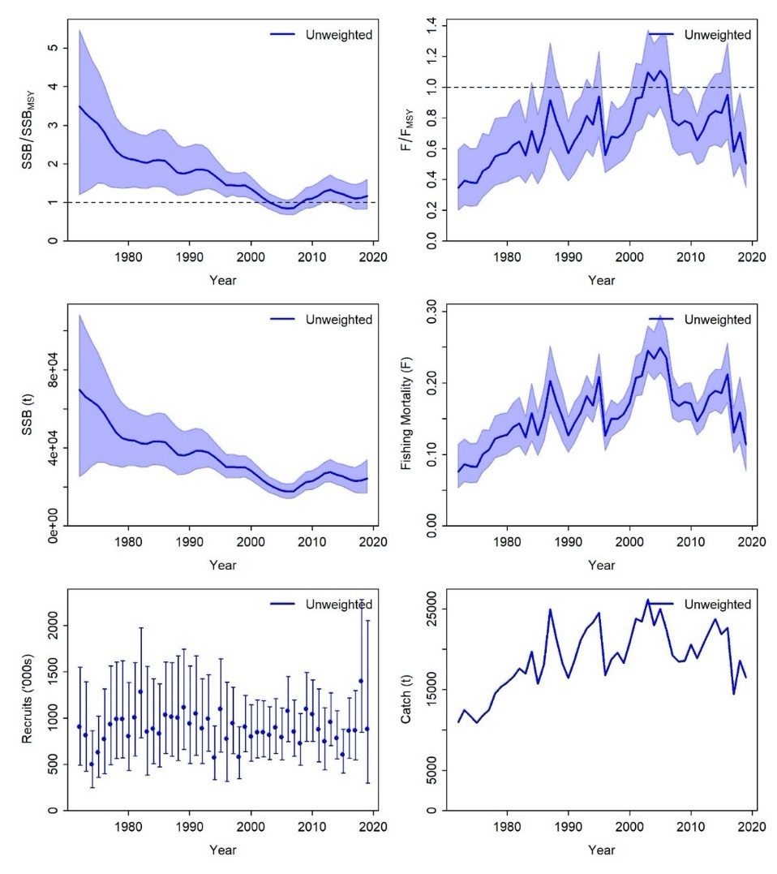
Figure PBUM-1. Time series of estimates of female spawning stock biomass over female spawning stock biomass at MSY (top left), fishing mortality overfishing mortality at MSY (top right), spawning stock biomass (center left), instantaneous fishing mortality (ages 1-10 year⁻¹, center right), recruitment (age-0 fish, bottom left), and catch (bottom right) for Pacific blue marlin (Makaira nigricans) derived from the 2021 stock assessment model ensemble. Lines (or points for recruitment) indicate the median value estimated from the joint multivariate delta-lognormal estimation, shaded areas (or error bars for recruitment) indicate the 95% confidence intervals. Unweighted indicates that both models have equal weights in the ensemble.
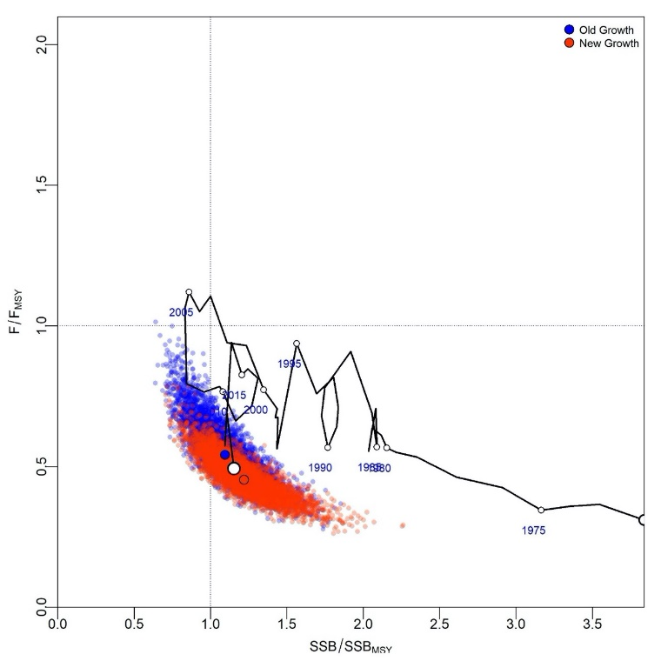
Figure PBUM-2. Kobe plot of the time series of estimates of relative fishing mortality (average of age 1-10) and relative spawning stock biomass of Pacific blue marlin (Makaira nigricans) during 1971-2019. The white circle denotes the delta-lognormal multivariate estimate of the combined models in 2019, blue dots indicate the final year stock status of the old growth model with the 10,000 multivariate draws, and red dots indicate the final year stock status of the new growth model with the 10,000 multivariate draws.

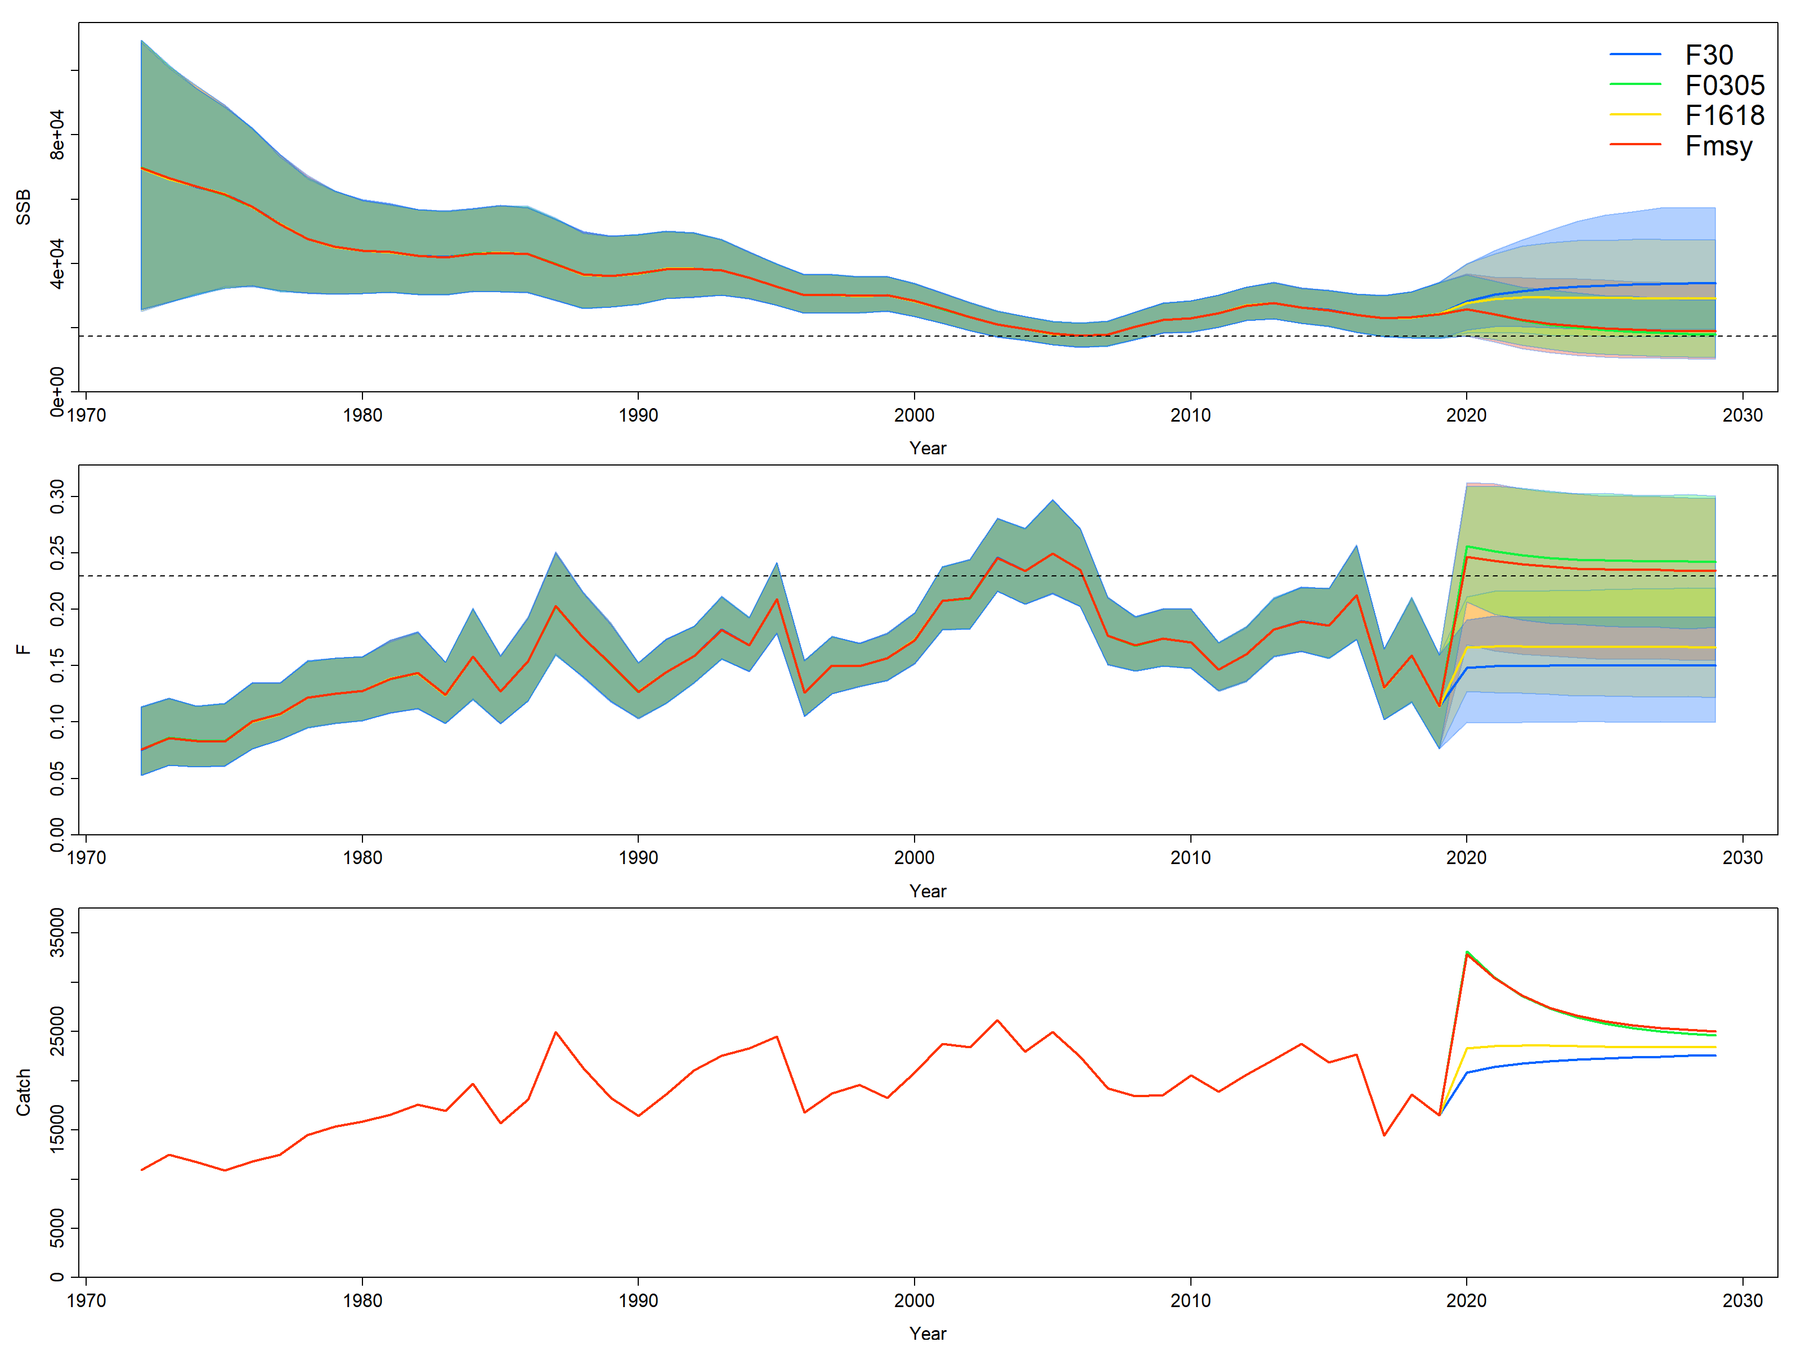
Figure PBUM-3. Historical and projected trajectories of spawning biomass and total catch from the Pacific blue marlin combined models based upon the four F scenarios: projected spawning biomass, dotted line indicates SSB_{MSY}, shading indicates 95% confidence intervals (top); projected instantaneous fishing mortality (ages 1-10 year⁻¹), dotted line indicates F_{MSY}, shading indicates 95% confidence intervals (center); and projected catch (mt. bottom). Green indicates scenario 1, F_{2003-2005;} red indicates scenario 2, F_{MSY}; yellow indicates scenario 3, F₂₀₁₆₋₂₀₁₈; and blue indicates scenario 4, F_{30%}. The list of projection scenarios can be found in Table 3.

SC13-2017 – SC16-2020 (NO STOCK ASSESSMENTS)

- There was no stock assessment for Pacific blue marlin in 2020. This was not discussed at SC17 due to its streamlined agenda and discussion were conducted virtually due to the impacts of COVID-19 pandemic. Therefore, the stock status descriptions and management advice from SC12 are still current for Pacific blue marlin.

- Stock Status and trends

- SC15 noted that no stock assessments were conducted for Pacific blue marlin in 2019. Therefore, the stock status descriptions from SC12 are still current for Pacific blue marlin. For further information on the stock status and trends from SC12, please see https://www.wcpfc.int/node/27769. Updated information on catches was not compiled for and reviewed by SC15.

- Management Advice and implications

- SC15 noted that no management advice has been provided since SC12 for Pacific blue marlin. Therefore, previous advice should be maintained, pending a new assessment or other new information. For further information on the management advice and implications from SC12, please see https://www.wcpfc.int/node/27769

SC12-2016 (STOCK ASSESSMENT CONDUCTED)

Stock status and trends

- SC12 noted the stock status for Pacific blue marlin provided by ISC in SC12-GN-IP-02 and SC12-SA-WP-12:
Estimates of total BUM stock biomass show a long term decline. Population biomass (age-1 and older) averaged roughly 130,965 t in 1971-1975, the first 5 years of the assessment time frame, and has declined by approximately 40% to 78,082 t in 2014 (Figure 7-11). Female spawning biomass was estimated to be 24,809 t in 2014, or about 25% above SSBMSY (Table 7-3 and Table 7-4). Fishing mortality on the stock (average F, ages 2 and older) averaged roughly F = 0.28 during 2012-2014, or about 12% below FMSY. The estimated spawning potential ratio of the stock (SPR, the predicted spawning output at the current F as a fraction of unfished spawning output) is currently SPR2012-2014 = 21%. Annual recruitment averaged about 897,000 recruits during 2008-2014, and no long-term trend in recruitment was apparent. Overall, the time series of spawning stock biomass and recruitment estimates indicate a long-term decline in spawning stock biomass and suggest a fluctuating pattern without trend for recruitment (Figure 7-11).

Table 7-3. Reported catch (t) used in the stock assessment along with annual estimates of population biomass (age-1 and older, t), female spawning biomass (t), relative female spawning biomass (SSB/SSBMSY), recruitment (thousands of age-0 fish), fishing mortality (average F, ages-2 and older), relative fishing mortality (F/FMSY), and spawning potential ratio of Pacific blue marlin.

Year | 2008 | 2009 | 2010 | 2011 | 2012 | 2013 | 2014 | Mean¹ | Min¹ | Max¹
Reported Catch | 17,828 | 18,282 | 20,086 | 18,165 | 19,407 | 20,727 | 20,356 | 18,232 | 9,160 | 25,589
Population Biomass | 71,768 | 69,720 | 72,696 | 72,995 | 76,697 | 78,761 | 78,082 | 101,149 | 69,720 | 135,623
Spawning Biomass | 22,706 | 23,065 | 22,392 | 23,182 | 23,432 | 24,771 | 24,809 | 41,717 | 20,972 | 71,807
Relative Spawning Biomass | 1.14 | 1.16 | 1.13 | 1.17 | 1.18 | 1.25 | 1.25 | 2.10 | 1.06 | 3.62
Recruitment (age 0) | 687 | 1031 | 702 | 1061 | 763 | 909 | 839 | 897 | 589 | 1181
Fishing Mortality | 0.27 | 0.29 | 0.30 | 0.26 | 0.27 | 0.28 | 0.28 | 0.22 | 0.09 | 0.38
Relative Fishing Mortality | 0.82 | 0.88 | 0.92 | 0.82 | 0.83 | 0.87 | 0.87 | 0.67 | 0.26 | 1.17
Spawning Potential Ratio | 22% | 21% | 20% | 22% | 22% | 21% | 21% | 31% | 15% | 51%
¹ During 1971-2014
Table 7-4. Estimates of biological reference points along with estimates of fishing mortality (F), female spawning stock biomass (SSB), recent average yield (C), and spawning potential ratio (SPR) of BUM, derived from the base case model assessment model, where “MSY” and “20%” indicate reference points based on maximum sustainable yield and a spawning potential ratio of 20%, respectively.
Reference Point | Estimate
F_{MSY} (age 2+) | 0.32
F20% (age 2+) | 0.30
F2012-2014 (age 2+) | 0.28
SSBMSY | 19,853 mt
SSB20% | 22,727 mt
SSB2014 | 24,809 mt
MSY | 19,901 mt
C2012-2014 | 20,163 mt
SPRMSY | 0.18
SPR2012-2014 | 0.21
Note: SSB values represent female spawning biomass only.

The Kobe plot depicts the stock status relative to MSY-based reference points for the base case model (Figure 7-12) and shows that spawning stock biomass decreased to roughly the MSY level in the mid-2000s, and has increased slightly in recent years (Table 7-4 and Figure 7-11).Based on the results of this 2016 stock assessment update, the Pacific blue marlin stock is not currently overfished and is not experiencing overfishing. Because Pacific blue marlin is mainly caught as bycatch, direct control of the annual catch amount through the setting of a total allowable catch may be difficult.”

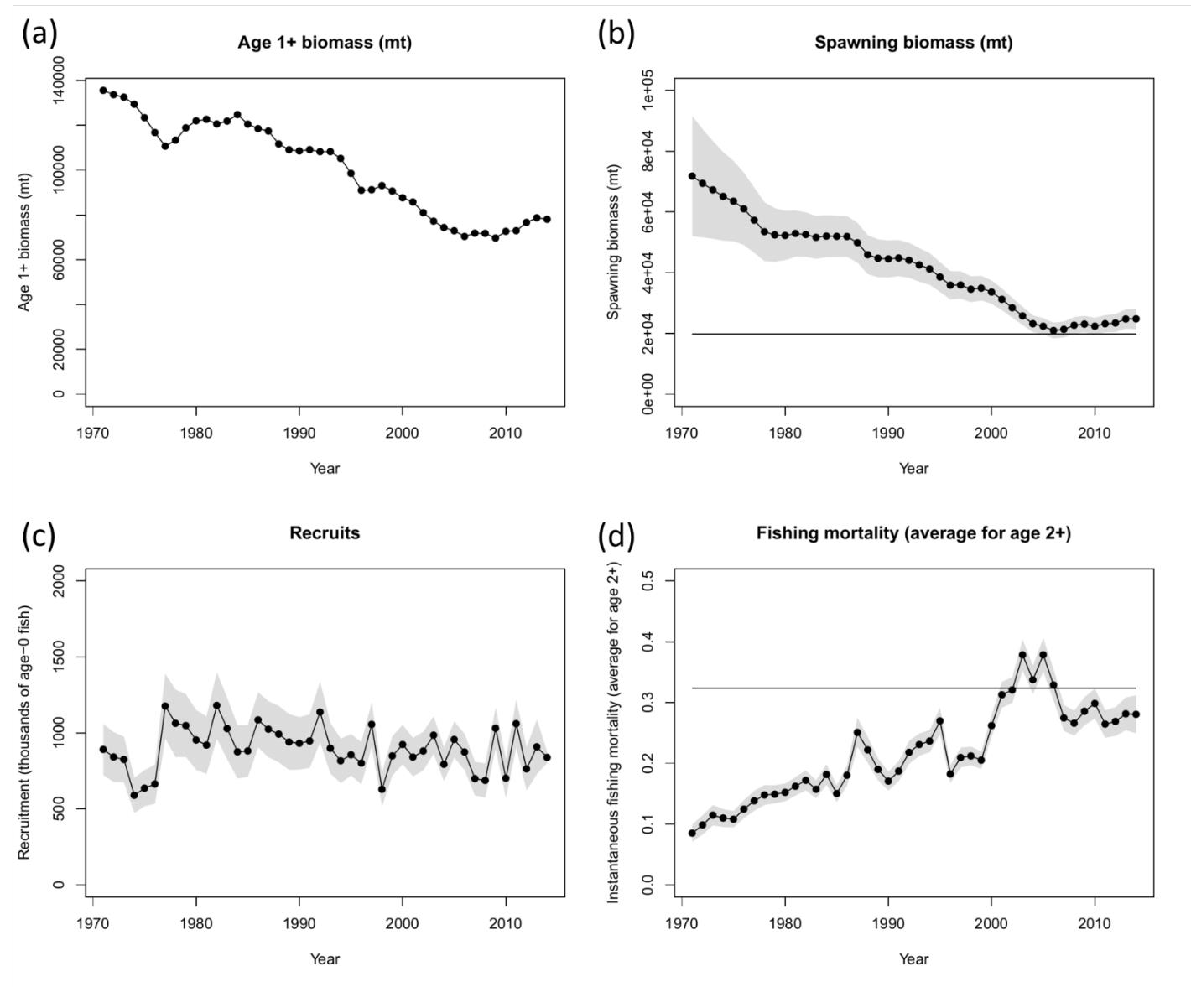
Figure 7-11. Time series of estimates of (a) population biomass (age 1+), (b) female spawning biomass, (c) recruitment (age-0 fish), and (d) instantaneous fishing mortality (average for age 2+, year-1) for BUM derived from the 2016 stock assessment update. The solid circles represents the maximum likelihood estimates by year for each quantity and the shadowed area represents the uncertainty of the estimates (± 1 standard deviation), except for the total biomass time series. The solid horizontal lines indicate the MSY- based reference points for spawning biomass and fishing mortality.

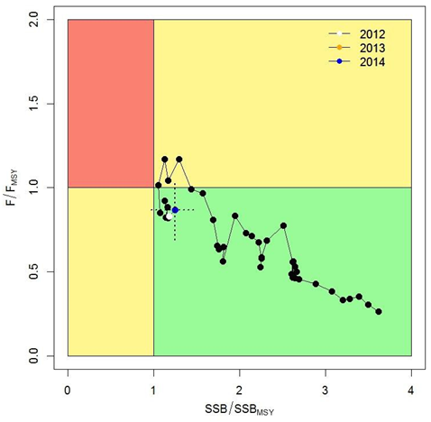 | Figure 7-12. Kobe plot of the time series of estimates of relative fishing mortality (average of age 2+) and relative spawning stock biomass of BUM during 1971-2014. The dashed lines denote the 95% confidence intervals for the estimates in the year 2014.

Management advice and implications

- SC12 noted the conservation advice for Pacific blue marlin provided by ISC in SC12-GN-IP-02 and SC12-SA-WP-12:

Since the stock is nearly full exploited, the ISC recommends that fishing mortality remain at or below current levels (2012-2014).
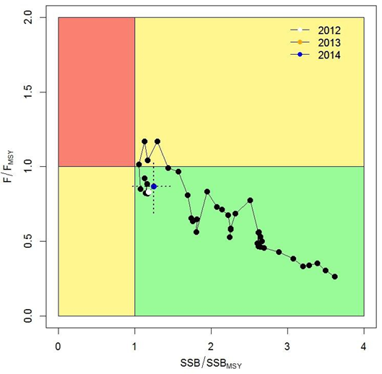 | Figure 7-12. Kobe plot of the time series of estimates of relative fishing mortality (average of age 2+) and relative spawning stock biomass of BUM during 1971-2014. The dashed lines denote the 95% confidence intervals for the estimates in the year 2014.

Useful References

SC17-SA-WP-08 Stock assessment report for Pacific blue marlin (Makaira Nigricans) through 2019. International Scientific Committee for Tuna and Tuna-like Species in the North Pacific Ocean (ISC)
https://meetings.wcpfc.int/node/12557

SC17-GN-IP-03 Report of the 21st Meeting of the International Scientific Committee for Tuna and Tuna-like Species in the North Pacific Ocean. https://meetings.wcpfc.int/node/12528

SC12-GN-IP-02 Report of the 16th Meeting of the International Scientific Committee for Tuna and Tuna-like Species in the North Pacific Ocean. ISC (International Scientific Committee for Tuna and Tuna-like Species in the North Pacific Ocean) https://wcpfc.int/node/27556

For current information related to Northern Stocks Working Group Reports and the ISC Plenary Report:
http://isc.fra.go.jp/reports/isc/isc18_reports.html

Previous Assessments

SC12-SA-WP12 Stock Assessment Update for Blue Marlin (Makaira nigricans) in the Pacific Ocean through 2014. ISC Billfish Working Group. https://wcpfc.int/node/27549

SC9-SA-WP-09 Stock Assessment of Blue Marlin in the Pacific Ocean in 2013 (Replacement Document 31 July 2013) https://wcpfc.int/node/4732

International Scientific Committee for Tuna and Tuna-like Species in the North Pacific Ocean

