**Western and Central Pacific Fisheries Commission (WCPFC)**

**E-REPORTING STANDARD DATA FIELDS**

**OPERATIONAL LOGSHEET DATA**

*Draft – Version 2.0*

*7th June 2015*

Contents

INTRODUCTION 2

1. PURSE SEINE LOGBOOK E-REPORTING STANDARDS 3

1.1 DATA MODEL DIAGRAM 3

1.2 PURSE SEINE TRIP-LEVEL DATA 4

1.3 LICENSE/PERMIT DATA 6

1.4 PS UNLOADING DATA 7

1.5 PS ACTIVITY DATA 9

1.6 PS SET LEVEL DATA 10

1.7 PS CATCH DATA 11

1.8 PS DISCARD DATA 12

1.9 PS WELL TRANSFER DATA 13

2. LONGLINE LOGBOOK E-REPORTING STANDARDS 14

2.1 DATA MODEL DIAGRAM 14

2.2 LONGLINE TRIP-LEVEL DATA 15

2.3 LICENSE/PERMIT DATA 17

2.4 LL ACTIVITY/SET DATA 18

2.5 LL CATCH DATA 19

APPENDICES 20

APPENDIX A1 – DATE/TIME FORMAT 20

APPENDIX A2 – POSITION/COORDINATE FORMAT 20

APPENDIX A3 – PORT LOCATION CODES 20

APPENDIX A4 – VESSEL IDENTIFICATION 21

APPENDIX A5 – PURSE SEINE OBSERVER ACTIVITY CODES 22

APPENDIX A6 – PURSE SEINE TUNA SCHOOL ASSOCIATION CODES 22

APPENDIX A7 – SPECIES CODES 22

APPENDIX A8 – PURSE SEINE REASON FOR DISCARD 23

# INTRODUCTION

These tables set out the proposed standards for the provision of operational logsheet data fields collected in the WCPFC tropical purse seine fishery and the longline fisheries through E-Reporting. These tables provide the minimum requirements for data entities, data formats and data validation to be established for data submitted to the national and regional fisheries authorities from E-Reporting systems. The data fields contained herein are based on information collected under the current regional standard data collection forms. This document acknowledges that national fisheries authorities require data (e.g. licence/permit numbers and for anticipated Catch Documentation System – CDS – requirements) that are not mandatory WCPFC data fields, so a column in these tables identifies whether the data field is a mandatory WCFPC data field[1] or not.

These E-Reporting data field standards are consistent with, and should be considered in conjunction with more detailed instructions[2] on how to collect LOGBOOK data provided by SPC.

(We would like to seek further explanation on the underlined sentence)

These tables are intended for, *inter alia*, E-Reporting service providers who have been contracted to provide electronic systems to record LOGBOOK information on-board purse seine vessels.

# PURSE SEINE LOGBOOK E-REPORTING STANDARDS

## DATA MODEL DIAGRAM

The following basic data model diagram outlines the structure of the entities and their relationships for purse seine operational logsheet data collected by E-Reporting systems and submitted to national and regional fisheries authorities. The tables that follow provide more information on the mechanisms of the links (relationships) between the entities.

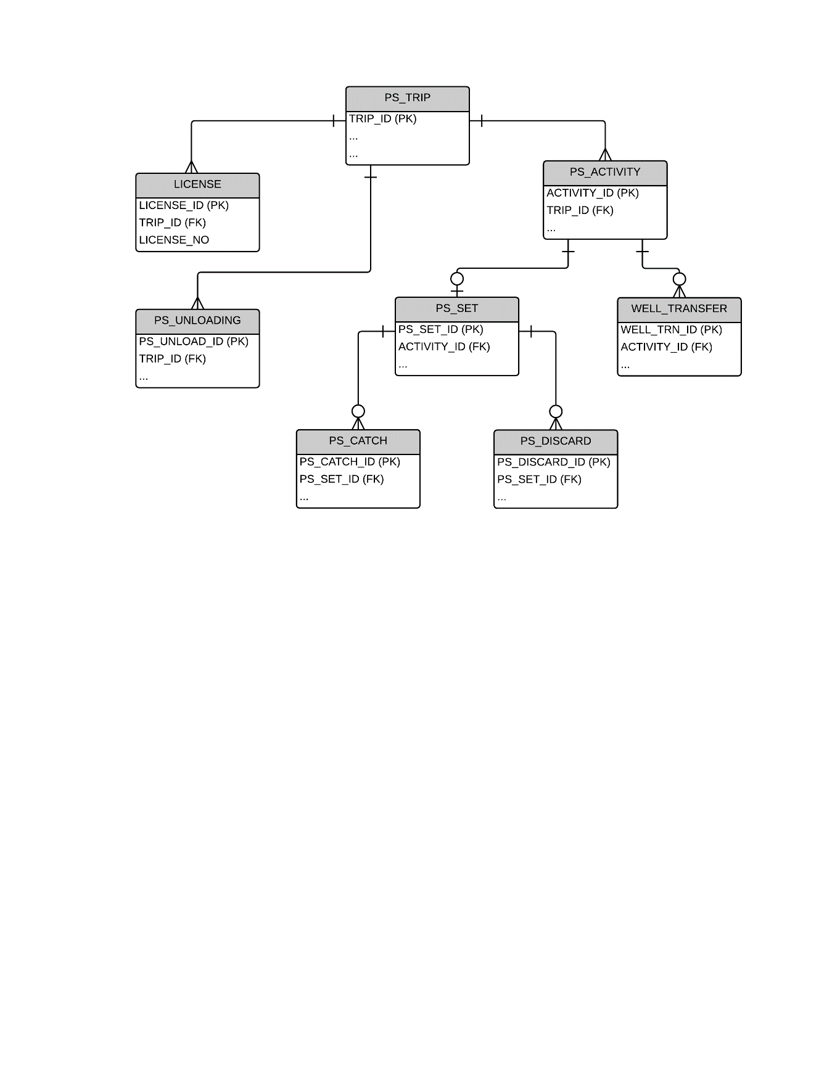

## PURSE SEINE TRIP-LEVEL DATA

| **PS_TRIP**  “The start of a trip is defined to occur when a vessel (a) leaves port after unloading part or all of the catch to transit to a fishing area or (b) recommences fishing operations or transits to a fishing area after transshipping part or all of the catch at sea (when this occurs in accordance with the terms and conditions of article 4 of Annex III of the Convention, subject to specific exemptions as per article 29 of the Convention).” | | | | | | | |
| --- | --- | --- | --- | --- | --- | --- | --- |
| **FIELD** | **Data Collection Instructions** | **Field format notes** | **Validation rules** | **NAF CODE** | **XML TAG** | **WCPFC**  **FIELD** |  |
| TRIP IDENTIFIER | Internally generated. Can be NATURAL KEY or unique integer. NATURAL KEY would be VESSEL IDENTIFIER + DEPARTURE DATE |  |  |  | <TRIP_ID> |  |  |
| VESSEL IDENIFIER | REFER TO APPENDIX A4 | | | | | |  |
| COUNTRY OF CHARTER | PROVIDE the Country responsible for chartering the vessel, where relevant.  This only applies if the vessel has been chartered according to the requirements under WCFPC CMM 2012-05 – chartering notifications. | CHAR(2)  ISO 3166-1 alpha-2t Two-letter country code  UPPER CASE | ISO 3166-1 alpha-2 t Two-letter country code  This field must be completed if it has been listed as a chartered vessel on the WCPFC web site according to the requirements under WCFPC CMM 2012-05 – chartering notifications. | CS | <CHARTER> | Y | We are fine with using TW as our country code. However, please do not clearly indicate the reference of ISO or UN codes in this documents.  A separate table may work for this purpose. |
| AGENT FOR UNLOADING | PROVIDE the name of the Agent for the Unloading | CHAR(50) | Where possible, link this field to a reference table of authorised Agents for unloading. (referential integrity) | AN | <Agent> | N |  |
| TRIP NUMBER | PROVIDE the trip number undertaken by this vessel for the year. Trip number is sequential, starting at 1 for first trip of the year for each vessel. | INTEGER(2) |  | TN | <TripNo> | N |  |
| PORT OF DEPARTURE | PROVIDE the Port of Departure | REFER TO APPENDIX A3 | Must be valid United Nations - Code for Trade and Transport Locations (UN/LOCODE) – see <http://www.unece.org/cefact/locode/service/location> | PE | <PortDepart> | Y | (Please don’t clearly indicate UN reference. A separate and redesigned table may also work for this purpose.) |
| PLACE OF UNLOADING | PROVIDE the Port of Return for Unloading | REFER TO APPENDIX A3 | Must be valid United Nations - Code for Trade and Transport Locations (UN/LOCODE) | PO | <PortUnload> | Y | (Please don’t clearly indicate UN reference. A separate and redesigned table may also work for this purpose.) |
| DATE and TIME OF DEPARTURE | PROVIDE the GMT/UTC DATE and TIME of departure for this trip | REFER TO APPENDIX A1 | ISO 8601 - Dates and times format  The chronology of Departure date with respect to Date of arrival in port and the Days at sea must be valid. | SD ST | <DateDepart> <TimeDepart> | Y |  |
| DATE AND TIME OF ARRIVAL IN PORT | PROVIDE the GMT/UTC DATE and TIME of arrival back in port for this trip | REFER TO APPENDIX A1 | ISO 8601 - Dates and times format  The chronology of Arrival date with respect to Date of Departure and the Days at sea must be valid. | ED ET | <DateArrival> <TimeArrival> | Y |  |
| FISH ONBOARD – START | PROVIDE the total amount of fish on-board at the time of leaving port on this trip. | NUMBER(4) | WARNING: Should be a realistic amount. For example, having catch >200 t. would be unrealistic? | QS | <AmountStart> | N |  |
| FISH ONBOARD – END | PROVIDE the total amount of fish on-board AFTER ALL UNLOADINGs have been undertaken before the next trip. | NUMBER(4) | WARNING: Should be a realistic amount. For example, having catch >200 t. would be unrealistic?  Having catch greater than what was caught on the trip is not possible. | QE | <AmountAfter> | N |  |

## LICENSE/PERMIT DATA

|  |  |  |  |  |  |  |  |  |
| --- | --- | --- | --- | --- | --- | --- | --- | --- |
| **LICENSE**  **PROVIDE each LICENSE/PERMIT that the vessel holds for the period of the trip.** | | | | | | | | |
| **FIELD** | **Data Collection Instructions** | | **Field format notes** | **Validation rules** | **NAF CODE** | **XML TAG** | **WCPFC**  **FIELD** |  |
| TRIP IDENTIFIER | | Internally generated. Can be NATURAL KEY or unique integer. NATURAL KEY would be VESSEL + DEPARTURE DATE |  |  |  | <TRIP_ID> |  |  |
| FISHING PERMIT/LICENSE NUMBERS | | PROVIDE License/Permit number that the vessel holds for the period of the TRIP. | CHAR(40)  UPPER CASE | Where possible, include validation to ensure the Permit format relevant to the agreement (national or sub-regional) complies to the required format. | LC | <License_NO> | N |  |

## PS UNLOADING DATA

| **PS_UNLOADING**  PROVIDE information for TRIP UNLOADING INFORMATION which covers one or several unloading events during or at the end of the trip to (i) carriers, (ii) on-shore processing plants (Canneries) and/or (iii) a net-share event with another catcher vessel | | | | | | | | |
| --- | --- | --- | --- | --- | --- | --- | --- | --- |
| **FIELD** | **Data Collection Instructions** | **Field format notes** | **Validation rules** | **NAF CODE** | **XML TAG** | **WCPFC**  **FIELD** | |  |
| TRIP IDENTIFIER | Internally generated. Can be NATURAL KEY or unique integer. NATURAL KEY would be VESSEL + DEPARTURE DATE |  | Link to TRIP information |  | <TRIP_ID> |  | | 非最低欄位需求 |
| UNLOADING START DATE | PROVIDE the start date for this specific Unloading event | REFER TO APPENDIX A1 | ISO 8601 - Dates and times format  GMT/UTC time  [YYYY]-[MM]-[DD]T[HH]:[MM]Z  The chronology of Unload Start date with respect to other dates for the trip and unloading must be valid. | SD | <StartDate> | N | |  |
| UNLOADING END DATE | PROVIDE the end date for this specific Unloading event | REFER TO APPENDIX A1 | ISO 8601 - Dates and times format  GMT/UTC time  [YYYY]-[MM]-[DD]T[HH]:[MM]Z  The chronology of Unload End date with respect to other dates for the trip and unloading must be valid. | ED | <EndDate> | N | |  |
| CARRIER VESSEL IDENTIFIER | REFER TO APPENDIX A4  If relevant, PROVIDE the receiving CARRIER VESSEL for this specific Unloading event. Note that for NET-SHARE events, this could be another purse seine catcher vessel. If Relevant, PROVIDE the FFA VID for the CARRIER vessel. Must be consistent with the WCPFC and FFA Vessel Registers | | | | | | | |
| CANNERY/ DESTINATION | If relevant, PROVIDE the receiving CANNERY/DESTINATION for this specific Unloading event. | CHAR(40)  UPPER CASE | Where possible, link this field to a reference table of authorised Canneries/Destinations (referential integrity) | FD  FN | <DESTINATION> | N |  | |
| SKJ UNLOADED | PROVIDE the total weight (metric tonnes) of SKIPJACK unloaded in this specific Unloading event | DECIMAL(7,3) | CONTROL TOTAL CHECK: Total amounts for this trip should reconcile checking total trip catch, catch on-board at start, catch on-board at end and all unloading events. | DQ | <UnloadSKJ> | N | |  |
| YFT UNLOADED | PROVIDE the total weight (metric tonnes) of YELLOWFIN unloaded in this specific Unloading event | DECIMAL(7,3) | DQ | <UnloadYFT> | N | |  |
| BET UNLOADED | PROVIDE the total weight (metric tonnes) of BIGEYE unloaded in this specific Unloading event | DECIMAL(7,3) | DQ | <UnloadBET> | N | |  |
| MIXED TUNA UNLOADED | PROVIDE the total weight (metric tonnes) of MIXED TUNA unloaded in this specific Unloading event | DECIMAL(7,3) | DQ | <UnloadMIX> | N | |  |
| OTHERS UNLOADED | PROVIDE the total weight (metric tonnes) of OTHERS unloaded in this specific Unloading event | DECIMAL(7,3) | DQ | <UnloadOTH> | N | |  |
| REJECTS UNLOADED | PROVIDE the total weight (metric tonnes) of REJECTED TUNA unloaded in this specific Unloading event | DECIMAL(7,3) | RT | <UnloadREJ> | N | |  |

## PS ACTIVITY DATA

| **PS_ACTIVITY**  PROVIDE information on the designated activities for each DAY AT SEA | | | | | | | | |
| --- | --- | --- | --- | --- | --- | --- | --- | --- |
| **FIELD** | **Data Collection Instructions** | **Field format notes** | **Validation rules** | **NAF CODE** | **XML TAG** | **WCPFC** | | **FIELD** |
| TRIP IDENTIFIER | Internally generated. Can be NATURAL KEY or unique integer. NATURAL KEY would be VESSEL + DEPARTURE DATE |  | Link to TRIP information |  | <TRIP_ID> |  |  | |
| ACTIVITY IDENTIFIER | Internally generated. Can be NATURAL KEY or unique integer. NATURAL KEY would be DATE + START TIME OF ACTIVITY |  |  |  | <ACTIVITY_ID> |  |  | |
| DATE | PROVIDE the DATE for each day that the vessel is at sea. | REFER TO APPENDIX A1 | Expect to be automatically integrated/generated with GPS DEVICE | DA | <DATE_EVENT > | Y |  | |
| START TIME OF ACTIVITY | PROVIDE the time when the ACTIVITY started | REFER TO APPENDIX A1 | Expect to be automatically integrated/generated with GPS DEVICE | ST | <TIME_EVENT> | Y |  | |
| LATITUDE | PROVIDE the LATITUDE position when the ACTIVITY started | REFER TO APPENDIX A2 | Expect to be automatically integrated/generated with GPS DEVICE | LT | <LAT> <LATH> | Y |  | |
| LONGITUDE | PROVIDE the LONGITUDE position when the ACTIVITY started | REFER TO APPENDIX A2 | Expect to be automatically integrated/generated with GPS DEVICE | LG | <LON> <LONH> | Y |  | |
| ACTIVITY | PROVIDE each new ACTIVITY of the vessel within the DAY | REFER TO APPENDIX A5 | The code must be within the valid range.  Ensure relational integrity for certain values, for example,  “1 – Fishing Set” must link to a SET record and perhaps to other tables  “8 – Non-Set Well Transfer” must link to a WELL_TRANSFER record | AT | <S_ACT_ID> | Y |  | |

## PS SET LEVEL DATA

| **PS_SET**  PROVIDE information for each FISHING SET | | | | | | | | |
| --- | --- | --- | --- | --- | --- | --- | --- | --- |
| **FIELD** | **Data Collection Instructions** | **Field format notes** | **Validation rules** | **NAF CODE** | **XML TAG** | **WCPFC** | | **FIELD** |
| TRIP IDENTIFIER | Internally generated. Can be NATURAL KEY or unique integer. NATURAL KEY would be VESSEL + DEPARTURE DATE |  | Link to TRIP information |  | <TRIP_ID> |  |  | |
| ACTIVITY IDENTIFIER | Internally generated. Can be NATURAL KEY or unique integer. NATURAL KEY would be DATE + START TIME OF ACTIVITY |  | Link to ACTIVITY (SET) |  | <ACTIVITY_ID> |  |  | |
| START DATE/TIME OF SET | PROVIDE the start time of the set which is defined at the time the SKIFF is launched. | REFER TO APPENDIX A1 | (Expect to be automatically integrated/generated with GPS DEVICE)  The chronology of SET START TIME with respect to other dates/times for the trip must be valid. | ST | <SetStart> | Y |  | |
| END DATE/TIME OF SET | PROVIDE the end time of the set which is defined as the time when the “RINGS UP” ON DECK. | REFER TO APPENDIX A1 | Expect to be automatically integrated/generated with GPS DEVICE  The chronology of SET END TIME with respect to other dates/times for the trip must be valid. | ET | <SetEnd> | Y |  | |
| SCHOOL ASSOCIATION | PROVIDE the School Associated Code | REFER TO APPENDIX A6 | The code must be within the valid range. | SA | <SCHOOL> | Y |  | |
| SCHOOL ASSOCIATION NOTE | PROVIDE information of the SCHOOL ASSOCIATION in cases where the school association is not covered in the list of School association codes 1. To 7. | VARCHAR(30) | Used only when the SCHOOL ASSOCIATION = 8 | SA | <SCH_NOTE> | Y |  | |

## PS CATCH DATA

| **PS_CATCH**  **PROVIDE information on each species catch RETAINED from a SET** | | | | | | | |
| --- | --- | --- | --- | --- | --- | --- | --- |
| **FIELD** | **Data Collection Instructions** | **Field format notes** | **Validation rules** | **NAF CODE** | **XML TAG** | **WCPFC**  **FIELD** | |
| TRIP IDENTIFIER | Internally generated. Can be NATURAL KEY or unique integer. NATURAL KEY would be VESSEL + DEPARTURE DATE |  | Link to TRIP information |  | <TRIP_ID> |  |  |
| ACTIVITY IDENTIFIER | Internally generated. Can be NATURAL KEY or unique integer. NATURAL KEY would be DATE + START TIME OF ACTIVITY |  | Link to ACTIVITY (SET) |  | <ACTIVITY_ID> |  |  |
| SET IDENTIFIER | Internally generated. Can be NATURAL KEY or unique integer. NATURAL KEY would be DATE + START TIME OF SET |  | Link to PS_SET |  | <PS_SET_ID> |  |  |
| SPECIES CODE | For each species taken in the set and RETAINED, PROVIDE the SPECIES CODE according to the FAO standard species code list | CHAR(3) | REFER TO APPENDIX 7. | DC | <SP_CODE> | Y |  |
| SIZE CATEGORY | For Yellowfin (YFT) and Bigeye tuna (BET) RETAINED catch, distinguish the catch by size category < 9kgs and > 9kgs) otherwise leave blank. | CHAR(2) | LG - Large Fish (>= 9 kgs)  SM - Small Fish (< 9 kgs)  <Blank> - Not applicable  Validate that it can only be used for YFT and BET. | DC | <SP_SIZE> | N |  |
| WELL TO | Well number where the catch is moved to.  Set catch for this species/size category may be moved to more than one well. (Used for Catch Documentation systems). | CHAR(3) | Valid code  DIS – Discard of fish to sea from a well (e.g. due to spoilage)  Snn – Starboard well with number = <nn>  Pnn – Port well with number = <nn>  Cnn – Central well with number = <nn> | TC | <WELL_TO> | N |  |
| RETAINED WEIGHT | PROVIDE the RETAINED ESTIMATED WEIGHT (metric tonnes, to 3 decimal places if possible) covering this species/size category combination. | DECIMAL(7,3) | Validate that it is within the acceptable range for this species. (Refer to the SPECIES_RANGE table provided) | DC | <SP_RET_MT> | Y |  |
| RETAINED NUMBER | PROVIDE the RETAINED NUMBER covering this species/size category combination. This is only required for non-target species. | INTEGER(6) | Validate that it is within the acceptable range for this species. (Refer to the SPECIES_RANGE table provided) | DC | <SP_RET_NO> | N |  |

## PS DISCARD DATA

|  |  |  |  |  |  |  |  |  |
| --- | --- | --- | --- | --- | --- | --- | --- | --- |
| **PS_DISCARD**  **PROVIDE information on each species catch DISCARDED from a SET** | | | | | | | | |
| **FIELD** | **Data Collection Instructions** | **Field format notes** | **Validation rules** | **NAF CODE** | **XML TAG** | **WCPFC** | **FIELD** | |
| TRIP IDENTIFIER | Internally generated. Can be NATURAL KEY or unique integer. NATURAL KEY would be VESSEL + DEPARTURE DATE |  | Link to TRIP information |  | <TRIP_ID> |  | |  |
| ACTIVITY IDENTIFIER | Internally generated. Can be NATURAL KEY or unique integer. NATURAL KEY would be DATE + START TIME OF ACTIVITY |  | Link to ACTIVITY (SET) |  | <ACTIVITY_ID> |  | |  |
| SET IDENTIFIER | Internally generated. Can be NATURAL KEY or unique integer. NATURAL KEY would be DATE + START TIME OF SET |  | Link to PS_SET |  | <PS_SET_ID> |  | |  |
| SPECIES CODE | For each species taken in the set and DISCARDED, PROVIDE the SPECIES CODE according to the FAO standard species code list | CHAR(3) | REFER TO APPENDIX 7. | DI | <SP_CODE> | Y | |  |
| DISCARDED WEIGHT | PROVIDE the DISCARDED ESTIMATED WEIGHT (metric tonnes, to 3 decimal places if possible) covering this species. | DECIMAL(7,3) | Validate that it is within the acceptable range for this species. (Refer to the SPECIES_RANGE table provided) | DI | <SP_DISC_MT> | Y | |  |
| DISCARDED NUMBER | PROVIDE the DISCARDED NUMBER, where appropriate. | INTEGER(6) | Validate that it is within the acceptable range for this species. (Refer to the SPECIES_RANGE table provided) | DI | <SP_DISC_NO> | Y | |  |
| REASON FOR DISCARD | PROVIDE the reason for the DISCARD. | INTEGER(1) | REFER TO APPENDIX 8. | DI | <DISC_REA_ID> | Y | |  |
| REASON FOR DISCARD NOTE | PROVIDE information of the REASON FOR DISCARD in cases where the code is not covered in the list of Reason codes 1. To 4. | VARCHAR(30) | Used only when the REASON FOR DISCARD = 5 | DI | <DISC_NOTE> | Y | |  |

## PS WELL TRANSFER DATA

|  |  |  |  |  |  |  |  |  |
| --- | --- | --- | --- | --- | --- | --- | --- | --- |
| **WELL_TRANSFER**  **PROVIDE information on each WELL TRANSFER or NET-to-WELL TRANSFER when the relevant ACTIVITIES are recorded** | | | | | | | | |
| **FIELD** | **Data Collection Instructions** | **Field format notes** | **Validation rules** | **NAF CODE** | **XML TAG** | **WCPFC** | **FIELD** | |
| TRIP IDENTIFIER | Internally generated. Can be NATURAL KEY or unique integer. NATURAL KEY would be VESSEL + DEPARTURE DATE |  | Link to TRIP information |  | <TRIP_ID> |  | |  |
| ACTIVITY IDENTIFIER | Internally generated. Can be NATURAL KEY or unique integer. NATURAL KEY would be DATE + START TIME OF ACTIVITY |  | Link to ACTIVITY (SET or WELL TRANSFER) |  | <ACTIVITY_ID> |  | |  |
| WELL FROM | Well number or the NET (in the case of a set) where the catch is coming from. | CHAR(3) | Valid code  Snn – Starboard well with number = <nn>  Pnn – Port well with number = <nn>  Cnn – Central well with number = <nn> | TC | <WELL_FROM> | N | |  |
| WELL TO | Well number where the catch is moved to. Note that this includes DISCARDs of fish from the well. | CHAR(3) | Valid code  DIS – Discard of fish to sea from a well (e.g. due to spoilage)  Snn – Starboard well with number = <nn>  Pnn – Port well with number = <nn>  Cnn – Central well with number = <nn> | TC | <WELL_TO> | N | |  |
| SPECIES CODE | For each species catch transferred, PROVIDE the SPECIES CODE according to the FAO standard species code list | CHAR(3)  UPPER CASE | REFER TO APPENDIX 7. | TC | <SP_CODE_WELL> | N | |  |
| SIZE CATEGORY | For Yellowfin (YFT) and Bigeye tuna (BET) transferred catch, distinguish the catch by size category < 9kgs and > 9kgs) otherwise leave blank. | CHAR(2) | LG - Large Fish (>= 9 kgs)  SM - Small Fish (< 9 kgs)  <Blank> - Not applicable  Validate that it can only be used for YFT and BET. | DC | <SP_WELL_SIZE> | N | |  |
| WEIGHT TRANSERRED | PROVIDE the WEIGHT (metric tonnes, to 3 decimal places if possible) of the species transferred. | DECIMAL(6,3) |  | TC | <SP_WELL_MT> | N | |  |

# LONGLINE LOGBOOK E-REPORTING STANDARDS

## DATA MODEL DIAGRAM

The following basic data model diagram outlines the structure of the entities and their relationships for longline operational logsheet data collected by E-Reporting systems and submitted to national and regional fisheries authorities. The tables that follow provide more information on the mechanisms of the links (relationships) between the entities.

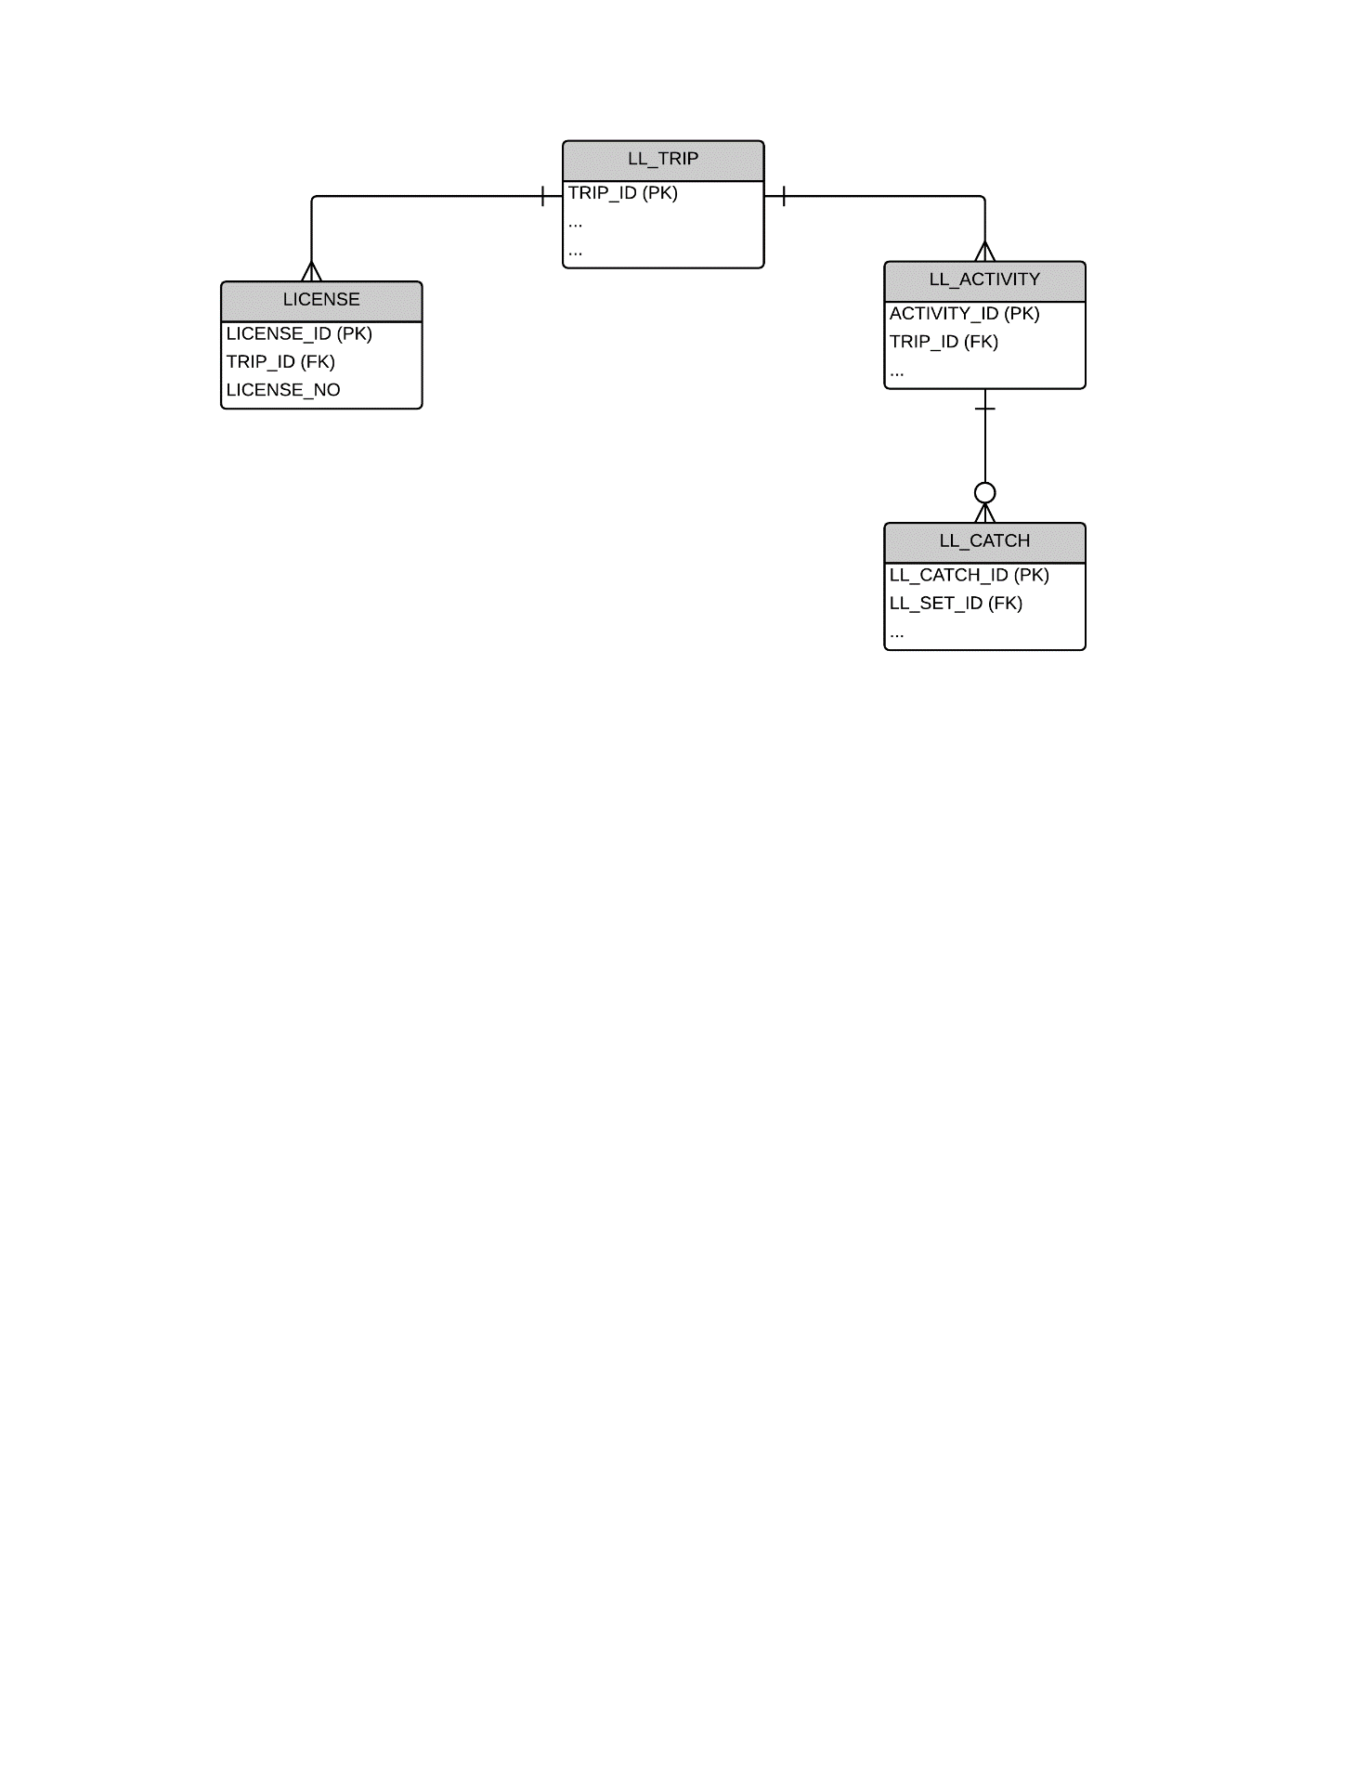

## LONGLINE TRIP-LEVEL DATA

| **LL_TRIP**  “The start of a trip is defined to occur when a vessel (a) leaves port after unloading part or all of the catch to transit to a fishing area or (b) recommences fishing operations or transits to a fishing area after transshipping part or all of the catch at sea (when this occurs in accordance with the terms and conditions of article 4 of Annex III of the Convention, subject to specific exemptions as per article 29 of the Convention).” | | | | | | | |
| --- | --- | --- | --- | --- | --- | --- | --- |
| **FIELD** | **Data Collection Instructions** | **Field format notes** | **Validation rules** | **NAF CODE** | **XML TAG** | **WCPFC**  **FIELD** |  |
| TRIP IDENTIFIER | Internally generated. Can be NATURAL KEY or unique integer. NATURAL KEY would be VESSEL IDENTIFIER + DEPARTURE DATE |  |  |  | <TRIP_ID> |  | We may use our internal identifier such as VESSEL IDENTIFIER + after transshipping DATE” |
| VESSEL IDENIFIER | REFER TO APPENDIX A4 | | | | |  |  |
| COUNTRY OF CHARTER | PROVIDE the Country responsible for chartering the vessel, where relevant.  This only applies if the vessel has been chartered according to the requirements under WCFPC CMM 2012-05 – chartering notifications. | CHAR(2)  ISO 3166-1 alpha-2 two-letter country code  UPPER CASE | ISO 3166-1 alpha-2 two-letter country code  This field must be completed if it has been listed as a chartered vessel on the WCPFC web site according to the requirements under WCFPC CMM 2012-05 – chartering notifications. | CS | <CHARTER> | Y |  |
| AGENT FOR UNLOADING | PROVIDE the name of the Agent for the Unloading | CHAR(50) | Where possible, link this field to a reference table of authorised Agents for unloading. (referential integrity) | AN | <Agent> | N |  |
| TRIP NUMBER | PROVIDE the trip number undertaken by this vessel for the year. Trip number is sequential, starting at 1 for first trip of the year for each vessel. | INTEGER(2) |  | TN | <TripNo> | N |  |
| PRIMARY TARGET SPECIES | PROVIDE the Primary Target species for this trip | CHAR(3) | REFER TO APPENDIX A7 | DC | <SP_CODE_TARGET> | N |  |
| PORT OF DEPARTURE | PROVIDE the Port of Departure | CHAR(5)  UN/LOCODE  UPPERCASE | REFER TO APPENDIX A3 | PE | <PortDepart> | Y |  |
| PLACE OF UNLOADING / TRANSHIPPMENT AT SEA | PROVIDE the Port of Return for Unloading or indicate TRANSHIPMENT AT SEA | CHAR(5)  UN/LOCODE  UPPERCASE | REFER TO APPENDIX A3 | PO | <PortUnload> | Y |  |
| DATE and TIME OF DEPARTURE | PROVIDE the GMT/UTC DATE and TIME of departure for this trip | REFER TO APPENDIX A1 | REFER TO APPENDIX A1 | SD ST | <DateDepart> | Y | Plz provide the reference for listing this filed as WCPFC logbook field. |
| DATE AND TIME OF ARRIVAL IN PORT / TRANSHIPMENT AT SEA | PROVIDE the GMT/UTC DATE and TIME of arrival back in port for this trip or indicate DATE for the TRANSHIPMENT AT SEA | REFER TO APPENDIX A1 | REFER TO APPENDIX A1 | ED ET | <DateArrival> | Y | Plz provide the reference for listing this filed as WCPFC logbook field. |

## LICENSE/PERMIT DATA

|  |  |  |  |  |  |  |  |  |
| --- | --- | --- | --- | --- | --- | --- | --- | --- |
| **LICENSE**  **PROVIDE each LICENSE/PERMIT that the vessel holds for the period of the trip.** | | | | | | | | |
| **FIELD** | **Data Collection Instructions** | | **Field format notes** | **Validation rules** | **NAF CODE** | **XML TAG** | **WCPFC**  **FIELD** |  |
| TRIP IDENTIFIER | | Internally generated. Can be NATURAL KEY or unique integer. NATURAL KEY would be VESSEL + DEPARTURE DATE |  |  |  | <TRIP_ID> |  | We may use our internal identifier such as VESSEL IDENTIFIER + after transshipping DATE” |
| FISHING PERMIT/LICENSE NUMBERS | | PROVIDE License/Permit number that the vessel holds for the period of the TRIP. | CHAR(40)  UPPER CASE | Where possible, include validation to ensure the Permit format relevant to the agreement (national or sub-regional) complies to the required format. | LC | <License_NO> | N |  |

## LL ACTIVITY/SET DATA

| **LL_ACTIVITY**  **PROVIDE the following information on EACH FISHING SET; if there was no fishing set on that day, provide information on the MAIN ACTIVITY FOR THAT DAY AT SEA** | | | | | | | | | |
| --- | --- | --- | --- | --- | --- | --- | --- | --- | --- |
| **FIELD** | **Data Collection Instructions** | | | **Field format notes** | **Validation rules** | **NAF CODE** | **XML TAG** | **WCPFC**  **FIELD** |  |
| TRIP IDENTIFIER | | Internally generated. Can be NATURAL KEY or unique integer. NATURAL KEY would be VESSEL + DEPARTURE DATE |  | | Link to TRIP information |  | <TRIP_ID> |  | We may use our internal identifier such as VESSEL IDENTIFIER + after transshipping DATE” |
| ACTIVITY IDENTIFIER | | Internally generated. Can be NATURAL KEY or unique integer. NATURAL KEY would be DATE + START TIME OF ACTIVITY |  | |  |  | <ACTIVITY_ID> |  |  |
| ACTIVITY DATE/TIME | | PROVIDE the NOON DATE/TIME for each day that the vessel is at sea when a set was not made on that day,  OR the START DATE/TIME of the SET | REFER TO APPENDIX A1 | | Expect to be automatically integrated/generated with GPS DEVICE | DA | <ACT_DATE> | Y | **This will not work for old or historic data.** |
| ACTIVITY | | PROVIDE the ACTIVITY CODE | NUMBER(2) | | REFER TO APPENDIX A5 | AT | <L_ACT_ID> | Y | **The Codes that we are using is not exactly same as Appendix 5.**  **For future data, this maybe ok for us. However, this will not work for old or historic data.** |
| LATITUDE | | PROVIDE the LATITUDE position when the ACTIVITY started | REFER TO APPENDIX A2 | | Expect to be automatically integrated/generated with GPS DEVICE  Check of position relative to previous position and whether it is realistic to have travelled that distance in the allotted time. | LT | <LAT> <LATH> | Y | **We would like to seek more explanation on this field. Moreover, some revisions to our current format may be needed.** |
| LONGITUDE | | PROVIDE the LONGITUDE position when the ACTIVITY started | REFER TO APPENDIX A2 | | （Expect to be automatically integrated/generated with GPS DEVICE  Check of position relative to previous position and whether it is realistic to have travelled that distance in the allotted time.） | LG | <LON> <LONH> | Y | **We would like to seek more explanation on this field. Moreover, some revisions to our current format may be needed.** |
| HOOKS BETWEEN FLOATS | | PROVIDE the HOOKS BETWEEN FLOATS (synonymous to BRANCHLINES between FLOATS) for this set | NUMBER(2) | | The code must be within the valid range.  Only relevant with ACTIVITY = “1 – FISHING SET” | SA | <HK_BTWN_FLT> | Y |  |
| HOOKS | | PROVIDE the total number of HOOKs set | NUMBER(4) | | The code must be within the valid range (e.g. < 5,000 hooks).  Only relevant with ACTIVITY = “1 – FISHING SET” | SA | <HOOKS> | Y |  |

LL CATCH DATA

|  |  |  |  |  |  |  |  |  |  |  |
| --- | --- | --- | --- | --- | --- | --- | --- | --- | --- | --- |
| **LL_CATCH**  **PROVIDE information on each species catch from a SET** | | | | | | | | | | |
| **FIELD** | **Data Collection Instructions** | | **Field format notes** | | **Validation rules** | | **NAF CODE** | **XML TAG** | **WCPFC**  **FIELD** |  |
| TRIP IDENTIFIER | | Internally generated. Can be NATURAL KEY or unique integer. NATURAL KEY would be VESSEL + DEPARTURE DATE | |  | | Link to TRIP information |  | <TRIP_ID> |  | We may use our internal identifier such as VESSEL IDENTIFIER + after transshipping DATE” |
| ACTIVITY IDENTIFIER | | Internally generated. Can be NATURAL KEY or unique integer. NATURAL KEY would be DATE + START TIME OF ACTIVITY | |  | | Link to ACTIVITY (SET) |  | <ACTIVITY_ID> |  |  |
| SPECIES CODE | | For each species taken in the set, PROVIDE the SPECIES CODE according to the FAO standard species code list | | CHAR(3)  UPPER CASE | | REFER TO APPENDIX 8. | DC | <SP_CODE_RET> | Y |  |
| RETAINED NUMBER | | PROVIDE the NUMBER OF RETAINED FISH covering this species. | | INTEGER(6) | | Validate that it is within the acceptable range for this species. (Refer to the SPECIES_RANGE table provided) | DC | <SP_RET_NO> | Y |  |
| RETAINED WEIGHT | | PROVIDE the RETAINED ESTIMATED WEIGHT (metric tonnes to three decimal places) for this species. | | DECIMAL(6,3) | | Validate that it is within the acceptable range for this species. (Refer to the SPECIES_RANGE table provided) | DC | <SP_RET_MT> | Y |  |
| DISCARDED / RELEASED NUMBER | | PROVIDE the NUMBER of this species DISCARDED or RELEASED. | | INTEGER(6) | | Validate that it is within the acceptable range for this species. (Refer to the SPECIES_RANGE table provided) | DC | <SP_RET_NO> | Y |  |

# APPENDICES

## APPENDIX A1 – DATE/TIME FORMAT

The DATE/TIME formats must adhere to the following standard:

ISO 8601 - Dates and times format – both local and UTC dates

[YYYY]-[MM]-[DD]T[HH]:[MM]Z for fields designated as UTC date/time

[YYYY]-[MM]-[DD]T[HH]:[MM] for fields designated as LOCAL date/time

## APPENDIX A2 – POSITION/COORDINATE FORMAT

The Latitude and Longitude coordinates must adhere to the ISO 6709 – Positions

Degrees and minutes to 3 decimal places

LATITUDE +/- DDMM.MMM

LONGITUDE +/- DDDMM.MMM

## APPENDIX A3 – PORT LOCATION CODES

The PORT LOCATION Codes must adhere to the UN/LOCODE standard UPPERCASE CHAR(5)

United Nations - Code for Trade and Transport Locations (UN/LOCODE) – see <http://www.unece.org/cefact/locode/service/location>

(Please dont clearly indicate UN reference. A separate and redesigned table may also work for this purpose.)

## APPENDIX A4 – VESSEL IDENTIFICATION

The attributes to be provided for the VESSEL needs to be consistent with several VESSEL registers at the global and regional level. The most important are the proposed IMO/UVI standard vessel identifier (UVI), the WCPFC vessel register and the FFA Vessel register.

|  |  |  |  |  |  |
| --- | --- | --- | --- | --- | --- |
| **FIELD** | **Data Collection Instructions** | **Field format notes** | **Validation rules** | **XML TAG** | **WCPFC**  **FIELD** |
| VESSEL NAME | PROVIDE the VESSEL attributes which should be consistent with the attributes stored in the WCPFC and FFA Regional Vessel Registers | CHAR(30)  UPPER CASE | Must be consistent with the WCPFC and FFA Vessel Registers | <VesselName> | Y |
| COUNTRY OF VESSEL REGISTRATION | CHAR(2)  ISO 3166-1 alpha-2two-letter country code  UPPER CASE | ISO 3166-1 alpha-2 two-letter country code  Must be consistent with the WCPFC and FFA Vessel Registers  Country of registration is distinct from the chartering nation, where relevant | <CountryReg> | Y |
| VESSEL REGISTRATION NUMBER | CHAR(20)  UPPER CASE | Must be consistent with the WCPFC and FFA Vessel Registers | <RegNo> | Y |
| FFA VESSEL REGISTER NUMBER | INTEGER(5) | Must be consistent with the FFA Vessel Register | <FFAVID> | N |
| WCPFC RFV VID | INTEGER(10) | Must be consistent with the WCPFC RFV | <WIN> | Y |
| UNIVERSAL VESSEL IDENTIFIER (UVI) | INTEGER(10) | Must be consistent with the WCPFC and FFA Vessel Registers | <IMO_UVI> | N |
| VESSEL INTERNATIONAL CALLSIGN | CHAR(10)  UPPER CASE | Must be consistent with the WCPFC and FFA Vessel Registers | <IRCS> | Y |

## APPENDIX A5 – PURSE SEINE OBSERVER ACTIVITY CODES

|  |  |  |  |  |
| --- | --- | --- | --- | --- |
| **S_ACTIV_ID** | **Description** | **PURSE SEINE LOGSHEET** | **LONGLINE LOGSHEET** | **PURSE SEINE OBSERVER** |
| 1 | Set | Y | Y | Y |
| 2 | Searching | Y | N | Y |
| 3 | Transit | Y | Y | Y |
| 4 | No fishing - Breakdown | Y | Y | Y |
| 5 | No fishing - Bad weather | Y | Y | Y |
| 6 | In port - please specify | Y | Y | Y |
| 7 | Net cleaning set | Y | N | Y |
| 8 | Investigate free school | Y | N | Y |
| 9 | Investigate floating object | Y | N | Y |
| 10 | Deploy - raft, FAD or payao | Y | N | Y |
| 11 | Retrieve - raft, FAD or payao | Y | N | Y |
| 12 | No fishing - Drifting at day's end | N | N | Y |
| 13 | No fishing - Drifting with floating object | N | N | Y |
| 14 | No fishing - Other reason (specify) | N | N | Y |
| 15 | Drifting -With fish aggregating lights | N | N | Y |
| 16 | Retrieve radio buoy | N | N | Y |
| 17 | Deploy radio buoy | N | N | Y |
| 18 | Transhipping or bunkering | N | Y | Y |
| 19 | Servicing FAD or floating object | Y | N | Y |
| 20 | *Helicoptor takes off to search* | *N* | *N* | *Y* |
| 21 | *Helicopter returned from search* | *N* | *N* | *Y* |

## APPENDIX A6 – PURSE SEINE TUNA SCHOOL ASSOCIATION CODES

|  |  |  |
| --- | --- | --- |
| **S_ACTIV_ID** | **Description** | **SCHOOL TYPE CATEGORY** |
| 1 | Unassociated (free school) | Unassociated |
| 2 | Feeding on Baitfish (free school) | Unassociated |
| 3 | Drifting log, debris or dead animal | Associated |
| 4 | Drifting raft, FAD or payao | Associated |
| 5 | Anchored raft, FAD or payao | Associated |
|
| 6 | Live whale | Associated |
| 7 | Live whale shark | Associated |
| 8 | Other (please specify) |  |
| 9 | No tuna associated |  |

## APPENDIX A7 – SPECIES CODES

Refer to the FAO three-letter species codes:

<http://www.fao.org/fishery/collection/asfis/en>

## APPENDIX A8 – PURSE SEINE REASON FOR DISCARD

|  |  |
| --- | --- |
| **REASON CODE** | **Description** |
| 1 | FISH DAMAGED / UNFIT FOR CONSUMPTION |
| 2 | VESSEL FULLY LOADED |
| 3 | GEAR FAILURE |
| 4 | NON-TARGET SPECIES |
| 5 | OTHER REASON (SPECIFY) |
|

1. The mandatory WCPFC data fields for operational LOGBOOK data are found in the “Scientific Data to be provided to the Commission - Attachment K, Annex 1. Standards for the Provision of Operational Level Catch and

   Effort Data” <http://www.wcpfc.int/system/files/Scientific%20Data%20to%20be%20Provided%20to%20the%20Commission%20-%20decision%20made%20by%20WCPFC10%20%28clean%29.pdf>
2. In addition to the WCPFC LOGBOOK data fields requirements, instructions for LOGBOOK data collection in the WCPFC Area are available with the regional standard observer data collection forms at <http://www.spc.int/oceanfish/en/data-collection/241-data-collection-forms>.