

The Commission for the Conservation and Management of
Highly Migratory Fish Stocks in the Western and Central Pacific Ocean

Scientific Committee

Silky Shark (Carcharhinus falciformis)

Stock Status AND Management Advice

Contents

SC20 2024 (STOCK ASSESSMENT CONDUCTED) 2
SC15, 2019 – SC19, 2023 (NO STOCK ASSESSMENT) 1
SC14 2018 (STOCK ASSESSMENT CONDUCTED) 2
SC13 2017 (NO STOCK ASSESSMENT) 3
Useful References 5
Previous Assessments 5

SC20 2024 (STOCK ASSESSMENT CONDUCTED)

- SC20 noted the extensive efforts undertaken to provide the stock assessment models and appreciates the thoroughness of the assessment. While the four assessment models provide reasonably different biomass and fishing mortality historical trends, SC20 noted that generally, all four models agree upon the terminal year stock status. SC20 recommended that stock status and management advice be based upon the dynamic surplus production model (DSPM) results as the most parsimonious and robust assessment presented.

Provision of scientific information to the Commission

  - Stock assessment and trends

- Silky sharks in the WCPO have no target fisheries and are caught as bycatch in longline and purse seine fisheries. Although caught in Pacific fisheries since the 1950s, catch records for silky sharks only began in the 1990s (Brouwer et al. 2023, Neubauer et al. 2023a). Since 2015, the WCPFC mandates the release of all silky sharks. Reliable catch history estimates are necessary for assessment due to unreliable logsheet and observer data, stemming from generic reporting codes prior to 2015, inadequate bycatch reporting, and inconsistent observer coverage. However, recent data improvements, biological data availability, and previous successful stock assessments led Brouwer and Hamer (2020) to recommend a data-rich assessment for the WCPO silky shark stock.

- The 2024 Pacific silky shark (Carcharhinus falciformis) stock assessment in the Western and Central Pacific Ocean (WCPO) is the third attempt at undertaking an assessment of Pacific silky sharks.

- This assessment used a multi-model approach to assess silky shark in the WCPO, addressing large uncertainties in the underlying data and challenges with fitting integrated stock assessments for sharks. To understand overfishing risk from different perspectives, a range of models with varying complexity and with different data requirements were applied, including a fully integrated stock assessment in Stock Synthesis, a length and age-structured assessment model (LAM), a dynamic surplus production model (DSPM), and a length-based spatial risk assessment (SRA). Each approach was treated independently, without the standardized use of consistent priors, though data inputs were standardized across all four assessment approaches given the single dataset available.

- Non-retention measures have led to sharks being cut free from longlines, potentially reducing the quality of recent catch (interaction) data for silky sharks. Other key uncertainties highlighted in the assessment include: species distribution and interactions with local oceanography and ENSO dynamics; growth uncertainties due to a lack of age-validation and limited data; and stock structure and mixing

- Fisheries interactions from 1995 to 2022 were reconstructed using an ensemble of spatial GLMM models (Neubauer et al. 2023a) that included oceanographic predictors, targeting effects and total effort per stratum (5x5 degree grid, flag, year, month). Post-release mortality was estimated at 15% for long-line fisheries, and 85% for purse-seine fisheries, contributing to total fishing mortality. The base assumption was that catches prior to the reconstructed catch period were lower and increased with an expansion of longline fishing effort in the late 1990s and 2000s (Figure FAL-01).

- CPUE indices were standardized based on observer data in Phase I of this project, and focused on longline and purse seine CPUE indices. However, due to high interannual variability in the longline fishery CPUE index and inconsistencies between different observer programs, only CPUE indices from the purse seine fishery were included in the assessment. The longline CPUE was deemed unreliable for reflecting silky shark abundance trends (Figure FAL-02). Purse-seine indices were only used through to 2020, as COVID-related disruptions led to data gaps and potential bias in observer CPUE for 2021 and 2022. Recent estimates were, therefore, based on 2019–2020 data.

- Fishing mortality remained stable until the 2010s, after which it declined substantially through to 2020 (Figure FAL-02]. Throughout the assessment period, fishing mortality was estimated to be below U_{crash} and U_{lim} reference values. Longline fisheries, which capture nearly the full size-range of silky sharks, were estimated to contribute the most to fishing mortality. Reductions in interactions as a result of changes in fishing practices and non-retention over the last decade have likely reduced this source of mortality substantially, allowing the stock to rebuild.

- Estimated process error was generally small, with uncertainties overlapping zero, though it showed a slight increasing trend in the first decade of the assessment and declined after 2015 (Figure FAL-03).

- Spawning stock biomass depletion was estimated to be relatively stable below 0.3 until the 2010s, after which it increased to 0.45 [0.22-0.82 95% credible interval] of unfished abundance by 2020 (Figure FAL-02) (according to the DSP model with the intermediate assumption). However, across the suite of models, biomass was poorly estimated, particularly the specific levels of depletion. Despite this uncertainty, there has been a consistent trend of increasing biomass across the suite of models since 2010.

Table FAL-01. Key sources of uncertainty in the 2024 silky shark stock assessment using the dynamic surplus production model.
Type | Rationale | Uncertainty | Impact | Confidence
Data
CPUE | Observer Index  (purse seine) | ENSO impacts lead to strong standardisation | Unclear if standardisation sufficiently removes ENSO signal from standardised index | Medium
Catch
Reconstructed from extrapolated observer catch-rates | Early low species specific reporting; recent non-retention may lead to bias | Recent catch possibly biased low; early catch highly uncertain; pre-1990 catch unknown | Unknown | Medium
Model
Dynamic surplus production | Most parsimonious model | Over-simplified life-history | Unknown | Medium
Spatial assumptions
No spatial structure | Little tagging data to understand structure | Unclear | Potentially important not quantified impact unknown | Low
Key parameter uncertainty
Initial depletion | Estimated from informative prior | Alternative priors used to capture unknown pre 1990s catch | Highly uncertain starting point | Medium
Productivity (Rmax) | Estimated from informative prior | Poorly understood a priori | Wide prior leads to high uncertainty within model runs | High
Structural uncertainties
Process error | Fixed | Not considered | Fits with fixed process error SD were reasonable | High
Estimation uncertainty
MCMC | Full Bayesian estimation integrating over key uncertainties (Rmax, Initial depletion) | Estimated | Base of uncertainty grid | High
Other sources of uncertainty
Poor recent observer coverage | COVID-driven reduction in coverage means CPUE cannot be used for 2021 and 2022 | Not considered | Most recent estimate with biomass index is 2020 | Low

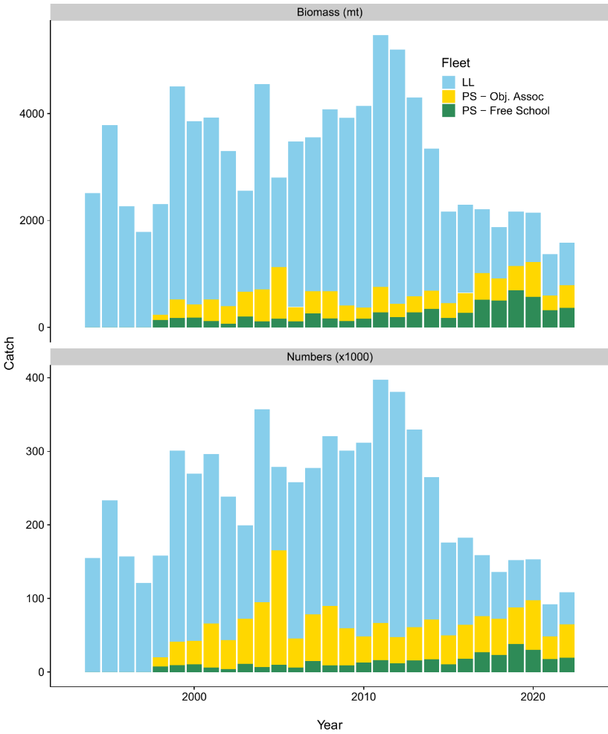
within 10 years
Figure FAL-01. Predicted retained catch by the fleet in biomass and numbers.

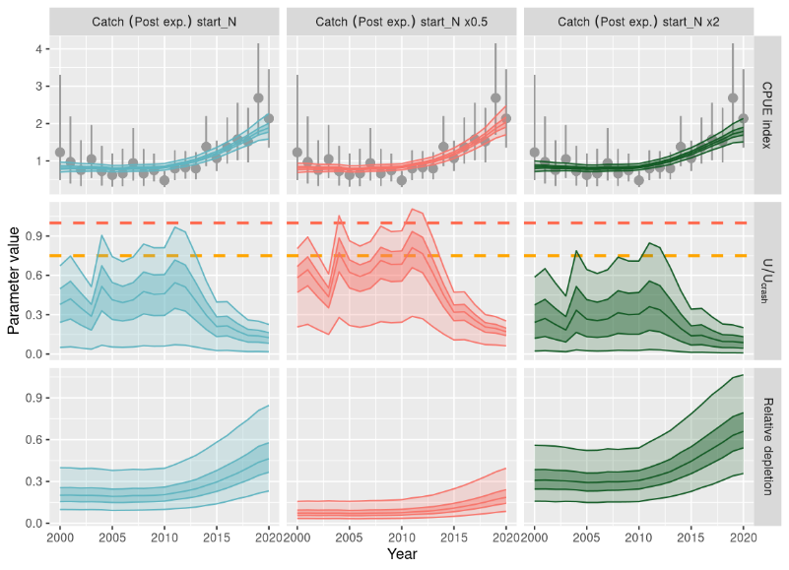

Figure FAL-02. Fitting of catch-per-unit-effort (CPUE) data using a dynamic surplus production model with independent model runs for each CPUE indices (dark shading, inter-quartile; light shading, 95% credible interval). Top row: Predicted CPUE with input CPUE (points) and observation error (interquartile range). Middle row: Time series of fishing mortality relative to the U_{Crash} (red) and U_{lim} = 0:75⋅U_{Crash} (orange) as estimated in the dynamic surplus production model. Bottom row: Estimated relative depletion (relative to unfished abundance K). The stock was not unfished in the first year of the time-series, and each column shows an alternative prior assumption about initial depletion.
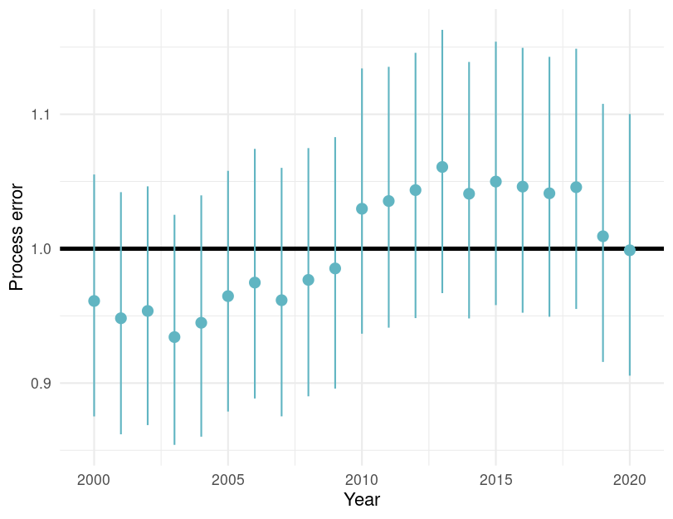

Figure FAL-03. Estimated process error by year with 95% credible intervals for the dynamic surplus production model for silky shark in the WCPO. Note this figure is not in the SC20-SA-WP-04 but is included here at the request of the SC20.

b. Stock Status

- The 2018 assessment for Silky shark showed high uncertainty, and SC14 concluded that the stock was not overfished, but subject to overfishing.

- There are no agreed reference points for sharks in the WCPFC. The 2024 model suggested that stock status has been improving since 2010. Recent (2019–2020) fishing mortality was estimated to be below biological reference points (U_{recent}/U_{crash}: 0.13 [95% credible interval 0.01–0.25]; the probability of U_{recent}/U_{crash} >1 was 0 and the probability of U_{recent}/U_{lim} >1 was 0) [Figure FAL-04, Table FAL-02]. Fishing mortality is estimated to have declined in recent years across all model types and appears to be below the levels that would preclude stock rebuilding and below the MSY reference point (according to the DSPM with intermediate assumption).

- According to these estimates, overfishing is very unlikely (< 10%) to be occurring relative to MSY-based reference points. However, abundance and depletion estimates were very uncertain, and SC20 considered the stock was about as likely as not (40-60 %) to be overfished relative to MSY-based reference points.

Table FAL-02. Estimates of management quantities (stock status as abundance N_{recent} relative to carrying capacity K), and fishing mortality (U) relative to indicators (U_{MSY}) and possible limit reference points U_{Lim}, U_{crash}). P(>RP) refers to the probability that the metric (status, fishing mortality) is above the respective indicator.
Summary: Silky shark
Year assessment conducted: 2024  Last year of data: 2020 | Biomass (abundance) | No agreed target or limit for sharks
 | Fishing mortality | Very Likely (>90%) to be below biological reference point: Overﬁshing is not occurring
 | Projection | No projections
 | Recommendation | Current mitigation measures do appear to be effective for silky sharks
Reference points |  | Estimate [5%–95% credible interval]
Abundance | - | -
Catch | - | -
Harvest rate  Harvest rate | U_{lim} (not agreed)  U_{crash} (not agreed) | 0.19 [0.09 – 0.38]  0.25 [0.16 – 0.48]
Recent estimates |  |  |  | Recent trend / projection
Total Depletion  Harvest rate | N_{recent}/K | 0.44 [0.10 – 0.96]  0.017 [0.0014 – 0.048] |  | Abundance increasing  F declining
Catch | C | 65 189 |  | Catch declining
Status |  |  | Likelihood
Harvest rate | U_{recent}/U_{lim} | 0.18 [0.02 – 0.34] | Very likely (<90%) to be
 |  |  | below limits
Harvest rate | U_{recent}/U_{crash} | 0.13 [0.01 – 0.25] | Very likely (>90%) to be
 |  |  | below limits
Projections
No projections

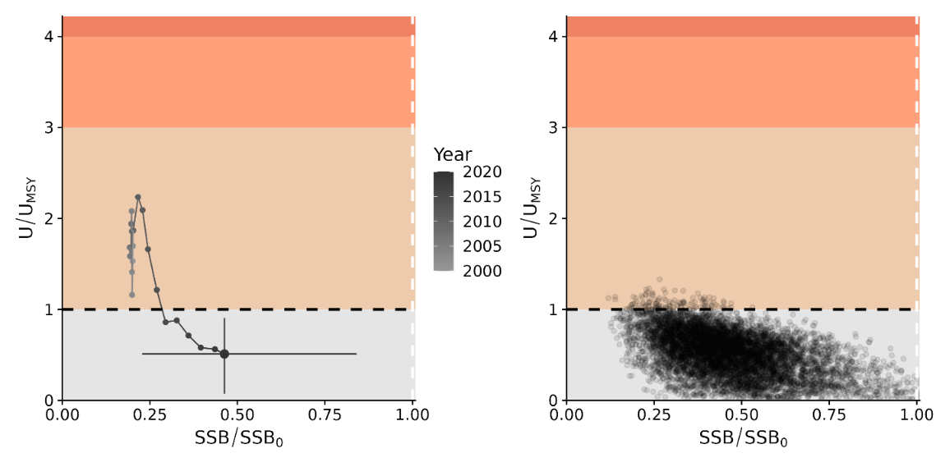 Figure FAL-04. Majuro plots for recent (2019–2020) stock status based on the dynamic surplus production model for silky shark in the WCPFC. Left-hand plots show the stock trajectory, with uncertainty shown for the most recent year in the analysis (2020). In contrast, the plot on the right-hand side shows individual draws from the posterior distribution(s) for recent (2019–2020) years.

- Management advice

- SC20 noted that due to challenges fitting the stock assessment models, no projections were provided to the SC, and recommended that if possible projections be included in future assessment reports.

- SC20 recommended interpreting the results of the silky shark stock assessment with caution due to the large amount of uncertainty in catch, stock structure, life history, and other important components of the assessment, but it noted that all of the models presented resulted in an improving trend in stock status for silky sharks.

- SC20 noted that further research is necessary to continue the improvement of this and other shark stock assessments and that current mitigation measures do appear to be effective for silky sharks.

SC15, 2019 – SC19, 2023 (NO STOCK ASSESSMENT)

- Stock status and trends

- SC19 noted that no stock assessments were conducted for silky shark in 2023. Therefore, the stock status descriptions from SC14 are still current for silky shark. For further information on the stock status and trends from SC14, please see https://www.wcpfc.int/node/32155. Updated information on catches was not compiled for and reviewed by SC15.

- Management advice and implications

- SC19 noted that no management advice has been provided since SC14 for silky shark. Therefore, previous advice should be maintained, pending a new assessment or other new information. For further information on the management advice and implications from SC14, please see https://www.wcpfc.int/node/32155.

SC14 2018 (STOCK ASSESSMENT CONDUCTED)

- The SC accepts the WCPO silky shark stock assessment as best available science for this stock.

a. Stock status and trends

- SC14 noted given the inherent uncertainty in the current assessment the current estimates of stock status should be considered indicative only. Although these estimates are not considered a reliable basis for management decision-making they represent progress since the 2013 assessment and the best available science concerning the status of silky sharks in the WCPO. Therefore, as part of its ongoing review of the established conservation and management measure for silky sharks (CMM 2013-08), the Commission may wish to consider these indicative results until such time as better estimates become available.

- SC14 noted that indications from the 2018 WCPO model show that the stock declined steadily over the model period (1995-2016) (Figure FAL-1). The assessment model estimates spawning biomass in 2016 to have been at 47% of the unexploited level (SB₂₀₁₆/SB₀ = 0.469). Current biomass is estimated to be above the MSY reference biomass level; however, there is considerable uncertainty associated with the estimate of stock status (SB₂₀₁₆/SB_{MSY} = 1.178 95% CI 0.590-1.770) (Table FAL-1). On balance, the stock is not considered to be overfished, i.e. there is a 78% probability that SB₂₀₁₆ is greater than SB_{MSY} (Table FAL-1).

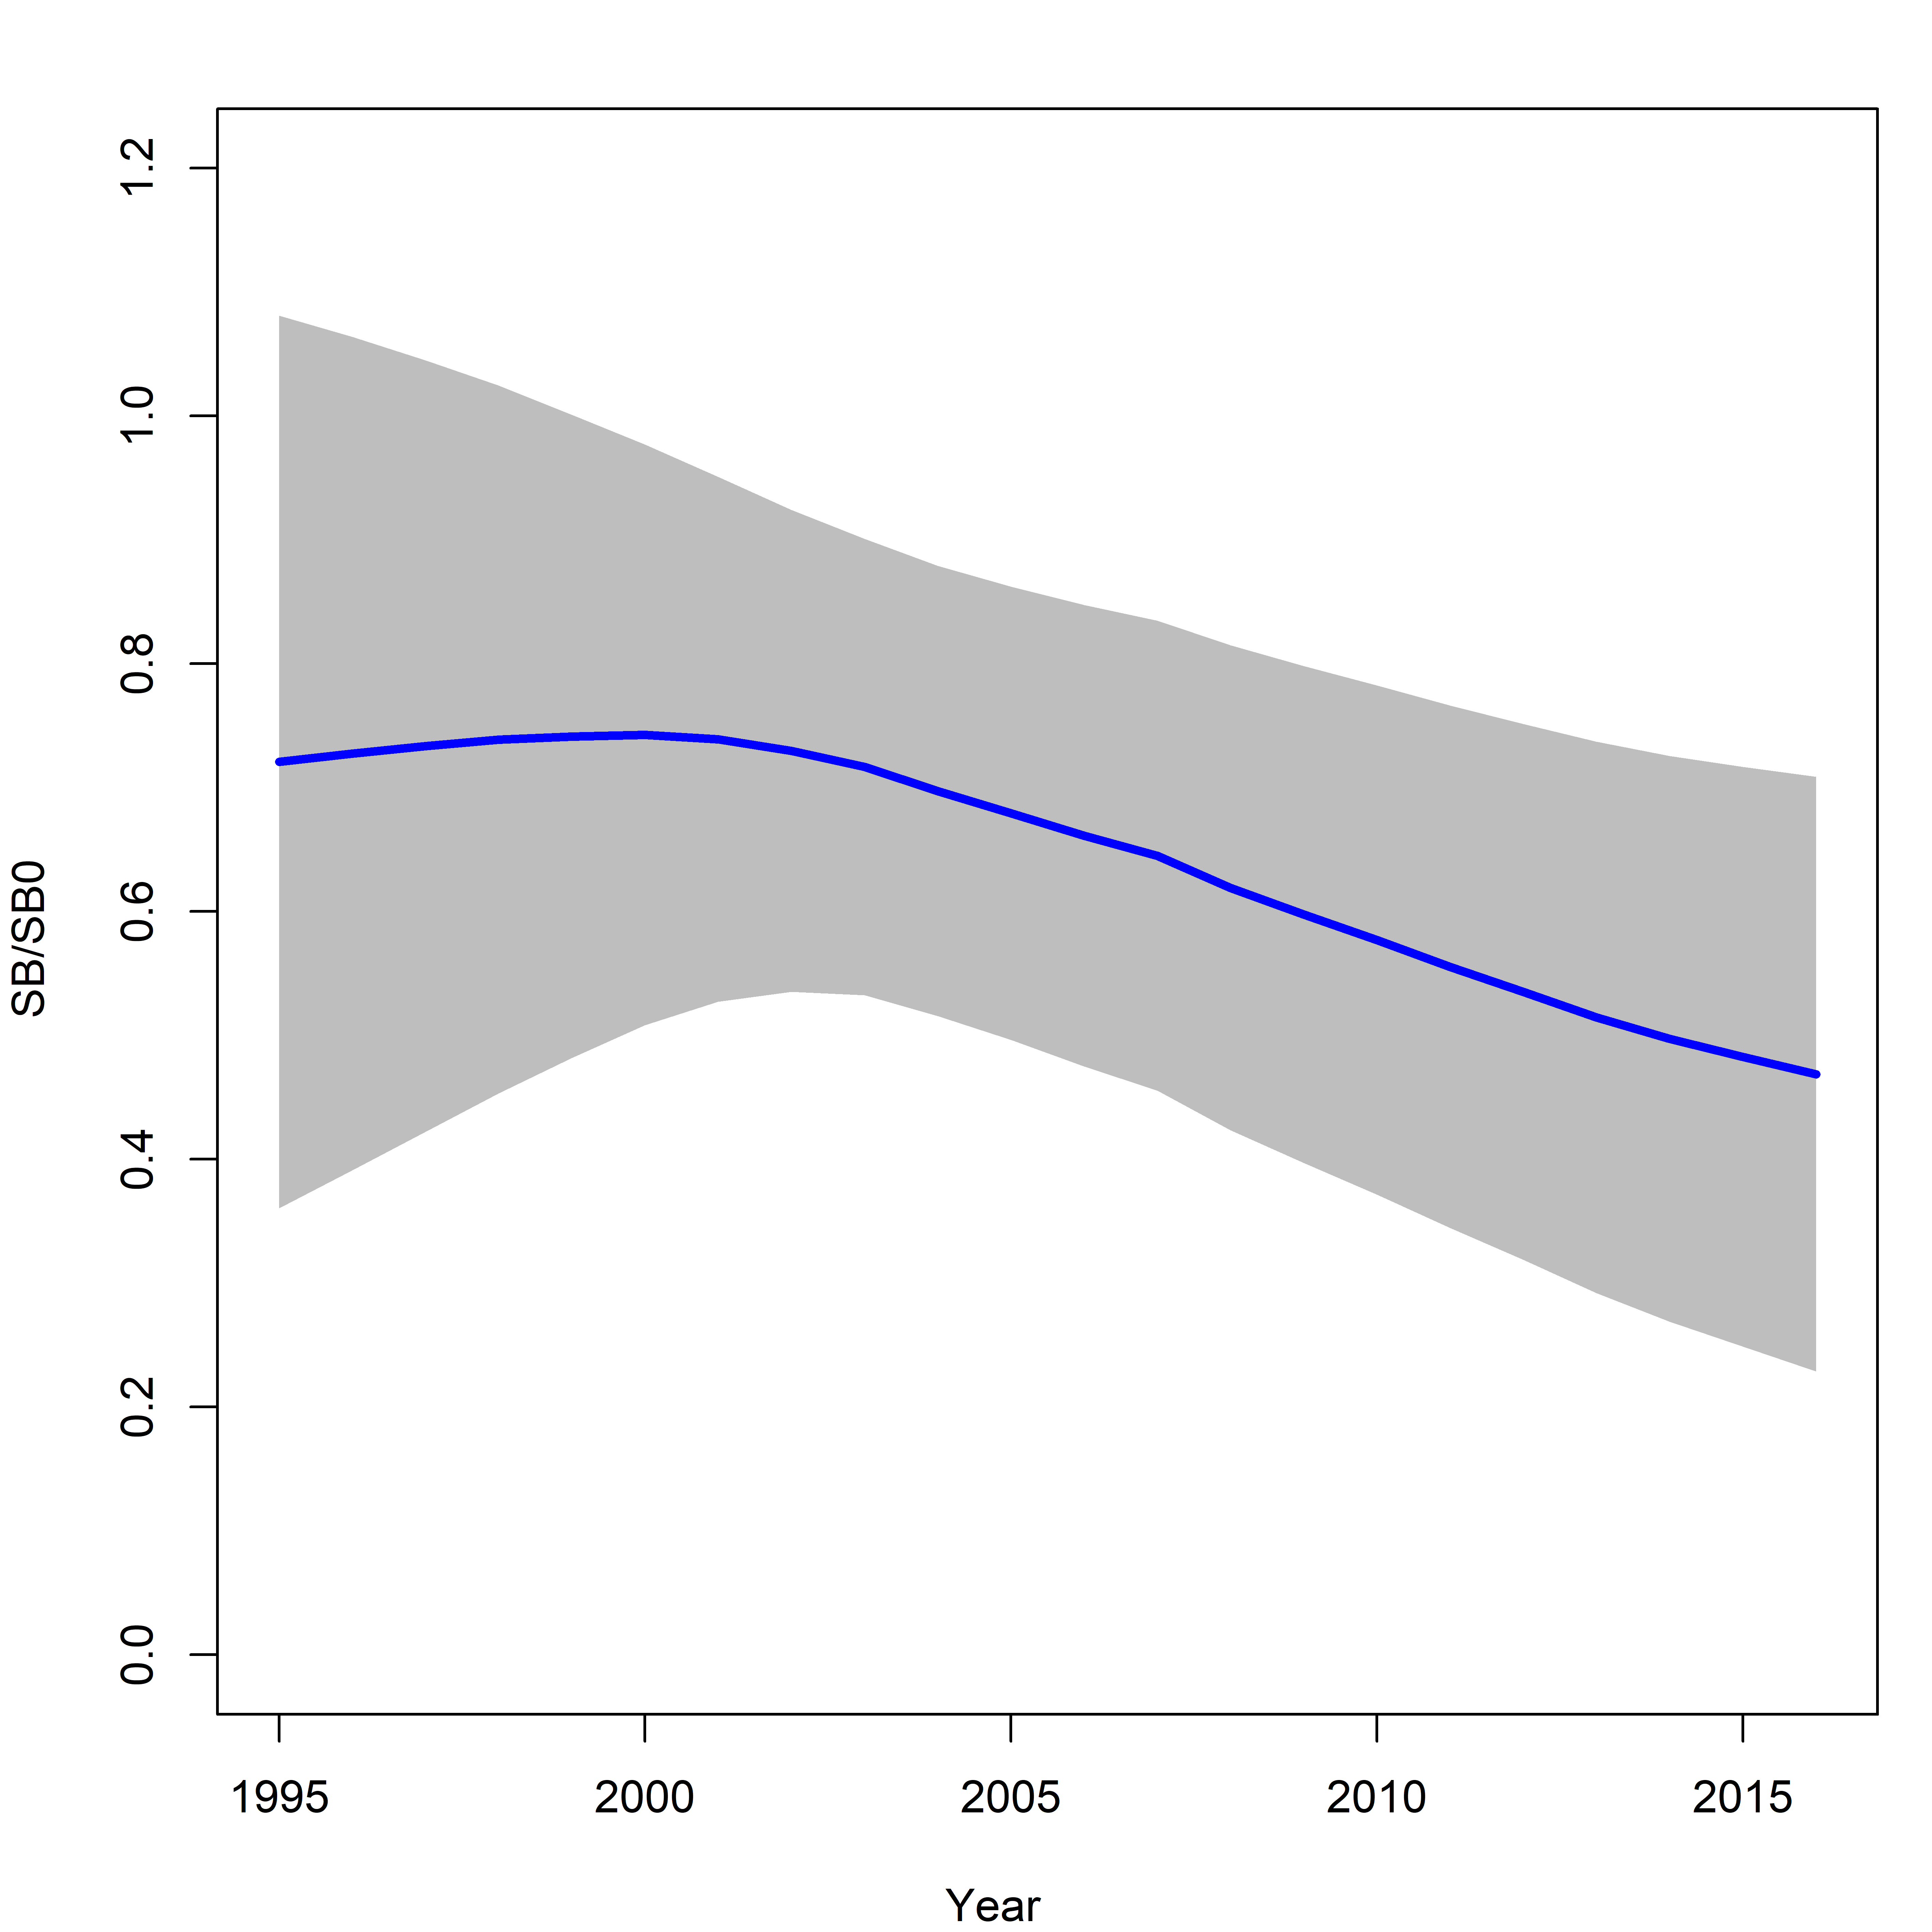 | Figure FAL-1: Estimated spawning biomass relative to unexploited biomass (SB₀) for the WCPO assessment model (CPUEqdev).

Table FAL-1: Management quantities (and 95% confidence intervals) for the WCPO assessment model (CPUEqdev).
Management quantity | Value | Confidence interval (95%)
SB₀ | 11,865 | 6,412-17,318
SB₁₉₉₅ | 8,552 | 2,590-14,513
SB_{MSY} | 4,721 | 2,560-6,882
SB_{MSY}/SB₀ | 0.398 | 0.397-0.399
SB₂₀₁₆ | 5,560 | 301-10,819
SB₂₀₁₆/SB₀ | 0.469 | 0.229-0.729
SB₂₀₁₆/SB_{MSY} | 1.178 | 0.590-1.77
Pr(SB₂₀₁₆ > SB_{MSY}) | 0.78
F₂₀₁₆/F_{MSY} | 1.607 | 0.316-2.810
Pr(F₂₀₁₆ > F_{MSY}) | 0.84
F₂₀₁₆ | 0.313
MSY | 12,162 | 6,711-17,615
Catch 2016 (mt) | 22,503

- Fishing mortality is estimated to be above F_{MSY} (F₂₀₁₆/F_{MSY} = 1.607, Pr(F₂₀₁₆ > F_{MSY}) = 84%). The current level of catch is substantially higher than the MSY. If catches remain at the current level there is a high probability that the biomass will decline to below the SB_{MSY} level in the foreseeable future (~ 5 years).

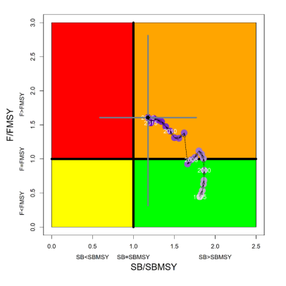 | Figure FAL-2: Kobe plot for the WCPO assessment model (CPUEqdev).

b. Management advice and implications

- SC14 concludes that on the basis of the best available science, and pending the availability of less uncertain stock status indicators, the stock is not overfished, but is subject to overfishing (Figure FAL-2).

- SC14 recommends, given that the WCPO silky shark stock continues to be subject to overfishing, that CMM 2013-08 be maintained as a precautionary measure.

SC13 2017 (NO STOCK ASSESSMENT)

- Stock status and trends

- SC13 noted that no stock assessments were conducted for these shark species in 2017. Therefore, the stock status descriptions from SC9 are still current for silky shark. Updated information on catches was not compiled for and reviewed by SC13.

- Management advice and implications

- SC13 noted that no management advice has been provided since SC9 for silky shark. Therefore, previous advice should be maintained, pending a new assessment or other new information.

Useful References

SC14-SA-WP-08 Pacific-wide Silky Shark (Carcharhinus falciformis) Stock Status Assessment and Addendum. https://www.wcpfc.int/node/31006

Previous Assessments

SC9-SA-WP-03 Updated Stock assessment of silky shark in the western and central Pacific Ocean. https://www.wcpfc.int/node/3685

SC8-SA-WP-07 Stock Assessment of Silky Sharks in the Western and Central Pacific Ocean Rev 1 (3 August 2012) https://wcpfc.int/node/3236

