The Commission for the Conservation and Management of
Highly Migratory Fish Stocks in the Western and Central Pacific Ocean

Scientific Committee

North Pacific Blue Shark (Prionace glauca)

Stock Status and Management Advice

Contents
SC18 2022 (STOCK ASSESSMENT CONDUCTED) 2
SC16 2020 – SC17 2021 (NO STOCK ASSESSMENT) 3
SC15 2019 (NO STOCK ASSESSMENT) 3
SC14 2018 (NO STOCK ASSESSMENT) 4
SC13 2017 (STOCK ASSESSMENT CONDUCTED) 5
Useful References 10
Previous Assessments 10

SC18 2022 (STOCK ASSESSMENT CONDUCTED)

- SC18 reviewed SC18-SA-WP-06 Stock assessment and future projections of blue sharks in the North Pacific Ocean through 2020), which presents the results of the stock assessment for blue sharks in the North Pacific Ocean conducted by the ISC SHARKWG using a fully integrated, size-based, age-, and sex-structured model.

- Stock status and trends

- SC18 thanked ISC for the updated stock assessment for North Pacific blue shark and noted the following conclusions on the stock status provided by ISC.

Target and limit reference points have not yet been established for pelagic sharks in the Pacific Ocean by either the WCPFC or the IATTC. Stock status was reported in relation to MSY-based reference points. The following information on the status of North Pacific BSH was provided.

The median of the annual spawning stock biomass (SSB) from the model ensemble had a steadily decreasing trend until 1992 and slightly increased until recent years. The median of the annual F from the model ensemble gradually increased in the late 1970s and 1980s and suddenly dropped around 1990, which slightly preceded the high-seas drift gillnet fishing ban, after which it has been slightly decreasing. The median of the annual age-0 recruitment estimates from the model ensemble appeared relatively stable with a slightly decreasing trend over the assessment period except for 1988, which shows a large pulse. The historical trajectories of stock status from the model ensemble revealed that North Pacific BSH had experienced some level of depletion and overfishing in previous years, showing that the trajectories moved through the overfishing zone, overfished and overfishing zone, and overfished zone in the Kobe plots relative to MSY reference points. However, in the last two decades, median estimates of the stock condition returned into the not overfished and not overfishing zone.

Based on these findings, the following information on the status of the North Pacific BSH is provided:
- Median female SSB in 2020 was estimated to be 1.170 of SSB_{MSY} (80th percentile, 0.570 - 1.776) and is likely (63.5% probability) not in an overfished condition relative to MSY-based reference points.
- Recent annual F (F₂₀₁₇₋₂₀₁₉) is estimated to be below F_{MSY} and overfishing of the stock is very likely (91.9% probability) not occurring relative to MSY-based reference points.
- The base case model results show that there is a 61.9% joint probability that NPO BSH stock is not in an overfished condition and that overfishing is not occurring relative to MSY based reference points.

- SC18 noted that the current assessment is an improvement over the previous assessment and supports the model ensemble approach taken in the 2022 stock assessment as a more comprehensive way of characterizing structural uncertainty in stock status. However, SC18 noted that the model ensemble did not consider some key uncertainties, in particular natural mortality or stock-recruitment steepness and SC18 recommended a more thorough use of the model ensemble approach is recommended to better represent uncertainty for future assessments.

- Management advice and implications

- SC18 noted the following conservation information from ISC.

Stock projections of biomass and catch of NPO BSH from 2020 to 2030 were performed
assuming four different harvest policies: F_{current} (2017-2019), F_{MSY}, F_{current}+20%, and F_{current}-20% and evaluated relative to MSY-based reference points. Based on these findings, the following conservation information is provided:
- Future projections in three of the four harvest scenarios (F_{current} (2017-2019), F_{current}+20%, and F_{current}-20%) showed that median SSB in the North Pacific Ocean will likely (>50 probability) increase; the F_{MSY} harvest scenario led to a decrease in median SSB.
- Median estimated SSB of BSH in the North Pacific Ocean will likely (>50 probability) remain above SSB_{MSY} in the next ten years for all scenarios except F_{MSY}; harvesting at F_{MSY} decreases SSB below SSB_{MSY} (Figure 5E, SC18-SA-WP-06).
- There remain some uncertainties in the time series based on the quality (observer vs. logbook) and timespans of catch and relative abundance indices, limited size composition data for several fisheries, the potential for additional catch not accounted for in the assessment, and uncertainty regarding life history parameters. Continued improvements in the monitoring of BSH catches, including recording the size and sex of sharks retained and discarded for all fisheries, as well as continued research into the biology, ecology, and spatial structure of BSH in the North Pacific Ocean are recommended.

- SC18 noted that recent estimated recruitment was below the average level from the Beverton-Holt stock recruit relationship, and that if these low recruitments persist into the future then the projection results could be overly optimistic.

SC16 2020 – SC17 2021 (NO STOCK ASSESSMENT)

There were no stock assessments conducted for North Pacific blue shark in 2020 - 2021. SC16 and SC17 did not discuss this in its abbreviated agenda due to the virtual nature of the meeting under the COVID-19 pandemic situation. Therefore, the stock status descriptions from SC13 are still current for North Pacific blue shark. For further information on the stock status and trends from SC13, please see https://www.wcpfc.int/node/29904.

SC15 2019 (NO STOCK ASSESSMENT)

- Stock status and trends

- SC15 noted that no stock assessments were conducted for North Pacific blue shark in 2019. Therefore, the stock status descriptions from SC13 are still current for North Pacific blue shark. For further information on the stock status and trends from SC13, please see https://www.wcpfc.int/node/29904. Updated information on catches was not compiled for and reviewed by SC15.

- Management advice and implications

- SC15 noted that no management advice has been provided since SC13 for North Pacific blue shark. Therefore, previous advice should be maintained, pending a new assessment or other new information. For further information on the management advice and implications from SC13, please see https://www.wcpfc.int/node/29904.

SC14 2018 (NO STOCK ASSESSMENT)

- Status and trends

- SC14 noted that no stock assessments were conducted for north Pacific blue shark in 2018. Therefore, the stock status descriptions from SC13 are still current for north Pacific blue shark. Updated information on catches was not compiled for and reviewed by SC14.

- Management advice and implications

- SC14 noted that no management advice has been provided since SC13 for north Pacific blue shark. Therefore, previous advice should be maintained, pending a new assessment or other new information. For further information on the management advice and implications from SC13, please see https://www.wcpfc.int/node/29904

- Recommendations on the designation of North Pacific blue shark as a Northern Stock

- Regarding the issue of the designation of North Pacific blue shark as a Northern Stock (WCPFC14 Report, Para 378), SC14 provides the following recommendations:
- SC14 recommends that the Commission clarify and quantify what is meant by “mostly north of 20 degrees N”.
- In relation to paragraph 1, SC14 recommends that a check-list of benchmark scientific information for North Pacific blue shark be developed to support the Commission’s deliberations in determining the designation of a northern stock. As such, the following draft checklist is forwarded for the Commission’s consideration.

No | Criteria | Response | Comments
1 | What proportion of the total estimated stock biomass occurs on average north of 20ºN? | Unknown | Current assessment model does not include population spatial structure. Nominal CPUE may be biased and could be overestimated in the north unless the effects of fishing time, depth and depth distribution of blue sharks are accounted for.
2 | Does all of the breeding/spawning area(s) occur north of 20 ºN? | No | Breeding area is mainly north of 20 ºN but may overlap areas south of 20 ºN
3 | Does all of the nursery area(s) occur north of 20 ºN | Yes | Mostly in the area 30-40 ºN
4 | Do any other important life history stages occur south of 20 ºN? | Yes | Pregnant females are commonly found south of 20 ºN
5 | What proportion of the total annual estimated catch occurs north of 20 ºN? | 0.88 on average | Based on raised, aggregated (5x5 degree) longline data 2014-2017 submitted to WCPFC (Operational data would provide better resolution than aggregated data)
6 | Is fishery catch-per-unit-effort demonstrably higher north of 20 ºN for comparable fisheries? | (i) Similar CPUE observed north and south of 20 ºN in Chinese Taipei LSTLL fishery and Hawaii deep-set LL fishery  (ii) CPUE higher north of 20 ºN in Japan shallow set research survey | CPUE comparisons may be biased by different depth distribution of blue shark north and south of 20 ºN.
7 | Is there sufficient information about fish movement between the areas north and south of 20 ºN? | Yes | Conventional tagging data shows that the maximum range of movements suggests at least northern and southern sub-populations of blue shark, as demarked by the equator.

SC13 2017 (STOCK ASSESSMENT CONDUCTED)

- Stock status and trends

- SC13 noted that ISC provided the following conclusions on the stock status of North Pacific blue shark.

The assessment uses a fully integrated approach in Stock Synthesis with model inputs that have been greatly improved since the previous assessment. The main differences between the present assessment and the 2014 assessment are: 1) use of SS with a thorough examination of the size composition data and the relative weighting of CPUE and composition data; 2) improved life history information, such as growth and reproductive biology, and their contribution to productivity assumptions; 3) an improved understanding and parametrization of the low fecundity stock recruit relationship (LFSR); 4) catch, CPUE and size time series updated through 2015; 5) a suite of model diagnostics including implementation of an Age Structured Production Model implemented in SS. There remain some uncertainties in the time series based on the quality (observer vs. logbook) and timespans of catch and relative abundance indices, limited size composition data for several fisheries, the potential for additional catch not accounted for in the assessment, and regarding life history parameters.

Extensive model explorations showed that the reference run had the best model performance and showed fits most consistent with the data. The CPUE indices used in the reference case were considered most representative of the North Pacific blue shark stock due to their broader spatial temporal coverage in the core distribution of the stock and the statistical soundness of the standardizations. Alternate CPUE series for the latter part of the time series produced different stock trajectories depending upon the index used, but in each case, median SSB during the last three years exceeded SSBMSY. Using alternate assumptions on stock productivity (i.e., form of the stock recruitment relationship) also resulted in variation in the stock trajectories; assuming stock productivity lower than supported by current biological studies, resulted in lowered spawning stock biomass relative to MSY.

Results of the reference case model showed that the spawning stock biomass was near a time-series high in the late 1970s, fell to its lowest level between 1990 to 1995, subsequently increased gradually to reach the time-series high again in 2005, and has since shown small fluctuations with no apparent trend (Figure NPBSH- 1B) close to the time-series high. Recruitment has fluctuated around 37,000,000 age-0 sharks annually with no apparent trend (Figure NPBSH-1A). Stock status is reported in relation to MSY based reference points.

Based on these findings, the following information on the status of the North Pacific blue shark stock is provided:
- Female spawning biomass in 2015 (SSB₂₀₁₅) was 69% higher than at MSY and estimated to be 295,774 mt (Table NPBSH-1; Figure NPBSH-1B).
- The recent annual fishing mortality (F₂₀₁₂₋₂₀₁₄) was estimated to be well below F_{MSY} at approximately 38% of F_{MSY} (Table NPBSH-1; Figure NPBSH-1C).
- The reference run produced terminal conditions that were predominately in the lower right quadrant of the Kobe plot (not overfished and overfishing not occurring) (Figure NPBSH-2).

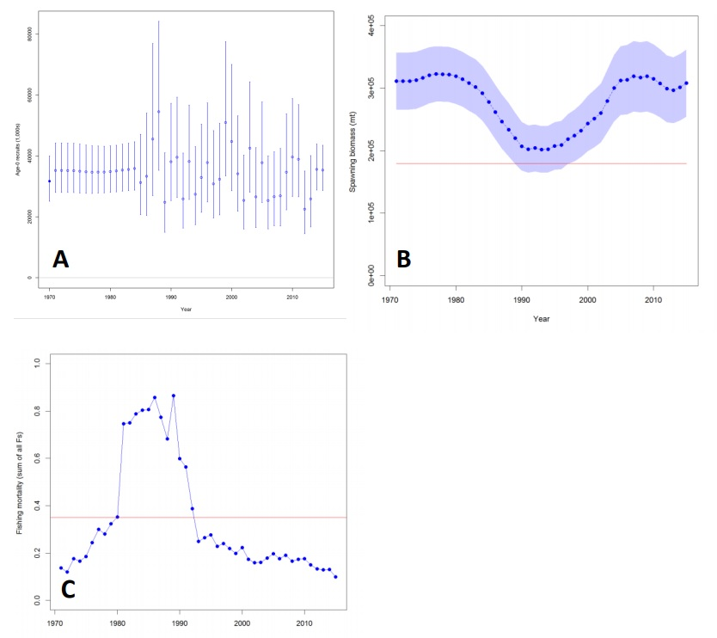

Figure NPBSH- 1. Results of the SS stock assessment reference case model: (A) estimated age-0 recruits (circles) and 95% confidence intervals (vertical bars); (B) estimated female spawning biomass and 95% confidence intervals (blue shaded area); (C) estimated fishing mortality (sum of F’s across all fishing fleets). Red solid lines indicate the estimates of SB_{MSY} and F_{MSY} in (B) and (C), respectively.

Table NPBSH-1. Estimates of key management quantities for the North Pacific blue shark SS stock assessment reference case model and the range of values for 13 sensitivity runs.
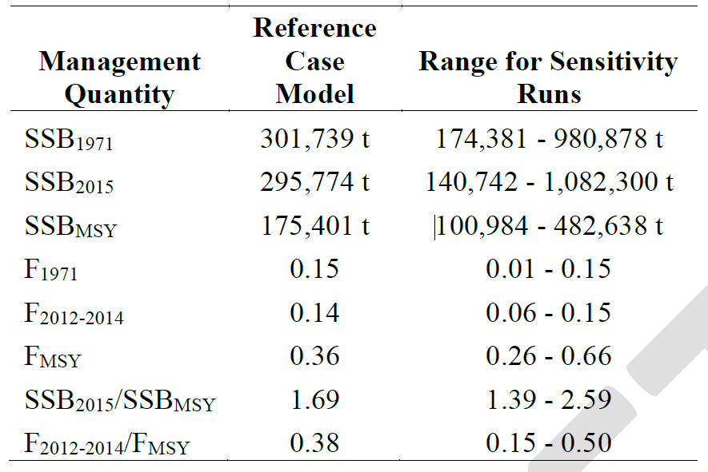

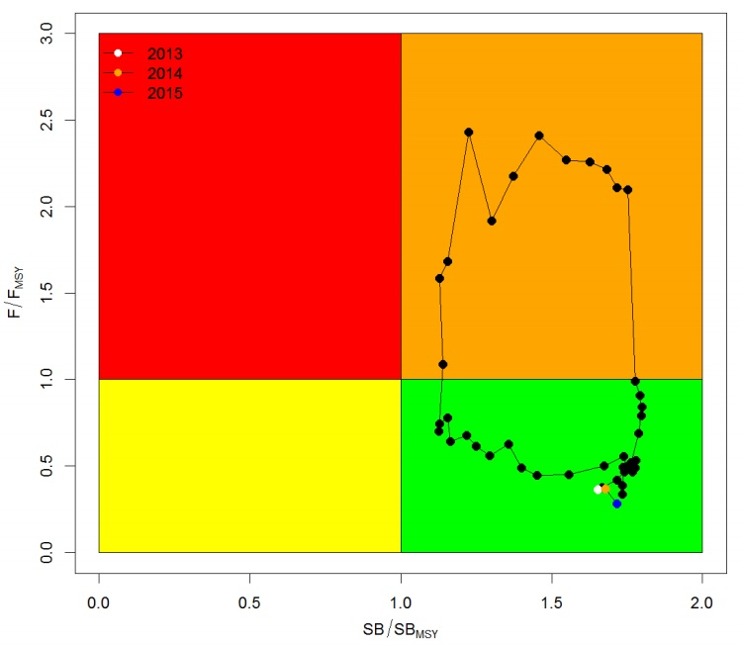
Figure NPBSH- 2. Kobe plot of the trends in estimates of relative fishing mortality and spawning biomass of North Pacific blue shark between 1971‐2015 for the reference case of the SS stock assessment model.

- Management advice and implications

- SC13 noted the following conservation information from ISC:

Target and limit reference points have not yet been established for pelagic sharks by the WCPFC or the IATTC, the organizations responsible for management of pelagic sharks caught in international fisheries for tuna and tuna-like species in the Pacific Ocean.

The 2015 SSB exceeds SSB_{MSY} and F₂₀₁₂₋₂₀₁₄ is below F_{MSY}. Future projections under different fishing mortality (F) harvest policies (status quo, +20%, -20%, F_{MSY}) show that median BSH biomass in the North Pacific will likely remain above B_{MSY} in the foreseeable future (Table NPBSH-2; Figure NPBSH-3). Other potential reference points were not considered in these evaluations.

Table NPBSH-2. Projected trajectory of spawning biomass (in metric tons) for alternative harvest scenarios.
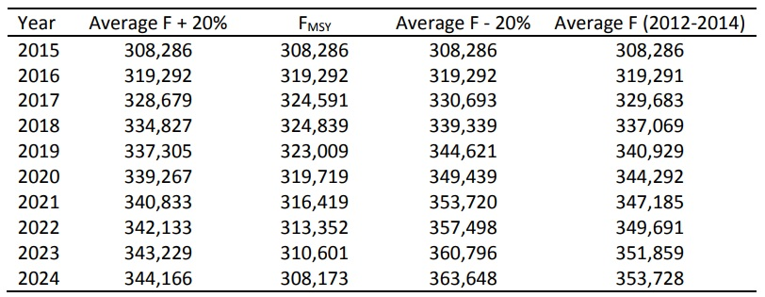

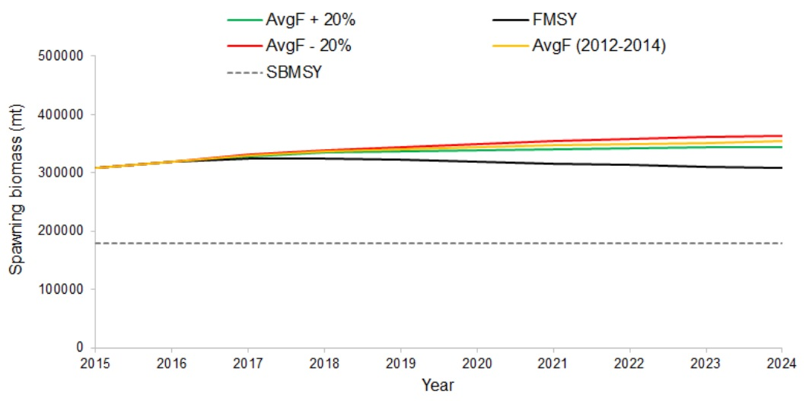
Figure NPBSH-3. Comparison of future projected blue shark spawning biomass under different F harvest policies (status quo, +20%, -20%, and F_{MSY}) using the SS reference case model. Status quo fishing mortality was based on the average from 2012-2014.

Useful References

SC18-SA-WP-06 Stock assessment and future projections of blue sharks in the North Pacific Ocean through 2020. https://meetings.wcpfc.int/node/16247

For current information related to Northern Stocks Working Group Reports and the ISC Plenary Report:
http://isc.fra.go.jp/reports/isc/isc22_reports.html

Previous Assessments

SC13-SA-WP-10 Stock Assessment and Future Projections of Blue Shark in the North Pacific Ocean through 2015. https://www.wcpfc.int/node/29523

SC10-SA-WP-14 Stock Assessment and Future Projections of Blue Shark in the North Pacific Ocean Rev 1. https://wcpfc.int/node/19204

SC9-SA-WP-02 Stock assessment of blue shark in the north Pacific Ocean using Stock Synthesis. https://wcpfc.int/node/3668

SC9-SA-WP11 Stock Assessment and Future Projections of Blue Shark in the North Pacific, plus reports from the associated ISC Shark WG Workshops. https://wcpfc.int/node/4730

SC3-SA-WP-07 North Pacific blue shark stock assessment. https://wcpfc.int/node/2055

