

The Commission for the Conservation and Management of
Highly Migratory Fish Stocks in the Western and Central Pacific Ocean

Scientific Committee

North Pacific Shortfin Mako Shark (Isurus oxyrinchus)

Stock Status and Management Advice

Contents
SC20 2024 (STOCK ASSESSMENT CONDUCTED) 2
SC15, 2019 – SC19, 2024 (NO STOCK ASSESSMENT) 10
SC14 2018 (STOCK ASSESSMENT CONDUCTED) 10
Useful References 13
PREVIOUS ASSESSMENTS 13

SC20 2024 (STOCK ASSESSMENT CONDUCTED)

- SC20 thanked the ISC SHARK WG for their thorough work conducted on the North Pacific shortfin mako shark stock assessment and acknowledged the significant improvement in the assessment due to the model ensemble approach.

- SC20 noted that the current assessment provides the best scientific information available on the North Pacific Ocean (NPO) shortfin mako shark (SMA) stock status. Results from this assessment should be considered with respect to the management objectives of the WCPFC and the IATTC, the organizations responsible for the management of pelagic sharks caught in international fisheries for tuna and tuna-like species in the Pacific Ocean. Target and limit reference points have not yet been established for pelagic sharks in the Pacific Ocean. In this assessment, stock status is reported in relation to maximum sustainable yield (MSY).

- SC20 noted that a Bayesian State-Space Surplus Production Model (BSPM) ensemble was used for this assessment; therefore, the reproductive capacity of this population was characterized using total depletion (D) rather than spawning abundance, which was used in the previous assessment. Total depletion is the total number of SMA divided by the unfished total number (i.e., carrying capacity). Recent D (D₂₀₁₉₋₂₀₂₂) was defined as the average depletion over the period 2019-2022. Exploitation rate (U) was used to describe the impact of fishing on this stock. The exploitation rate is the proportion of the SMA population that is removed by fishing. Recent U (U₂₀₁₈₋₂₀₂₁) is defined as the average U over the period 2018-2021. Note that the exploitation rate is defined relative to population carrying capacity.

- SC20 recognized that there continue to be a number of uncertainties with regard to NPO SMA, particularly related to population scale. The SC20 recommended that the ISC SHARKWG undertake a CKMR feasibility study in 2025-2026, to determine the magnitude of sampling that may be needed as well as a potential sampling strategy and any associated challenges, and report back to ISC26 and SC22.

Provision of scientific information to the Commission

- A summary of reference points and management quantities for the model ensemble is shown in Table NPSMA-01. A conceptual model developed for NPO SMA to organize an understanding of NPO SMA, identify plausible hypotheses for stock dynamics and fisheries structures, and to highlight key uncertainties is shown in Figure NPSMA-01. The time series of total annual catch by fishery is shown in Figure NPSMA-02. Standardized indices of relative abundance used in the stock assessment model ensemble are shown in Figure NPSMA-03, representing relative trends in abundance, provided by Japan, Chinese Taipei, and the U.S.A. Time series of estimated: depletion (D), exploitation rate (U), depletion relative to the depletion at maximum sustainable yield (D/D_{MSY}), exploitation rate relative to the exploitation rate that produces MSY (U/U_{MSY}), and total fishery removals (numbers) are shown in Figure NPSMA-04. The bivariate distribution of the average recent depletion relative to the depletion at MSY (D_{2019 – 2022}/D_{MSY}) against the average recent exploitation rate relative to the exploitation rate at MSY (U_{2018 – 2021}/U_{MSY}) is shown in Figure NPSMA-05. Stochastic stock projections of depletion relative to MSY (D/D_{MSY}) and catch (total removals) of NPO SMA from 2023 to 2032 are shown in Figure NPSMA-06.

a. Stock status and trends

- Within the modelled period, catch generally increased from ~50,000 individuals per year in 1994 to ~80,000 individuals per year in 2022 (~94,000 individuals per year, average 2018-2022; Figure NPSMA-02). Catches in the modelled period come predominantly from longline fisheries.

- During the 1994-2022 period, the median D of the model ensemble in the initial year 𝐷₁₉₉₄ was estimated to be 0.19 (95% CI: credible intervals = 0.08-0.44), and steadily improved over time and 𝐷₂₀₁₉₋₂₀₂₂ was 0.60 (95% CI = 0.23-1.00) (Table NPSMA-01 and Figure NPSMA-04). Although there are large uncertainties in the estimated population scale, the best available data for the stock assessment are four standardized abundance indices from the longline fisheries of Japan, Chinese Taipei, and the US; and all four indices indicate a substantial (>100%) increase in the population during the assessment period. The population was likely heavily impacted prior to the start of the modelled period (1994), after which it has been steadily recovering. It is hypothesized that the fishing impact prior to the modelled period was likely due to the high-seas drift gillnet fisheries operating from the late 1970s until it was banned in 1993, though specific impacts from this fishery on SMA are uncertain as species-specific catch data are not available for sharks. Consistent with the estimated trends in depletion, the exploitation rates were estimated to be gradually decreasing from 0.023 (95% CI = 0.004-0.09) in 1994 to the recently estimated exploitation rate (U₂₀₁₈₋₂₀₂₁) of 0.018 (95% CI = 0.004-0.07). The decreasing trends in estimated exploitation rates were likely due to the increase in estimated population size being greater than increases in the observed catch.

- The median of recent D (_{D2019−2022}) relative to the estimated D at MSY (D_{MSY} = 0.51, 95% CI = 0.40-0.70) was estimated to be 1.17 (95% CI = 0.46-1.92) (Table NPSMA-01 and Figure NPSMA-04). The recent median exploitation rate (𝑈₂₀₁₈₋₂₀₂₁) relative to the estimated exploitation rate at MSY (U_{MSY} = 0.05, 95% CI =0.03-0.09) was estimated to be 0.34 (95% CI = 0.07-1.20) (Table NPSMA-01 and Figure NPSMA-04). Surplus production models are a simplification of age-structured population dynamics and can produce biased results if this simplification masks important components of the age-structured dynamics (e.g., selectivity curves are dome-shaped or there is a long-time lag to maturity). Simulations suggest that under circumstances representative of the observed SMA fishery and population characteristics (e.g., dome-shaped index selectivity, long lag to maturity, and increasing indices), the BSPM ensemble may produce biased results. Representative simulations suggested that the D₂₀₁₉₋₂₀₂₂ estimate has a positive bias of approximately 7.3% (median). The trajectories of stock status from the model ensemble revealed that North Pacific SMA had experienced a high level of depletion prior to the start of the model and was likely overfished in the 1990s and 2000s, relative to MSY reference points.

- Based on these findings, the following information on the status of the NPO SMA is provided by the SC20:
- No biomass-based or fishing mortality-based limit or target reference points have been established for NPO SMA by the IATTC or WCPFC;
- Recent median D (D2019-2022) is estimated from the model ensemble to be 0.60 (95% CI = 0.23-1.00). The recent median D₂₀₁₉₋₂₀₂₂ was 1.17 times D_{MSY} (95% CI = 0.46-1.92) and the stock is likely (66% probability) not in an overfished condition relative to MSY-based reference points;
- Recent U (U₂₀₁₈₋₂₀₂₁) is estimated from the model ensemble to be 0.018 (95% CI = 0.004-0.07). U₂₀₁₈₋₂₀₂₁ was 0.34 times (95% CI = 0.07-1.20) U_{MSY} and overfishing of the stock is likely not occurring (95% probability) relative to MSY-based reference points;
- The model ensemble results show that there is a 65% joint probability that the North Pacific SMA stock is not in an overfished condition and that overfishing is not occurring relative to MSY-based reference points; and
- Several uncertainties may limit the interpretation of the assessment results including uncertainty in catch (historical and modelled period) and the biology and reproductive dynamics of the stock, and the lack of CPUE indices that fully index the stock.

b. Management advice and implications

- Stock projections of depletion and catch of North Pacific SMA from 2023 to 2032 were performed assuming four different harvest policies: 𝑈₂₀₁₈₋₂₀₂₁, 𝑈_{𝑀𝑆𝑌}, 𝑈₂₀₁₈₋₂₀₂₁ + 20%, and 𝑈₂₀₁₈₋₂₀₂₁ − 20% and evaluated relative to MSY-based reference points (Figure NPSMA-06).

- Based on these findings, the following conservation information is provided:
- Future projections in three of the four harvest scenarios (U₂₀₁₈₋₂₀₂₁ + 20%, and U₂₀₁₈₋₂₀₂₁ − 20%) showed that median D in the North Pacific Ocean will likely (>50% probability) increase; only the U_{MSY} harvest scenario led to a decrease in median D.
- Median estimated D of SMA in the North Pacific Ocean will likely (>50% probability) remain above D_{MSY} in the next 10 years for all scenarios except U_{MSY}; harvesting at U_{MSY} decreases D towards D_{MSY} (Figure NPSMA-06).
- Model projections using a surplus production model may oversimplify the age structured population dynamics and as a result could be overly optimistic.

Table NPSMA-01. Summary of reference points and management quantities for the model ensemble. Values in parentheses represent the 95% credible intervals when available. Note that exploitation rate is defined relative to the carrying capacity.
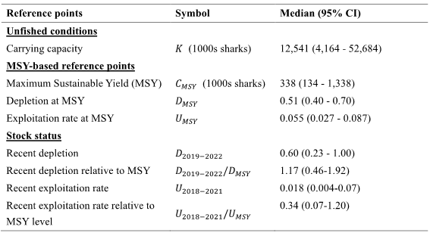

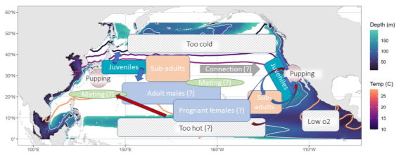
Figure NPSMA-01. Conceptual model for NPO SMA. Contour lines (warm colors) are shown for the average annual 10°, 15°, 18°, and 28°C sea surface temperature isotherms. Background shading (cooler colors) shows the depth of the oxygen minimum zone (3ml/L), a white isocline indicates a depth of 100m which could be limiting based on SMA vertical dive profiles.

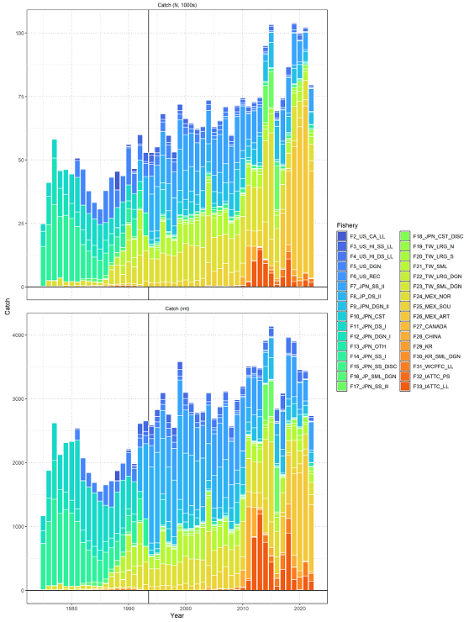

Figure NPSMA-02. Catch of North Pacific shortfin mako by fishery as assembled by the SHARK WORKING GROUP. Upper panel is catch in numbers (1000s) and lower panel is catch in biomass (mt). The vertical black line indicates the start of the assessment period in 1994.

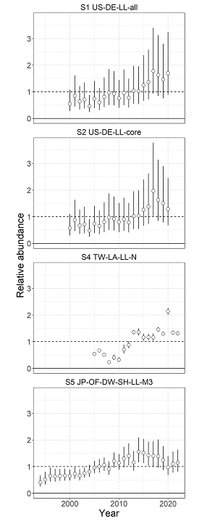
Figure NPSMA-03. Standardized indices of relative abundance used in the stock assessment model ensemble. Open circles show observed values (standardized to mean of 1; black horizontal line) and the vertical bars indicate the observation error (95% confidence interval).

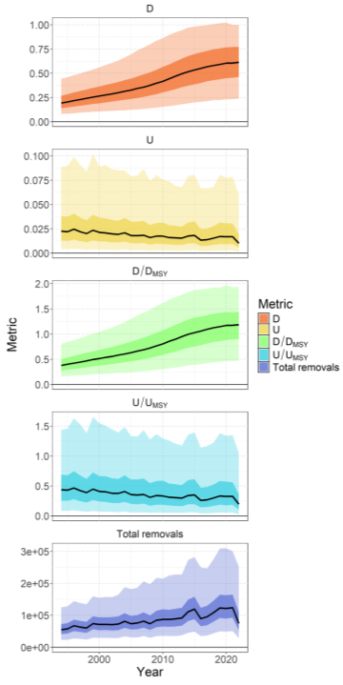
Figure NPSMA-04. Time series (solid lines) of estimated depletion (D), exploitation rate (U), depletion relative to the depletion at maximum sustainable yield (D/D_{MSY}), exploitation rate relative to the exploitation rate that produces MSY (U/U_{MSY}), and total fishery removals (numbers). Darker shading indicates a 50% credible interval, and lighter shading indicates a 95% credible interval.
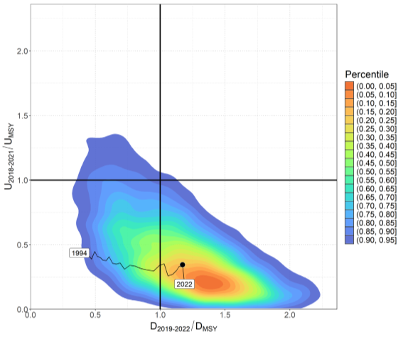
Figure NPSMA-05. Kobe plot showing the bivariate distribution (shaded polygon) average recent depletion relative to the depletion at MSY (D₂₀₁₉₋₂₀₂₂/D_{MSY} ) against the average recent exploitation rate relative to the exploitation rate at MSY (U₂₀₁₈₋₂₀₂₁/U_{MSY}). The median of this bivariate distribution is shown with the solid black point. The time series of annual D_{t}/D_{MSY} versus U_{t}/U_{MSY} is shown from 1994 to 2022.

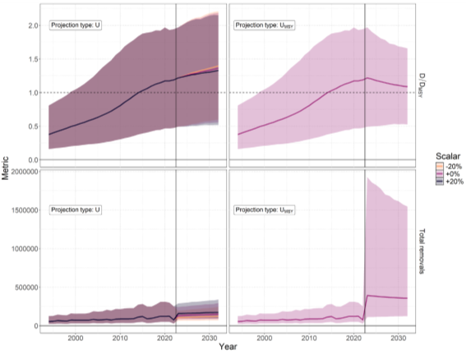

Figure NPSMA-06. Stochastic stock projections of depletion relative to MSY (𝑫/𝑫_{𝑴𝑺𝒀}) and catch (total removals) of North Pacific SMA from 2023 to 2032 were performed assuming four different harvest rate policies: U₂₀₁₈₋₂₀₂₁, U₂₀₁₈₋₂₀₂₁ + 𝟐𝟎%, U₂₀₁₈₋₂₀₂₁ −𝟐𝟎%, and U_{MSY}. The 95% credible interval around the projection is shown by the shaded polygon.

SC15, 2019 – SC19, 2024 (NO STOCK ASSESSMENT)

- Stock status and trends

- SC19 noted that no stock assessments were conducted for North Pacific shortfin mako shark in 2023. Therefore, the stock status descriptions from SC14 are still current for North Pacific shortfin mako shark. For further information on the stock status and trends from SC14, please see https://www.wcpfc.int/node/32155. Updated information on catches was not compiled for and reviewed by SC15.

- Management advice and implications

- SC19 noted that no management advice has been provided since SC14 for North Pacific shortfin mako shark. Therefore, previous advice should be maintained, pending a new assessment or other new information. For further information on the management advice and implications from SC14, please see https://www.wcpfc.int/node/32155.

SC14 2018 (STOCK ASSESSMENT CONDUCTED)

- Stock status and trends

- SC14 noted that ISC provided the following conclusions on the stock status of North Pacific Shortfin Mako Shark in the Pacific Ocean in 2017, as presented in SC14-SA-WP-11 (Stock Assessment of Shortfin Mako Shark in the North Pacific Ocean Through 2016).

Based on these findings, the following information on the status of the SFM stock is provided:
- Target and limit reference points have not been established for pelagic sharks in the Pacific Ocean. Stock status is reported in relation to MSY.
- The results from the base case model show that, relative to MSY, the North Pacific shortfin mako stock is likely (>50%) not in an overfished condition and overfishing is likely (>50%) not occurring relative to MSY-based abundance and fishing intensity reference points (Table SFM-4; Figure SFM-9A).

Stock status was also examined under six alternative states of nature that represented the most important sources of uncertainty in the assessment. Results of these models with alternative states of nature were consistent with the base case model and showed that, relative to MSY, the North Pacific shortfin mako shark stock is likely (>50%) not in an overfished condition and overfishing is likely (>50%) not occurring (Figure SFM-9B).

- Management Advice and implications

- SC14 noted the following conservation advice from ISC:

Stock projections of biomass and catch of North Pacific shortfin mako from 2017 to 2026 were performed assuming three alternative constant fishing mortality scenarios: 1) status quo, average of 2013-2015 (F₂₀₁₃-₂₀₁₅); 2) F₂₀₁₃₋₂₀₁₅ + 20%; and 3) F₂₀₁₃₋₂₀₁₅ - 20% (Figure SFM-10).

Based on these future projections, the following conservation information is provided:
- If fishing mortality remains constant at F2013-15 or is decreased 20%, then the Stock Abundance is expected to increase gradually;
- If fishing mortality is increased 20% relative to F2013-2015, then the Stock Abundance is expected to decrease in the final years of the projection.
- It should be noted that, given the uncertainty in fishery data and key biological processes within the model, especially the stock recruitment relationship, the models’ ability to project into the future is highly uncertain.

Research Needs

There is uncertainty in the estimated historical catches of North Pacific shortfin mako shark. Substantial time and effort was spent on estimating historical catch and more work remains to be conducted. In particular, the SHARKWG identified two future improvements that are critical: 1) identify all fisheries that catch shortfin mako shark in the NPO, including fisheries that were not previously identified by the SHARKWG; and 2) methods to estimate shortfin mako shark catches should be improved, especially for the early period from 1975 to 1993.

Table SFM-4. Summary of reference points and management quantities for the shortfin mako shark (Isurus oxyrinchus) base case model. The percentages in brackets are the CV of the estimated quantity in the base case model.
Management Quantity | Symbol | Units | Base case
Spawning abundance (number of mature female sharks | SA0 | 1000s of sharks | 1465.8 (23%)
Maximum Sustainable Yield (MSY) | CMSY | Metric tons (t) | 3127.1 (22%)
Spawning Abundance at MSY | SAMSY | 1000s of sharks | 633.7 (23%)
Fishing Intensity at MSY | 1-SPRMSY | NA | 0.26
Current spawning abundance relative to MSY | SA2016/SAMSY | NA | 1.36
Current spawning abundance relative to unfished level | SA2016/SA0 | NA | 0.58
Recent fishing Intensity relative to MSY | (1-SPR2013-15)/(1- SPRMSY) | MSY | 0.62

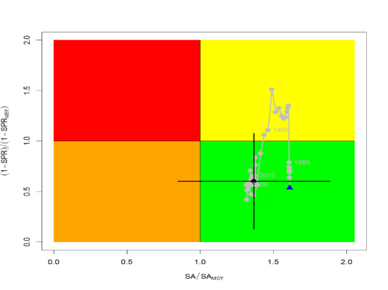
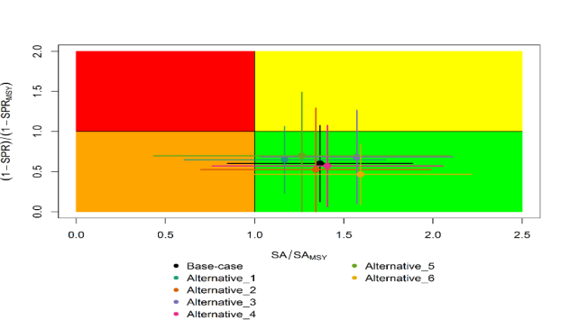
A
B
Figure SFM-9. Kobe plots of shortfin mako shark in the North Pacific Ocean showing. A) The time series of the ratio of SA to SA at MSY (SA_{MSY}) and fishing intensity to fishing intensity at MSY (1-SPR_{MSY}), and B) the same ratios for the terminal year (2016) for six alternative states of nature. SA is spawning abundance measured as the number of mature females. Fishing intensity is estimated as 1-SPR. Values for the start (1975) and end (2016) years in the time series (A) are indicated by the blue triangle and black circle, respectively. Gray numbers indicate selected years. Alternative states of nature in B) include: Alternative_1) higher catch, Alternative_2) lower catch; Alternative_3) higher uncertainty on Japan shallow-set CPUE index (1975-1993) (CV=0.3); Alternative_4) fit to Japan offshore distant water longline shallow-set fleet (JPN_SS_I; 1975-2016) and Hawaii longline shallow-set fleet (US_SS; 2005-2016), and no fit to initial equilibrium catch; Alternative_5) low steepness, h=0.26; and Alternative_6) high steepness, h=0.37. Solid lines indicate 95% confidence intervals.

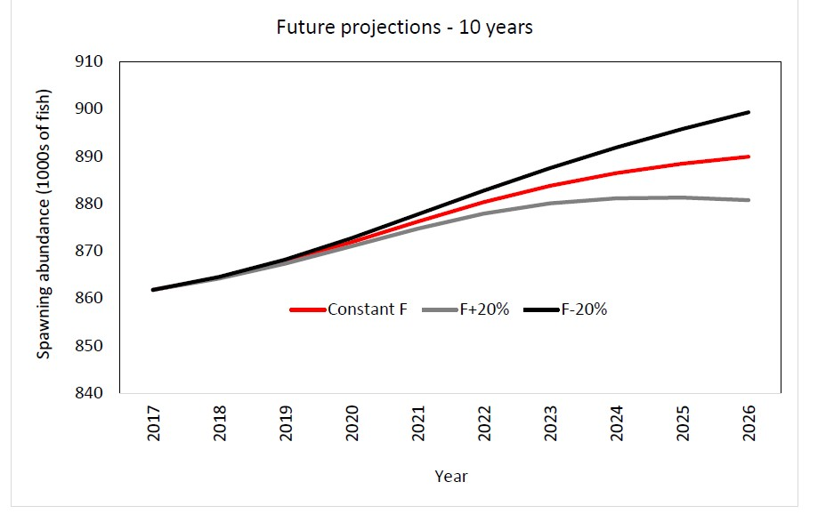
Figure SFM-10. Comparison of future projected North Pacific shortfin mako (Isurus oxyrinchus) spawning abundance under different F harvest policies (Constant F 2013-2015, +20%, -20%) using the base case model. Constant F was based on the average from 2013-2015.

Useful References

SC14-SA-WP-11 Stock Assessment of Shortfin Mako Shark in the North Pacific Ocean Through 2016. https://www.wcpfc.int/node/31025

For current information related to Northern Stocks Working Group Reports and the ISC Plenary Report:
http://isc.fra.go.jp/reports/isc/isc18_reports.html

PREVIOUS ASSESSMENTS
SC11-SA-WP-08 Indicator-based analysis of the status of shortfin mako shark in the North Pacific ocean. https://www.wcpfc.int/node/21778

